Title: SWift, a user-centered digital editor for SignWriting within SWORD project
Authors: Fabrizio Borgia, Claudia S. Bianchini, Maria De Marsico

Fabrizio Borgia:
Mail: fabrizio.borgia@uniroma1.it
Affiliation: Dep. of Computer Science – “Sapienza” University of Rome
Address: Via Salaria 113, 00198 Rome, Italy
Claudia S. Bianchini:
Mail: claudia.savina.bianchini@univ-poitiers.fr
Affiliation: UFR Lettres et Langues / EA3816 FoReLL - Université de Poitiers
Address: 1 Rue R. Cantel - 86073 POITIERS - FRANCE
Maria De Marsico:
Mail: demarsico@di.uniroma1.it
Affiliation: Dep. of Computer Science – “Sapienza” University of Rome
Address: Via Salaria 113, 00198 Rome, Italy

Language: English
Category: SignWriting in Software o SignWriting in Research

SWift, a user-centered digital editor for SignWriting within SWORD project

Since the early years of SignWriting (SW), both the research and the deaf community acknowledged its importance for digital communication. The applications designed to support its use range from the first “SignWriter Computer Program” (1986) to the modern digital editors [1].
Heterogeneous requirements must be taken into account: the large amount of symbols requires a robust yet intuitive organization of the search space; the organization and rules of the International SignWriting Alphabet (ISWA) must be considered too; finally, both a user-friendly navigation context for finding and fetching symbols (glyphs), as well as a space to compose the desired sign, have to be provided; an often underestimated key requirement, underlying the whole design and implementation processes, is an optimal usability level of the produced application.
The present work introduces SWift (SignWriting improved fast transcriber) [2] - a SW digital editor designed, developed and tested in close cooperation with the ISTC-CNR research team, mostly composed of deaf people. We followed the principles of User-Centered and Collaborative Design to produce an application for, and with, the Deaf Community.

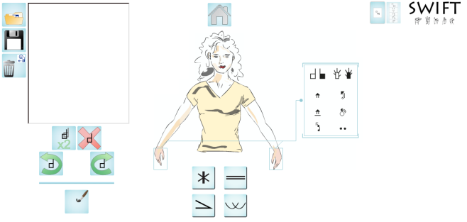
Fig. 1: Home screen of SWift, the hand symbol area being highlighted by the user

SWift provides all the functions of any SW digital editor, plus some more. The symbol fetching system was designed anew, in order to fit the needs of SW-beginners too. The system leads the user to the desired symbol category (head, hands, etc.) using a stylized human puppet (Fig. 1) as starting point. Instead of browsing the whole symbol space, SWift allows the user to search for the desired symbol through an iterative reduction of the answer set of symbols, obtained by refining the searched features (e.g., for the hand, side, orientation, etc.). The system does not force to choose such features in a predetermined order, but rather allows deciding the one to start with. For instance, one user may decide to begin looking for a specific hand symbol by entering the number of fingers, while another may decide to enter the hand orientation first.
The user interface (UI) has been thoroughly designed. To make the composition process easy and fast, we minimized the use of text elements, and avoided UI cluttering.
SWift allows the user to save the created signs in multiple formats: as a text file (XML) - via the SWML [1] format; as an image file (PNG); and remotely – storing the sign name and the association with its component glyphs in the SWift’s own database. It is also possible to store phrases and longer stories. Appropriate statistics computed on the database, whose reliability improves over time, allow to include an automatic suggestion engine, which analyses in real-time the sign that the user is composing and suggests likely glyphs to include next, or even a complete sign, therefore relieving the user from the burden of starting a whole new search.
SWift is designed to use different ISWA versions as symbol base. At present, SWift adopts a revised and enhanced version of the ISWA, following Bianchini [3].
One key stage in the lifecycle of any software is the usability testing phase, which was one of our main concerns. Basing our efforts on the work of [4], we designed the Sign-Aloud Protocol [5] - a deaf-oriented usability test protocol based on the well-known Think-Aloud Protocol. The test results show an acceptable usability of the application and they are summarized in the present work.
[1] Sutton, V. (n.d.). SignWriting for Sign Languages. Retrieved from http://www.signwriting.org/ on November 13, 2013.
[2] Bianchini, C.S., Borgia, F., Bottoni, P., De Marsico, M. (2012). SWift - A SignWriting improved fast transcriber. In Proceedings of AVI2012 (Capri, 21-25 May 2012).

[3] Bianchini, C.S. (2012). Analyse métalinguistique de l'émergence d'un système d'écriture des Langues des Signes: SignWriting et son application à la Langue des Signes Italienne (LIS). Ph.D. thesis, Université de Paris 8 - Università degli Studi di Perugia.

[4] Roberts, V.L., Fels, D.I. (2006).Methods for inclusion. Int. J. of Human-Computer Studies, 64(6):489-501.

[5] Bianchini, C.S., Borgia, F., De Marsico, M. (2012). SWift - A SignWriting editor to bridge between deaf world and e-learning. In Proceedings of ICALT2012 (Rome, 7-10 July 2012).

