CATEGORY: SignWriting in Research
“Implementation into the SWORD project of observations
arising from the process of users' appropriating and adapting SignWriting”
Claudia S. Bianchini¹ & Fabrizio Borgia²

¹ claudia.savina.bianchini@univ-poitiers.fr
UFR Lettres et Langues / EA3816 FoReLL
Université de Poitiers
1 Rue R. Cantel - 86073 POITIERS - FRANCE
² fabrizio.borgia@uniroma1.it
Dep. of Computer Science
“Sapienza” University of Rome
Via Salaria 113 - 00198 ROME - ITALY

Since the early years of the 2000s, SW has been used as a transcription and writing system for Italian Sign Language (LIS) by the "Written-LIS laboratory” (LLISS) at the ISTC-CNR in Rome. Between 2007 and 2012, during the preparation of her doctoral thesis, Bianchini [1] observed the modalities of using SW at LLISS and analyzed the ways by which its deaf and hearing members made the system their own.
It is worth mentioning that the LLISS people were self-taught in SW, on the basis of the 1995 manual and of the 2004 version of SignPuddle. Despite a very good knowledge of SW, we noted recurring problems in its use, and tried to understand the reasons. We thus realized that many difficulties arose because of the lack of strict coherence in the organization of SW that was evident both in the manual and in the 2006 SignPuddle server in use in the lab. One example is the movements of the hands in which: (1) all changes in a BaseSymbol do not describe the same trajectory; and (2) it is not possible to realize the same trajectories on every level (Figure 1). Therefore, we decided to carry out a complete reorganization of SW while totally respecting the work of Sutton and her team (I.e., no “original” glyph has been deleted), but suggesting additions so as to increase the coherence of the system (see Figure 1) [2]. This idea originated observing the written productions of LLISS people, where many glyphs were created "ad hoc" to represent movements, configurations, facial expressions and other signing elements not already provided in the different versions of SW.
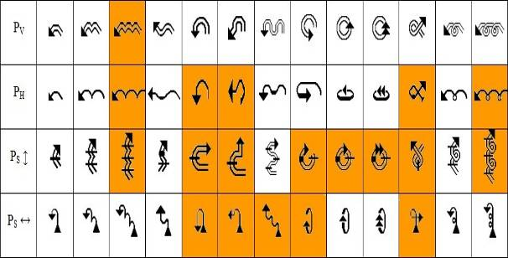
Figure 1 - White boxes: the possible trajectories within the official ISWA2008, by planes;
Orange boxes: the trajectories which were added improve the system coherence.
This reclassification required a new numbering system for the glyphs, which also involves the advantage, for the linguists, to easily extract the different glyph features (e.g., a query may extract all, and only, the movement from right to left of the right hand in the horizontal plane).
This work, however, was not an end in itself: in fact, all the deaf people we worked with prefer to hand-write SW, considering the use of SignPuddle too slow; therefore, as part of the project SWORD (SW Oriented Resources for the Deaf) implemented by the Informatics Dept of “Sapienza University of Rome”, and in particular of the Borgia’s doctoral dissertation, a new software was created, which allows to quickly digitally-write SW. This software, called SWIFT (SW improved fast transcriber)[3], is based on said reclassification and will be presented in detail in the paper by Bianchini, Borgia & DeMarsico.

[1] C. S. Bianchini, Analyse métalinguistique de l'émergence d'un système d'écriture des Langues des Signes: SignWriting et son application à la Langue des Signes Italienne (LIS), Ph.D. thesis, Université de Paris 8 - Università degli Studi di Perugia (2012).
[2] C.S. Bianchini, F. Borgia. 2012. Writing Sign languages: analysis of the evolution of the SignWriting system from 1995 to 2010, and proposals for future developments. Proc. Int. Jubilee Congr. Technical University of Varna, 6: 118-123.
[3] Bianchini, C.S., Borgia, F., Bottoni, P., De Marsico, M. (2012). SWift - A SignWriting improved fast transcriber. In Proceedings of AVI2012 (Capri, 21-25 May 2012).

Mostly due to the fact that SW is a system in constant evolution and, as such, is the result of “sedimentation” of several successive layers (see for more details Bianchini & Borgia, 2012).

