ABSTRACT
Presentation 56
SignWriting Symposium 2016

SignWriting in
Tunisian Deaf Education

Wafa Laajili
Tunisian Sign Language Instructor
foofa.laajili@yahoo.fr

Mohamed Ali Balti
SignWriting Instructor at
Ibn Charaf University in Tunisia
livingtabernacle@yahoo.fr

Teacher Wafa Laajili presented a SignWriting demonstration to educators in Tunisia on the 4th of May 2016. Wafa introduced her experiences using SignWriting in the classroom with Deaf students.

Here is the invitation to the event:

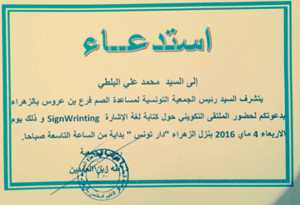

Wafa invited many people; teachers, students, linguists, associations etc... Mohamed Ali Balti participated in this event and shared his own experience with teaching SignWriting. Wafa prepared for three months. She made many videos and songs! Congratulations, Wafa!
