ABSTRACT
Presentation 55
SignWriting Symposium 2016

Moving Forward with Sign Language
Projects in Formal SignWriting (FSW)

Stephen E. Slevinski, Jr.

Software Developer of SignPuddle,

SWIS, & Sign Language Wikipedias

slevinski@signwriting.org

Imagine a world in which every sign language user can freely share in the sum of all knowledge.

Sign languages are human languages. Any topic that can be discussed in a spoken language can be discussed in a signed language. It's important to realize the benefits of a person being able to access information in their primary language. It's exciting to realize that sign language wikipedia projects are now possible with Sutton SignWriting.

For the past several years, we have been working on the technical infrastructure to make it possible to have a wikipedia in any sign language. We've been using Translate Wiki to localize the user interface. Most commonly, SignWriting is displayed vertically and for MediaWiki this requires a custom skin with the CSS vertical writing mode enabled. The technical details are complex, and we continue to make progress.

As we've seen with Wikipedia itself, there is a snowball effect with these types of projects. More people getting involved, leads to more people getting involved. One of the major factors holding back the widespread acceptance of SignWriting is having enough reading material available to make it worthwhile to learn SignWriting. The sign language wikipedia projects are important for the growth of SignWriting and the positive effects of the sign language wikipedias will benefit all sign language users far beyond just the particular wikipedia projects themselves.

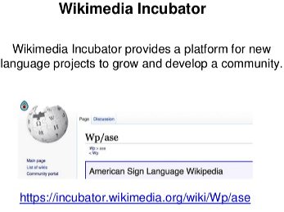

Sign language wikipedia projects are now possible with Sutton SignWriting. We encourage sign language users to get involved by learning SignWriting and the MediaWiki software. We encourage technical MediaWiki users of all levels to get involved and help us improve and streamline the technical details. We encourage everyone to imagine a world in which every sign language user can freely share in the sum of all knowledge.

