ABSTRACT
Presentation 54
SignWriting Symposium 2016

SignTyp: a Cross Linguistic Database
and Dictionaries for Sign Languages

Harry van der Hulst
University of Connecticut
Department of Linguistics
Oak Hall, Room 362, U-1145
365 Fairfield Way
Storrs, CT 06269-1145, USA
harry.van.der.hulst@uconn.edu
Rachel Channon
Sign Language Investigations
Greenbelt, MD. 20770
rchannon1@verizon.net

SignTyp is a research tool – a database of phonological and phonetic information. It is also a set of online sign language dictionaries, and the prompts used to create the dictionaries.

Goals for Online Dictionaries
– To collect 1000 signs each from 15+ sign languages (citation forms). Signers respond to the same prompts cross- linguistically.

– To transcribe each sign in SignWriting – a notation system for signs created by Valerie Sutton

– To create 15+ sign online dictionaries

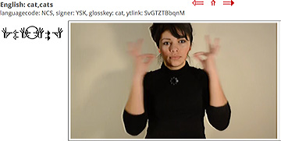
Sign for CAT in Nicaraguan Sign Language

Goals for Research Database

– To convert SignWriting transcriptions into a more granular analytic coding to enable phonetic/phonological analysis of the structure of signs

– To provide a comparative study of the phonological structure of 15+ globally diverse sign languages

– To test and develop sign phonology models

– To investigate the role of iconicity in phonological form

– To develop a cognitive model that generalizes over ‘phonological’ form in signed and spoken languages

