CURRICULUM VITAE
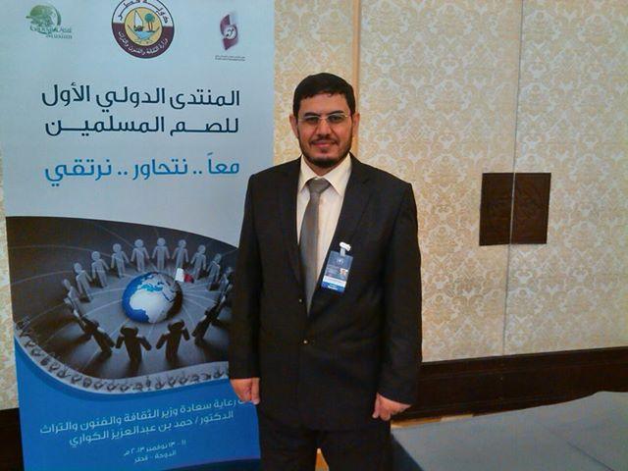
__________________________________________
Mohamed Ismail Abushaira, PH.D & B.SC.
Asociate Prof august 2013 - now
School of Education
KAU Jeddah
Kingdom of Saudi Arabia
.

Mobile : +(966) 558923823
Emails: m_abushaira@hotmail.com ____________________________________________

Education

2003-2007 Jordan University
- PhD Degree in Special Educatio. School of Education.
Theses: The Effect of Signwriting on the Achievement and Vocabulary Acquiring for Deaf Student at Al AmalSchool for Deaf in Amman City
1992-1996 University of Jordan
- B.Sc. Degree in Special Education,School of Education.

Teaching/Lecturing Experience
- 2011-/now Teaching as Lecturer for Special education (School of Education- KAU) (First Semester11/12).
- 2007-2011 Teaching as Lecturer for Special education (School of Education- KSU) (First Semester07/08)..
- 2003-2007 Teacher for deaf students at Al Amal School For deaf – Amman,Jordan
- 1996-2003 Teacher for deaf students at Al Amal School For deaf- Burydah, Saudi Arabia

AWARDS/HONORS/SCHOLARSHIPS/ Highlights:

- Community college – KSU.
- Amman city mayor.
- KSU president.
- Mohamed bin Sultan Award for special education
- The administer of al Qasseem regional education district
- The deputy of administer of al Qasseem regional education district.
- The administer of al ammal deaf institute for boys.
- The secretary of special education department.
- WAMY Wold Asociation of moslim youth KSA

COURSES AND WORKSHOPS:
- Photoshop program
- Articulate Program
- SPSS
- New Stuff members course / ksu
- Intel Computer course
- Computer license course UJCDL Jordan
- Special education meeting
- Making electronic exams course
- Teaching Deaf course
- Sign language course
- Articulate
- Black Board

Publications:
- Abushaira, Mohamed, Mahfooth, Abderaoof . (2015). Deaf Community Culture components and its relation to Hearing culture. Life Science Journal 2014;11(10)
- Abushaira, Mohamed, abdulaziz, Omar. (2015) . Needs of Students with Disabilities at King Abdulaziz University and its Relationship with Some Variables. Sylwan, 2015.(3)
- Husin,A, Abushaira, M.(2013) Development of Emotional Intelligence (EI) Scale for Students of the University of Jordan (UJ) and Verification of its Validity and Reliability at Jordanian Environment. . Life Science Journal 2013;10(4).2374-2383
- Abushaira, Mohamed. (2012)Job satisfaction among special education teachers in Jordan. International Interdisciplinary Journal of Education Volume 1, Issue 3 April,2012.48-56
- Abushaira, Mohamed. (2013)Effects of Inclusion on Language Development in Hearing-Impaired Students in Jeddah Schools: Perspectives of Teachers and Parents. Life Science Journal 2013;10(2).2374-2383
- Muhammad. (2012) . Employers trends run toward the disabled depending on a number of variables . Journal of the Faculty of Education at the University of Kafr El -Sheikh second issue twelfth year
- Abouchaarh , Mohammed . (2012) typing errors for deaf people in the city of Jeddah ( diagnostic study ) . : Journal of Arab Studies in Education and science Alnevsaladd 27 Months July 2012
- Abusaira, Muhammad & Ahmad , Abdullah (2012) . Inter Net evaluate sites that offer special education services from the perspective of special education students at King Abdul Aziz University Educational Journal specialized first volume number 0.6 . ( 342-359 ) .
- Abusaira, Mohammed . (2010) . Teaching students with autism spectrum disorder . Deanship of Scientific Research , King Saud University . I 1
- Abushaira, Mohammed (2003), the foundations of writing sign language WWW.SIGNWRITING.ORG
- Abushaira Muhammad (2003) Starter Program Guide reference WWW.SIGNWRITING.ORG
- Abushaira Mohammed (2008) Sign Puddle manual WWW.SIGNWRITING.ORG
- Abushaira Muhammad (2009) Parents Guide to Special Education . Online e-Book

Research grand
- Deanship of Scientific Research (DSR), King Abdulaziz University, Jeddah
- under the grant No [13-372-D1432] . Abushaira, Mohamed. (2013)Effects of Inclusion on Language Development in Hearing-Impaired Students in Jeddah Schools: Perspectives of Teachers and Parents. Life Science Journal 2013;10(2).2374-2383

- Deanship of Scientific Research (DSR), King Abdulaziz University, Jeddah
under the grant No [372 - 148 -D1432] for research project title : The Needs of Special needs students at KAU Acording of some variables.

- Deanship of Scientific Research (DSR), King Abdulaziz University, Jeddah
under the grant No [372 - 392 -D1432] for research project title :Competence of teachers for special needs students

- Deanship of Scientific Research (DSR), King Abdulaziz University, Jeddah
under the grant No [372 - 303 - D1435] for research project title : Deaf Community Culture components and its relation of Hearing culture

Presented Courses
- Introduction to special education/KSU
- Adaptive behavior skills/KSU
- Learning disabilities/KSU
- Special education Administration/KSU
- Education community about disability/KSU
- Working with handicapped person families /KSU
- Teaching methods /KSU
- Assistive Technology/KSU
- Foundation of Islamic Education /KSU
- Diagnoses and Evaluation in Special Education UJ/KSU
- Early Intervention UJ
- Sign Language 1 KAU
- Sign Language 2 KAU
- Voice Disorder KAU
- Auditory Disorders KAU
- Teaching Deaf Students KAU
- Teaching Hard of Hearing KAU
- Academic skills1 KAU
- Academic skills2 KAU
- Deaf language development KAU
- Behaviour problems KAU
- Learning disability teaching methods KAU
- Practical education KAU
- Oral communication KAU

Conference’s Papers:

- First Islamic Forum for Deaf Muslims Doha, Qatar 10-13 / 11/2013
- .Thirty- Fifth Symposium of the Islamic economy 8-10 September 1434 Jeddah
- Second Scientific Conference for the education of the deaf Qatar , Research entitled writing sign language
- The fortieth anniversary of the establishment of the role of the Koran in Kuwait working paper entitled methods teach hearing impaired
- A workshop entitled writing sign language deaf Technology Center Jordan Amman
- A panel discussion about writing sign language , King Saud University , Riyadh
- Sign writing a scientific symposium, Faculty of Education, King Abdul Aziz University

