

**SignAnimating**

**4-Multilingual SpeechWriting**

**(Non-official proposals based on**

**Wöhrmann´s SpeechWriting system)**

**Arabic (Algerian), Bulgarish, English (American and British), Finnish, French, German, Italian, Norwegian, Polish, Portuguese, Russian and Spanish.**

By André Lemyre

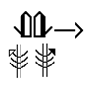

SignAnimating 4-Multilingual SpeechWriting (Non-official proposals based on Wöhrmann´s SpeechWriting system). Arabic (Algerian), Bulgarish, English (American and British), Finnish, French, German, Italian, Norwegian, Polish, Portuguese, Russian and Spanish.

By André Lemyre

[andre-andre@hotmail.ca](mailto:andre-andre@hotmail.ca)

Montreal, Quebec, Canada

First Edition

©2014-09-14

This book was prepared with SignWriter Studio™ version 1.2.2 © 2009 created by Jonathan Duncan. It can be downloaded at <http://signwriterstudio.com/>

This manual is posted on the web:

<http://www.signwriting.org/symposium/presentation0020.html>

This publication and the SignWriting Script are free

to use under the Creative Commons Attribution 3.0 License

<http://creativecommons.org/licenses/by/3.0/>

Table of Contents

Introduction 7

Terms 9

Visemes and Kinemes Lists. 11

Animation Design 13

SpeechAnimating Examples 14

Receptive Viewpoint 16

Frame size 17

Symbols Size 18

Subtitling 18

Writing the message in SpeechWriting 19

SpeechWriting Combination with SignWriting 21

SignAnimating a Small Project in 20 Minutes. 23

International Phonetic Alphabet 27

Phonetic keyboards 30

Phonetic translation 31

Phoneme Lists 32

International Phonetic Alphabet chart for the target language 33

Comparison of Spoken Languages 34

Google Translate Orally 35

Visemes 36

Viseme Readability 37

Lip Reading 38

Signwriting 40

Wöhrmann´s SpeechWriting system. 41

MouthWriting (Mundbildschrift in German) 43

German and English MouthWriting (2014 Mundbildschrift) 44

German-English Consonants (Pulmonic) 52

German-English Vowels 54

Affricate, Double Articulations and others 55

Mundbildschrift Animations 55

LipWriting (Mundbilder in der GebärdenSchrift in German). 56

LipWriting Consonants (Pulmonic) 58

LipWriting Vowels 60

Examples of Affricate, Double Articulations and Others 60

Spelling Rules for LipWriting in Signwriting 61

Mundbilder Animations 62

Association of LipWriting and MouthWriting 63

MouthWriting in Several Languages 67

Building a MouthWriting Symbol Set 68

Theoretical Basis 70

List of Phonemes of the Target Language 70

International Phonetic Alphabet chart for the target language 72

Analysis 74

MouthWriting and LipWriting Symbol Components 80

Mouth Shapes 82

Tongue and Teeth 83

Movement, Contact and Nose SignWriting Symbols 84

Short and Long Phonemes 85

SpeechWriting Breathing Symbol 87

Nasal consonants (Pulmonic) 89

Affrication 89

Non-SignWriting Symbols 90

Hand Shapes 91

Focus on Viseme Sets or on LipWriting Symbol Sets 93

Example of French Symbol Set Creation 94

LipWriting in Several Languages 101

Developing a Visemes List 102

Deciding the Layout of the Animation 107

Animated Gif Constraint and Advantages 108

Videos Constraints and Advantages 108

Dictionary Mode 109

Anki Electronic Flashcards Mode 110

Overview of SignAnimating and SpeechAnimating Modes 111

SpeechWriting - Mundbilder in GebärdenSchrift 112

SignWriting Mode 113

SignAnimating Mode 113

SpeechWriting - Mundbilder in GebärdenSchrift Mode 114

SpeechAnimating Mode 115

Mundbildschrift Word Mode 116

Mundbildschrift Phoneme Mode 117

Mundbildschrift with SignAnimating Mode 118

SpeechWriting - Mundbilder with SignWriting Mode 118

SpeechAnimating with SignAnimating Mode 119

Cued Speech with SpeechAnimating Mode 120

Cued Speech in Receptive View Point 122

Cued Speech Syllables 122

Kinemes and Visemes 130

Wöhrmann SpeechWriting System With Hand Codes 140

Conclusion 144

Annex A Multi-Lingual SpeechWriting 145

Arabic 146

LipWriting (Algerian Arabic) 146

MouthWriting 147

Cued Speech (Arabic) 148

English 150

MouthWriting 150

LipWriting 154

American English Cued Speech 156

British English 157

British English Cued Speech 157

Finnish 160

Cued Speech 163

French 165

MouthWriting 165

LipWriting 170

German 175

MouthWriting (Mundbildschrift) 175

LipWriting (Mundbilder) 180

Italian 182

MouthWriting 183

LipWriting 187

Norwegian 191

Portuguese 195

MouthWriting 195

Spanish 200

Cued Speech 202

Annex B Mundbildschrift Examples 205

Mundbildschrift Bulgarian Example 205

Mundbildschrift Polish Example 206

Mundbildschrift Russian Example 207

Annex C Deleg SignWriting Software 208

Bibliography 210

# Introduction

This is not an official reference guide for SpeechWriting. It is a suggestion on how SpeechWriting can be applied to several languages for SpeechAnimating.

SpeechAnimating is the process of animating sequences of symbols of Wöhrmann ´s SpeechWriting system. SpeechWriting includes two sections: MouthWriting (Mundbildschrift in German) and LipWriting (Mundbilder in der GebärdenSchrift in German).

SpeechWriting was invented for spoken German. It was adapted to support English. Much of this guide is not about SpeechAnimating; we present guidelines on how to adapt SpeechWriting to other languages. Complementary information about SpeechAnimating is available in the three other SignAnimating guides.

This document suggests several alternative designs on how best to represent speech with SignWriting animation. It discusses the advantages and limitations of animations over static SignWriting. No suggestion is definitive until SignWriters reflect on it, improve it and agree on its official usage.

In order to adapt SpeechWriting to other languages, many aspects remain to be defined. Many symbols need to be created for phonemes used in specific languages. The adaptation to other languages is based on the comparison of lists of phonemes and visemes. The level of details of the material used varies, some use phonetic symbols, other use graphemes. Some authors identify more phonemes than others for a given language. This document presents these limitations.

We also present how cued speech can be represented and animated by combining LipWriting and SignWriting.

I wish to thank Stefan Wöhrmann whom allowed me to use his material about his SpeechWriting system. Without him, the whole concept of SpeechWriting as we know it would not exist. SignAnimating also would be limited without his inspiring contributions throughout the years.

Refer to SignAnimating 1-Techniques for a step-by-step instructions on how to produce SignAnimating movie or GIF files.

Refer to SignAnimating 2-Design for a reflection on several possible layouts of SignAnimating and the advantages and limitations of each one.

Refer to SignAnimating 3-Symbols for suggested conventions on how SignWriting symbols may be converted to SignAnimating symbol sequences.

André Lemyre



# Terms

|  |  |
| --- | --- |
| Terms | Description |
| SpeechWriting | SpeechWriting includes two sections: MouthWriting (Mundbildschrift in German) and LipWriting (Mundbilder in der GebärdenSchrift in German).  It was invented by Stefan Wöhrmann. |
| LipWriting  (Mundbilder in der GebärdenSchrift in German)  (Writing what is seen, when Lip Reading) | *A standardized writing system for picturing the way the lips look when a person speaks words. These symbols do not represent sounds but can be associated with spoken words, that are seen on the lips when “Lip Reading”.*  It was invented by Stefan Wöhrmann using SignWriting symbols.  Example: |
| MouthWriting  (Mundbildschrift in German)  (Exact translation Mouth Picture Writing) | *A standardized writing system for picturing the sounds of human language. Compared to the International Phonetic Alphabet MouthWriting is not as detailed and complete but easy to read and sufficient enough to support even young deaf students in their articulation process to develop better spoken language skills. Used like a spelling system for writing complete words in mouth pictures, and can be applied to any spoken language.*  *…*  *Mundbildschrift is not part of SignWriting.*  It was invented by Stefan Wöhrmann.  Example: |

Wöhrmann, Stefan (2014) in sws0002_01_How_I_teach_Mundbildschrift and Wöhrmann, Stefan (2014) in sws0002_02_Mundbilder_in_SignWriting_and_Spelling_rules

|  |  |  |  |
| --- | --- | --- | --- |
| Terms | | Description | Written Version |
| Grapheme | |  |  |
|  | | A grapheme is the smallest semantically distinguishing unit in a written language, analogous to the phonemes of spoken languages. Example: a letter. | Text |
| Phoneme | |  |  |
|  |  | A phoneme is the smallest contrastive unit in the sound system of a language. | MouthWriting  International Phonetic Alphabet character |
| Kineme | |  |  |
|  | | A kineme is the smallest unit of speech articulation—that is, the feature of a sound (phoneme) that is determined by the position or movement of the speech organs. | MouthWriting  International Phonetic Alphabet articulatory parameters |
| Morpheme | |  |  |
|  | | Morphemes are the next 'basic part' in words. Not single letters or phonemes, but short words or syllables.  Examples:   * food, foot * bend, lend, blend | Short words or syllables. |

|  |  |  |
| --- | --- | --- |
| Terms | Description | Written Version |
| Viseme |  |  |
|  | A viseme is any of several speech sounds which look the same, for example when lip reading. | LipWriting |

## Visemes and Kinemes Lists.

Phonemes are well defined for languages, for instance with the International Phonetic Alphabet.

We quote an interesting blog about visemes and morphemes.

*“Most lipreading tutors and books will start by teaching visemes. Visemes are for lipreaders, what phonemes are for listeners: the smallest 'standardized' building blocks of words. Phonemes are the basic 'sounds' of a language, visemes are the basic 'mouth-patterns'. I use 'mouth-patterns' instead of 'lip-patterns', because to recognize a viseme, you have to watch lips, tongue, cheeks, and to see voicing: the throat of the speaker.  
…  
For visemes, it was much more difficult...There is no 'standardized' set of visemes, within or across languages.  
…   
The main thing everyone seems to agree on, is that there are far fewer visemes than phonemes. Many phonemes are invisible, many others are ambiguous: several phonemes share the same mouthpattern. The usual example is 'b-m-p'. Three phonemes - one viseme.  
  
BUT!  
Even if we could agree on the number of visemes, teaching single visemes is only a very first step. Visemes change shape, in the context of other letters! A viseme that is perfectly visible when pronounced on its own, may be completely invisible when it's in the company of other letters / phonemes. Or it will look very different. Visible speech is not a sequence of still pictures, it's dynamic. The articulators have to go from one location to the next, and often what you see is not the end-location, but the movement!  
  
Two examples …*

* *'food' versus 'foot': indistinguishable because both words share the same visemes. But if you say the words side by side, people will see the difference. Because of the end 'd' in food, the 'oo' in 'food' is much longer in duration, than in 'foot'. So we add another viseme: long 'oo' versus short 'oo'?*
* *'bend' - 'lend' - 'blend': in many speakers, the 'l' is quite visible. But when it's preceded with a pretty dominant 'b', it may completely disappear from sight!*

*This doesn't only happen within words, it happens in all connected speech: phrases, sentences, etc.  
…  
Morphemes are the next 'basic part' in words. Not single letters / phonemes, but short words, or syllables. The good thing about morphemes is that they are meaningful. The bad news is that there are many more morphemes in a language, than phonemes.  
As for the examples above: each of the words is a separate morpheme: food, foot, bend, lend, blend.  
…  
Morphemes show up in research about teaching children to read. E.g. Improving Literacy by Teaching Morphemes, by T. Nunes and P. Bryant, 2006.  
  
The moral of the story: I really really think we can Improve Lipreading by Teaching Morphemes! “*

Blog posted by [Liesbeth Pyfers](https://plus.google.com/111559381640866157531) at

<http://lipreadeu.blogspot.ca/2012/05/visemes-or-morphemes.html>

# Animation Design

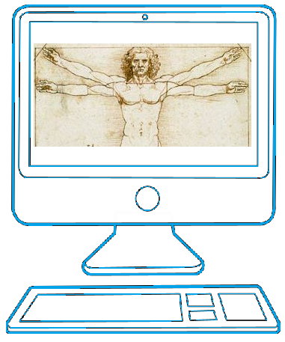

Vitruvian Man by Leonardo da Vinci

## SpeechAnimating Examples

We will use the German word and sign for Strauß (Ostrich in German) to compare animation designs. Explanation of the symbols used will be provided in subsequent chapters.

Officially, the sign Strauß (Ostrich in German) is written as follow in Jacobsen, Birgit (2007) Das Gebardenbuch Das kleine 1x1 der Gebardensprache. Band 2. Hamburg, Germany. The SignWriting uses Stefan Wöhrmann’s SpeechWriting system representing the visemes (Mundbild) that can be read on lips.

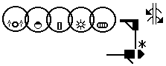

The SignWriting is completed with a sequence of phoneme symbols (Mundbildschrift) matching phonetic characters.

|  |  |  |  |  |  |
| --- | --- | --- | --- | --- | --- |
|  | | | | | |
| ʃ | t | r | a | ʊ | s |

Depending on the purpose of the animation, several sub-sets of those symbols may be animated.

1. MouthWriting represents phonemes in several frames. It can be used to teach speech. It may contain text or phonetic subtitles.

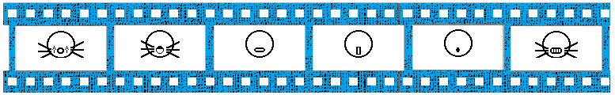

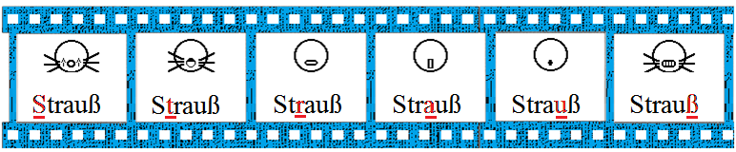

Strauß (Ostrich in German)

1. In this MouthWriting example, to provide some structure, we introduced an Eyes Blink symbol with a Neutral Mouth symbol to represent the end of a word and a period to indicate an end of sentence.

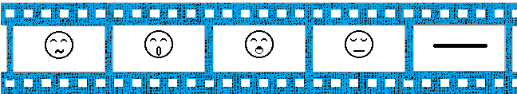

Bonne (Good in French)

1. MouthAnimating with SignAnimating Mode represents each phoneme in several frames with the sign. The reader could pronounce the sounds while they are displayed. It is the most complete way to express a sign with articulation through an animation.

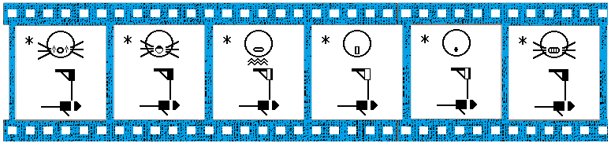

Strauß (Ostrich in German MouthWriting and DGS sign language)

1. LipWriting and SignAnimating is a combination of the visemes with the signs. It represents dynamically and precisely what the Deaf person sees during the communication of a sign.

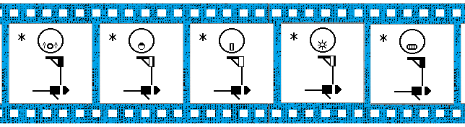

Strauß (Ostrich in German LipWriting and DGS sign language)

## Receptive Viewpoint

Standard SignWriting is written from the expressive viewpoint. SignWriting can also be written from the receptive view point.

|  |  |
| --- | --- |
| Receptive View Point | Expressive View Point |
|  |  |
| The same hand shape has 2 different representations. | |

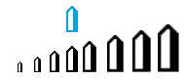SignAnimating follows all SignWriting rules except for one: symbols change of size depending of their proximity to the body.

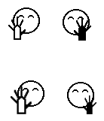

When animating from the receptive viewpoint, the left and right sides are inversed. Also the zoom effect is inversed. As the hand goes further from the signer, it becomes closer to the viewer. Instead of animating a zoomed out hand shape on the right side, it becomes a zoomed in hand shape on the left side.

## Frame size

C:\Users\alemyre\AppData\Local\Microsoft\Windows\Temporary Internet Files\Content.IE5\UINPU9Q9\MC900291940[1].wmfThe head will be static during the animation (unless a head movement is required). Identify the tallest and widest signs. Evaluate how much room will be required above, below, left and right of the head.

The frame size needs to be sufficient to contain all used signs in the message and possibly other signs when reused.

In the example below, the signer indicate up, down, left and right, to do so, space is needed above, below and both sides of the character. This seems to be the standard frame minimal size if animations need to be reusable. If the chosen frame size is smaller, the addition of a single larger sign may require resizing and re-centering each frame of each sign previously animated.

|  |  |
| --- | --- |
|  |  |
|  | A frame may require 6.5 head sizes horizontally and 4.5 head sizes vertically to fit an almost complete range of motion. |

## Symbols Size

Animated gif files may be resized in a web page, an e-mail, a web page or a Powerpoint presentation. Ensure that the symbols and subtitles will remain clear and readable when shrunk. The resolution of details may not suffice.





## Subtitling

Subtitling can be expressed in gloss or in written language. If it is embedded in the animation, it reduces the reusability. It is affected by the frame rate that may change. The same text must be copied exactly at the same location in several frames. It must be added after the face, before the hands. If different face frames are used for a word, same text must be copied exactly at the same location. The addition of a written word may require to re-edit all subsequent frames if the signed and the written words are not in the same order.

If the subtitle is displayed under the animation, but not within it, it is easier to update. The animation and the subtitle may not be synchronized.

A simple font like Arial may be a better choice than a fancy font. The font size must allow the longest word of the language to fit within the frame and remain readable. There may be 2 lines of subtitles.

Subtitles may be preferred to FingerSpelling to fill in when a word has no equivalent in the SignWriting dictionary. It may be under a face, or simply a display of text. The signer may point to the subtitle.

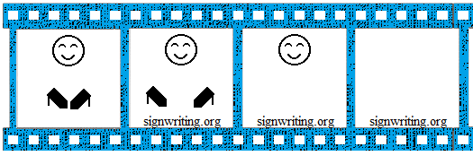

## Writing the message in SpeechWriting

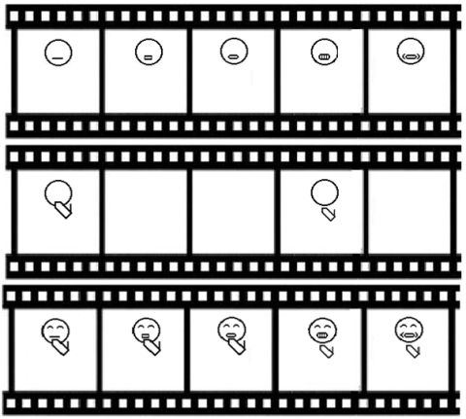

SpeechWriting may be used in animation. Several base frames are required for mouth configuration. The amount of visemes combined with the amount of hand configuration or displacement determines the minimal number of frames required. A frame with a neutral mouth is required.

In the following example, we combine SignWriting and SpeechWriting in 3 horizontal storyboards. SpeechAnimating requires more details. For each word, we must determine how many visemes are present and how they will be combined with the hand shapes.

If the SpeechWriting is not already defined within the sign, it may be developed based on a phonetic conversion table.

|  |
| --- |
| Conversion from Text to Phonetic and to SpeechWriting. |
| 1. Verify if the SpeechWriting is defined in SignPuddle Online. |
| 1. If the Speechwriting is not defined, enter the word in a phonetic translator. 2. A simple dictionary may also be used to get the phonetic translation of the word. 3. If desired, ensure that you take into account the interactions between successive words.   <http://tom.brondsted.dk/text2phoneme/> |
| 1. Software taking a GLOSS as an input to convert the GLOSS in a phonetic alphabet sequence can be found for several languages:   <http://learn-foreign-language-phonetics.com/> |
| 1. Look in Wöhrmann SpeechWriting symbol table or the conversion table with phonetic equivalencies in annex. 2. This Wöhrmann SpeechWriting system should be used as it is to maintain uniformity among languages.   pilts |
| 1. When a language does not distinguish between two visemes but Wöhrmann’s SpeechWriting system provides a distinction, we keep the German system to avoid loss of information. 2. For some languages, two phonemes may be considered different visually when German considers they share the same visemes. 3. Refer to corresponding chapters of this document to resolve the differences. |

## SpeechWriting Combination with SignWriting

User defined SpeechWriting symbols can be retrieved from the Favorite tab of SignWriter Studio™. SignWriter Studio™ version 1.2.2 © 2009 created by Jonathan Duncan can be downloaded at <http://signwriterstudio.com/>

When SpeechWriting is superposed with SignWriting, care must be taken to not overlap the mouth, the hand shapes, the eyes, or the nose. Hand shapes close to the head should remain clearly readable, if not in all frames, at least in some frame. If the mouth is hidden by other symbols, the SpeechWriting loses its accuracy.

LipWriting may require a large surface, in particular when several regional accents are present. We used fingers symbol to write Roman numbers. If a convention is followed for a whole dictionary in SignPuddle spoken dialects or regionalisms may be combined in the same entry.

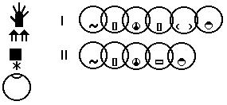

Baleine (Whale in LSQ with I Montreal Accent balɛn, II with Quebec accent balajn)

In order to save more space; we may write only the mouth symbols.

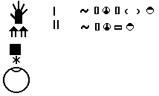

Baleine (Whale in LSQ with I Montreal Accent [balɛn], II with Quebec accent [balajn])

The sign could be animated in SpeechAnimating or in cued speech animation by simply overlapping the mouth shape to the face.

With Roman numbers, it is easy to write up to 10 different dialect pronunciations.

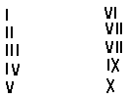

This approach can also be used to write text (keeping in mind that LipWriting reflects the ambiguities and limitations of lip reading).

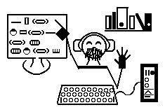

<http://www.signbank.org/SignPuddle1.5/canvas.php?ui=8&sgn=53&sid=23163>

by Stefan Wöhrmann (English text).

## SignAnimating a Small Project in 20 Minutes.

Small projects (15 frames per animation) can be completed by following these step-by-step instructions.

|  |
| --- |
| SignWriting steps. |
| 1. Select and export the SignPuddle™ official dictionary or a subset in a file.   [http://www.signbank.org/SignPuddle™/](http://www.signbank.org/signpuddle/)  http://www.signbank.org/signpuddle2.0/data/ui/4/11.png |
| 1. Install SignWriter Studio™ on your computer.   <http://signwriterstudio.com/> |
| 1. Import a dictionary in SignWriter Studio™. |
| 1. Select an existing sign. 2. Create a copy of the sign or create a new sign. |
| 1. Edit the sign by selecting symbols to duplicate or reposition. 2. If necessary, add a face.  It defines where the hands will be located. 3. Zoom-in or zoom-out the hand shapes to represent depth. 4. Remove most movement symbols. |

|  |
| --- |
| Frame Preparation Steps. |
| 1. Launch 2 instances of MicrosoftTM Paint.   One will be used as a source of symbols for the whole sign and the other will contain the frame currently edited.   1. Enable the display of the grid. |
| 1. Resize the MicrosoftTM Paint display so each sign of the animation will fit.   Suggestion: 6 cm by 4 cm. This represents 4 ½ head diameters by 6 ½ head diameters.     1. Save the file in .gif format. |
| 1. Copy an image of SignWriter Studio™ symbols. 2. Paste the symbols’ image in Paint. 3. Paste with transparency the required symbols of the sign. 4. Always keep the head at the same location, otherwise it will move during the animation. |
| 1. Create several copies of the file with the same name and a counter. 2. Edit each file to represent the movement. |

|  |
| --- |
| Animation steps. |
| 1. Load the files in a gif animator.   <http://www.online-image-editor.com/gifmaker/>    Warning, only 15 images can be included in each animation with this editor. |
| 1. Select the duration of each image. 2. Choose to Edit the images. |
| 1. Apply the background transparency if desired. |
| 1. Save the file on the computer. |
| 1. Open the file with an internet browser to verify that the intended result is obtained. 2. Insert the animation in Microsoft PowerPoint with a colored background to verify its transparency. |

# International Phonetic Alphabet

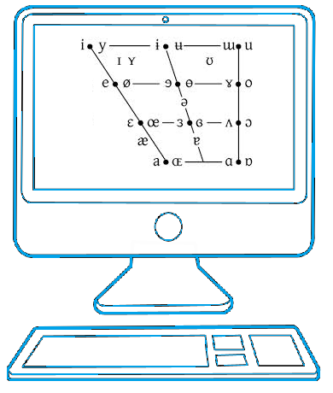

We will use the International Phonetic Alphabet to analyse Wöhrmann SpeechWriting system developed initially for German and explore how it could be generalized to other languages.

The phonemes (sounds) are classified by the way they are articulated. The main tables are the pulmonic consonants and the vowels. Long vowels are followed by the symbol “**:**”. For instance, the sound [a], is writen [a:] when it lasts longer. We will not discuss the other phonetic tables in this guide.

|  |  |  |
| --- | --- | --- |
| Places of Articulation (Passive and Active) | | |
|  | 1. Exo-labial,  2. Endo-labial,  3. Dental,  4. Alveolar,  5. Post-alveolar,  6. Pre-palatal,  7. Palatal,  8. Velar,  9. Uvular, | 10. Pharyngeal,  11. Glottal,  12. Epiglottal,  13. Radical,  14. Postero-dorsal,  15. Antero-dorsal,  16. Laminal,  17. Apical,  18. Sub-apical |

The International Phonetic Alphabet chart,

* "IPA Chart, <http://www.langsci.ucl.ac.uk/ipa/ipachart.html> , available under a Creative Commons Attribution-Sharealike 3.0 Unported License. Copyright © 2005 International Phonetic Association"
* can be downloaded at: <http://www.langsci.ucl.ac.uk/ipa/fullchart.html>

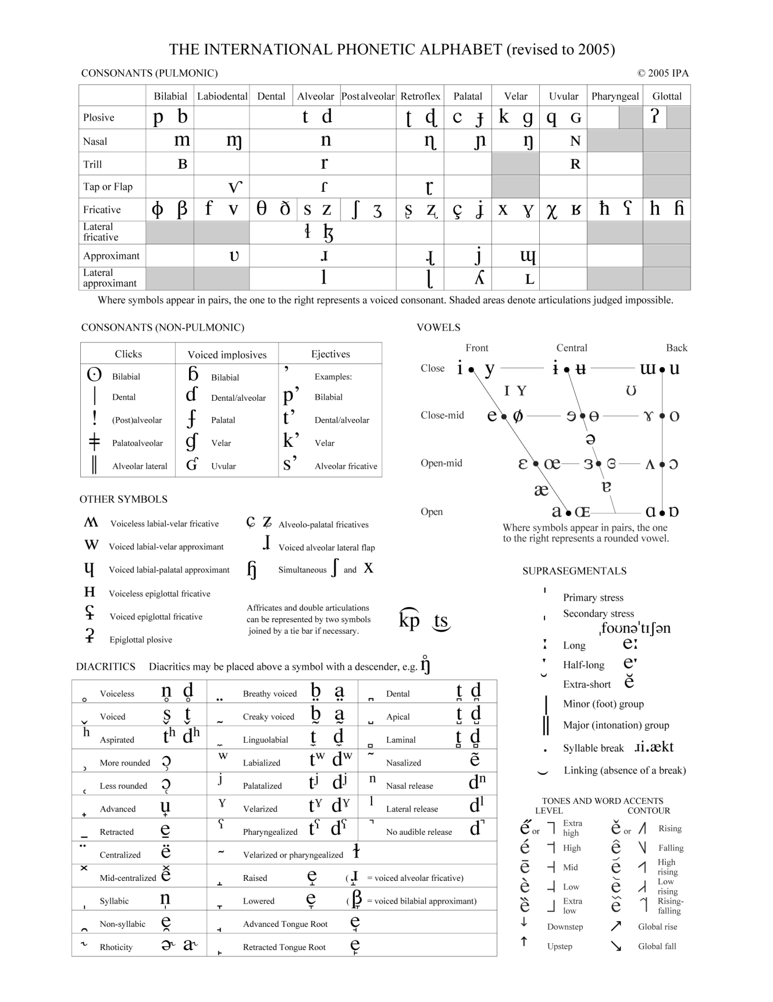

## Phonetic keyboards

Several phonetic keyboards are available on internet. For the purpose of SignWriting and SpeechWriting a phonetic keyboard may be used to copy phonetic symbols in SignWriter StudioTM. This allows creating new entries that can be added in the Favorite tab to ease editing.

Phonetic keyboard: It also has a button to download phonetic fonts.

<http://westonruter.github.io/ipa-chart/keyboard/>

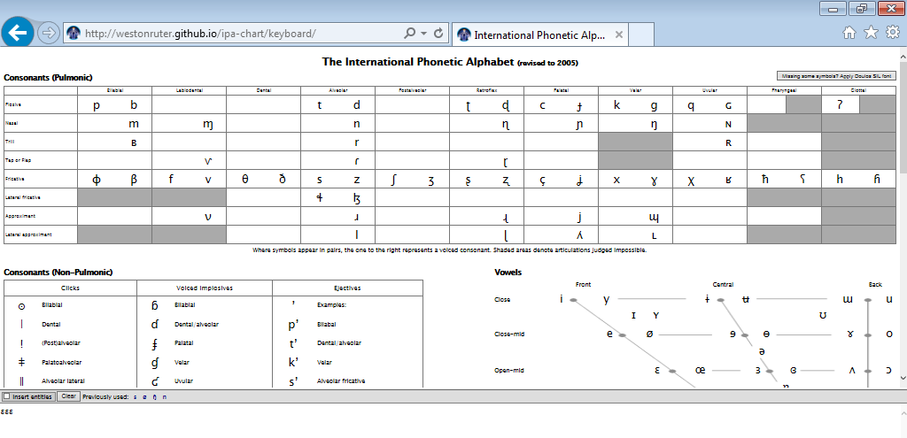

Several phonetic keyboards are available at : <http://www.sil.org/>

<http://scripts.sil.org/cms/scripts/page.php?site_id=nrsi&id=UniIPAKeyboard>

[Windows Keyboards](http://scripts.sil.org/cms/scripts/page.php?site_id=nrsi&id=UniIPAKeyboard#2c8bacba)  
        [IPA Keyman Keyboard](http://scripts.sil.org/cms/scripts/page.php?site_id=nrsi&id=UniIPAKeyboard#dee994f5)  
            [Keyman Download](http://scripts.sil.org/cms/scripts/page.php?site_id=nrsi&id=UniIPAKeyboard#cc88a256)  
        [IPA MSKLC Keyboard](http://scripts.sil.org/cms/scripts/page.php?site_id=nrsi&id=UniIPAKeyboard#b47f8dfb)  
            [MSKLC Download](http://scripts.sil.org/cms/scripts/page.php?site_id=nrsi&id=UniIPAKeyboard#2d08bc68)  
        [IPA FreeKey Keyboard (using AutoHotkey)](http://scripts.sil.org/cms/scripts/page.php?site_id=nrsi&id=UniIPAKeyboard#3843fc99)  
        [Other (non-SIL) Windows Keyboards](http://scripts.sil.org/cms/scripts/page.php?site_id=nrsi&id=UniIPAKeyboard#2c063876)  
        [Related Windows Resources](http://scripts.sil.org/cms/scripts/page.php?site_id=nrsi&id=UniIPAKeyboard#c4d7c4eb)  
    [Ubuntu (Linux) Keyboards](http://scripts.sil.org/cms/scripts/page.php?site_id=nrsi&id=UniIPAKeyboard#dfc8e3bf)  
    [Mac OS X Keyboards](http://scripts.sil.org/cms/scripts/page.php?site_id=nrsi&id=UniIPAKeyboard#79dbd88a)  
        [IPA Unicode Macintosh Keyboard](http://scripts.sil.org/cms/scripts/page.php?site_id=nrsi&id=UniIPAKeyboard#f5738dec)  
            [Download](http://scripts.sil.org/cms/scripts/page.php?site_id=nrsi&id=UniIPAKeyboard#801ab246)  
        [Other Mac OS X Keyboards](http://scripts.sil.org/cms/scripts/page.php?site_id=nrsi&id=UniIPAKeyboard#74a0454d)  
        [Related Mac OS X Resources](http://scripts.sil.org/cms/scripts/page.php?site_id=nrsi&id=UniIPAKeyboard#3865bc62)  
        [Page History for Mac OS X Keyboards](http://scripts.sil.org/cms/scripts/page.php?site_id=nrsi&id=UniIPAKeyboard#f4aea558)  
    [Related Resources](http://scripts.sil.org/cms/scripts/page.php?site_id=nrsi&id=UniIPAKeyboard#76287708)

## Phonetic translation

Several softwares taking a GLOSSE as an input can convert the GLOSSE in a phonetic alphabet sequence. It is a simple way to transcribe a word in phonetic before writing its equivalent in SpeechWriting and adapt it for SpeechAnimating.

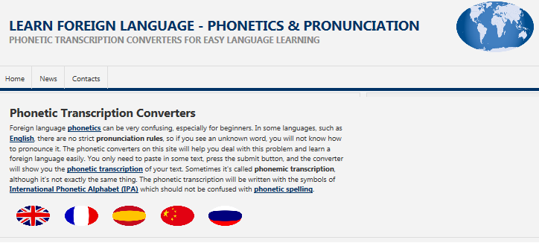

<http://learn-foreign-language-phonetics.com/>

Spanish phonetic translator: <http://www.aucel.com/pln/transbase.html>

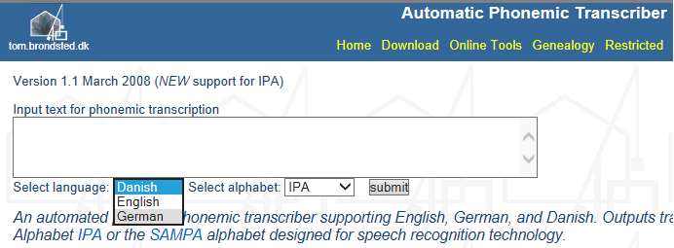

<http://tom.brondsted.dk/text2phoneme/>

## Phoneme Lists

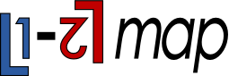To get the complete International Phonetic Alphabet chart for 500 languages; L1-L2map, an online tool, can be used at <http://calst.hf.ntnu.no/l1-l2map/> . L1-L2*map* was developed by Jacques Koreman, Olaf Husby, Preben Wik and Øyvind Bech. It is hosted at the Norwegian University of Science and Technology. <http://www.ntnu.edu/isl/calst-for-learners>

<http://calst.hf.ntnu.no/l1-l2map/compare_languages/>

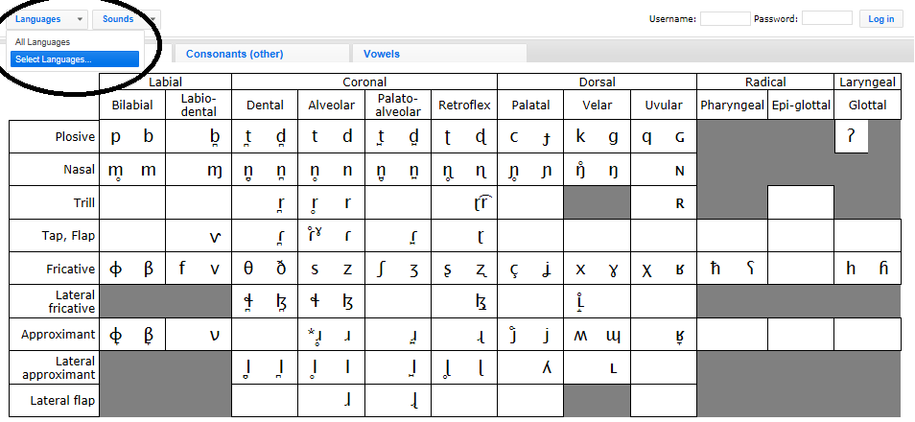

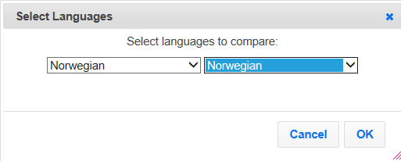Select the option to compare a language with itself.

Language information displays the complete phoneme sets.

|  |
| --- |
| Norwegian Sounds |
| [[pʰ](http://calst.hf.ntnu.no/l1-l2map/sounds/24/)] [[b](http://calst.hf.ntnu.no/l1-l2map/sounds/33/)] [[t̪ʰ](http://calst.hf.ntnu.no/l1-l2map/sounds/43/)] [[d̪](http://calst.hf.ntnu.no/l1-l2map/sounds/49/)] [[ʈʰ](http://calst.hf.ntnu.no/l1-l2map/sounds/96/)] [[ɖ](http://calst.hf.ntnu.no/l1-l2map/sounds/101/)] [[kʰ](http://calst.hf.ntnu.no/l1-l2map/sounds/128/)] [[s](http://calst.hf.ntnu.no/l1-l2map/sounds/266/)] [[ʃ](http://calst.hf.ntnu.no/l1-l2map/sounds/278/)] [[f](http://calst.hf.ntnu.no/l1-l2map/sounds/298/)] [[ɡ](http://calst.hf.ntnu.no/l1-l2map/sounds/135/)] [[ç](http://calst.hf.ntnu.no/l1-l2map/sounds/311/)] [[ɾ](http://calst.hf.ntnu.no/l1-l2map/sounds/528/)] [[l](http://calst.hf.ntnu.no/l1-l2map/sounds/568/)] [[ɭ](http://calst.hf.ntnu.no/l1-l2map/sounds/572/)] [[ʋ](http://calst.hf.ntnu.no/l1-l2map/sounds/585/)] [[j](http://calst.hf.ntnu.no/l1-l2map/sounds/594/)] [[m](http://calst.hf.ntnu.no/l1-l2map/sounds/609/)] [[n̪](http://calst.hf.ntnu.no/l1-l2map/sounds/615/)] [[ɳ](http://calst.hf.ntnu.no/l1-l2map/sounds/635/)] [[ŋ](http://calst.hf.ntnu.no/l1-l2map/sounds/649/)] [[ʏ](http://calst.hf.ntnu.no/l1-l2map/sounds/713/)] [[ɪ](http://calst.hf.ntnu.no/l1-l2map/sounds/715/)] [[yː](http://calst.hf.ntnu.no/l1-l2map/sounds/716/)] [[iː](http://calst.hf.ntnu.no/l1-l2map/sounds/720/)] [[ʉː](http://calst.hf.ntnu.no/l1-l2map/sounds/726/)] [[ʉ](http://calst.hf.ntnu.no/l1-l2map/sounds/728/)] [[ʊ](http://calst.hf.ntnu.no/l1-l2map/sounds/735/)] [[uː](http://calst.hf.ntnu.no/l1-l2map/sounds/740/)] [[eː](http://calst.hf.ntnu.no/l1-l2map/sounds/753/)] [[ø̞ː](http://calst.hf.ntnu.no/l1-l2map/sounds/769/)] [[e̞](http://calst.hf.ntnu.no/l1-l2map/sounds/775/)] [[o̞ː](http://calst.hf.ntnu.no/l1-l2map/sounds/785/)] [[œ](http://calst.hf.ntnu.no/l1-l2map/sounds/790/)] [[æː](http://calst.hf.ntnu.no/l1-l2map/sounds/806/)] [[æ](http://calst.hf.ntnu.no/l1-l2map/sounds/807/)] [[ä](http://calst.hf.ntnu.no/l1-l2map/sounds/819/)] [[ɒ̝](http://calst.hf.ntnu.no/l1-l2map/sounds/820/)] [[ɑː](http://calst.hf.ntnu.no/l1-l2map/sounds/826/)] [[øy](http://calst.hf.ntnu.no/l1-l2map/sounds/852/)] [[ɔy](http://calst.hf.ntnu.no/l1-l2map/sounds/875/)] [[æʉ](http://calst.hf.ntnu.no/l1-l2map/sounds/883/)] [[äi](http://calst.hf.ntnu.no/l1-l2map/sounds/887/)] [[æi](http://calst.hf.ntnu.no/l1-l2map/sounds/888/)] [[h](http://calst.hf.ntnu.no/l1-l2map/sounds/920/)] [[ʉi](http://calst.hf.ntnu.no/l1-l2map/sounds/998/)] [[ui](http://calst.hf.ntnu.no/l1-l2map/sounds/905/)] |
| Vanvik, A. 1972. A phonetic-phonemic analysis of Standard Eastern Norwegian. Norwegian Journal of Linguistics 26: 119-64. |

### International Phonetic Alphabet chart for the target language

Still with L1-L2map, online tool, the charts for consonants, vowels and diphthongs are displayed.

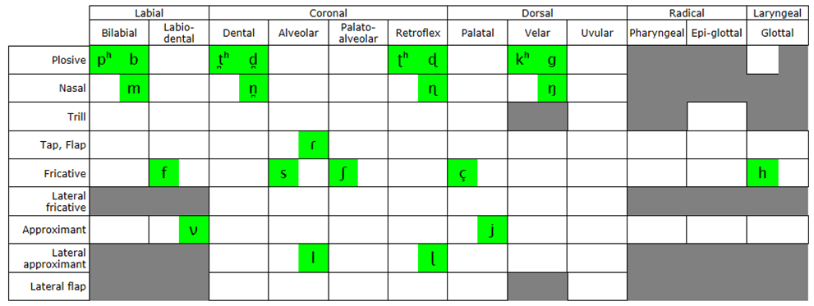

Norwegian Consonants

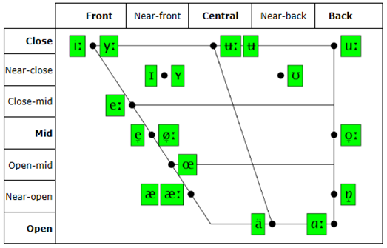

Norwegian Vowels

## Comparison of Spoken Languages

With L1-L2map, we can compare the International Phonetic Alphabet charts for different languages. In the example, we compare German with the target Norwegian language.

|  |  |
| --- | --- |
| German | Norwegian |
| 44 segments | 47 segments |
| [[pʰ](http://calst.hf.ntnu.no/l1-l2map/sounds/24/)] [[b](http://calst.hf.ntnu.no/l1-l2map/sounds/33/)] [[tʰ](http://calst.hf.ntnu.no/l1-l2map/sounds/79/)] [[d](http://calst.hf.ntnu.no/l1-l2map/sounds/85/)] [[kʰ](http://calst.hf.ntnu.no/l1-l2map/sounds/128/)] [[ɡ](http://calst.hf.ntnu.no/l1-l2map/sounds/135/)] [[s](http://calst.hf.ntnu.no/l1-l2map/sounds/266/)] [[z](http://calst.hf.ntnu.no/l1-l2map/sounds/267/)] [[ʃ](http://calst.hf.ntnu.no/l1-l2map/sounds/278/)] [[ʒ](http://calst.hf.ntnu.no/l1-l2map/sounds/280/)] [[f](http://calst.hf.ntnu.no/l1-l2map/sounds/298/)] [[ʋ](http://calst.hf.ntnu.no/l1-l2map/sounds/585/)] [[x](http://calst.hf.ntnu.no/l1-l2map/sounds/319/)] [[ts](http://calst.hf.ntnu.no/l1-l2map/sounds/387/)] [[pf](http://calst.hf.ntnu.no/l1-l2map/sounds/421/)] [[ʁ](http://calst.hf.ntnu.no/l1-l2map/sounds/333/)] [[l](http://calst.hf.ntnu.no/l1-l2map/sounds/568/)] [[j](http://calst.hf.ntnu.no/l1-l2map/sounds/594/)] [[m](http://calst.hf.ntnu.no/l1-l2map/sounds/609/)] [[n](http://calst.hf.ntnu.no/l1-l2map/sounds/630/)] [[ŋ](http://calst.hf.ntnu.no/l1-l2map/sounds/649/)] [[ʏ](http://calst.hf.ntnu.no/l1-l2map/sounds/713/)] [[ɪ](http://calst.hf.ntnu.no/l1-l2map/sounds/715/)] [[yː](http://calst.hf.ntnu.no/l1-l2map/sounds/716/)] [[iː](http://calst.hf.ntnu.no/l1-l2map/sounds/720/)] [[ʊ](http://calst.hf.ntnu.no/l1-l2map/sounds/735/)] [[uː](http://calst.hf.ntnu.no/l1-l2map/sounds/740/)] [[øː](http://calst.hf.ntnu.no/l1-l2map/sounds/749/)] [[eː](http://calst.hf.ntnu.no/l1-l2map/sounds/753/)] [[oː](http://calst.hf.ntnu.no/l1-l2map/sounds/762/)] [[ə](http://calst.hf.ntnu.no/l1-l2map/sounds/781/)] [[œ](http://calst.hf.ntnu.no/l1-l2map/sounds/790/)] [[ɛː](http://calst.hf.ntnu.no/l1-l2map/sounds/792/)] [[ɛ](http://calst.hf.ntnu.no/l1-l2map/sounds/795/)] [[ɔ](http://calst.hf.ntnu.no/l1-l2map/sounds/803/)] [[ɐ](http://calst.hf.ntnu.no/l1-l2map/sounds/812/)] [[äː](http://calst.hf.ntnu.no/l1-l2map/sounds/816/)] [[ɔi](http://calst.hf.ntnu.no/l1-l2map/sounds/874/)] [[äi](http://calst.hf.ntnu.no/l1-l2map/sounds/887/)] [[äu](http://calst.hf.ntnu.no/l1-l2map/sounds/892/)] [[h](http://calst.hf.ntnu.no/l1-l2map/sounds/920/)] [[tʃ](http://calst.hf.ntnu.no/l1-l2map/sounds/406/)] [[ä](http://calst.hf.ntnu.no/l1-l2map/sounds/819/)] [[ç](http://calst.hf.ntnu.no/l1-l2map/sounds/311/)] | [[pʰ](http://calst.hf.ntnu.no/l1-l2map/sounds/24/)] [[b](http://calst.hf.ntnu.no/l1-l2map/sounds/33/)] [[t̪ʰ](http://calst.hf.ntnu.no/l1-l2map/sounds/43/)] [[d̪](http://calst.hf.ntnu.no/l1-l2map/sounds/49/)] [[ʈʰ](http://calst.hf.ntnu.no/l1-l2map/sounds/96/)] [[ɖ](http://calst.hf.ntnu.no/l1-l2map/sounds/101/)] [[kʰ](http://calst.hf.ntnu.no/l1-l2map/sounds/128/)] [[s](http://calst.hf.ntnu.no/l1-l2map/sounds/266/)] [[ʃ](http://calst.hf.ntnu.no/l1-l2map/sounds/278/)] [[f](http://calst.hf.ntnu.no/l1-l2map/sounds/298/)] [[ɡ](http://calst.hf.ntnu.no/l1-l2map/sounds/135/)] [[ç](http://calst.hf.ntnu.no/l1-l2map/sounds/311/)] [[ɾ](http://calst.hf.ntnu.no/l1-l2map/sounds/528/)] [[l](http://calst.hf.ntnu.no/l1-l2map/sounds/568/)] [[ɭ](http://calst.hf.ntnu.no/l1-l2map/sounds/572/)] [[ʋ](http://calst.hf.ntnu.no/l1-l2map/sounds/585/)] [[j](http://calst.hf.ntnu.no/l1-l2map/sounds/594/)] [[m](http://calst.hf.ntnu.no/l1-l2map/sounds/609/)] [[n̪](http://calst.hf.ntnu.no/l1-l2map/sounds/615/)] [[ɳ](http://calst.hf.ntnu.no/l1-l2map/sounds/635/)] [[ŋ](http://calst.hf.ntnu.no/l1-l2map/sounds/649/)] [[ʏ](http://calst.hf.ntnu.no/l1-l2map/sounds/713/)] [[ɪ](http://calst.hf.ntnu.no/l1-l2map/sounds/715/)] [[yː](http://calst.hf.ntnu.no/l1-l2map/sounds/716/)] [[iː](http://calst.hf.ntnu.no/l1-l2map/sounds/720/)] [[ʉː](http://calst.hf.ntnu.no/l1-l2map/sounds/726/)] [[ʉ](http://calst.hf.ntnu.no/l1-l2map/sounds/728/)] [[ʊ](http://calst.hf.ntnu.no/l1-l2map/sounds/735/)] [[uː](http://calst.hf.ntnu.no/l1-l2map/sounds/740/)] [[eː](http://calst.hf.ntnu.no/l1-l2map/sounds/753/)] [[ø̞ː](http://calst.hf.ntnu.no/l1-l2map/sounds/769/)] [[e̞](http://calst.hf.ntnu.no/l1-l2map/sounds/775/)] [[o̞ː](http://calst.hf.ntnu.no/l1-l2map/sounds/785/)] [[œ](http://calst.hf.ntnu.no/l1-l2map/sounds/790/)] [[æː](http://calst.hf.ntnu.no/l1-l2map/sounds/806/)] [[æ](http://calst.hf.ntnu.no/l1-l2map/sounds/807/)] [[ä](http://calst.hf.ntnu.no/l1-l2map/sounds/819/)] [[ɒ̝](http://calst.hf.ntnu.no/l1-l2map/sounds/820/)] [[ɑː](http://calst.hf.ntnu.no/l1-l2map/sounds/826/)] [[øy](http://calst.hf.ntnu.no/l1-l2map/sounds/852/)] [[ɔy](http://calst.hf.ntnu.no/l1-l2map/sounds/875/)] [[æʉ](http://calst.hf.ntnu.no/l1-l2map/sounds/883/)] [[äi](http://calst.hf.ntnu.no/l1-l2map/sounds/887/)] [[æi](http://calst.hf.ntnu.no/l1-l2map/sounds/888/)] [[h](http://calst.hf.ntnu.no/l1-l2map/sounds/920/)] [[ʉi](http://calst.hf.ntnu.no/l1-l2map/sounds/998/)] [[ui](http://calst.hf.ntnu.no/l1-l2map/sounds/905/)] |
| Moulton, W.G. 1962. The Sounds of English and German. University of Chicago Press, Chicago. Wangler, H.H. 1972. Physiologische Phonetik, eine Einfuhrung. N.G. Elwert Verlag, Marburg. | Vanvik, A. 1972. A phonetic-phonemic analysis of Standard Eastern Norwegian. Norwegian Journal of Linguistics 26: 119-64. |

In the example, we compare German and Norwegian. We see several phonemes in German displayed in blue. Several phonemes in Norwegian language are red. We see that there are few common phonemes in green. Depending on the chosen languages and dialects, the comparison differs.

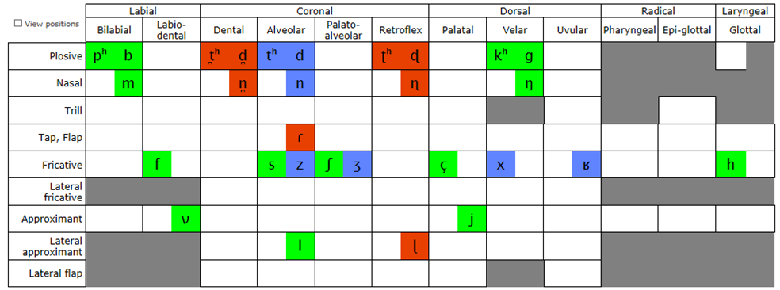

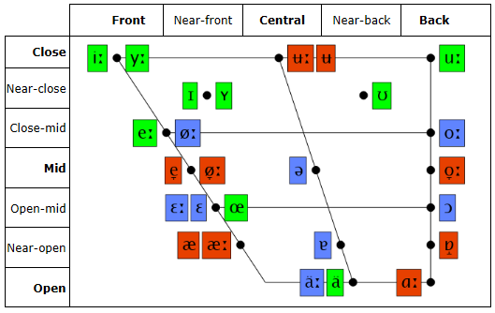

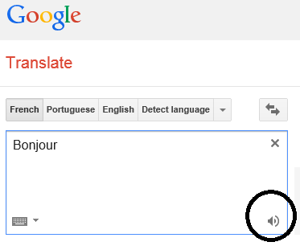

## Google Translate Orally

Hearing people needing to compare phonemes can type words in Google Translate and listen to the pronunciation.

<https://translate.google.ca/>

# Visemes

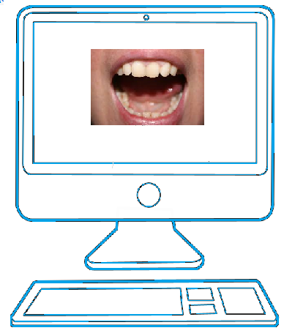

## Viseme Readability

A viseme is a group of phonemes whose visual expression is the same.

The coarticulation: The map from phonemes to visemes is one-to-many: the same phoneme can have many different visual forms. The lip shape for a sound is influenced by the previous and by the next sound.

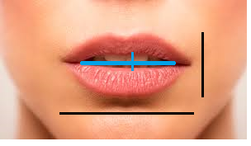Distinction between visemes can be done by computer using:

* the width of the internal lip contour
* the width of the external lip contour
* the height of the internal lip contour
* the height of the external lip contour

Lip reading does not allow perceiving voicing, nasalization, anteriority and posteriority. Labial visemes (bilabial, protrudes and labiodental) are easier to read than lingual or dental articulation.

|  |  |  |
| --- | --- | --- |
| Visibility of Organ Movements | | |
| Visible | Jaw | Opening / Closing  Forwarding / Retraction |
| Visible | Lips | Stretching / Protrusion  Opening / Closing  Elevation / Lowering |
| Sometimes visible | Tongue | Movement forward / backward  Tension / Compression  Forwarding / Retraction / Elevation |
| A little visible | Larynx | Elevation / Lowering |
| Non-visible | Velum | Opening / Closing |

DUMONT, A. (2008). Orthophonie et surdité. Communiquer, comprendre, parler. Issy-les-Moulineaux, Elsevier Masson. Degré de visibilité des mouvements des organes phonateurs. Page 195.

## Lip Reading

The above description is accurate but not intuitive. When teaching lip reading to Deafs; more visual descriptions are used.

In the example, we see how visemes are described for French in Quebec, Canada. Phonetic alphabet is not used. Visemes are described by comparing their shape to one another. We see descriptions of mouth more or less opened. The mouth shape may be circular. Lips may be protruding. The teeth may be closed or touch the tongue. Visemes vary from one individual to the other or depending on the word context.

**Quebec French Lip Reading Guideline**

|  |  |  |
| --- | --- | --- |
| Vowels | Mouth | Lips |
| /i/ | The mouth is almost closed. | The lips are much stretched. |
| /é/ | The mouth is a little more opened than for / i/. | The lips are a little less stretched than for / i/. |
| /è, in/ | The mouth is a little more opened than for / i,é/. | The lips are a little less tensed. |
| Open Vowel | | |
| /a, an/ | The mouth is wide opened. | - |
| Rounded Vowels | | |
| /o, on/ | The mouth is opened. | The lips are rounded. |
| /u, ou/ | The mouth is almost closed. | The lips are rounded and protruded. |
| /eu, un/ | The mouth is opened. | The lips are rounded and a little protruded. |
| Neutral Vowels | | |
| /e/ | The mouth is opened. | The lips are rounded and a little less protruded than /eu-un /. |

(1997) Programme d'entraînement à la lecture labiale. DVD 1 Leçon 1. (c) Institut Raymond-Dewar. Centre de réadaptation spécialisé en surdité et en communication. La Fondation Surdité et Communication. Montreal, Canada.

|  |  |  |
| --- | --- | --- |
| Consonants | Mouth and Teeth | Lips |
| /b, m, p/ | - | The lips are pressed together. |
| /f, v/ | - | The upper teeth touch the lower lip. |
| /ch, j/ | The teeth touch. | The lips are rounded and protruded. |
| /s, z/  (Hard to read) | The teeth touch. | When pronounced alone, lips are stretched and partially opened. |
| /s, z/  (When pronounced with another sound; they take its shape). | - | - |
| /L/ | The tongue tip touches the back of the upper teeth. | Usually, the /L/ is easy to read.  The lips are partially opened. |
| /d, n, t/  (Hard to read, sounds look the same but varies depending on the person) | Variants:   1. The tip of the tongue hits rapidly the back of the upper teeth. 2. The tip of the tongue is placed between the teeth. This is more visible. 3. The tip of the tongue hits rapidly the back of the lower teeth. This is not visible. | |
| /g, gn, k, r/  (sounds look the same) | The mouth is partially opened.  The tongue is curved and touches the back of the palate. This is not visible.  Some people pronounce the /r/ by vibrating the tongue tip. Then, the /r/ is more visible and can be distinguished from /g, gn, k/.  Some people contract the neck muscles a little. | |

(1997) Programme d'entraînement à la lecture labiale. DVD 1 Leçon 1. (c) Institut Raymond-Dewar. Centre de réadaptation spécialisé en surdité et en communication. La Fondation Surdité et Communication. Montreal, Canada.

## Signwriting

The above descriptions can be paired with SignWriting mouth, teeth and cheeks symbols. Their symbol names are descriptive and ease the matching with a viseme as we see in the following table.

|  |  |
| --- | --- |
| SignWriting Symbols | SignWriting Symbol Names |
|  | Mouth Open Rectangle Yawn  Mouth Open Rectangle  Mouth Open Oval  Mouth Open Oval Wrinkled  Mouth Open Circle  Mouth Open Wrinkled  Mouth Closed Neutral  Mouth Tense  Teeth on Lips  Tongue Tip Touches Inside Mouth  Tongue Inside Mouth Relaxed (up)  Mouth Open Forward  Teeth  Mouth Wrinkles Single  Tongue Inside Mouth Relaxed (down)  Mouth Wrinkles Double  Teeth on Tongue  Mouth Open Oval Yawn |

To teach speech and lip reading with SignWriting, we need a structured system. We will use Stefan Wöhrmann ´s SpeechWriting system.

# Wöhrmann´s SpeechWriting system.

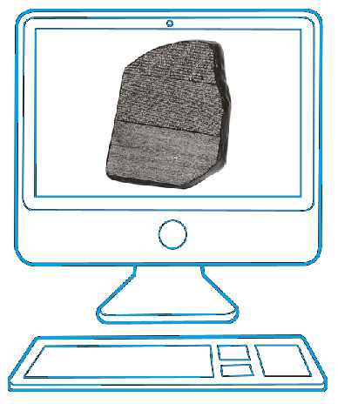

Rosetta Stone (196 B.C.)

*It is my experience, as a teacher of Deaf children in the Osnabrück School for the Deaf since 1991, where I have taught Deaf children SignWriting and Wöhrmann's SpeechWriting since the year 2000, that Deaf children have received enormous benefit from being able to read documents in written sign language, and to also be able at the same time, to read the mouth-movements of the corresponding words, and thus improve their oral "spoken-language" skills. It is remarkable seeing Deaf children's language skills improve using a combination of Sutton SignWriting and Wöhrmann's SpeechWriting.*

Wöhrmann, Stefan (2014) in <http://www.signwriting.org/symposium/presentation0002.html>

SpeechWriting includes two sections: MouthWriting (Mundbildschrift in German) and LipWriting (Mundbilder in der GebärdenSchrift in German).

A viseme represents several phonemes. Similarly, each LipWriting symbol summarizes several MouthWriting symbols. LipWriting uses SignWriting symbol set. MouthWriting uses a symbol set invented by Stefan Wöhrmann which is not part of current SignWriting symbol set.

Example: **Strauß** (Ostrich in German)

|  |  |  |
| --- | --- | --- |
| MouthWriting | LipWriting | SignWriting |
|  |  |  |

## MouthWriting (Mundbildschrift in German)

(Exact translation Mouth Picture Writing)

Mundbildschrift is not part of SignWriting. It is defined as follows.

*A standardized writing system for picturing the sounds of human language. Compared to the International Phonetic Alphabet MouthWriting is not as detailed and complete but easy to read and sufficient enough to support even young deaf students in their articulation process to develop better spoken language skills. Used like a spelling system for writing complete words in mouth pictures, and can be applied to any spoken language.*

*"Mundbildschrift" is a notation to transcribe the sounds of spoken German and to support deaf students in their effort to improve the articulation of German words. Mundbildschrift is a stand-alone symbol-set focussing on sound-production and there are no additional symbols involved that can be associated with sign language. These sounds are widely transcribed by means of the* ***International Phonetic Alphabet (IPA).***

***…***

*This "Mundbildschrift" notation has the form similar to the IPA (International Phonetic Alphabet), with an exact 1 to 1 mapping of spoken sounds and relevant symbols. For this purpose, I developed a number of additional mouth symbols that are not included in the Sutton symbol set, but are needed for writing the sounds of language. I had to distinguish between* ***long*** *and* ***short*** *vowels,* ***voiced*** *or* ***voiceless****, and* ***oral*** *or* ***nasal sounds****.”*

*…*

*SpeechWriting symbols show the circle for the head and a special set of symbols for the mouth (lips), tongue, teeth, - but also symbols to differentiate between voiced and voiceless, long and short, nasal or oral sounds as well.*

*…*

*The development of Mundbildschrift is still in progress and definitely I will have to create more symbols if other people ask for support in order to describe the sound of their given spoken language.*

Wöhrmann, Stefan (2014) in sws0002_01_How_I_teach_Mundbildschrift.

*In contrast to the symbols of Mundbildschrift, the "mouth-symbols" in SignWriting documents are strictly separated from any auditory impression of spoken language. They are based exclusively on visual aspects. This distinction is important to understand the difficulties in lip reading.*

*…*

*Although some symbols from Mundbildschrift are also used in SignWriting documents, they may not be interpreted in the same way.*

*There are* ***no differences*** *between long and short vowels, voiced or voiceless, and oral or nasal sounds and there is no symbol for “H”. Accordingly, the assignments made here as well as in lip-reading in part are ambiguous and require some oral language skills in the corresponding sign language associated with spoken language.*

Wöhrmann, Stefan (2014) in sws0002_02_Mundbilder_in_SignWriting_and_Spelling_rules

|  |  |  |  |  |
| --- | --- | --- | --- | --- |
| Viseme LipWriting Using SignWriting | SignWriting  Symbol Name | Phonemes | MouthWriting | |
|  | Mouth Tense | b p |  |  |
|  | Teeth on Lips | f v |  |  |

Mundbildschrift evolved through years ans still is evolving. At present, the symbol set is used in German and English (reviewed in 2014). One given symbol should be associated with one given speech sound. Future developments include the creation of new symbols by Stefan Wöhrmann when required for other languages.

Refer to Mundbildschrift tables for the symbol sets used in German and English.

### German and English MouthWriting (2014 Mundbildschrift)

|  |  |  |  |
| --- | --- | --- | --- |
| MouthWriting | Phonemes | German  Words | English Words |
|  | [a:] | Aal, Lahm | Arm |
|  | [ʌ] | Hat, Am, Ast | Cup, Luck |
|  | [ɜ:] | - | Germany |
|  | [ɛ:] | Käse, Spät,  Nähen,  Gähnen  Fähre, Mähne | Long as in Air |
|  | [ɛ] | Hätte, Kette,  Es, Eltern, Bett, Ärger | Cat, Black |
|  | [b] | Boot, Braun, Aber, Bei, Bis | Bed, Bad, Lab |
|  | [ç] | Ich, Teich,  Euch, Elch,  Männchen,  Echt,  Nächste,  Möchte,  Storch, Richtig | - |
|  | [x] | Acht,  Tochter,  Bauch,  Buch,  Tauchen, Krach | - |
|  | [d] | Dose, Das,  Dumm, Die, Du | Did, Lady |
|  | [dʒ] | Dschungel | Judge |
|  | [e:] | Esel, Schnee, Mehl | Similar to “a” in  Northern  English  Gate |
|  | [ə] | Eine, Katze | Away, Cinema |
|  | [f] | Fisch, Affe,  Fragen,Vater,  Voll, Frisch, Physik | Find, If |
|  | [g] | Gut, Gras,  Gurke, Bagger, | Give, Go, Flag, Dog |
|  | [ʒ] | Garage,  Etage, Jalousie | Like “sh” but voiced |
|  | [h] | Haus, Hund, Hallo, Heute | House, He, Hat |
|  | [i:] | Vieh, Igel,  Tier, Ihm, Die | Long “ee” as  in Bee or Teeth |
|  | [i] | In, Kind, Insel, Ist | Hit, Sitting |
|  | [j] | Junge, Ja,  Jo – Jo, Yacht | Yes, Yellow, You |
|  | [k] | Kind, Zucker, Mokka, Clown, Chaos, Flug, Krank, Dick, Trinken, | Cat, Black, Skull |
|  | [l] | Lampe, Ball, Lesen, Leise, Alt | Leg, Little |
|  | [m] | Mann, Mama, Im, Immer | Month, Him |
|  | [n] | Name, Nein, Hand,Tante,  Rennen, Kanne, Nun | No, Ten |
|  | [ŋ] | Ring, Zange, Junge, Bon,  Krank, Trinken | Sing, Finger |
|  | [o:] | Ofen, Oma, Kohle, Zoo | Long “o”  similar to  Go but with  the lips  more  rounded and more open |
|  | [ɔ] | Toll, Doch,  Offen, Tom, Komm | Hot, Rock |
|  | [ø:] | König, Löwe, Blöd, Öl, | Similar to  “eu” in  French  Peu  say a long “e”  and purse  your lips |
|  | [ø] | Öffnen,  Köstlich, Hölle | Short, cross  between “i”  in Dirt and  "eu” in  French Peu |
|  | [ɔ:] | - | Call, Four, Saw |
|  | [p] | Papa, Opa, Laub, Raubt, | Pet, Map, Spear |
|  | [pf] | Pflicht, Pferd | - |
|  | [R] | Rot, Raupe, Rudern, Rufen | “rrr” as if the  speaker  was  gargling |
|  | [r] | - | Wrap, Red, Try |
|  | [z] | So,Sie, Saft, Rasen, Riese, Rose, Leise | Zoo, Lazy |
|  | [s] | Glas, Klasse, Groß, City, Hast, Raspel, Muss,Wasser | Sun, Miss |
|  | [ʃ] | Schule, Stein, Hirsch  Spinne, Shampoo, Chance | She, Crash, Dish |
|  | [ð] | - | English “th“ voiced as in: This, Mother, They |
|  | [θ] | - | English “th“ voiceless as in: Think, Both |
|  | [t] | Tasse, Ratte,  Theater, Stadt, Wand,  Hund, Turnen, Tot, Traurig, Rund | Tea, Pet, Getting |
|  | [tʃ] | Klatschen, Tschüs, Knutschen | - |
|  | [u:] | Du, Uhu, Buch, Tube, Huhn, Stuhl | Long “oo” as in Boot with the lips much more rounded |
|  | [ʊ] | Mutter, Und, Hund, | Put, Could, Book |
|  | [y:] | Güte,Gefühl, Kühl, Üben, Mühe, Mühle | Say a long German “ie“ sound and then purse your lips |
|  | [y] | Glück, Zurück, Küste, Dünn, Mücke | Short, like “u“ in French Une or  English Dune, but with lips pressed much closer together |
|  | [v] | Wo, Wasser, Vase, Eventuell | Voice, Five, Have |
|  | [ks] | Taxi, Hexe, Keks | - |
|  | [ts] | Zahn, Katze, Pizza, Rätsel, Schiedsrichter, Zu | - |

Wöhrmann, Stefan (2014) An Overview of Symbols in Mundbildschrift.

**Some symbols were created or defined for Brazilian-Portuguese.**

|  |  |  |
| --- | --- | --- |
| MouthWriting | Phonemes | Portuguese Word |
|  | R produced with the trembling tongue | Fernando |
|  | [j]  Also used for  [ʎ] | Milha, Olho, Velha |
|  | [ɲ] | Amanhã, Sonho, Banho, Punhado |

|  |  |  |
| --- | --- | --- |
| Symbols used in the past but no longer in the current list | | |
| MouthWriting | **Phonemes** | **German Words** |
|  | [au] | Auto, Stau, Laut, Haus, Kakao |
|  | [] | Feuer, Eule, Gebäude, Konvoi, Aufräumen |
|  | [] | Eis, Hai, Eimer, Leise, Meyer, Reihe, Karl May |

  Other symbols no longer in usage will be presented below.

### German-English Consonants (Pulmonic)

|  | **Bilabial** | **Labiodental** | **Dental** | | **Alveolar** | **Postalveolar** | | **Retroflex** | **Palatal** | **Velar** | **Uvular** | **Pharyngeal** | | **Glottal** | |
| --- | --- | --- | --- | --- | --- | --- | --- | --- | --- | --- | --- | --- | --- | --- | --- |
| **Plosive** | p    b |  | t    d | | | | | ʈ ɖ | c ɟ | k    ɡ | q ɢ |  |  | ʔ |  |
| **Nasal** | m | ɱ | n | | | | | ɳ | ɲ | ŋ | ɴ |  | |  | |
| **Trill** | ʙ |  | r | | | | |  |  |  | ʀ |  | |  | |
| **Tap or Flap** |  | ⱱ | ɾ | | | | | ɽ |  |  |  |  | |  | |
| **Fricative** | ɸ β | f    v | θ  ð | s    z | | | ʃ    ʒ | ʂ ʐ | ç    ʝ | x    ɣ | χ ʁ | ħ ʕ | | h ɦ | |
| **Lateral fricative** |  |  | ɬ ɮ | | | | |  |  |  |  |  | |  | |
| **Approximant** |  | ʋ | ɹ | | | | | ɻ | j | ɰ |  |  | |  | |
| **Lateral approximant** |  |  | l | | | | | ɭ | ʎ | ʟ |  |  | |  | |

Where the symbols appear in pairs, the one to the right represents a voiced consonant. Shaded areas denote articulations judged impossible.

### German-English Vowels

|  | **Front** | **Central** | | **Back** |
| --- | --- | --- | --- | --- |
| **Close** | i y    **i :** y: | ɨ ʉ | | ɯ u  u: |
|  | ɪ ʏ | | ʊ | |
| **Close-mid** | e ø    ø: | ɘ ɵ | | ɤ o  o: |
|  | ə | | | |
| **Open-mid** | ɛ œ    ɛ: | ɜ ɞ | | ʌ ɔ    ɔ: |
|  | æ | ɐ | |  |
| **Open** | a ɶ  a: |  | | ɑ ɒ |

Where symbols appear in pairs, the one to the right represents a rounded vowel.

### Affricate, Double Articulations and others

|  |  |  |
| --- | --- | --- |
|  |  |  |
| ks | ts | tʃ |
|  | pf | dʒ |

### Mundbildschrift Animations

Several animations of Mundbildschrift are at:

<http://www.signwriting.org/symposium/presentation0002.html>

## LipWriting (Mundbilder in der GebärdenSchrift in German).

(Writing what is seen, when Lip Reading)

*A standardized writing system for picturing the way the lips look when a person speaks words. These symbols do not represent sounds but can be associated with spoken words, that are seen on the lips when “Lip Reading”.*

Wöhrmann, Stefan (2014) in sws0002_02_Mundbilder_in_SignWriting_and_Spelling_rules

|  |  |  |
| --- | --- | --- |
| Wöhrmann´s LipWriting Symbols  (Mundbilder) | SignWriting Symbol Names | Phoneme Equivalencies |
|  | Mouth Open Rectangle Yawn | ʌ  a: |
|  | Mouth Open Rectangle | ɛ  ɛ: |
|  | Mouth Open Oval | ə  e: |
|  | Mouth Open Oval Wrinkled | i  i: |
|  | Mouth Open Circle | ø  ø:  o: |
|  | Mouth Open Wrinkled | u:  ʊ  y  y: |
|  | Mouth Closed Neutral | m |
|  | Mouth Tense | b  p |
|  | Teeth on Lips | f  v |
|  | Tongue Tip Touches Inside Mouth | l |
|  | Tongue Inside Mouth Relaxed (up) | d  n  ŋ  t |
|  | Mouth Open Forward | ʒ  ʃ |
|  | Teeth | z  s  ks  ts |
|  | Mouth Wrinkles Single | j |
|  | Tongue Inside Mouth Relaxed (down) | k  r  ɡ |
|  | Mouth Wrinkles Double | X  ç |
|  | Teeth on Tongue | th ð θ |
|  | Mouth Open Oval Yawn | ɔ |

Wöhrmann, Stefan (2014) How I Teach Mundbildschrift.

### LipWriting Consonants (Pulmonic)

|  | **Bilabial** | **Labiodental** | **Dental** | | **Alveolar** | **Postalveolar** | | **Retroflex** | **Palatal** | **Velar** | **Uvular** | **Pharyngeal** | | **Glottal** | |
| --- | --- | --- | --- | --- | --- | --- | --- | --- | --- | --- | --- | --- | --- | --- | --- |
| **Plosive** | p b |  | t d | | | | | ʈ ɖ | c ɟ | k ɡ | q ɢ |  |  | ʔ |  |
| **Nasal** | m | ɱ | n | | | | | ɳ | ɲ | ŋ | ɴ |  | |  | |
| **Trill** | ʙ |  | r | | | | |  |  |  | ʀ |  | |  | |
| **Tap or Flap** |  | ⱱ | ɾ | | | | | ɽ |  |  |  |  | |  | |
| **Fricative** | ɸ β | f v | θ ð | s z | | | ʃ ʒ | ʂ ʐ | ç ʝ | x ɣ | χ ʁ | ħ ʕ | | h ɦ | |
| **Lateral fricative** |  |  | ɬ ɮ | | | | |  |  |  |  |  | |  | |
| **Approximant** |  | ʋ | ɹ | | | | | ɻ | j | ɰ |  |  | |  | |
| **Lateral approximant** |  |  | l | | | | | ɭ | ʎ | ʟ |  |  | |  | |

Where the symbols appear in pairs, the one to the right represents a voiced consonant. Shaded areas denote articulations judged impossible.

### LipWriting Vowels

|  | **Front** | **Central** | | **Back** |
| --- | --- | --- | --- | --- |
| **Close** | i y | ɨ ʉ | | ɯ u |
|  | ɪ ʏ | | ʊ | |
| **Close-mid** | e ø | ɘ ɵ | | ɤ o |
|  | ə | | | |
| **Open-mid** | ɛ œ | ɜ ɞ | | ʌ ɔ |
|  | æ | ɐ | |  |
| **Open** | a ɶ |  | | ɑ ɒ |

Where symbols appear in pairs, the one to the right represents a rounded vowel.

### Examples of Affricate, Double Articulations and Others

|  |  |  |  |  |
| --- | --- | --- | --- | --- |
|  | | |  |  |
| au |  |  | ks | ts |

### Spelling Rules for LipWriting in Signwriting

It is important to understand the spelling rules for LipWriting in SignWriting documents in order to animate them properly.

|  |
| --- |
| Spelling rules for LipWriting in SignWriting documents |
| *I defined the following spelling rules for writing Mundbilder in SignWriting:* |
| *We write the Mundbilder from left to right.* |
| *The head circles of the Mundbilder slightly overlap. This is an indication of a sequence of movements when speaking.* |
| *We only write the complete set of Mundbilder for a given sign if we can observe the signer mouthing the whole word. This will always happen within a performance following exact signed German (LBG)* |
| *Frequently, however, it is not necessary to write all the Mundbilder and indications being sufficient so that omissions are normal and usual, without impeding the flow of reading when the key difference between alternative meanings of the gesture was considered in the mouth images.* |
| *Mundbilder offer readers the chance to capture the intentioned concept exactly and quickly. Especially during translation exercises and LBG - dictations more mouth pictures are better than less. The higher the linguistic competence of the learner, the less mouth images are necessary ... the weaker the language skills, the more mouth images are desirable.* |
| *Always remember that your decision to choose the adequate Mundbild has to follow in sign writing documents purely visual cues of the mouth movements of the signer. Especially in the beginning scribes are in trouble and make many spelling mistakes, because they focus too much on the spelling of the corresponding German word.* |
| *Similar to the syllables in the spoken language, it is often helpful, to vary the overlap of the head circles slightly to allow the reader a better orientation. (The head circles may / can / should not overlap at this point but only touch).* |
| *A rule violation occurs when a number of mouth images are written so that the tip circles overlap, although units (syllables / sounds / mouth images) are in between from whatever reason omitted.* |
| *In other words, it is entirely at the discretion of the writer, how many mouth images he considers desirable, appropriate, and necessary. However, once omissions occur, they must be made clear through a gap between the head circles at the corresponding location. Otherwise, the expectations of the reader are injured and leading to a "stutter" effect when reading.* |
| *Especially in compound terms, it is often the case that the hands start to perform the first part and afterwards the second part of a sign. Here it is advisable to provide a visual cue, even with the head circles of the Mundbilder. For this reason, you should place the Mundbilder according to the manual instructions of the first term and the second term: e.g. “house” and “boat” or “tree” and “house”.* |
| *Basically, there is no rule violation to write the complete Mundbilder in a compound noun in a series centered over the two parts of the sign.* |
| *But I strongly recommend that the head circles between the two parts of a compound term provide guidance and thus represent a good reading aid.* |
| *This means that the overlap at the connecting point is smaller. The head circles are just touching but not overlapping.* |

Wöhrmann, Stefan (2014) in sws0002_02_Mundbilder_in_SignWriting_and_Spelling_rules

### Mundbilder Animations

A long animation combining Mundbilder and SignAnimating is at:

<http://movementwriting.org/animation/sgn-DE/>

### Association of LipWriting and MouthWriting

|  |  |  |
| --- | --- | --- |
| **Wöhrmann´s Lip Writing Symbols** | **Phonemes** | **Wöhrmann´s MouthWriting Symbols** |
|  | ʌ  a: |  |
|  | ɛ  ɛ: |  |
|  | ə  e: |  |
|  | i  i: |  |
|  | ø  ø:  o:  ɜ: |  |
|  | u:  ʊ  y  y: |  |
|  | m |  |
|  | b  p |  |
|  | f  v |  |
|  | l |  |
|  | d  n  ŋ  t |  |
|  | ʒ  ʃ |  |
|  | z  s  ks  ts |  |
|  | j |  |
|  | k  r  ɡ |  |
|  | X  ç |  |
|  | ð  θ |  |
|  | ɔ  d :  ɔ: |  |
| There is no need of LipWriting symbol for h. | h |  |
|  | dʒ |  |
|  | pf |  |
|  | tʃ |  |

# MouthWriting in Several Languages

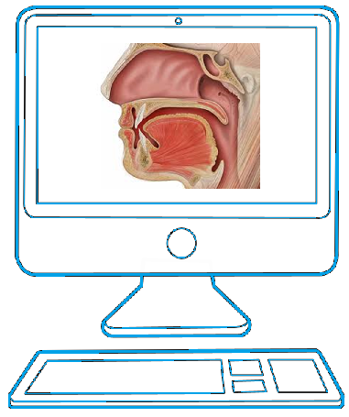

## Building a MouthWriting Symbol Set

Creating a MouthWriting (Mundbildschrift) symbol set for a new language can have a long term impact on its usage and even affect the creation of other subsequent MouthWriting symbol sets. Great care must be taken to avoid errors and ambiguities. New adopted symbols may be shared if the SpeechWriting symbol set is adapted to new languages.

|  |
| --- |
| Steps |
| Theoretical Basis: |
| 1. Verify if the target language has a MouthWriting (Mundbildschrift) symbol set. |
| 1. Verify if the target language has a LipWriting (Mundbilder) symbol set. |
| 1. Get the latest MouthWriting (Mundbildschrift) symbol sets developed by Stefan Wöhrmann (German and English in 2014). |
| 1. Get the International Phonetic Alphabet chart for languages that already have MouthWriting symbol sets. |
| 1. Get the list of phonemes in the target language. There may be more than one list if dialects or accents are present. |
| 1. Get the International Phonetic Alphabet chart for the target language. |
| Analysis: |
| 1. Compare the International Phonetic Alphabet chart for the target language and the language having a symbol set. |
| 1. Use Delegs software (<http://www.delegs.com/delegseditor/> ). 2. Develop a table containing:   Each MouthWriting symbols.  Each phonetic symbol in the languages having MouthWriting symbols.  Each additional phonetic symbol of the target language.  Simple words using each phonetic symbol. |
| 1. Identify the phonemes that have a defined MouthWriting symbol. |
| 1. Identify the MouthWriting symbols that are not used in the target language. |
| 1. Identify the phonemes that have no defined MouthWriting symbol. |
| 1. Identify unused symbols. |
| 1. Sample SignPuddle signs to identify if some mouth symbols are already used informally for speech writing. People, institutions and geographic names may have some informal speech writing. Use the search feature with obvious mouth shapes to find other associated mouth symbols. |
| Missing Symbols: |
| 1. Identify symbols that could be adapted to a phoneme in the target language. Concert with a specialist before assuming that two phonemes are similar enough to share symbols. |
| 1. List the phonemes in the target language that need a new symbol. |
| 1. Get complete descriptions of the phonemes needing a new symbol. A clear picture may help to build the symbol. |
| 1. Compare the phonemes needing a new symbol with pictures on the SpeechWriting web page. By clicking on the letters in the first column, more details are displayed with a picture.   <http://www.gebaerdenschrift.de/read/Mundbilder/uebersicht_mundbilder.htm#Übersicht Mundbilder> |
| Trial of a New Symbol Set. |
| 1. Do not modify the meaning of existing MouthWriting symbols. 2. Concert with Stefan Wöhrmann before creating new symbols in order to develop a standard that will be reusable for other languages. |
| 1. Test the new symbols set with several users: sign writers, children, teachers… Collect their feedback. Correct errors and ambiguities. This step may be very long. |
| Extension of the Official Symbol Set. |
| 1. Share the symbol set developed for the target language. |
| 1. When the new symbols are created, make them available through SignPuddle, Delegs or other SignWriting softwares |

## Theoretical Basis

Use the bibliography as a starting point to get the latest MouthWriting (Mundbildschrift) and LipWriting (Mundbilder) symbol sets developed by Stefan Wöhrmann (German and English in 2014).

Do not modify the meaning of existing MouthWriting symbols. Remain as close as possible from the existing symbol set in order to maintain a standardized way to match phonemes and visemes.

### List of Phonemes of the Target Language

Several documents list the phonemes of a language. Some use syllables examples, words examples; some use the use the International Phonetic Alphabet and some use the International Phonetic Alphabet chart. Often the lists are incomplete or lack details in order to remain accessible to non-professional unfamiliar with the International Phonetic Alphabet. It is preferable to start with a complete set to start the phonemes analysis, even if simplifications are made afterward. It is to expect that a symbol set may be used in sign language dictionaries in the future, rigor is important.

To get the complete International Phonetic Alphabet chart for 500 languages; L1-L2map, an online tool, can be used at <http://calst.hf.ntnu.no/l1-l2map/> . L1-L2*map* was developed by Jacques Koreman, Olaf Husby, Preben Wik and Øyvind Bech. It is hosted at the Norwegian University of Science and Technology. <http://www.ntnu.edu/isl/calst-for-learners>

<http://calst.hf.ntnu.no/l1-l2map/compare_languages/>



We will use Norwegian dialects in the examples that follow.

Select the option to compare a language with itself.



Language information displays the complete phoneme sets.

|  |
| --- |
| Norwegian Sounds |
| [[pʰ](http://calst.hf.ntnu.no/l1-l2map/sounds/24/)] [[b](http://calst.hf.ntnu.no/l1-l2map/sounds/33/)] [[t̪ʰ](http://calst.hf.ntnu.no/l1-l2map/sounds/43/)] [[d̪](http://calst.hf.ntnu.no/l1-l2map/sounds/49/)] [[ʈʰ](http://calst.hf.ntnu.no/l1-l2map/sounds/96/)] [[ɖ](http://calst.hf.ntnu.no/l1-l2map/sounds/101/)] [[kʰ](http://calst.hf.ntnu.no/l1-l2map/sounds/128/)] [[s](http://calst.hf.ntnu.no/l1-l2map/sounds/266/)] [[ʃ](http://calst.hf.ntnu.no/l1-l2map/sounds/278/)] [[f](http://calst.hf.ntnu.no/l1-l2map/sounds/298/)] [[ɡ](http://calst.hf.ntnu.no/l1-l2map/sounds/135/)] [[ç](http://calst.hf.ntnu.no/l1-l2map/sounds/311/)] [[ɾ](http://calst.hf.ntnu.no/l1-l2map/sounds/528/)] [[l](http://calst.hf.ntnu.no/l1-l2map/sounds/568/)] [[ɭ](http://calst.hf.ntnu.no/l1-l2map/sounds/572/)] [[ʋ](http://calst.hf.ntnu.no/l1-l2map/sounds/585/)] [[j](http://calst.hf.ntnu.no/l1-l2map/sounds/594/)] [[m](http://calst.hf.ntnu.no/l1-l2map/sounds/609/)] [[n̪](http://calst.hf.ntnu.no/l1-l2map/sounds/615/)] [[ɳ](http://calst.hf.ntnu.no/l1-l2map/sounds/635/)] [[ŋ](http://calst.hf.ntnu.no/l1-l2map/sounds/649/)] [[ʏ](http://calst.hf.ntnu.no/l1-l2map/sounds/713/)] [[ɪ](http://calst.hf.ntnu.no/l1-l2map/sounds/715/)] [[yː](http://calst.hf.ntnu.no/l1-l2map/sounds/716/)] [[iː](http://calst.hf.ntnu.no/l1-l2map/sounds/720/)] [[ʉː](http://calst.hf.ntnu.no/l1-l2map/sounds/726/)] [[ʉ](http://calst.hf.ntnu.no/l1-l2map/sounds/728/)] [[ʊ](http://calst.hf.ntnu.no/l1-l2map/sounds/735/)] [[uː](http://calst.hf.ntnu.no/l1-l2map/sounds/740/)] [[eː](http://calst.hf.ntnu.no/l1-l2map/sounds/753/)] [[ø̞ː](http://calst.hf.ntnu.no/l1-l2map/sounds/769/)] [[e̞](http://calst.hf.ntnu.no/l1-l2map/sounds/775/)] [[o̞ː](http://calst.hf.ntnu.no/l1-l2map/sounds/785/)] [[œ](http://calst.hf.ntnu.no/l1-l2map/sounds/790/)] [[æː](http://calst.hf.ntnu.no/l1-l2map/sounds/806/)] [[æ](http://calst.hf.ntnu.no/l1-l2map/sounds/807/)] [[ä](http://calst.hf.ntnu.no/l1-l2map/sounds/819/)] [[ɒ̝](http://calst.hf.ntnu.no/l1-l2map/sounds/820/)] [[ɑː](http://calst.hf.ntnu.no/l1-l2map/sounds/826/)] [[øy](http://calst.hf.ntnu.no/l1-l2map/sounds/852/)] [[ɔy](http://calst.hf.ntnu.no/l1-l2map/sounds/875/)] [[æʉ](http://calst.hf.ntnu.no/l1-l2map/sounds/883/)] [[äi](http://calst.hf.ntnu.no/l1-l2map/sounds/887/)] [[æi](http://calst.hf.ntnu.no/l1-l2map/sounds/888/)] [[h](http://calst.hf.ntnu.no/l1-l2map/sounds/920/)] [[ʉi](http://calst.hf.ntnu.no/l1-l2map/sounds/998/)] [[ui](http://calst.hf.ntnu.no/l1-l2map/sounds/905/)] |
| Vanvik, A. 1972. A phonetic-phonemic analysis of Standard Eastern Norwegian. Norwegian Journal of Linguistics 26: 119-64. |

### International Phonetic Alphabet chart for the target language

Still with L1-L2map, online tool, the charts for consonants, vowels and diphthongs are displayed.



Norwegian Consonants



Norwegian Vowels

In Norwegian, several dialects co-exist; they can be compared with one another. The same comparison may be performed with each language supported by SpeechWriting.

|  |  |  |  |
| --- | --- | --- | --- |
| Norwegian | Norwegian  Bergen | Norwegian  Elverum | Norwegian  Malm |
| 47 segments | 40 segments | 45 segments | 50 segments |
| [[pʰ](http://calst.hf.ntnu.no/l1-l2map/sounds/24/)] [[b](http://calst.hf.ntnu.no/l1-l2map/sounds/33/)] [[t̪ʰ](http://calst.hf.ntnu.no/l1-l2map/sounds/43/)] [[d̪](http://calst.hf.ntnu.no/l1-l2map/sounds/49/)] [[ʈʰ](http://calst.hf.ntnu.no/l1-l2map/sounds/96/)] [[ɖ](http://calst.hf.ntnu.no/l1-l2map/sounds/101/)] [[kʰ](http://calst.hf.ntnu.no/l1-l2map/sounds/128/)] [[s](http://calst.hf.ntnu.no/l1-l2map/sounds/266/)] [[ʃ](http://calst.hf.ntnu.no/l1-l2map/sounds/278/)] [[f](http://calst.hf.ntnu.no/l1-l2map/sounds/298/)] [[ɡ](http://calst.hf.ntnu.no/l1-l2map/sounds/135/)] [[ç](http://calst.hf.ntnu.no/l1-l2map/sounds/311/)] [[ɾ](http://calst.hf.ntnu.no/l1-l2map/sounds/528/)] [[l](http://calst.hf.ntnu.no/l1-l2map/sounds/568/)] [[ɭ](http://calst.hf.ntnu.no/l1-l2map/sounds/572/)] [[ʋ](http://calst.hf.ntnu.no/l1-l2map/sounds/585/)] [[j](http://calst.hf.ntnu.no/l1-l2map/sounds/594/)] [[m](http://calst.hf.ntnu.no/l1-l2map/sounds/609/)] [[n̪](http://calst.hf.ntnu.no/l1-l2map/sounds/615/)] [[ɳ](http://calst.hf.ntnu.no/l1-l2map/sounds/635/)] [[ŋ](http://calst.hf.ntnu.no/l1-l2map/sounds/649/)] [[ʏ](http://calst.hf.ntnu.no/l1-l2map/sounds/713/)] [[ɪ](http://calst.hf.ntnu.no/l1-l2map/sounds/715/)] [[yː](http://calst.hf.ntnu.no/l1-l2map/sounds/716/)] [[iː](http://calst.hf.ntnu.no/l1-l2map/sounds/720/)] [[ʉː](http://calst.hf.ntnu.no/l1-l2map/sounds/726/)] [[ʉ](http://calst.hf.ntnu.no/l1-l2map/sounds/728/)] [[ʊ](http://calst.hf.ntnu.no/l1-l2map/sounds/735/)] [[uː](http://calst.hf.ntnu.no/l1-l2map/sounds/740/)] [[eː](http://calst.hf.ntnu.no/l1-l2map/sounds/753/)] [[ø̞ː](http://calst.hf.ntnu.no/l1-l2map/sounds/769/)] [[e̞](http://calst.hf.ntnu.no/l1-l2map/sounds/775/)] [[o̞ː](http://calst.hf.ntnu.no/l1-l2map/sounds/785/)] [[œ](http://calst.hf.ntnu.no/l1-l2map/sounds/790/)] [[æː](http://calst.hf.ntnu.no/l1-l2map/sounds/806/)] [[æ](http://calst.hf.ntnu.no/l1-l2map/sounds/807/)] [[ä](http://calst.hf.ntnu.no/l1-l2map/sounds/819/)] [[ɒ̝](http://calst.hf.ntnu.no/l1-l2map/sounds/820/)] [[ɑː](http://calst.hf.ntnu.no/l1-l2map/sounds/826/)] [[øy](http://calst.hf.ntnu.no/l1-l2map/sounds/852/)] [[ɔy](http://calst.hf.ntnu.no/l1-l2map/sounds/875/)] [[æʉ](http://calst.hf.ntnu.no/l1-l2map/sounds/883/)] [[äi](http://calst.hf.ntnu.no/l1-l2map/sounds/887/)] [[æi](http://calst.hf.ntnu.no/l1-l2map/sounds/888/)] [[h](http://calst.hf.ntnu.no/l1-l2map/sounds/920/)] [[ʉi](http://calst.hf.ntnu.no/l1-l2map/sounds/998/)] [[ui](http://calst.hf.ntnu.no/l1-l2map/sounds/905/)] | [[pʰ](http://calst.hf.ntnu.no/l1-l2map/sounds/24/)] [[b](http://calst.hf.ntnu.no/l1-l2map/sounds/33/)] [[t̪ʰ](http://calst.hf.ntnu.no/l1-l2map/sounds/43/)] [[d̪](http://calst.hf.ntnu.no/l1-l2map/sounds/49/)] [[kʰ](http://calst.hf.ntnu.no/l1-l2map/sounds/128/)] [[ɡ](http://calst.hf.ntnu.no/l1-l2map/sounds/135/)] [[s](http://calst.hf.ntnu.no/l1-l2map/sounds/266/)] [[f](http://calst.hf.ntnu.no/l1-l2map/sounds/298/)] [[ʁ](http://calst.hf.ntnu.no/l1-l2map/sounds/333/)] [[l](http://calst.hf.ntnu.no/l1-l2map/sounds/568/)] [[ʋ](http://calst.hf.ntnu.no/l1-l2map/sounds/585/)] [[j](http://calst.hf.ntnu.no/l1-l2map/sounds/594/)] [[m](http://calst.hf.ntnu.no/l1-l2map/sounds/609/)] [[n̪](http://calst.hf.ntnu.no/l1-l2map/sounds/615/)] [[ŋ](http://calst.hf.ntnu.no/l1-l2map/sounds/649/)] [[ʏ](http://calst.hf.ntnu.no/l1-l2map/sounds/713/)] [[ɪ](http://calst.hf.ntnu.no/l1-l2map/sounds/715/)] [[yː](http://calst.hf.ntnu.no/l1-l2map/sounds/716/)] [[iː](http://calst.hf.ntnu.no/l1-l2map/sounds/720/)] [[ʉː](http://calst.hf.ntnu.no/l1-l2map/sounds/726/)] [[ʉ](http://calst.hf.ntnu.no/l1-l2map/sounds/728/)] [[ʊ](http://calst.hf.ntnu.no/l1-l2map/sounds/735/)] [[uː](http://calst.hf.ntnu.no/l1-l2map/sounds/740/)] [[eː](http://calst.hf.ntnu.no/l1-l2map/sounds/753/)] [[ø̞ː](http://calst.hf.ntnu.no/l1-l2map/sounds/769/)] [[e̞](http://calst.hf.ntnu.no/l1-l2map/sounds/775/)] [[o̞ː](http://calst.hf.ntnu.no/l1-l2map/sounds/785/)] [[œ](http://calst.hf.ntnu.no/l1-l2map/sounds/790/)] [[æː](http://calst.hf.ntnu.no/l1-l2map/sounds/806/)] [[æ](http://calst.hf.ntnu.no/l1-l2map/sounds/807/)] [[ɑ](http://calst.hf.ntnu.no/l1-l2map/sounds/827/)] [[ɒ̝](http://calst.hf.ntnu.no/l1-l2map/sounds/820/)] [[ɑː](http://calst.hf.ntnu.no/l1-l2map/sounds/826/)] [[øy](http://calst.hf.ntnu.no/l1-l2map/sounds/852/)] [[ɔy](http://calst.hf.ntnu.no/l1-l2map/sounds/875/)] [[æʉ](http://calst.hf.ntnu.no/l1-l2map/sounds/883/)] [[äi](http://calst.hf.ntnu.no/l1-l2map/sounds/887/)] [[æi](http://calst.hf.ntnu.no/l1-l2map/sounds/888/)] [[h](http://calst.hf.ntnu.no/l1-l2map/sounds/920/)] [[ç](http://calst.hf.ntnu.no/l1-l2map/sounds/311/)] | [[pʰ](http://calst.hf.ntnu.no/l1-l2map/sounds/24/)] [[b](http://calst.hf.ntnu.no/l1-l2map/sounds/33/)] [[t̪ʰ](http://calst.hf.ntnu.no/l1-l2map/sounds/43/)] [[d̪](http://calst.hf.ntnu.no/l1-l2map/sounds/49/)] [[ʈʰ](http://calst.hf.ntnu.no/l1-l2map/sounds/96/)] [[ɖ](http://calst.hf.ntnu.no/l1-l2map/sounds/101/)] [[kʰ](http://calst.hf.ntnu.no/l1-l2map/sounds/128/)] [[s](http://calst.hf.ntnu.no/l1-l2map/sounds/266/)] [[ʃ](http://calst.hf.ntnu.no/l1-l2map/sounds/278/)] [[f](http://calst.hf.ntnu.no/l1-l2map/sounds/298/)] [[ɡ](http://calst.hf.ntnu.no/l1-l2map/sounds/135/)] [[ç](http://calst.hf.ntnu.no/l1-l2map/sounds/311/)] [[ɾ](http://calst.hf.ntnu.no/l1-l2map/sounds/528/)] [[l](http://calst.hf.ntnu.no/l1-l2map/sounds/568/)] [[ɭ](http://calst.hf.ntnu.no/l1-l2map/sounds/572/)] [[ʋ](http://calst.hf.ntnu.no/l1-l2map/sounds/585/)] [[j](http://calst.hf.ntnu.no/l1-l2map/sounds/594/)] [[m](http://calst.hf.ntnu.no/l1-l2map/sounds/609/)] [[n̪](http://calst.hf.ntnu.no/l1-l2map/sounds/615/)] [[ɳ](http://calst.hf.ntnu.no/l1-l2map/sounds/635/)] [[ŋ](http://calst.hf.ntnu.no/l1-l2map/sounds/649/)] [[ʏ](http://calst.hf.ntnu.no/l1-l2map/sounds/713/)] [[ɪ](http://calst.hf.ntnu.no/l1-l2map/sounds/715/)] [[yː](http://calst.hf.ntnu.no/l1-l2map/sounds/716/)] [[iː](http://calst.hf.ntnu.no/l1-l2map/sounds/720/)] [[ʉː](http://calst.hf.ntnu.no/l1-l2map/sounds/726/)] [[ʉ](http://calst.hf.ntnu.no/l1-l2map/sounds/728/)] [[ʊ](http://calst.hf.ntnu.no/l1-l2map/sounds/735/)] [[uː](http://calst.hf.ntnu.no/l1-l2map/sounds/740/)] [[eː](http://calst.hf.ntnu.no/l1-l2map/sounds/753/)] [[ø̞ː](http://calst.hf.ntnu.no/l1-l2map/sounds/769/)] [[e̞](http://calst.hf.ntnu.no/l1-l2map/sounds/775/)] [[o̞ː](http://calst.hf.ntnu.no/l1-l2map/sounds/785/)] [[œ](http://calst.hf.ntnu.no/l1-l2map/sounds/790/)] [[æː](http://calst.hf.ntnu.no/l1-l2map/sounds/806/)] [[æ](http://calst.hf.ntnu.no/l1-l2map/sounds/807/)] [[ɑ](http://calst.hf.ntnu.no/l1-l2map/sounds/827/)] [[ɒ̝](http://calst.hf.ntnu.no/l1-l2map/sounds/820/)] [[ɑː](http://calst.hf.ntnu.no/l1-l2map/sounds/826/)] [[øy](http://calst.hf.ntnu.no/l1-l2map/sounds/852/)] [[ɔy](http://calst.hf.ntnu.no/l1-l2map/sounds/875/)] [[œʉ](http://calst.hf.ntnu.no/l1-l2map/sounds/999/)] [[äi](http://calst.hf.ntnu.no/l1-l2map/sounds/887/)] [[æi](http://calst.hf.ntnu.no/l1-l2map/sounds/888/)] [[h](http://calst.hf.ntnu.no/l1-l2map/sounds/920/)] | [[pʰ](http://calst.hf.ntnu.no/l1-l2map/sounds/24/)] [[b](http://calst.hf.ntnu.no/l1-l2map/sounds/33/)] [[t̪ʰ](http://calst.hf.ntnu.no/l1-l2map/sounds/43/)] [[d̪](http://calst.hf.ntnu.no/l1-l2map/sounds/49/)] [[ʈʰ](http://calst.hf.ntnu.no/l1-l2map/sounds/96/)] [[ɖ](http://calst.hf.ntnu.no/l1-l2map/sounds/101/)] [[cʰ](http://calst.hf.ntnu.no/l1-l2map/sounds/104/)] [[ɟ](http://calst.hf.ntnu.no/l1-l2map/sounds/109/)] [[kʰ](http://calst.hf.ntnu.no/l1-l2map/sounds/128/)] [[ɡ](http://calst.hf.ntnu.no/l1-l2map/sounds/135/)] [[s](http://calst.hf.ntnu.no/l1-l2map/sounds/266/)] [[ʃ](http://calst.hf.ntnu.no/l1-l2map/sounds/278/)] [[f](http://calst.hf.ntnu.no/l1-l2map/sounds/298/)] [[ç](http://calst.hf.ntnu.no/l1-l2map/sounds/311/)] [[ɾ](http://calst.hf.ntnu.no/l1-l2map/sounds/528/)] [[ɽ](http://calst.hf.ntnu.no/l1-l2map/sounds/531/)] [[l](http://calst.hf.ntnu.no/l1-l2map/sounds/568/)] [[ɭ](http://calst.hf.ntnu.no/l1-l2map/sounds/572/)] [[ʎ](http://calst.hf.ntnu.no/l1-l2map/sounds/573/)] [[ʋ](http://calst.hf.ntnu.no/l1-l2map/sounds/585/)] [[j](http://calst.hf.ntnu.no/l1-l2map/sounds/594/)] [[m](http://calst.hf.ntnu.no/l1-l2map/sounds/609/)] [[n̪](http://calst.hf.ntnu.no/l1-l2map/sounds/615/)] [[ɳ](http://calst.hf.ntnu.no/l1-l2map/sounds/635/)] [[ɲ](http://calst.hf.ntnu.no/l1-l2map/sounds/640/)] [[ŋ](http://calst.hf.ntnu.no/l1-l2map/sounds/649/)] [[ʏ](http://calst.hf.ntnu.no/l1-l2map/sounds/713/)] [[ɪ](http://calst.hf.ntnu.no/l1-l2map/sounds/715/)] [[yː](http://calst.hf.ntnu.no/l1-l2map/sounds/716/)] [[iː](http://calst.hf.ntnu.no/l1-l2map/sounds/720/)] [[ʉː](http://calst.hf.ntnu.no/l1-l2map/sounds/726/)] [[ʉ](http://calst.hf.ntnu.no/l1-l2map/sounds/728/)] [[ʊ](http://calst.hf.ntnu.no/l1-l2map/sounds/735/)] [[uː](http://calst.hf.ntnu.no/l1-l2map/sounds/740/)] [[eː](http://calst.hf.ntnu.no/l1-l2map/sounds/753/)] [[ø̞ː](http://calst.hf.ntnu.no/l1-l2map/sounds/769/)] [[e̞](http://calst.hf.ntnu.no/l1-l2map/sounds/775/)] [[o̞ː](http://calst.hf.ntnu.no/l1-l2map/sounds/785/)] [[œ](http://calst.hf.ntnu.no/l1-l2map/sounds/790/)] [[æː](http://calst.hf.ntnu.no/l1-l2map/sounds/806/)] [[æ](http://calst.hf.ntnu.no/l1-l2map/sounds/807/)] [[ɑ](http://calst.hf.ntnu.no/l1-l2map/sounds/827/)] [[ɒ̝](http://calst.hf.ntnu.no/l1-l2map/sounds/820/)] [[ɑː](http://calst.hf.ntnu.no/l1-l2map/sounds/826/)] [[øy](http://calst.hf.ntnu.no/l1-l2map/sounds/852/)] [[e̞i](http://calst.hf.ntnu.no/l1-l2map/sounds/862/)] [[ɔy](http://calst.hf.ntnu.no/l1-l2map/sounds/875/)] [[œʉ](http://calst.hf.ntnu.no/l1-l2map/sounds/999/)] [[äi](http://calst.hf.ntnu.no/l1-l2map/sounds/887/)] [[h](http://calst.hf.ntnu.no/l1-l2map/sounds/920/)] |
| Norwegian  Oslo | **Norwegian**  **Sandnessjøen** | **Norwegian**  **Stavanger** | **Norwegian**  **Tromsø** |
| 45 segments | 52 segments | 40 segments | 49 segments |
| [[pʰ](http://calst.hf.ntnu.no/l1-l2map/sounds/24/)] [[b](http://calst.hf.ntnu.no/l1-l2map/sounds/33/)] [[t̪ʰ](http://calst.hf.ntnu.no/l1-l2map/sounds/43/)] [[d̪](http://calst.hf.ntnu.no/l1-l2map/sounds/49/)] [[ʈʰ](http://calst.hf.ntnu.no/l1-l2map/sounds/96/)] [[ɖ](http://calst.hf.ntnu.no/l1-l2map/sounds/101/)] [[kʰ](http://calst.hf.ntnu.no/l1-l2map/sounds/128/)] [[s](http://calst.hf.ntnu.no/l1-l2map/sounds/266/)] [[ʃ](http://calst.hf.ntnu.no/l1-l2map/sounds/278/)] [[f](http://calst.hf.ntnu.no/l1-l2map/sounds/298/)] [[ɡ](http://calst.hf.ntnu.no/l1-l2map/sounds/135/)] [[ç](http://calst.hf.ntnu.no/l1-l2map/sounds/311/)] [[ɾ](http://calst.hf.ntnu.no/l1-l2map/sounds/528/)] [[l](http://calst.hf.ntnu.no/l1-l2map/sounds/568/)] [[ɭ](http://calst.hf.ntnu.no/l1-l2map/sounds/572/)] [[ʋ](http://calst.hf.ntnu.no/l1-l2map/sounds/585/)] [[j](http://calst.hf.ntnu.no/l1-l2map/sounds/594/)] [[m](http://calst.hf.ntnu.no/l1-l2map/sounds/609/)] [[n̪](http://calst.hf.ntnu.no/l1-l2map/sounds/615/)] [[ɳ](http://calst.hf.ntnu.no/l1-l2map/sounds/635/)] [[ŋ](http://calst.hf.ntnu.no/l1-l2map/sounds/649/)] [[ʏ](http://calst.hf.ntnu.no/l1-l2map/sounds/713/)] [[ɪ](http://calst.hf.ntnu.no/l1-l2map/sounds/715/)] [[yː](http://calst.hf.ntnu.no/l1-l2map/sounds/716/)] [[iː](http://calst.hf.ntnu.no/l1-l2map/sounds/720/)] [[ʉː](http://calst.hf.ntnu.no/l1-l2map/sounds/726/)] [[ʉ](http://calst.hf.ntnu.no/l1-l2map/sounds/728/)] [[ʊ](http://calst.hf.ntnu.no/l1-l2map/sounds/735/)] [[uː](http://calst.hf.ntnu.no/l1-l2map/sounds/740/)] [[eː](http://calst.hf.ntnu.no/l1-l2map/sounds/753/)] [[ø̞ː](http://calst.hf.ntnu.no/l1-l2map/sounds/769/)] [[e̞](http://calst.hf.ntnu.no/l1-l2map/sounds/775/)] [[o̞ː](http://calst.hf.ntnu.no/l1-l2map/sounds/785/)] [[œ](http://calst.hf.ntnu.no/l1-l2map/sounds/790/)] [[æː](http://calst.hf.ntnu.no/l1-l2map/sounds/806/)] [[æ](http://calst.hf.ntnu.no/l1-l2map/sounds/807/)] [[ɑ](http://calst.hf.ntnu.no/l1-l2map/sounds/827/)] [[ɒ̝](http://calst.hf.ntnu.no/l1-l2map/sounds/820/)] [[ɑː](http://calst.hf.ntnu.no/l1-l2map/sounds/826/)] [[øy](http://calst.hf.ntnu.no/l1-l2map/sounds/852/)] [[ɔy](http://calst.hf.ntnu.no/l1-l2map/sounds/875/)] [[æʉ](http://calst.hf.ntnu.no/l1-l2map/sounds/883/)] [[äi](http://calst.hf.ntnu.no/l1-l2map/sounds/887/)] [[æi](http://calst.hf.ntnu.no/l1-l2map/sounds/888/)] [[h](http://calst.hf.ntnu.no/l1-l2map/sounds/920/)] | [[pʰ](http://calst.hf.ntnu.no/l1-l2map/sounds/24/)] [[b](http://calst.hf.ntnu.no/l1-l2map/sounds/33/)] [[t̪ʰ](http://calst.hf.ntnu.no/l1-l2map/sounds/43/)] [[d̪](http://calst.hf.ntnu.no/l1-l2map/sounds/49/)] [[ʈʰ](http://calst.hf.ntnu.no/l1-l2map/sounds/96/)] [[ɖ](http://calst.hf.ntnu.no/l1-l2map/sounds/101/)] [[cʰ](http://calst.hf.ntnu.no/l1-l2map/sounds/104/)] [[ɟ](http://calst.hf.ntnu.no/l1-l2map/sounds/109/)] [[kʰ](http://calst.hf.ntnu.no/l1-l2map/sounds/128/)] [[ɡ](http://calst.hf.ntnu.no/l1-l2map/sounds/135/)] [[s](http://calst.hf.ntnu.no/l1-l2map/sounds/266/)] [[ʃ](http://calst.hf.ntnu.no/l1-l2map/sounds/278/)] [[f](http://calst.hf.ntnu.no/l1-l2map/sounds/298/)] [[ç](http://calst.hf.ntnu.no/l1-l2map/sounds/311/)] [[ɾ](http://calst.hf.ntnu.no/l1-l2map/sounds/528/)] [[ɽ](http://calst.hf.ntnu.no/l1-l2map/sounds/531/)] [[l](http://calst.hf.ntnu.no/l1-l2map/sounds/568/)] [[ɭ](http://calst.hf.ntnu.no/l1-l2map/sounds/572/)] [[ʎ](http://calst.hf.ntnu.no/l1-l2map/sounds/573/)] [[ʋ](http://calst.hf.ntnu.no/l1-l2map/sounds/585/)] [[j](http://calst.hf.ntnu.no/l1-l2map/sounds/594/)] [[m](http://calst.hf.ntnu.no/l1-l2map/sounds/609/)] [[n̪](http://calst.hf.ntnu.no/l1-l2map/sounds/615/)] [[ɳ](http://calst.hf.ntnu.no/l1-l2map/sounds/635/)] [[ɲ](http://calst.hf.ntnu.no/l1-l2map/sounds/640/)] [[ŋ](http://calst.hf.ntnu.no/l1-l2map/sounds/649/)] [[ʏ](http://calst.hf.ntnu.no/l1-l2map/sounds/713/)] [[ɪ](http://calst.hf.ntnu.no/l1-l2map/sounds/715/)] [[yː](http://calst.hf.ntnu.no/l1-l2map/sounds/716/)] [[iː](http://calst.hf.ntnu.no/l1-l2map/sounds/720/)] [[ʉː](http://calst.hf.ntnu.no/l1-l2map/sounds/726/)] [[ʉ](http://calst.hf.ntnu.no/l1-l2map/sounds/728/)] [[ʊ](http://calst.hf.ntnu.no/l1-l2map/sounds/735/)] [[uː](http://calst.hf.ntnu.no/l1-l2map/sounds/740/)] [[eː](http://calst.hf.ntnu.no/l1-l2map/sounds/753/)] [[ø̞ː](http://calst.hf.ntnu.no/l1-l2map/sounds/769/)] [[e̞](http://calst.hf.ntnu.no/l1-l2map/sounds/775/)] [[o̞ː](http://calst.hf.ntnu.no/l1-l2map/sounds/785/)] [[œ](http://calst.hf.ntnu.no/l1-l2map/sounds/790/)] [[æː](http://calst.hf.ntnu.no/l1-l2map/sounds/806/)] [[ʉi](http://calst.hf.ntnu.no/l1-l2map/sounds/998/)] [[æ](http://calst.hf.ntnu.no/l1-l2map/sounds/807/)] [[ɑ](http://calst.hf.ntnu.no/l1-l2map/sounds/827/)] [[ɒ̝](http://calst.hf.ntnu.no/l1-l2map/sounds/820/)] [[ɑː](http://calst.hf.ntnu.no/l1-l2map/sounds/826/)] [[øy](http://calst.hf.ntnu.no/l1-l2map/sounds/852/)] [[e̞i](http://calst.hf.ntnu.no/l1-l2map/sounds/862/)] [[ɔy](http://calst.hf.ntnu.no/l1-l2map/sounds/875/)] [[œʉ](http://calst.hf.ntnu.no/l1-l2map/sounds/999/)] [[äi](http://calst.hf.ntnu.no/l1-l2map/sounds/887/)] [[h](http://calst.hf.ntnu.no/l1-l2map/sounds/920/)] [[ui](http://calst.hf.ntnu.no/l1-l2map/sounds/905/)] | [[ʃ](http://calst.hf.ntnu.no/l1-l2map/sounds/278/)] [[pʰ](http://calst.hf.ntnu.no/l1-l2map/sounds/24/)] [[b](http://calst.hf.ntnu.no/l1-l2map/sounds/33/)] [[t̪ʰ](http://calst.hf.ntnu.no/l1-l2map/sounds/43/)] [[d̪](http://calst.hf.ntnu.no/l1-l2map/sounds/49/)] [[kʰ](http://calst.hf.ntnu.no/l1-l2map/sounds/128/)] [[ɡ](http://calst.hf.ntnu.no/l1-l2map/sounds/135/)] [[s](http://calst.hf.ntnu.no/l1-l2map/sounds/266/)] [[f](http://calst.hf.ntnu.no/l1-l2map/sounds/298/)] [[ʁ](http://calst.hf.ntnu.no/l1-l2map/sounds/333/)] [[l](http://calst.hf.ntnu.no/l1-l2map/sounds/568/)] [[ʋ](http://calst.hf.ntnu.no/l1-l2map/sounds/585/)] [[j](http://calst.hf.ntnu.no/l1-l2map/sounds/594/)] [[m](http://calst.hf.ntnu.no/l1-l2map/sounds/609/)] [[n̪](http://calst.hf.ntnu.no/l1-l2map/sounds/615/)] [[ŋ](http://calst.hf.ntnu.no/l1-l2map/sounds/649/)] [[ʏ](http://calst.hf.ntnu.no/l1-l2map/sounds/713/)] [[ɪ](http://calst.hf.ntnu.no/l1-l2map/sounds/715/)] [[yː](http://calst.hf.ntnu.no/l1-l2map/sounds/716/)] [[iː](http://calst.hf.ntnu.no/l1-l2map/sounds/720/)] [[ʉː](http://calst.hf.ntnu.no/l1-l2map/sounds/726/)] [[ʉ](http://calst.hf.ntnu.no/l1-l2map/sounds/728/)] [[ʊ](http://calst.hf.ntnu.no/l1-l2map/sounds/735/)] [[uː](http://calst.hf.ntnu.no/l1-l2map/sounds/740/)] [[eː](http://calst.hf.ntnu.no/l1-l2map/sounds/753/)] [[ø̞ː](http://calst.hf.ntnu.no/l1-l2map/sounds/769/)] [[e̞](http://calst.hf.ntnu.no/l1-l2map/sounds/775/)] [[o̞ː](http://calst.hf.ntnu.no/l1-l2map/sounds/785/)] [[œ](http://calst.hf.ntnu.no/l1-l2map/sounds/790/)] [[æ](http://calst.hf.ntnu.no/l1-l2map/sounds/807/)] [[ɑː](http://calst.hf.ntnu.no/l1-l2map/sounds/826/)] [[ä](http://calst.hf.ntnu.no/l1-l2map/sounds/819/)] [[ɒ̝](http://calst.hf.ntnu.no/l1-l2map/sounds/820/)] [[øy](http://calst.hf.ntnu.no/l1-l2map/sounds/852/)] [[ɔy](http://calst.hf.ntnu.no/l1-l2map/sounds/875/)] [[œʉ](http://calst.hf.ntnu.no/l1-l2map/sounds/999/)] [[äi](http://calst.hf.ntnu.no/l1-l2map/sounds/887/)] [[h](http://calst.hf.ntnu.no/l1-l2map/sounds/920/)] [[ç](http://calst.hf.ntnu.no/l1-l2map/sounds/311/)] [[e̞i](http://calst.hf.ntnu.no/l1-l2map/sounds/862/)] | [[pʰ](http://calst.hf.ntnu.no/l1-l2map/sounds/24/)] [[b](http://calst.hf.ntnu.no/l1-l2map/sounds/33/)] [[t̪ʰ](http://calst.hf.ntnu.no/l1-l2map/sounds/43/)] [[d̪](http://calst.hf.ntnu.no/l1-l2map/sounds/49/)] [[ʈʰ](http://calst.hf.ntnu.no/l1-l2map/sounds/96/)] [[ɖ](http://calst.hf.ntnu.no/l1-l2map/sounds/101/)] [[cʰ](http://calst.hf.ntnu.no/l1-l2map/sounds/104/)] [[ɟ](http://calst.hf.ntnu.no/l1-l2map/sounds/109/)] [[kʰ](http://calst.hf.ntnu.no/l1-l2map/sounds/128/)] [[ɡ](http://calst.hf.ntnu.no/l1-l2map/sounds/135/)] [[s](http://calst.hf.ntnu.no/l1-l2map/sounds/266/)] [[ʃ](http://calst.hf.ntnu.no/l1-l2map/sounds/278/)] [[f](http://calst.hf.ntnu.no/l1-l2map/sounds/298/)] [[ç](http://calst.hf.ntnu.no/l1-l2map/sounds/311/)] [[ɾ](http://calst.hf.ntnu.no/l1-l2map/sounds/528/)] [[l](http://calst.hf.ntnu.no/l1-l2map/sounds/568/)] [[ɭ](http://calst.hf.ntnu.no/l1-l2map/sounds/572/)] [[ʎ](http://calst.hf.ntnu.no/l1-l2map/sounds/573/)] [[ʋ](http://calst.hf.ntnu.no/l1-l2map/sounds/585/)] [[j](http://calst.hf.ntnu.no/l1-l2map/sounds/594/)] [[m](http://calst.hf.ntnu.no/l1-l2map/sounds/609/)] [[n̪](http://calst.hf.ntnu.no/l1-l2map/sounds/615/)] [[ɳ](http://calst.hf.ntnu.no/l1-l2map/sounds/635/)] [[ɲ](http://calst.hf.ntnu.no/l1-l2map/sounds/640/)] [[ŋ](http://calst.hf.ntnu.no/l1-l2map/sounds/649/)] [[ʏ](http://calst.hf.ntnu.no/l1-l2map/sounds/713/)] [[ɪ](http://calst.hf.ntnu.no/l1-l2map/sounds/715/)] [[yː](http://calst.hf.ntnu.no/l1-l2map/sounds/716/)] [[iː](http://calst.hf.ntnu.no/l1-l2map/sounds/720/)] [[ʉː](http://calst.hf.ntnu.no/l1-l2map/sounds/726/)] [[ʉ](http://calst.hf.ntnu.no/l1-l2map/sounds/728/)] [[ʊ](http://calst.hf.ntnu.no/l1-l2map/sounds/735/)] [[uː](http://calst.hf.ntnu.no/l1-l2map/sounds/740/)] [[eː](http://calst.hf.ntnu.no/l1-l2map/sounds/753/)] [[ø̞ː](http://calst.hf.ntnu.no/l1-l2map/sounds/769/)] [[e̞](http://calst.hf.ntnu.no/l1-l2map/sounds/775/)] [[o̞ː](http://calst.hf.ntnu.no/l1-l2map/sounds/785/)] [[œ](http://calst.hf.ntnu.no/l1-l2map/sounds/790/)] [[æː](http://calst.hf.ntnu.no/l1-l2map/sounds/806/)] [[æ](http://calst.hf.ntnu.no/l1-l2map/sounds/807/)] [[ɑ](http://calst.hf.ntnu.no/l1-l2map/sounds/827/)] [[ɒ̝](http://calst.hf.ntnu.no/l1-l2map/sounds/820/)] [[ɑː](http://calst.hf.ntnu.no/l1-l2map/sounds/826/)] [[øy](http://calst.hf.ntnu.no/l1-l2map/sounds/852/)] [[e̞i](http://calst.hf.ntnu.no/l1-l2map/sounds/862/)] [[ɔy](http://calst.hf.ntnu.no/l1-l2map/sounds/875/)] [[äi](http://calst.hf.ntnu.no/l1-l2map/sounds/887/)] [[œʉ](http://calst.hf.ntnu.no/l1-l2map/sounds/999/)] [[h](http://calst.hf.ntnu.no/l1-l2map/sounds/920/)] |
| Norwegian  Trondheim | **Norwegian**  **CALST** | **Norwegian**  **FINAL** | **Norwegian**  **INITIAL** |
| 50 segments | 56 segments | 43 segments | 40 segments |
| [[pʰ](http://calst.hf.ntnu.no/l1-l2map/sounds/24/)] [[b](http://calst.hf.ntnu.no/l1-l2map/sounds/33/)] [[t̪ʰ](http://calst.hf.ntnu.no/l1-l2map/sounds/43/)] [[d̪](http://calst.hf.ntnu.no/l1-l2map/sounds/49/)] [[ʈʰ](http://calst.hf.ntnu.no/l1-l2map/sounds/96/)] [[ɖ](http://calst.hf.ntnu.no/l1-l2map/sounds/101/)] [[cʰ](http://calst.hf.ntnu.no/l1-l2map/sounds/104/)] [[ɟ](http://calst.hf.ntnu.no/l1-l2map/sounds/109/)] [[kʰ](http://calst.hf.ntnu.no/l1-l2map/sounds/128/)] [[ɡ](http://calst.hf.ntnu.no/l1-l2map/sounds/135/)] [[s](http://calst.hf.ntnu.no/l1-l2map/sounds/266/)] [[ʃ](http://calst.hf.ntnu.no/l1-l2map/sounds/278/)] [[f](http://calst.hf.ntnu.no/l1-l2map/sounds/298/)] [[ç](http://calst.hf.ntnu.no/l1-l2map/sounds/311/)] [[ɾ](http://calst.hf.ntnu.no/l1-l2map/sounds/528/)] [[ɽ](http://calst.hf.ntnu.no/l1-l2map/sounds/531/)] [[l](http://calst.hf.ntnu.no/l1-l2map/sounds/568/)] [[ɭ](http://calst.hf.ntnu.no/l1-l2map/sounds/572/)] [[ʎ](http://calst.hf.ntnu.no/l1-l2map/sounds/573/)] [[ʋ](http://calst.hf.ntnu.no/l1-l2map/sounds/585/)] [[j](http://calst.hf.ntnu.no/l1-l2map/sounds/594/)] [[m](http://calst.hf.ntnu.no/l1-l2map/sounds/609/)] [[n̪](http://calst.hf.ntnu.no/l1-l2map/sounds/615/)] [[ɳ](http://calst.hf.ntnu.no/l1-l2map/sounds/635/)] [[ɲ](http://calst.hf.ntnu.no/l1-l2map/sounds/640/)] [[ŋ](http://calst.hf.ntnu.no/l1-l2map/sounds/649/)] [[ʏ](http://calst.hf.ntnu.no/l1-l2map/sounds/713/)] [[ɪ](http://calst.hf.ntnu.no/l1-l2map/sounds/715/)] [[yː](http://calst.hf.ntnu.no/l1-l2map/sounds/716/)] [[iː](http://calst.hf.ntnu.no/l1-l2map/sounds/720/)] [[ʉː](http://calst.hf.ntnu.no/l1-l2map/sounds/726/)] [[ʉ](http://calst.hf.ntnu.no/l1-l2map/sounds/728/)] [[ʊ](http://calst.hf.ntnu.no/l1-l2map/sounds/735/)] [[uː](http://calst.hf.ntnu.no/l1-l2map/sounds/740/)] [[eː](http://calst.hf.ntnu.no/l1-l2map/sounds/753/)] [[ø̞ː](http://calst.hf.ntnu.no/l1-l2map/sounds/769/)] [[e̞](http://calst.hf.ntnu.no/l1-l2map/sounds/775/)] [[o̞ː](http://calst.hf.ntnu.no/l1-l2map/sounds/785/)] [[œ](http://calst.hf.ntnu.no/l1-l2map/sounds/790/)] [[æː](http://calst.hf.ntnu.no/l1-l2map/sounds/806/)] [[æ](http://calst.hf.ntnu.no/l1-l2map/sounds/807/)] [[ɑ](http://calst.hf.ntnu.no/l1-l2map/sounds/827/)] [[ɒ̝](http://calst.hf.ntnu.no/l1-l2map/sounds/820/)] [[ɑː](http://calst.hf.ntnu.no/l1-l2map/sounds/826/)] [[øy](http://calst.hf.ntnu.no/l1-l2map/sounds/852/)] [[e̞i](http://calst.hf.ntnu.no/l1-l2map/sounds/862/)] [[ɔy](http://calst.hf.ntnu.no/l1-l2map/sounds/875/)] [[œʉ](http://calst.hf.ntnu.no/l1-l2map/sounds/999/)] [[äi](http://calst.hf.ntnu.no/l1-l2map/sounds/887/)] [[h](http://calst.hf.ntnu.no/l1-l2map/sounds/920/)] | [[pʰ](http://calst.hf.ntnu.no/l1-l2map/sounds/24/)] [[b](http://calst.hf.ntnu.no/l1-l2map/sounds/33/)] [[t̪ʰ](http://calst.hf.ntnu.no/l1-l2map/sounds/43/)] [[d̪](http://calst.hf.ntnu.no/l1-l2map/sounds/49/)] [[ʈʰ](http://calst.hf.ntnu.no/l1-l2map/sounds/96/)] [[ɖ](http://calst.hf.ntnu.no/l1-l2map/sounds/101/)] [[cʰ](http://calst.hf.ntnu.no/l1-l2map/sounds/104/)] [[ɟ](http://calst.hf.ntnu.no/l1-l2map/sounds/109/)] [[kʰ](http://calst.hf.ntnu.no/l1-l2map/sounds/128/)] [[ɡ](http://calst.hf.ntnu.no/l1-l2map/sounds/135/)] [[s](http://calst.hf.ntnu.no/l1-l2map/sounds/266/)] [[ʃ](http://calst.hf.ntnu.no/l1-l2map/sounds/278/)] [[f](http://calst.hf.ntnu.no/l1-l2map/sounds/298/)] [[ç](http://calst.hf.ntnu.no/l1-l2map/sounds/311/)] [[ɾ](http://calst.hf.ntnu.no/l1-l2map/sounds/528/)] [[ɽ](http://calst.hf.ntnu.no/l1-l2map/sounds/531/)] [[l](http://calst.hf.ntnu.no/l1-l2map/sounds/568/)] [[ɭ](http://calst.hf.ntnu.no/l1-l2map/sounds/572/)] [[ʎ](http://calst.hf.ntnu.no/l1-l2map/sounds/573/)] [[ʋ](http://calst.hf.ntnu.no/l1-l2map/sounds/585/)] [[j](http://calst.hf.ntnu.no/l1-l2map/sounds/594/)] [[m](http://calst.hf.ntnu.no/l1-l2map/sounds/609/)] [[n̪](http://calst.hf.ntnu.no/l1-l2map/sounds/615/)] [[ɳ](http://calst.hf.ntnu.no/l1-l2map/sounds/635/)] [[ɲ](http://calst.hf.ntnu.no/l1-l2map/sounds/640/)] [[ŋ](http://calst.hf.ntnu.no/l1-l2map/sounds/649/)] [[ʏ](http://calst.hf.ntnu.no/l1-l2map/sounds/713/)] [[ɪ](http://calst.hf.ntnu.no/l1-l2map/sounds/715/)] [[ʉː](http://calst.hf.ntnu.no/l1-l2map/sounds/726/)] [[ʉ](http://calst.hf.ntnu.no/l1-l2map/sounds/728/)] [[ʊ](http://calst.hf.ntnu.no/l1-l2map/sounds/735/)] [[uː](http://calst.hf.ntnu.no/l1-l2map/sounds/740/)] [[eː](http://calst.hf.ntnu.no/l1-l2map/sounds/753/)] [[ø̞ː](http://calst.hf.ntnu.no/l1-l2map/sounds/769/)] [[yː](http://calst.hf.ntnu.no/l1-l2map/sounds/716/)] [[œ](http://calst.hf.ntnu.no/l1-l2map/sounds/790/)] [[æː](http://calst.hf.ntnu.no/l1-l2map/sounds/806/)] [[ʉi](http://calst.hf.ntnu.no/l1-l2map/sounds/998/)] [[æ](http://calst.hf.ntnu.no/l1-l2map/sounds/807/)] [[iː](http://calst.hf.ntnu.no/l1-l2map/sounds/720/)] [[ɑː](http://calst.hf.ntnu.no/l1-l2map/sounds/826/)] [[ä](http://calst.hf.ntnu.no/l1-l2map/sounds/819/)] [[øy](http://calst.hf.ntnu.no/l1-l2map/sounds/852/)] [[e̞i](http://calst.hf.ntnu.no/l1-l2map/sounds/862/)] [[ɔy](http://calst.hf.ntnu.no/l1-l2map/sounds/875/)] [[œʉ](http://calst.hf.ntnu.no/l1-l2map/sounds/999/)] [[äi](http://calst.hf.ntnu.no/l1-l2map/sounds/887/)] [[æi](http://calst.hf.ntnu.no/l1-l2map/sounds/888/)] [[h](http://calst.hf.ntnu.no/l1-l2map/sounds/920/)] [[ui](http://calst.hf.ntnu.no/l1-l2map/sounds/905/)] [[ʁ](http://calst.hf.ntnu.no/l1-l2map/sounds/333/)] [[æʉ](http://calst.hf.ntnu.no/l1-l2map/sounds/883/)] [[ɒ̝](http://calst.hf.ntnu.no/l1-l2map/sounds/820/)] [[oː](http://calst.hf.ntnu.no/l1-l2map/sounds/762/)] [[e̞](http://calst.hf.ntnu.no/l1-l2map/sounds/775/)] [[ɑ](http://calst.hf.ntnu.no/l1-l2map/sounds/827/)] | [[pʰ](http://calst.hf.ntnu.no/l1-l2map/sounds/24/)] [[b](http://calst.hf.ntnu.no/l1-l2map/sounds/33/)] [[t̪ʰ](http://calst.hf.ntnu.no/l1-l2map/sounds/43/)] [[d̪](http://calst.hf.ntnu.no/l1-l2map/sounds/49/)] [[ʈʰ](http://calst.hf.ntnu.no/l1-l2map/sounds/96/)] [[ɖ](http://calst.hf.ntnu.no/l1-l2map/sounds/101/)] [[kʰ](http://calst.hf.ntnu.no/l1-l2map/sounds/128/)] [[ɡ](http://calst.hf.ntnu.no/l1-l2map/sounds/135/)] [[s](http://calst.hf.ntnu.no/l1-l2map/sounds/266/)] [[ʃ](http://calst.hf.ntnu.no/l1-l2map/sounds/278/)] [[f](http://calst.hf.ntnu.no/l1-l2map/sounds/298/)] [[ɾ](http://calst.hf.ntnu.no/l1-l2map/sounds/528/)] [[l](http://calst.hf.ntnu.no/l1-l2map/sounds/568/)] [[ɭ](http://calst.hf.ntnu.no/l1-l2map/sounds/572/)] [[ʋ](http://calst.hf.ntnu.no/l1-l2map/sounds/585/)] [[j](http://calst.hf.ntnu.no/l1-l2map/sounds/594/)] [[m](http://calst.hf.ntnu.no/l1-l2map/sounds/609/)] [[n̪](http://calst.hf.ntnu.no/l1-l2map/sounds/615/)] [[ɳ](http://calst.hf.ntnu.no/l1-l2map/sounds/635/)] [[ŋ](http://calst.hf.ntnu.no/l1-l2map/sounds/649/)] [[ʏ](http://calst.hf.ntnu.no/l1-l2map/sounds/713/)] [[ɪ](http://calst.hf.ntnu.no/l1-l2map/sounds/715/)] [[yː](http://calst.hf.ntnu.no/l1-l2map/sounds/716/)] [[iː](http://calst.hf.ntnu.no/l1-l2map/sounds/720/)] [[ʉː](http://calst.hf.ntnu.no/l1-l2map/sounds/726/)] [[ʉ](http://calst.hf.ntnu.no/l1-l2map/sounds/728/)] [[ʊ](http://calst.hf.ntnu.no/l1-l2map/sounds/735/)] [[uː](http://calst.hf.ntnu.no/l1-l2map/sounds/740/)] [[eː](http://calst.hf.ntnu.no/l1-l2map/sounds/753/)] [[ø̞ː](http://calst.hf.ntnu.no/l1-l2map/sounds/769/)] [[e̞](http://calst.hf.ntnu.no/l1-l2map/sounds/775/)] [[o̞ː](http://calst.hf.ntnu.no/l1-l2map/sounds/785/)] [[œ](http://calst.hf.ntnu.no/l1-l2map/sounds/790/)] [[æː](http://calst.hf.ntnu.no/l1-l2map/sounds/806/)] [[æ](http://calst.hf.ntnu.no/l1-l2map/sounds/807/)] [[ä](http://calst.hf.ntnu.no/l1-l2map/sounds/819/)] [[ɒ̝](http://calst.hf.ntnu.no/l1-l2map/sounds/820/)] [[ɑː](http://calst.hf.ntnu.no/l1-l2map/sounds/826/)] [[øy](http://calst.hf.ntnu.no/l1-l2map/sounds/852/)] [[ɔy](http://calst.hf.ntnu.no/l1-l2map/sounds/875/)] [[æʉ](http://calst.hf.ntnu.no/l1-l2map/sounds/883/)] [[äi](http://calst.hf.ntnu.no/l1-l2map/sounds/887/)] [[æi](http://calst.hf.ntnu.no/l1-l2map/sounds/888/)] | [[pʰ](http://calst.hf.ntnu.no/l1-l2map/sounds/24/)] [[b](http://calst.hf.ntnu.no/l1-l2map/sounds/33/)] [[t̪ʰ](http://calst.hf.ntnu.no/l1-l2map/sounds/43/)] [[d̪](http://calst.hf.ntnu.no/l1-l2map/sounds/49/)] [[kʰ](http://calst.hf.ntnu.no/l1-l2map/sounds/128/)] [[ɡ](http://calst.hf.ntnu.no/l1-l2map/sounds/135/)] [[s](http://calst.hf.ntnu.no/l1-l2map/sounds/266/)] [[ʃ](http://calst.hf.ntnu.no/l1-l2map/sounds/278/)] [[f](http://calst.hf.ntnu.no/l1-l2map/sounds/298/)] [[ç](http://calst.hf.ntnu.no/l1-l2map/sounds/311/)] [[ɾ](http://calst.hf.ntnu.no/l1-l2map/sounds/528/)] [[l](http://calst.hf.ntnu.no/l1-l2map/sounds/568/)] [[ʋ](http://calst.hf.ntnu.no/l1-l2map/sounds/585/)] [[j](http://calst.hf.ntnu.no/l1-l2map/sounds/594/)] [[m](http://calst.hf.ntnu.no/l1-l2map/sounds/609/)] [[n̪](http://calst.hf.ntnu.no/l1-l2map/sounds/615/)] [[ʏ](http://calst.hf.ntnu.no/l1-l2map/sounds/713/)] [[ɪ](http://calst.hf.ntnu.no/l1-l2map/sounds/715/)] [[yː](http://calst.hf.ntnu.no/l1-l2map/sounds/716/)] [[iː](http://calst.hf.ntnu.no/l1-l2map/sounds/720/)] [[ʉː](http://calst.hf.ntnu.no/l1-l2map/sounds/726/)] [[ʉ](http://calst.hf.ntnu.no/l1-l2map/sounds/728/)] [[ʊ](http://calst.hf.ntnu.no/l1-l2map/sounds/735/)] [[uː](http://calst.hf.ntnu.no/l1-l2map/sounds/740/)] [[eː](http://calst.hf.ntnu.no/l1-l2map/sounds/753/)] [[ø̞ː](http://calst.hf.ntnu.no/l1-l2map/sounds/769/)] [[e̞](http://calst.hf.ntnu.no/l1-l2map/sounds/775/)] [[o̞ː](http://calst.hf.ntnu.no/l1-l2map/sounds/785/)] [[œ](http://calst.hf.ntnu.no/l1-l2map/sounds/790/)] [[æː](http://calst.hf.ntnu.no/l1-l2map/sounds/806/)] [[æ](http://calst.hf.ntnu.no/l1-l2map/sounds/807/)] [[ä](http://calst.hf.ntnu.no/l1-l2map/sounds/819/)] [[ɒ̝](http://calst.hf.ntnu.no/l1-l2map/sounds/820/)] [[ɑː](http://calst.hf.ntnu.no/l1-l2map/sounds/826/)] [[øy](http://calst.hf.ntnu.no/l1-l2map/sounds/852/)] [[ɔy](http://calst.hf.ntnu.no/l1-l2map/sounds/875/)] [[æʉ](http://calst.hf.ntnu.no/l1-l2map/sounds/883/)] [[äi](http://calst.hf.ntnu.no/l1-l2map/sounds/887/)] [[æi](http://calst.hf.ntnu.no/l1-l2map/sounds/888/)] [[h](http://calst.hf.ntnu.no/l1-l2map/sounds/920/)] |

In the example, we compare two entries: Norwegian in blue and Norwegian Bergen in red. Shared phonemes are displayed in green.

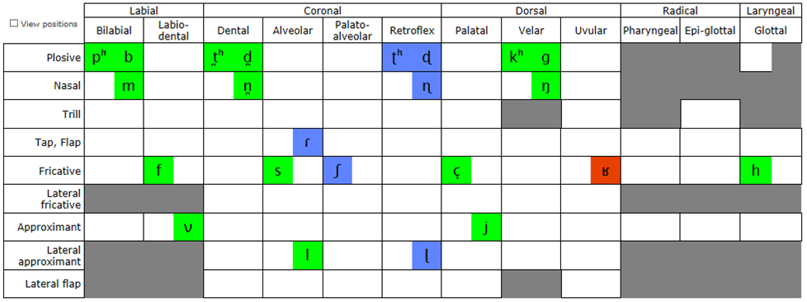

### Analysis

Sample SignPuddle signs to identify if some mouth symbols are already used informally for speech writing. People, institutions and geographic names may have some informal speech writing. Use the search feature with obvious mouth shapes to find other associated mouth symbols.



Perform a search by groups for the cheeks, mouth and tongue symbols.

<http://www.signbank.org/signpuddle/>

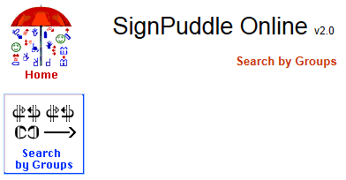

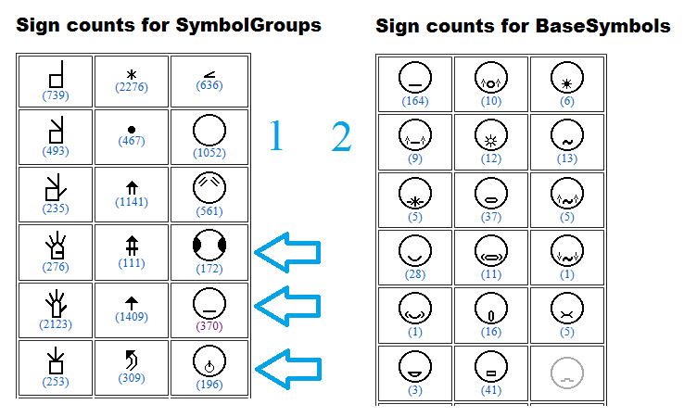

Compare the International Phonetic Alphabet chart for the target language and the language having a symbol set. In the example, we compare German with the target Norwegian language.

|  |  |
| --- | --- |
| German | Norwegian |
| 44 segments | 47 segments |
| [[pʰ](http://calst.hf.ntnu.no/l1-l2map/sounds/24/)] [[b](http://calst.hf.ntnu.no/l1-l2map/sounds/33/)] [[tʰ](http://calst.hf.ntnu.no/l1-l2map/sounds/79/)] [[d](http://calst.hf.ntnu.no/l1-l2map/sounds/85/)] [[kʰ](http://calst.hf.ntnu.no/l1-l2map/sounds/128/)] [[ɡ](http://calst.hf.ntnu.no/l1-l2map/sounds/135/)] [[s](http://calst.hf.ntnu.no/l1-l2map/sounds/266/)] [[z](http://calst.hf.ntnu.no/l1-l2map/sounds/267/)] [[ʃ](http://calst.hf.ntnu.no/l1-l2map/sounds/278/)] [[ʒ](http://calst.hf.ntnu.no/l1-l2map/sounds/280/)] [[f](http://calst.hf.ntnu.no/l1-l2map/sounds/298/)] [[ʋ](http://calst.hf.ntnu.no/l1-l2map/sounds/585/)] [[x](http://calst.hf.ntnu.no/l1-l2map/sounds/319/)] [[ts](http://calst.hf.ntnu.no/l1-l2map/sounds/387/)] [[pf](http://calst.hf.ntnu.no/l1-l2map/sounds/421/)] [[ʁ](http://calst.hf.ntnu.no/l1-l2map/sounds/333/)] [[l](http://calst.hf.ntnu.no/l1-l2map/sounds/568/)] [[j](http://calst.hf.ntnu.no/l1-l2map/sounds/594/)] [[m](http://calst.hf.ntnu.no/l1-l2map/sounds/609/)] [[n](http://calst.hf.ntnu.no/l1-l2map/sounds/630/)] [[ŋ](http://calst.hf.ntnu.no/l1-l2map/sounds/649/)] [[ʏ](http://calst.hf.ntnu.no/l1-l2map/sounds/713/)] [[ɪ](http://calst.hf.ntnu.no/l1-l2map/sounds/715/)] [[yː](http://calst.hf.ntnu.no/l1-l2map/sounds/716/)] [[iː](http://calst.hf.ntnu.no/l1-l2map/sounds/720/)] [[ʊ](http://calst.hf.ntnu.no/l1-l2map/sounds/735/)] [[uː](http://calst.hf.ntnu.no/l1-l2map/sounds/740/)] [[øː](http://calst.hf.ntnu.no/l1-l2map/sounds/749/)] [[eː](http://calst.hf.ntnu.no/l1-l2map/sounds/753/)] [[oː](http://calst.hf.ntnu.no/l1-l2map/sounds/762/)] [[ə](http://calst.hf.ntnu.no/l1-l2map/sounds/781/)] [[œ](http://calst.hf.ntnu.no/l1-l2map/sounds/790/)] [[ɛː](http://calst.hf.ntnu.no/l1-l2map/sounds/792/)] [[ɛ](http://calst.hf.ntnu.no/l1-l2map/sounds/795/)] [[ɔ](http://calst.hf.ntnu.no/l1-l2map/sounds/803/)] [[ɐ](http://calst.hf.ntnu.no/l1-l2map/sounds/812/)] [[äː](http://calst.hf.ntnu.no/l1-l2map/sounds/816/)] [[ɔi](http://calst.hf.ntnu.no/l1-l2map/sounds/874/)] [[äi](http://calst.hf.ntnu.no/l1-l2map/sounds/887/)] [[äu](http://calst.hf.ntnu.no/l1-l2map/sounds/892/)] [[h](http://calst.hf.ntnu.no/l1-l2map/sounds/920/)] [[tʃ](http://calst.hf.ntnu.no/l1-l2map/sounds/406/)] [[ä](http://calst.hf.ntnu.no/l1-l2map/sounds/819/)] [[ç](http://calst.hf.ntnu.no/l1-l2map/sounds/311/)] | [[pʰ](http://calst.hf.ntnu.no/l1-l2map/sounds/24/)] [[b](http://calst.hf.ntnu.no/l1-l2map/sounds/33/)] [[t̪ʰ](http://calst.hf.ntnu.no/l1-l2map/sounds/43/)] [[d̪](http://calst.hf.ntnu.no/l1-l2map/sounds/49/)] [[ʈʰ](http://calst.hf.ntnu.no/l1-l2map/sounds/96/)] [[ɖ](http://calst.hf.ntnu.no/l1-l2map/sounds/101/)] [[kʰ](http://calst.hf.ntnu.no/l1-l2map/sounds/128/)] [[s](http://calst.hf.ntnu.no/l1-l2map/sounds/266/)] [[ʃ](http://calst.hf.ntnu.no/l1-l2map/sounds/278/)] [[f](http://calst.hf.ntnu.no/l1-l2map/sounds/298/)] [[ɡ](http://calst.hf.ntnu.no/l1-l2map/sounds/135/)] [[ç](http://calst.hf.ntnu.no/l1-l2map/sounds/311/)] [[ɾ](http://calst.hf.ntnu.no/l1-l2map/sounds/528/)] [[l](http://calst.hf.ntnu.no/l1-l2map/sounds/568/)] [[ɭ](http://calst.hf.ntnu.no/l1-l2map/sounds/572/)] [[ʋ](http://calst.hf.ntnu.no/l1-l2map/sounds/585/)] [[j](http://calst.hf.ntnu.no/l1-l2map/sounds/594/)] [[m](http://calst.hf.ntnu.no/l1-l2map/sounds/609/)] [[n̪](http://calst.hf.ntnu.no/l1-l2map/sounds/615/)] [[ɳ](http://calst.hf.ntnu.no/l1-l2map/sounds/635/)] [[ŋ](http://calst.hf.ntnu.no/l1-l2map/sounds/649/)] [[ʏ](http://calst.hf.ntnu.no/l1-l2map/sounds/713/)] [[ɪ](http://calst.hf.ntnu.no/l1-l2map/sounds/715/)] [[yː](http://calst.hf.ntnu.no/l1-l2map/sounds/716/)] [[iː](http://calst.hf.ntnu.no/l1-l2map/sounds/720/)] [[ʉː](http://calst.hf.ntnu.no/l1-l2map/sounds/726/)] [[ʉ](http://calst.hf.ntnu.no/l1-l2map/sounds/728/)] [[ʊ](http://calst.hf.ntnu.no/l1-l2map/sounds/735/)] [[uː](http://calst.hf.ntnu.no/l1-l2map/sounds/740/)] [[eː](http://calst.hf.ntnu.no/l1-l2map/sounds/753/)] [[ø̞ː](http://calst.hf.ntnu.no/l1-l2map/sounds/769/)] [[e̞](http://calst.hf.ntnu.no/l1-l2map/sounds/775/)] [[o̞ː](http://calst.hf.ntnu.no/l1-l2map/sounds/785/)] [[œ](http://calst.hf.ntnu.no/l1-l2map/sounds/790/)] [[æː](http://calst.hf.ntnu.no/l1-l2map/sounds/806/)] [[æ](http://calst.hf.ntnu.no/l1-l2map/sounds/807/)] [[ä](http://calst.hf.ntnu.no/l1-l2map/sounds/819/)] [[ɒ̝](http://calst.hf.ntnu.no/l1-l2map/sounds/820/)] [[ɑː](http://calst.hf.ntnu.no/l1-l2map/sounds/826/)] [[øy](http://calst.hf.ntnu.no/l1-l2map/sounds/852/)] [[ɔy](http://calst.hf.ntnu.no/l1-l2map/sounds/875/)] [[æʉ](http://calst.hf.ntnu.no/l1-l2map/sounds/883/)] [[äi](http://calst.hf.ntnu.no/l1-l2map/sounds/887/)] [[æi](http://calst.hf.ntnu.no/l1-l2map/sounds/888/)] [[h](http://calst.hf.ntnu.no/l1-l2map/sounds/920/)] [[ʉi](http://calst.hf.ntnu.no/l1-l2map/sounds/998/)] [[ui](http://calst.hf.ntnu.no/l1-l2map/sounds/905/)] |
| Moulton, W.G. 1962. The Sounds of English and German. University of Chicago Press, Chicago. Wangler, H.H. 1972. Physiologische Phonetik, eine Einfuhrung. N.G. Elwert Verlag, Marburg. | Vanvik, A. 1972. A phonetic-phonemic analysis of Standard Eastern Norwegian. Norwegian Journal of Linguistics 26: 119-64. |

In the example, we compare the consonants of German and the Norwegian target language. We see several phonemes in German in blue displayed in blue. Their SpeechWriting symbols are not used. Several phonemes in the target Norwegian language are red. The will need SpeechWriting symbols, possibly by the re-assignation of unused symbols. We see that there are few common phonemes in green; their SpeechWriting symbols are already defined.

Depending on the chosen dialect, the comparison may differ. Given that the dialects co-exist in the same country (and eventually in the same school); reusability of the symbol set is important to teach a second language.



Use this comparison to create a table containing:

* Each MouthWriting symbols.
* Each phonetic symbol in the languages having MouthWriting symbols.
* Each additional phonetic symbol of the target language.
* Simple words using each phonetic symbol.

Identify the phonemes that have a defined MouthWriting symbol. Identify the MouthWriting symbols that are not used in the target language. Identify the phonemes that have no defined MouthWriting symbol. Identify unused symbols. Identify unused symbols that could be modified for a phoneme in the target language. List the phonemes in the target language that need a new symbol.

Get complete descriptions of the phonemes needing a new symbol. A clear picture may help to build the symbol. Compare the phonemes needing a new symbol with pictures on the SpeechWriting web page. By clicking on the letters in the first column, more details are displayed with a picture.

<http://www.gebaerdenschrift.de/read/Mundbilder/uebersicht_mundbilder.htm#Übersicht Mundbilder>

Concert with a specialist before assuming that two phonemes are similar enough to share a symbol.

In the following example, we have a preliminary list based on work by Ingvild Roald. The first column distinguish the desired viseme categories based on *Kristoffersen, Kristian Emil; Simonsen, Hanne Gram & Sveen, Andreas (red):* **Språk, En grunnbok**. The second column provides examples of graphemes. The third column contains the phonemes.

The fourth and fifth column contains the symbols from Wöhrmann´s LipWriting and MouthWriting strictly applied.

We observe that several Norwegian phonemes do not have a LipWriting symbol. They need to be created. We also observe that in Norwegian, the visemes are grouped differently than in German. A reviewed table and new symbols will be required.

|  |  |  |  |  |
| --- | --- | --- | --- | --- |
| Ingvild Roald Suggested LipWriting Categories | Letter(s)  Eastern Norwegian (western Oslo areas) | Eastern  Phonemes Symbol Norwegian (western Oslo areas) | Wöhrmann´s LipWriting Symbols | Wöhrmann´s MouthWriting Symbols |
|  | A | a: |  |  |
| a | - | - |
|  | E | e: |  |  |
| ɛ |  |  |
|  | E, light  (schwa) | ə |  |  |
|  | I | i: |  |  |
| ɪ | - | - |
|  | O  Ø | u: |  |  |
| ʊ |  |  |
| ø: |  |  |
| oe | - | - |
|  | Y | y: |  |  |
| ʏ | - | - |
|  | U, Skj, Sj,  Sl, sk | ʉ: | - | - |
| ʉ | - | - |
| ʃ |  |  |
|  | Æ | æ: | - | - |
| æ | - | - |
|  | Å | o: |  |  |
| ɔ |  |  |
|  | B, P | b |  |  |
| p |  |  |
|  | F, V | f |  |  |
| v |  |  |
| ʋ | - | - |
|  | D, N, T, RN | d |  |  |
| n |  |  |
| t |  |  |
| ɳ | - | - |
|  | G, K, NG, R-throath | ɡ |  |  |
| k |  |  |
| ŋ |  |  |
|  | J | j |  |  |
|  | Kj, Tj | ç |  |  |
|  | L, R- tongue tip,  --rt, -rd-, -rl | l |  |  |
| ɭ | - | - |
| ʈ |  |  |
| ɖ | - | - |
| ɾ | - | - |
| r |  |  |
| ɽ | - | - |
|  | M | m |  |  |
|  | S | s |  |  |

Preliminary list based on work by Ingvild Roald, dr. philos, by Stephan Wöhrmann (his MundbildShrift as of 2012) and on the book

*Kristoffersen, Kristian Emil; Simonsen, Hanne Gram & Sveen, Andreas (red):*

**Språk, En grunnbok,** Oslo 2005 (Universitetsforlaget), ISBN 82-15-00760-0

# MouthWriting and LipWriting Symbol Components

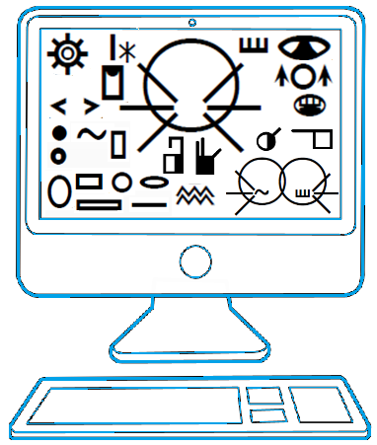

LipWriting and MouthWriting symbols set are used to teach one or two languages to Deaf children or adults. The expressiveness and the clarity of the symbols are important. Similar phonemes must be written in a similar way; different phonemes must look different. The Deaf student must write or read what is felt while speaking. If the symbol set is obvious, the student will refer to it naturally to simplify the learning process.

MouthWriting and LipWriting symbol charts may be present in the class room while speech or language is taught. If both charts are similar, it is easier to pass from one to the other. When inventing new symbols, both charts must be considered.

We analyse now the structure of the exising symbol charts in order to see how they can be used for new phonemes.

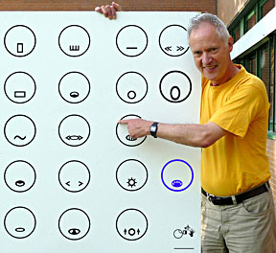

Stefan Wöhrmann and his LipWriting chart.

|  |
| --- |
| **Concert with Stefan Wöhrmann to create new symbols in order to develop a standard that will be reusable for other languages. Do not reassign existing MouthWriting symbols to other phonemes.** |

The International Phonetic Alphabet contains 90 pulmonic consonants and vowels. It also contains non-pulmonic consonants, diacritic, suprasegmentals and tones and other symbols. Often, a symbol is also required for longer sounds.The intent of this guide is not to create 90 symbols. A team of specialist may work on such project.

We present patterns on how the MouthWriting symbol set was developed to illustrate how new symbols may be created.

## Mouth Shapes

Several mouth shapes are available: circle, oval, rectangle, hexagonal, linear, tensed…

|  |  |  |  |  |  |
| --- | --- | --- | --- | --- | --- |
| Mouth Shapes | | | | | |
|  | [o:] |  | [ɔ] |  | [ə] |
|  | [u:] |  | [y:] |  |  |
|  | [ʌ] |  | [ɛ] |  | [e:] |
|  | [b] |  | [m] |  |  |

Mouth shapes may be embedded in others.

|  |  |  |  |
| --- | --- | --- | --- |
| Embedded Mouth Shapes | | | |
|  | [ʊ] |  | [y] |
|  | [ø:] |  | [ø] |

The lips may not be displayed.

|  |  |  |  |
| --- | --- | --- | --- |
| No lips | | | |
|  | [h] |  | [i] |

## Tongue and Teeth

Several representations of the tongue are available, they are influenced by the mouth shape and size.

|  |  |  |  |  |  |
| --- | --- | --- | --- | --- | --- |
| Tongue and Mouth Shapes | | | | | |
|  | [l] |  | [ŋ] |  | [θ] |
|  | [d] |  | [g] |  |  |

Teeth may be displayed

|  |  |  |  |  |  |
| --- | --- | --- | --- | --- | --- |
| Teeth | | | | | |
|  | [ð] |  | [v] |  | [z] |

## Movement, Contact and Nose SignWriting Symbols

MouthWriting symbols may contain SignWriting movement symbols, within or below the face. They may represent the tremling of the tongue, the throat or protruded lips.

|  |  |  |  |  |  |
| --- | --- | --- | --- | --- | --- |
| Movement Symbols | | | | | |
|  | [R] |  | [R] |  | [x] |
|  | [ʃ] |  | [ʒ] |  |  |

MouthWriting symbols may contain a SignWriting Nose symbol or a contact symbols to represent nasal phonemes or an invisible mouth positioning.

|  |  |  |  |  |  |
| --- | --- | --- | --- | --- | --- |
| Contact Symbols | | | | | |
|  | [n] |  | [ŋ] |  | [ts] |

## Short and Long Phonemes

There are several mechanisms to distinguish a phoneme from its elongated version. A symbol may be split, stretched, or contain more symbols. A phoneme existing only in an elongated version may not require a mechanism to distinguish it from a shorter version.

|  |  |  |  |
| --- | --- | --- | --- |
| Symbols | Phonemes | Symbols | Long Phonemes |
| Split symbols | | | |
|  | [ɛ] |  | [ɛ:] |
|  | [ɔ] |  | [ɔ:] |
|  | [ʌ] | - | - |
| - | - |  | [a:] |
| Stretched Symbols | | | |
|  | [ø] |  | [ø:] |
| Simplification | | | |
| - | - |  | [e:] |
| Disambiguation based on muscle action (wrinkles) | | | |
|  | [ə] | - | - |
|  | [i] |  | [i:] |
| - | - |  | [u:] |
|  | [ʊ] |  | - |
|  | [y] |  | [y:] |

To create a new symbol set, several situations may arise.

1. German has a symbol for a long phoneme but the target language needs a short and a long phoneme symbol.

Example:

1. We may consider that [e:] symbol is an elongated version of [e]. So the symbol in the target language for [e] would be shorter. This is the preferred analysis.
2. We may consider that German does not use [e], only [e:]. So a target language needing both lengths may consider that German is a simplification of the following two symbols. Germans would not benefit of the complexity of splitting the symbol. This analysis goes against the original symbol set in two languages to add a single symbol. It is not suggested.
3. We may create a symbol for [ʌ:] based on [ʌ]. The shape is elongated, it is simple to split it in half, so this is the suggested approach.

|  |  |  |  |  |  |  |
| --- | --- | --- | --- | --- | --- | --- |
|  | German  Symbol |  | Target Language  Symbol Specification | | | |
|  |  | [e:] |  | [e] |  | [e:] |
|  |  | [e:] |  | [e] |  | [e:] |
|  |  | [ʌ] |  | [ʌ] |  | [ʌ:] |

1. Similarly, when a phoneme has two symbols for German, the simplest symbol may be used for a target language that needs only one. That is easy for children but it goes against standardization. The opposite may be preferred; when a symbol exists, it is used. This would lead to a bigger standardized symbol set; it may be harder to make them all look different and simple.

|  |  |  |  |  |  |
| --- | --- | --- | --- | --- | --- |
| Symbol Simplification | | | | Target Language Symbol Simplification | |
|  | [i] |  | [i:] |  | [i:] |
|  | [y] |  | [y:] |  | [y] |

## SpeechWriting Breathing Symbol

MouthWriting uses a symbol set that differs from SignWriting. The inhale SignWriting symbol is used to represent exhaled phonemes. It is simpler to write for symbols that are already complex. The Breathing symbol is used to distinguish phonemes that share the same viseme. In the International Phonetic Alphabet consonant chart, they are often associated in the same category. In all cases, SpeechWriting associated the Breathing symbol to the phoneme that is most to the left in the chart. In the International Phonetic Alphabet, when two sound share the same description, the sound to the right is a voiced consonant.

|  |  |
| --- | --- |
| SignWriting | |
| Inhale | **Exhale** |
|  |  |
| MouthWriting  Breathing | |
|  | |

|  |  |  |  |
| --- | --- | --- | --- |
| Breathing Symbol in MouthWriting | | | |
|  | [ç] |  | [j] |
|  | [x] |  | [R] |
|  | [f] |  | [v] |
|  | [h] | - | - |
|  | [k] |  | [g] |
|  | [s] |  | [z] |
|  | [p] |  | [b] |
|  | [ʃ] |  | [ʒ] |
|  | [θ] |  | [ð] |
|  | [t] |  | [d] |

## Nasal consonants (Pulmonic)

We observe that two nasal consonants have a nose symbol. The phoneme [m] is a nasal consonant but it does not have a nose symbol.

|  |  |  |  |  |  |
| --- | --- | --- | --- | --- | --- |
| Nasal Consonants (Pulmonic) | | | | | |
|  | [n] |  | [ŋ] |  | [m] |

## Affrication

Some combined phonemes contain 2 mouth shapes symbols. They are so important to the language that they are in the symbol list. We show some examples even if they no longer are part of the official list.

|  |  |  |  |
| --- | --- | --- | --- |
| Affrication | | | |
|  | [dʒ] |  | [pf] |
|  | [tʃ] |  | [ks] |
|  | [ts] |  | [au] |
|  | [] |  | [] |

## Non-SignWriting Symbols

Several symbols above are adaptations of SignWriting. They are not part of SignWriting symbol set, they contain additional information. Some symbols as below are foreign to SignWriting and were created to express non visible aspects of speech.

|  |  |  |  |
| --- | --- | --- | --- |
| Symbols Creation | | | |
|  | [r] |  | [l] |

## Hand Shapes

Until recently, Wöhrmann SpeechWriting System also used hand shapes to express German phonemes. This approach may be used to develop an international MouthWriting system.

<http://www.gebaerdenschrift.de/read/Mundbilder/uebersicht_mundbilder.htm>

|  |  |  |  |  |  |
| --- | --- | --- | --- | --- | --- |
| Graphemes | MouthWriting Symbol | Words | Graphemes | MouthWriting Symbol | Words |
| C | http://www.gebaerdenschrift.de/images/SW%20symbols/dictionary/Artikulation/Mundbildschrift/k.gif | Cola | T | http://www.gebaerdenschrift.de/images/SW%20symbols/dictionary/Artikulation/Mundbildschrift/t.gif | Telefon |
| Ch | http://www.gebaerdenschrift.de/images/SW%20symbols/dictionary/Artikulation/Mundbildschrift/k.gif | Christus | X | http://www.gebaerdenschrift.de/images/SW%20symbols/dictionary/Artikulation/Mundbildschrift/x_ks.gif | Xylophon |
| D | http://www.gebaerdenschrift.de/images/SW%20symbols/dictionary/Artikulation/Mundbildschrift/d.gif | Dach | Y | http://www.gebaerdenschrift.de/images/SW%20symbols/dictionary/Artikulation/Mundbildschrift/ue_lang.gif | Dynamo |
| G | http://www.gebaerdenschrift.de/images/SW%20symbols/dictionary/Artikulation/Mundbildschrift/g.gif | Geld | Ö | http://www.gebaerdenschrift.de/images/SW%20symbols/dictionary/Artikulation/Mundbildschrift/oe_lang.gif | Öl |
| K | http://www.gebaerdenschrift.de/images/SW%20symbols/dictionary/Artikulation/Mundbildschrift/k.gif | Kirche | ö | http://www.gebaerdenschrift.de/images/SW%20symbols/dictionary/Artikulation/Mundbildschrift/oe_kurz.gif | öffnen |
| N | http://www.gebaerdenschrift.de/images/SW%20symbols/dictionary/Artikulation/Mundbildschrift/n.gif | Name | Ü | http://www.gebaerdenschrift.de/images/SW%20symbols/dictionary/Artikulation/Mundbildschrift/ue_lang.gif | Übung |
| Ng | http://www.gebaerdenschrift.de/images/SW%20symbols/dictionary/Artikulation/Mundbildschrift/ng_nk_lang_krank.gif | Wange | Qu | http://www.gebaerdenschrift.de/images/SW%20symbols/dictionary/Artikulation/Mundbildschrift/qu.gif | Quadrat |
| Ü | http://www.gebaerdenschrift.de/images/SW%20symbols/dictionary/Artikulation/Mundbildschrift/ue_kurz.gif | Mütze | st | http://www.gebaerdenschrift.de/images/SW%20symbols/dictionary/Artikulation/Mundbildschrift/sst_ast.gif | Ast |
|  |  |  | St | http://www.gebaerdenschrift.de/images/SW%20symbols/dictionary/Artikulation/Mundbildschrift/st_stunde.gif | Stern |

## Focus on Viseme Sets or on LipWriting Symbol Sets

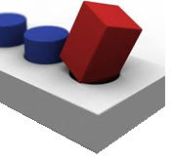

There is an International Phonetic Alphabet, but there is no International Visemes Alphabet. Therefore, researchers associate phonemes with visemes with varying results. This complicates the creation of LipWriting charts.

There are two possible approached when we want to define a LipWriting conversion table for a new language.

A) We may want to preserve the set of phonemes associated with each visemes from the research used to define the visemes for the target language. The resulting LipWriting chart cannot be standardized with other languages.

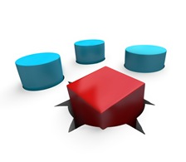

B) We may want to stay as close as possible to the LipWriting conversion tables already existing; even if they group phonemes differently. The resulting LipWriting chart will not match with some researches on the target language.

When this choice is made, the remaining unsupported new phonemes will follow the set to which they are the closest (example a goes with a: ).

Still, if the resulting system is clear and well defined, it can be used for a given language. The main constraint is to not change the set when it becomes a widely used standard.

## Example of French Symbol Set Creation

In the following example of French MouthWriting, we observe the following:

1. Some French phonetic symbols do not have an equivalent MouthWriting symbol because the sound is not present in German or English. They may already be defined for a longer or shorter pronunciation. See [a:].
2. Some MouthWriting symbols are not used in French because the phonemes are not part of the language. The symbols could be used for other phonemes. See [ʌ].
3. Some MouthWriting symbols are already defined and can be used for French. See [b].

|  |  |  |  |
| --- | --- | --- | --- |
| MouthWriting | Phoneme | French Word | Comments |
|  | [a:] |  | Needs a symbol for [a]  Papa |
|  | [ʌ] |  |  |
|  | [ɛ:] | Mère |  |
|  | [ɛ] | Fête |  |
|  | [b] | Bateau |  |
|  | [ç] |  | Unused phoneme and symbol |
|  | [x] |  | Unused phoneme and symbol |
|  | [d] | Ronde, Dalle |  |
|  | [dʒ] | Badge, jogging |  |
|  | [e:] |  | Needs a symbol for [e]  Bébé |
|  | [ə] | Le, Je |  |
|  | [f] | Fort, Physique, Fenêtre |  |
|  | [g] | Garder, Digue |  |
|  | [ʒ] | Je, Jouer |  |
|  | [h] |  | Unused phoneme and symbol |
|  | [i:] |  | Unused phoneme and symbol.  Needs a symbol for [I]  Bille, cirque, ville |
|  | [i] | Ami |  |
|  | [j] | Fille, Pied, Merveilleux, Yoga, Ail |  |
|  | [k] | Quatre, Qui, Coucou |  |
|  | [l] | Large |  |
|  | [m] | Maman |  |
|  | [n] | Nom, Numéro |  |
|  | [ŋ] |  | Unused phoneme and symbol.  Needs a symbol for [ɲ]  Campagne, gagner, agneau |
|  | [o:] |  | Unused phoneme and symbol.  Needs a symbol for [o]  Auto, bientôt, veau |
|  | [ɔ] | Mode, Poste |  |
|  | [ø:] | similar to  “eu” in  French  “peu”  say a long e  and purse your lips | Unused phoneme and symbol |
|  | [ø] | Aveu, Jeu, Bleu, Feu, Joyeux |  |
|  | [ɔ:] |  | Unused phoneme and symbol |
|  | [p] | Pomme |  |
|  | [pf] |  | Unused phoneme and symbol |
|  | [R] | Ronde |  |
|  | [r] | Terre |  |
|  | [z] | Zèbre, Chaise, Loisir |  |
|  | [s] | Assez, Sac |  |
|  | [ʃ] | Chat |  |
|  | [ð] |  | Unused phoneme and symbol |
|  | [θ] |  | Unused phoneme and symbol |
|  | [t] | Tourner |  |
|  | [tʃ] | Chips, Atchoum, Chum |  |
|  | [u:] |  | Unused phoneme and symbol.  Needs a symbol for [u]  Hibou, loup, vous |
|  | [ʊ] |  | Unused phoneme and symbol |
|  | [y:] | Muse | Unused phoneme and symbol |
|  | [y] | Musique, Musée, Flûte, Du |  |
|  | [v] | Vase, Voir, Laver |  |
|  | [ks] | Xylophone |  |
|  | [ts] |  | Unused phoneme and symbol |

|  |
| --- |
| New Symbols Needed for French Phonemes |

|  |  |  |  |  |  |
| --- | --- | --- | --- | --- | --- |
| [ɑ] | Âme, Passe | [U] | Soupe | [ẽ] | Pain, Faim |
| [ə] | Je, Le | [Y] | Sur, Tuque | [ʁ] | Ferme |
| [e] | Bébé | [ã] | Ambulance, Dent | [w] | Oui, Toi |
| [œ] | Beurre, Coeur, Seul | [ɔ̃] | Nombre, Son | [ɥ] | Lui, Muet, Nuage |
| [o] | Auto | [œ̃] | Un, Brun |  |  |

Equivalency table developed from German symbol set with the help of Hélène Lienard and additional French phonetic symbol list of Bull, Kathleen; Gauthier, Mélanie and St-Jacques, Sophie (2012) Le langage parlé complété. Cahier de formation de base. École St-Jude, Montréal, Canada. Page 14.

# LipWriting in Several Languages

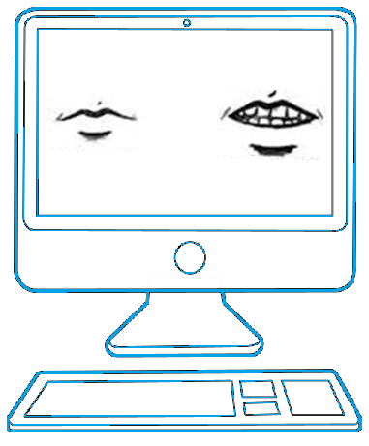

## Developing a Visemes List

The first step toward the elaboration of a LipWriting chart is to obtain a list of visemes for the target language. Depending on the researchers, a given language may have more or less visemes. Some visemes are harder to distinguish. They may be considered as equivalent or as different. Visemes readability may be affected by surrounding syllables.

For the Algerian Arabic visemes equivalencies, we used:

Special Issue of International Journal of Computer Applications (0975 – 8887)

on Software Engineering, Databases and Expert Systems – SEDEXS, September 2012

Visual Speech Analysis,Application to Arabic Phonemes

Fatma Zohra Chelali*,* Khadidja Sadeddine, Amar Djeradi. Speech communication and signal processing laboratory. Electronics and computer Science Faculty. Houari Boumedienne University of sciences and Technologies, Algiers, Algeria

<http://research.ijcaonline.org/sedex/number2/sedex1015.pdf>

According to this study, there are 11 visemes. The associated phonemes are grouped by visemes.

|  |  |  |
| --- | --- | --- |
| Latin Characters | Arabic Letters | Phonemes |
| 1. Ba | { م ,ب } | /b, m/ |
| 2. Cha | { ج ,ش } | / š , z/ |
| 3. dha | {ظ ,ذ ,ث } | / θ, δ, δ/ |
| 4. Ha | {ه , ح , غ , ع , أ , ق ,خ , ك } | /?, ς, γ, ħ, h, k, x, q/ |
| 5. Ta | {س , ت , ن , د , ي , ص , ج , ط , ز , ض } | /d, n, t, s, Z, ť, ʒ, ś, j, ď/ |
| 6. Fa | { ف} | /f/ |
| 7. La | { ل} | /l/ |
| 8. Ra | { ر} | /r/ |
| 9. wa | { و} | /w/ |
| 10. | ممالة ظمه | /u/ |
| 11. | ممالة كسرة | /i/ |

The source language is the combined chart for English and German MouthWriting and Lipwriting. The target language is Algerian Arabic in the following example.

We observe that:

* several phonemes exist in Algerian but do not exist in German or
* several phonemes exist in German but do not exist in Algerian,
* some phonemes are grouped differently.

In the following table, the first column represents the source languages (German and English LipWriting chart). The second column represents the target language (Algerian Arabic). Points represent phonemes elements. A circle represents a set, a viseme or LipWriting symbol. Several elements in a set represent phonemes sharing the same viseme.

|  |
| --- |
| Conversion Options And Examples |
| Source and Target Language Viseme Equivalencies    Same phonemes and same visemes. |
| * We observe that several Algerian phonemes can be associated to German phonemes; therefore, the corresponding LipWriting visemes symbols are simple. It is the case of: /i, l, u, f/. |
| Split Symbols in Target language    Split target language phoneme equivalency in two visemes.  Phonemes sharing the same viseme may keep different LipWriting symbols. |
| * In Algerian, /b, m/ are considered as the same viseme. In German, they are considered as distinct. We may choose to keep the distinction and we use two LipWriting symbols. * The visemes for /d, n, t, s, Z, ť, ś, j, ď/ are split in four German visemes /j/, /ʒ, ʃ /, /d, n, ŋ, t/ and /z, s, ks, ts/. We keep the four visemes, we do not merge them. |
| Target Language Viseme Generalisation    Phonemes sharing the same viseme also share the same LipWriting symbol. |
| * In Algerian, /θ, δ/ are considered as the same viseme. In German, only /θ/ is defined, so they share the same LipWriting symbol. * Phonemes /š, z/ are grouped in Algerian. In German, /š/ does not exist. Both /š, z/ share the symbol for /z/. |
| Promotion of a MouthWriting Symbol to a LipWriting Symbol (see below) |
| Exclusion of a Source Language Symbol    Source language phoneme equivalency split in two visemes.  Phonemes not sharing the same viseme may use different LipWriting symbols. |
| * In Algerian, /r/ must be a distinct phoneme. In German it is associated with /k, r, ɡ/. We could use the Mouthwriting symbol for /r/ as a LipWriting symbol. |
| Transfer of Set    A phoneme may change of viseme and of LipWriting symbols. |
| * German /s, z/ are associated, but in Algerian, the /s/ is associated with /d, n, t, s, Z, ť, ś, j, ď/. We keep this association in Algerian. * The Algerian viseme for / ς, γ, ħ, h, k, x, q/ does not exist in German, it is grouped differently: /k, r, ɡ/ and / x, ç /. We keep the viseme for / x/. |
| New Symbol or New Assignation Needed |
| * In Algerian, /w/ is distinct phoneme. In German it is not defined. We could use the Mouthwriting symbol for /u:/ which is close phonetically as a LipWriting symbol. |

|  |  |  |  |  |
| --- | --- | --- | --- | --- |
| SignWriting Symbols | SignWriting Symbol Names | Phonemes Equivalencies | Algerian  Phonemes Equivalencies | Algerian Symbol Names |
|  | Mouth Open Rectangle Yawn | ʌ  a: | - | - |
|  | Mouth Open Rectangle | ɛ  ɛ: | - | - |
|  | Mouth Open Oval | ə  e: | - | - |
|  | Mouth Open Oval Wrinkled | i  i: | i | ممالة كسرة فم |
|  | Mouth Open Circle | ø  ø:  o: | - | - |
|
|  | Mouth Open Wrinkled | u:  ʊ  y  y: | u | ممالة ظمه فم |
|  | Mouth Closed Neutral | m | m | م فم |
|  | Mouth Tense | b  p | b | ب فم |
|  | Teeth on Lips | f  v | f | ف فم |
|  | Tongue Tip Touches Inside Mouth | l | l | ل فم |
|  | Tongue Inside Mouth Relaxed (up) | d  n  ŋ  t | d  n  t  added:  ť  ď | ت, ن, د, ط, ض فم |
|  | Mouth Open Forward | ʒ  ʃ | ʒ | فم ج |
|  | Teeth | z  s  ks  ts | z,  s,  š (added) | س , ص , ز فم |
|  | Mouth Wrinkles Single | j | j | ي فم |
|  | Tongue Inside Mouth Relaxed (down) | k  r  ɡ | ?, ς, γ, ħ, h, k, q | {ه , ح , غ , ع , أ , ق , ك } فم |
| r | /r/ is a distinct viseme from /k,g/ in Algerian, this symbol cannot be used for /r/. |
|  | Mouth Wrinkles Double | x  ç | x | خ فم |
|  | Teeth on Tongue | th ð θ | θ, δ, δ | ظ, ذ, ث فم |
| Exception |  |  |  |  |
|  | MouthWriting symbol used as LipWriting | r | r | ر فم |
|  | MouthWriting symbol used as LipWriting | u: | w | و فم |

# Deciding the Layout of the Animation

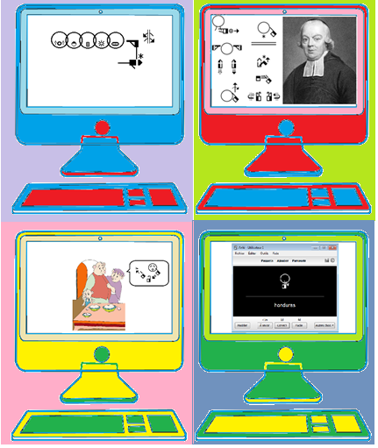

Several layouts of animation are possible. They may focus on either:

* 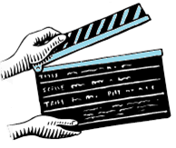LipWriting,
* MouthWriting,
* SignWriting with LipWriting,
* SignAnimating with LipAnimating,
* SignAnimating with MouthAnimating,
* Cued speech animating…

They may contain written subtitles for earing people or for educational purposes.

The message may be carried with animated gif image or in a video.

## Animated Gif Constraint and Advantages

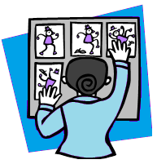Animated gif does not allow the reader to watch the message at her/his own pace without missing a part of the message. The animated gif loop is acceptable only for short messages. Because the animated image loops, the reader must wait for the next iteration to read missed symbols. There must be a frame separating the end of the animation from the next iteration.

It is sufficient for short messages. It is portable on all computers. The files are small. The files can be inserted in e-mails, PowerPoint presentations, web pages… The animation background may be transparent; they can be displayed in front of any background or illustration.

## Videos Constraints and Advantages

The files are bigger and may not be readable on computers which do not have the corresponding video viewer. To be shared, they must be accessed through internet with you tube or equivalent social media.

In a video, the reader can rewind the message, but it restarts at an arbitrary location and several symbols must be read before the missed sign is displayed.

## Dictionary Mode

A dictionary with animations may be easier to read for less experiences sign writers. It can be a simple alternative to existing dictionaries using videos.

|  |  |  |  |  |
| --- | --- | --- | --- | --- |
| Dictionary Mode (gif) | | | | |
| Unit size | Context | Frame speed | Reader’s attention | Search |
| Sign in SignWriting with SpeechWriting.  SignAnimating sequence of symbols. | Image.  Individual signs | Very fast. | When needed. | Cannot search.  Wait next loop. |
| The message structure is obvious for teaching material.  Animations are embedded in a PowerPoint presentation or an html page on an intranet, on internet and even on a CD-ROM. | | | | |

|  |  |  |
| --- | --- | --- |
| **Strauß** http://www.oiseaux.net/photos/loic.epelboin/images/autruche.d.afrique.loep.6g.jpg |  |  |

Ostrich (German prononciation, DGS SignWriting with SpeechWriting and SignAnimating first frames)

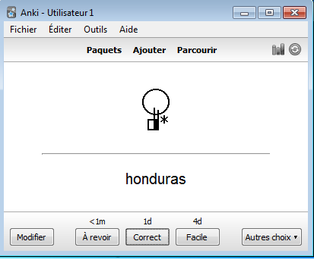

## Anki Electronic Flashcards Mode

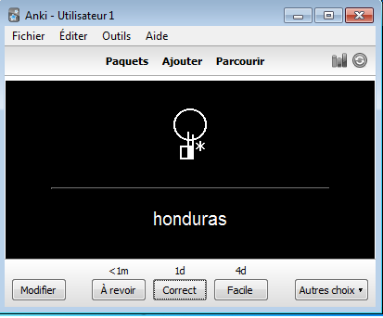In the example, we see a free SignWriting flashcard application developed with SignWriter StudioTM and Anki. With SignWriter StudioTM dictionary, everybody can export easily a selected subset of any SignWriting dictionary. Anki and Ankidroid display the words on a frequency based on the errors of the user. Anki and Ankidroid can display text and small MP4 videos. Anki can be used online, offline and even on Android cell phones. Anki interface is multi-lingual and it is often used to learn languages (for example Chinese).

<http://signwriterstudio.com/>

<http://ankisrs.net/>

<https://ankiweb.net/>

<https://play.google.com/store/apps/details?id=com.ichi2.anki&hl=fr>

|  |  |  |  |  |
| --- | --- | --- | --- | --- |
| Flashcards Mode (gif) | | | | |
| Unit size | Context | Frame speed | Reader’s attention | Search |
| Sign in SignWriting.  SignAnimating sequence of symbols. | Individual signs | Static.  Very fast. | When needed. | Cannot search.  Wait next loop. |
| The message structure is obvious for teaching material.  Anki can be used online, offline and even on Android cell phones. | | | | |

# Overview of SignAnimating and SpeechAnimating Modes

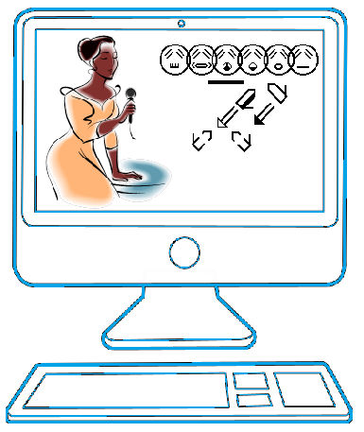

Willkommen (Welcome in DGS)

## SpeechWriting - Mundbilder in GebärdenSchrift

The SpeechWriting system was integrated it in animations by Stefan Wöhrmann. Several base frames are required for mouth configuration. A frame with a neutral mouth is required. The amount of visible syllables combined with the amount of hand configuration or displacement determines the minimal number of frames required. We assume that 4 syllables are pronounced per second and that some may not be readable on lips.

Articulation is superposed with SignWriting. Care must be taken to not overlap articulation with a neutral mouth, the eyes or the nose. Hand shapes close to the head should remain clearly displayed, if not in all frames, at least in some frame to be read.

For static SignWriting with articulation, the size of the frames will contain the largest amount of faces with mouth to carry the intended message.

We will use the German word and sign for Strauß (Ostrich in German) to compare the SpeechAnimating modes.

Officially, the sign is written as follow in Jacobsen, Birgit (2007) Das Gebardenbuch Das kleine 1x1 der Gebardensprache. Band 2. Hamburg, Germany. The SignWriting uses Stefan Wöhrmann’s SpeechWriting system representing the visemes (Mundbild) that can be read on lips.



The SignWriting is completed with a sequence of phoneme symbols (Mundbildschrift) matching a phonetic character.

|  |  |  |  |  |  |
| --- | --- | --- | --- | --- | --- |
|  | | | | | |
| ʃ | t | r | a | ʊ | s |

Depending on the purpose of the animation, several sub-sets of those symbols may be animated.

## SignWriting Mode

SignWriting Mode represents the sign in one frame. Several signs may be displayed one after the other, each in a single frame.

|  |  |  |  |  |  |
| --- | --- | --- | --- | --- | --- |
| SignWriting Mode (gif or video) | | | | | |
| Unit size | | Context | Frame speed | Reader’s attention | Search |
| Sign. | Sign.  Sentence. | | Fast. | Constant.  Can pause a video.  Cannot read forward and backward. | Wait next loop.  Hard to find beginning of a sign within a sentence. |
| Allows displaying a long text within a small surface. | | | | | |

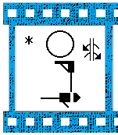

## SignAnimating Mode

SignAnimating Mode represents the sign in several frames. Several signs may be displayed one after the other, each in several frames.

|  |  |  |  |  |
| --- | --- | --- | --- | --- |
| SignAnimating Mode (gif or video) | | | | |
| Unit size | Context | Frame speed | Reader’s attention | Search |
| Symbols. | Sign. | Fast. | Constant.  Can pause. | Wait next loop.  Hard to find beginning of a sign within intermediary symbols |
| Can convey a message accurately with many details. Needs more frames than SignWriting. Need to create intermediary frames for animation purpose. Can be displayed with high frame rate depending on the reader’s expected speed; but with more frames. Takes longer to edit intermediary positions and hand shapes. Need to follow some SignAnimating standards for reusability and to accelerate the editing. SignWriting standards do not suffice. | | | | |

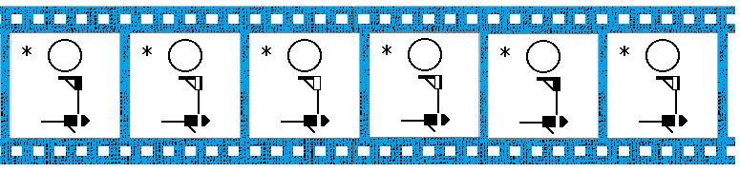

## SpeechWriting - Mundbilder in GebärdenSchrift Mode

SpeechWriting symbols - Mundbilder in GebärdenSchrift (articulatory movement writing) may be displayed in an animated gif image. The SpeechWriting is either horizontal or vertical. The faces are not centered. Horizontally; the reader’s eyes focus on the left edge of the animation and go toward the left for longer words. Vertically; the reader’s eyes focus on the top of the animation and go downward for longer words.

|  |  |  |  |  |
| --- | --- | --- | --- | --- |
| SpeechWriting - Mundbilder in GebärdenSchrift Mode (gif and video) | | | | |
| Unit size | Context | Frame speed | Reader’s attention | Search |
| Word. | Sentence. | Slow. | Constant.  Can pause. | Wait next loop for Gif.  Slow frames easy to browse but slow to view for videos. |
| The symbols are in a sentence context.  The message structure is not obvious for a Deaf reader unless the SpeechWriting is combined with SignWriting. It is a representation of lip reading and the associated difficulties to distinguish phonemes that share the same visemes. Some phonemes are not lip readable, they are not represented in SpeechWriting unless by longer previous phonemes. | | | | |

|  |  |
| --- | --- |
| Vertical SpeechWriting | Horizontal  SpeechWriting |
|  |  |
| Bonne journée (Good day in French) | |

## SpeechAnimating Mode

SpeechAnimating symbols may be displayed in an animated gif image. It may be used for short messages. The message structure is not obvious for a Deaf reader unless the SpeechAnimating is combined with SignAnimating. It is a representation of lip reading and the associated difficulties to distinguish phonemes that share the same visemes. Some phonemes are not lip readable, they are not represented in SpeechWriting - Mundbilder in GebärdenSchrift - unless by longer previous phonemes.

|  |  |  |  |  |
| --- | --- | --- | --- | --- |
| SpeechAnimating Mode (gif and video) | | | | |
| Unit size | Context | Frame speed | Reader’s attention | Search |
| Viseme. | Sentence. | Slow. | Constant.  Can pause. | Wait next loop for Gif.  Slow frames easy to browse but slow to view for videos. |
| The symbols are in a sentence context. | | | | |

In the example, to provide some structure, we introduced an Eyes Blink symbol with a Neutral Mouth symbol to represent the end of a word and a period to indicate an end of sentence.



Bonne (Good in French)

## Mundbildschrift Word Mode

The pronunciation of a word is displayed graphically. The written word can be displayed in subtitled to associate it to the pronunciation. The symbols may be displayed horizontally or vertically.

|  |  |  |  |  |
| --- | --- | --- | --- | --- |
| Mundbildschrift Word Mode (gif or video) | | | | |
| Unit size | Context | Frame speed | Reader’s attention | Search |
| Word | Sentence. | Slow. | Constant.  Can pause a video.  Cannot read forward and backward. | Wait next loop. |
| Allows displaying several words within a small surface. The reader could pronounce the sounds while they are displayed. | | | | |

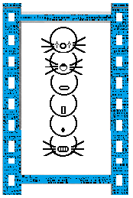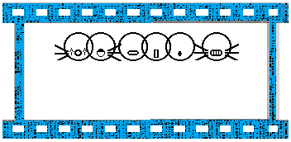

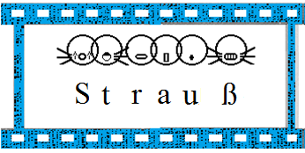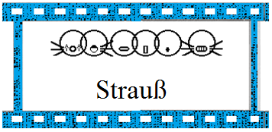

## Mundbildschrift Phoneme Mode

Mundbildschrift Phoneme Mode represents phonemes in several frames. It can be used to teach speech. It may contain text or phonetic subtitles.

|  |  |  |  |  |
| --- | --- | --- | --- | --- |
| Mundbildschrift Phoneme Mode (gif or video) | | | | |
| Unit size | Context | Frame speed | Reader’s attention | Search |
| Phoneme | Word. | Fast. | Constant.  Can pause a video.  Cannot read forward and backward. | Wait next loop.  Hard to find beginning of a word within phonemes symbols. |
| Allows displaying several words within a small surface. The reader could pronounce the sounds while they are displayed. | | | | |





## Mundbildschrift with SignAnimating Mode

Mundbildschrift with SignAnimating Mode represents each phoneme in several frames with the sign. The reader could pronounce the sounds while they are displayed. It is the most complete way to express a sign with articulation through an animation.

|  |  |  |  |  |
| --- | --- | --- | --- | --- |
| Mundbildschrift with SignAnimating Mode (gif or video) | | | | |
| Unit size | Context | Frame speed | Reader’s attention | Search |
| Phoneme | Word.  Sign. | Fast. | Constant.  Can pause a video.  Cannot read forward and backward. | Wait next loop.  Hard to find beginning of a word within phonemes symbols and intermediary movements of the sign. |
| Allows displaying several words within a small surface. | | | | |



## SpeechWriting - Mundbilder with SignWriting Mode

SpeechWriting - Mundbilder and SignWriting is a concise combination of the visemes with the signs. It resumes in a single image all what the Deaf person sees during the communication of a sign with articulation.

|  |  |  |  |  |
| --- | --- | --- | --- | --- |
| SpeechWriting with SignWriting Mode (gif or video) | | | | |
| Unit size | Context | Frame speed | Reader’s attention | Search |
| Word.  Sign. | Sentence | Slow. | Constant.  Can pause a video.  Cannot read forward and backward. | Wait next loop.  Can search a sign within a sentence |
| Allows displaying several words within a small surface. | | | | |

### SpeechAnimating with SignAnimating Mode

SpeechAnimating and SignAnimating is a combination of the visemes with the signs. It represents dynamically and precisely what the Deaf person sees during the communication of a sign.

|  |  |  |  |  |
| --- | --- | --- | --- | --- |
| SpeechAnimating with SignAnimating Mode (gif or video) | | | | |
| Unit size | Context | Frame speed | Reader’s attention | Search |
| Phoneme.  SignWriting symbols. | Word.  Sign. | Fast. | Constant.  Can pause a video.  Cannot read forward and backward. | Wait next loop.  Hard to find beginning of a word within visemes symbols and intermediary movements of the sign. |
| Allows displaying several words within a small surface. | | | | |



# Cued Speech with SpeechAnimating Mode

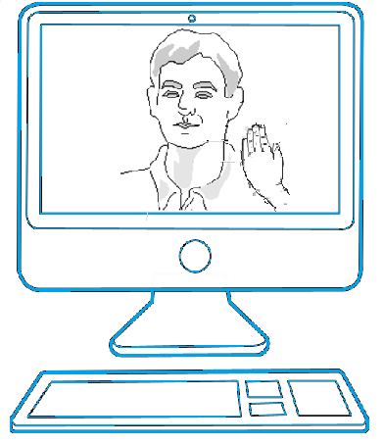

We present the basics of cued speech in order to illustrate how it can be animated. Cued speech was invented by the Dr. Orin Cornett in the United States in 1966. Speech has many phonemes that look the same by lip reading. Several phonemes are not visible by lip reading. Cued speech combines the visemes information with hand configurations and position. This allows distinguishing each phoneme.

It is a syllabic system where:

* Oral syllables are displayed by the movement of the lips and the tongue,
* The oral consonants and half-consonants are distinguished by hand configuration,
* The oral vowels are distinguished by the hand positions relatively to the face.

Cued speech differs from sign language. It is not a language. It is a system of codes used to teach speech and written language. Students reading cued speech may not code cued speech themselves. These students may be accustomed to cued speech only from the receptive view point. Cued speech is performed alternating between the dominant and the non-dominant hand. The codes are often performed with the non-dominant hand while the teacher uses the dominant hand to write on a blackboard or while the parent performs domestic tasks.

In the reminder of this text, we will use the term cued speech to refer the French variant. The French version is called Language Parlé Complété (LPC). For actual cued English, refer to the bibliography.

|  |
| --- |
| LipWriting is Required to Animate Cued Speech |
| Cued speech hand configurations and position relatively to the face do not suffice to represent the phonemes. The viseme is required.  Wöhrmann’s LipWriting system (Mundbilder) expresses clearly the mouth configuration and SignWriting expresses clearly hand shapes and localisation. We combine both notations to animate cued speech. |

## Cued Speech in Receptive View Point

LPC teaching material displays the non-dominant left hand from a receptive view point. Therefore, it is worth considering that cued speech may be written with the receptive point of view with the left hand. We will adopt this convention. The receptive view point presents the benefit of having only dark hand shapes which have a good contrast on most background including the face circle. An animation mixing sign language and cued speech would have to use only the expressive view point which is the standard.

|  |  |
| --- | --- |
| Cued speech from the expressive view point with the dominant right hand. | Cued speech from the receptive view point with the non-dominant left hand. |
|  |  |
|  |  |

## Cued Speech Syllables

In cued speech, sentences are split in pairs of consonant-vowel. Phonemes are linked together like in speech. To code a simple pair of sounds (consonant + vowel), the consonant hand configuration is moved toward the face region corresponding to the vowel. The pair of consonant-vowel is spoken simultaneously with the hand position. In SpeechAnimating, one hand shape is superposed to one face region symbol with one or two SpeechWriting symbols associated to the viseme.

|  |  |
| --- | --- |
| Viens voir | V/iens/ v/oi/r |

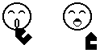When the vowel is not preceded by a consonant, the opened hand is placed is moved toward the face region corresponding to the vowel. In SpeechAnimating, the face region symbol is not displayed. The hand shape is at 45o when it is in contact with the face or the throat. The hand shape is vertical when it is beside the head.

In French, when the ending syllable of a word and the first syllable of the next word are linked during the pronunciation, they are also linked in cued speech. This corresponds to the lip reading a Deaf person would do. Similarly in SpeechAnimating, words are connected when applicable.

When the same cued speech symbol is repeated for two pairs of consonant-vowel, a small movement forward of the hand distinguishes the first from the second pair of consonant-vowel. It is a subtle movement. The lips distinguish the two pairs of consonant-vowel. The small movement is sometimes used when the hand shape changes but the hand position remains the same. Such movement does not occur during the pair of consonant-vowel. The hand does not move between the consonant and the vowel within a pair of sounds.

Cued speech coding varies according to individual and regional accents. This corresponds to the lip reading a Deaf person would do. It is suggested for SpeechAnimating to follow dictionary phonetic transcriptions to ease animations reusability.

In cued speech animation, the eyes are represented. They are not necessary but they will look more natural and will provide an additional hint for keys close to the eye. It also leads to using a neutral face with closed eyes for pauses.

SignAnimating and SpeechAnimating can be represented simultaneously in the same frame. It is similar to a regular conversation between Deaf people. Sign language and cued speech cannot be represented simultaneously in the same frame because one hand is continuously used for codes.

|  |  |  |  |
| --- | --- | --- | --- |
| Hand positions to code vowels  Language Parlé Complété LPC  (French Cued Speech) | SignWriting Positions | French Vowels | Cued Speech  Code |
|  |  | in - eu | p  pommette  (cheekbone) |
|  | [a] – [o] - e | c  côté  (side) |
|  | i – on - an | b  bouche  (mouth) |
|  | ou – è – [ɔ] | m  menton  (chin) |
|  | un – é – u - [ɑ] | g  gorge  (throat) |
| We can write the hand shapes horizontally for the mouth, this helps distinguishing between chin and cheekbone position when the symbols are small. Note that when using cued speech the hand remains almost vertical, aligned with the arm to avoid articulation injuries. | | | |

|  |
| --- |
| Choice of Hand Shapes |
| We used close fists symbols because they already exist in the symbol bank. Circle hand shapes are also valid but only 2 are in the symbol bank. From the receptive point of view, they look the same in cued speech. |
| The symbol 3 for s – r is created according to symbol creation rules. One existing SignWriting symbol has spread fingers which is not the case for French cued speech.  We use  and as a simplification of the existing SignWriting symbols: |

|  |  |  |  |
| --- | --- | --- | --- |
| Finger keys to code consonants  Language Parlé Complété LPC  (French Cued Speech) | SignWriting handshapes | French consonants | Cued Speech  Code |
|  |  | p – d – j (/ʒ/)  pied, **d**os, **j**oue, **g**enou | 1 |
|  |  | k – v –z  **c**ou, **v**entre, **z**èbre | 2 |
|  |  | s – r (and English r)  **s**ang, **r**ein, **r**eggae | 3 |
|  |  | b – n - / ɥ/  **b**ras, **n**ez, c**u**ir | 4 |
|  |  | m – t- f  and each vowel not preceded by a consonant  **m**ain, **t**ête, **f**ront | 5 |
|  |  | l - ch – gn – /w/  **l**obe, **ch**air, ga**gn**er, t**oi** | 6 |
|  |  | g – dj (/dʒ/)  **g**orge, **J**oe | 7 |
|  |  | y (/j/) – tch  oe**il**, **ch**ips | 8 |

Cued speech has abbreviations for the hand keys and position to use. They write the consonant key code (from 1 to 8) followed by the vowel position code (p, c, b, m, g).

|  |  |  |
| --- | --- | --- |
| Viens voir | V/iens/ v/oi/r | 2c 8p 2c 6g 3c |

Vowels, when not preceded by a consonant, are represented as follows:

|  |  |  |  |  |
| --- | --- | --- | --- | --- |
| in – eu | [a] – [o] – e | i – on – an | ou – è – [ɔ] | un – é – u - [ɑ] |
|  |  |  |  |  |
| p | c | b | m | g |
|  |  |  |  |  |

Consonants, when not followed by a vowel, are represented as follows:

|  |  |  |  |
| --- | --- | --- | --- |
| p – d – j (/ʒ/) | k – v –z | s – r | b – n - / ɥ/ |
|  |  |  |  |
| 1 | 2 | 3 | 4 |
|  |  |  |  |
| m – t- f | **l - ch – gn – /w/** | **g – dj (/dʒ/)** | **y (/j/) – tch** |
|  |  |  |  |
| 5 | 6 | 7 | 8 |
|  |  |  |  |

Pairs of consonant-vowel are represented as follows. The longest fingertip touches the face location. The contact symbol is not necessary for cued speech animation because a contact is always implied. It is better if the close fist symbol is not placed exactly at the same distance from the face. The small movement indicated a change of key and it is also used for cued speech.

We can write the hand shapes horizontally for the mouth, this helps distinguishing between chin and cheekbone position when the symbols are small. Note that when using cued speech the hand remains almost vertical, aligned with the arm to avoid articulation injuries.

|  |  |  |  |  |  |
| --- | --- | --- | --- | --- | --- |
|  | in – eu | [a] – [o] – e | i – on – an | ou – è – [ɔ] | un – é –  u - [ɑ] |
|  | p | c | b | m | g |
| p – d – j (/ʒ/)    1 | 1p | 1c | 1b | 1m | 1g |
| k – v –z    2 | 2p | 2c | 2b | 2m | 2g |
| s – r    3 | 3p | 3c | 3b | 3m | 3g |
| b – n - / ɥ/    4 | 4p | 4c | 4b | 4m | 4g |
| m – t- f    5 | 5p | 5c | 5b | 5m | 5g |
| l - ch –  gn – /w/    6 | 6p | 6c | 6b | 6m | 6g |
| g – dj (/dʒ/)    7 | 7p | 7c | 7b | 7m | 7g |
| y (/j/) – tch    8 | 8p | 8c | 8b | 8m | 8g |



In the following combination, the hand is vertical because both finger tips touch the chin.

|  |  |  |  |  |
| --- | --- | --- | --- | --- |
| Cued Speech with SpeechAnimating (gif or video) | | | | |
| Unit size | Context | Frame speed | Reader’s attention | Search |
| Phoneme. | Syllable. | Very fast | Constant | Wait next loop.  Hard to find beginning of a word within intermediary syllables. |
| Cued speech completes lip reading to distinguish phonemes. | | | | |

In the example, to provide some structure, we introduced an Eyes Blink symbol with a Neutral Mouth symbol to represent the end of a word and a period to indicate an end of sentence.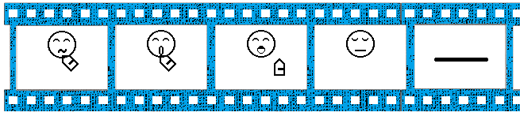Bonne en LPC (Good with cued speech in French)

|  |  |  |  |  |
| --- | --- | --- | --- | --- |
| Construction of a Cued Speech Animation | | | | |
| French | Bonne  (good) | | | Pause or link to next word first syllable |
| LipWriting |  |  |  | - |
| Phoneme | B | [ɔ] | n | none |
| Cued speech keys |  | |  | pause |
| Cued speech codes | 4m | | 4c | none |
| Cued speech animation |  |  |  |  |

|  |  |  |  |  |  |
| --- | --- | --- | --- | --- | --- |
| Construction of a Cued Speech Animation | | | | | |
| French | Journée  (day) | | | | |
| LipWriting |  |  |  |  |  |
| Phoneme | ʒ | u | R | n | e |
| Cued speech keys |  | |  |  | |
| Cued speech codes | 1m | | 3c | 4g | |
| Cued speech animation |  |  |  |  |  |

# Kinemes and Visemes

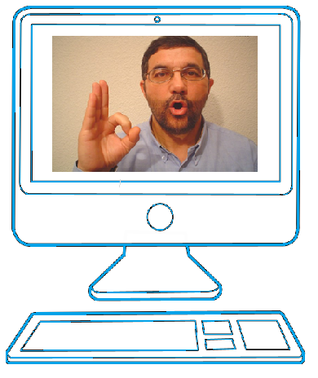

Kineme by Oscar Huamaní C.

In previous chapters, we saw how LipWriting can be combined with cued speech to create animations. We explore in this chapter how LipWriting can be associated with kinemes represented by a hand shape. The following system was developed in Peru. It is used to teach speech like MouthWriting but visually like cued speech, not in a written form. Students familiar with this approach could benefit from animations and from the symbols developed for MouthWriting and SignWriting.

The following presentation is an adaptation from the work of Oscar Huamaní C. Psychologist, specialized in speech therapy in Peru.

*"****Supporting material for the correction of phonetic-phonological disorders and demutization***

*The kinemes presented in this material were proposed by Borregón Sanz (2005) and are designed to promote the memorization of the phonemes.*

*Concepts:*

***Viseme:*** *It is the visual image of the articulation (posture of the articulators during emission of phoneme), ie how the articulation of the phoneme is displayed.*

***Kineme (movement)****: It refers to gestural, motor, meaningful and symbolic realization associated with the articulation. The visemes and kinemes complement, there is a kineme for each articulation. When articulations are equal or similar, for example: bilabial, "m", "b" and "p" that have the same place of articulation, the kinemes allows us to differentiate them."*

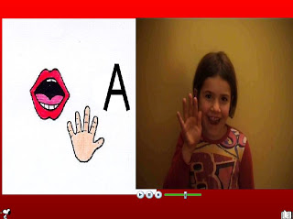“*I want to* *share with you* *the "*gestural *74c.apoyos*" A *very useful tool* *for corrective* *approach to the* *phonetic-*phonological disorder. *The program contains* *24* *kinemes* *(gestures* *of support* *to phonemes*), *of which 5* *correspond to* *the vowel* *phonemes* *and 19* *consonant phonemes*. *Each of these* *gestures* *accompanies a* *video* *where you can see* *the* *application.*  
*The use of this* *program has no* *age limit*, since *learning* *of gestures* *is simple and* *is achieved* *through* *fun and games*. *The use of* *this type of exercise* *is very* *positive* *at school,* *even at* *age three.* *Nor* *has limits* *their use* *in most* *of the pathologies* *of language,* *since it is always* *fruitful* *to use* *the maximum possible* *sensory pathways*, thereby increasing *opportunities for access* *to the phoneme*. *Moreover* *the* *"*gestural *support*" *may be used* *either individually*, *collectively* *well*, depending on *the requirements of each* *case.* *It also allows* *work with a* *particular* *phoneme*, *in isolation*, *or* *gradually and* *in management* *as deemed* *appropriate.*

*The program allows us to work:  
• Activities of differentiation and auditory and visual recognition of phonemes, first in isolation and then in words and phrases.  
• Activities of auditory memory, increasing the retention rate with gestural-visual and sensorimotor gestures support.  
• Activities motor memory, imitation movements representing phonemes and / or graphemes.  
• phonemic awareness activities, which help to more accurately perceive the sounds of spoken language.  
• Activities of phonological contrasts for the correct integration of phonemes.  
• Activities of temporal sequencing and pace memorizing and reproducing sequences of sounds and / or gestures.  
• Activities that allow reflection on speech, leading to the natural and progressive association of phonemes.”*

Translation of original text in Spanish written by Oscar Huamaní C. Psychologist, specialized in speech therapy.

Refer to:

<http://logopediaperu.blogspot.ca/search/label/material%20de%20apoyo>

For more details refer to:

* Santos Borregón Sanz (2010) Los trastornos de la articulación. Volume 26 de Colección Lenguaje y Comunicación. Volume 26 de Lenguaje y comunicación. Ciencias de la Educación Preescolar y Especial. ISBN: 8478697616, 9788478697618. 96 pages.

and Oscar Huamaní C. web site from which the following table is based:

* <http://logopediaperu.blogspot.ca/2009/11/visemas-y-kinemas.html>

We use the receptive viewpoint because the keys are used for teaching purpose, not as a language. Simplified symbols are used as the user may not know SignWriting. We represent the back of the hand instead of its side when both are used to point to the throat to have a smaller symbol set. We do not represent the contact region with nose or neck symbols. We do not use the curlicue hand shape because the circular hand shape is accurate enough to indicate that the thumb and the index form a circle.

|  |
| --- |
| LipWriting is Required to Animate Symbols |
| Hand configurations and position relatively to the face do not suffice to represent the phonemes. The viseme is required.  Wöhrmann’s LipWriting system (Mundbilder) expresses clearly the mouth configuration and SignWriting expresses clearly hand shapes and localisation. We combine both notations to animate. |

|  |  |  |
| --- | --- | --- |
|  | Index pointing to the larynx (feature: loudness) | |
|  | d | b |
| Visemes | D:\Oscar Huamani\Mis documentos\EAR-todas las fotos\Kinema D.jpg |  |
| Precise symbols |  |  |
| Simple symbols |  |  |

|  |  |  |
| --- | --- | --- |
|  | Index pointing to the nose (feature: nasality) | Circle |
|  | m | o |
| Visemes |  |  |
| Precise symbols |  |  |
| Simple symbols |  |  |

|  |  |  |  |
| --- | --- | --- | --- |
| Exceptions | | | |
|  | r and rr | ch  [ʃ] | x  [ks] |
| Visemes |  |  |  |
| Precise symbols | The sounds “r” and “rr” are not the same as in LipWriting:    They come from the tip of the tongue.  In MouthWriting: | The viseme for “ch” is obviously not circular, unlike the LipWriting symbol. This illustrates how phonemes influence each other when they are pronounced one after the other. “chi” will be more stretched than “chu” which is has more protruded lips.    The Mouthwriting symbol is valid and is kept without change until the symbol set explicits interactions between phonemes. | Both phonemes are combined in a single code representing LipWriting of “k” and the horizontal hand of “s”.  **+****=** |
| Simple symbols |  |  |  |

|  |  |  |  |  |
| --- | --- | --- | --- | --- |
| Visemes | Hand Shapes and Position Differentiating Kinemes | Grapheme  and phoneme | Symbol | Description |
|  |  | p |  | Cheeks slightly inflated (feature: bilabial) |
|  |  | m |  | Index pointing to the nose (feature: nasality) |
|  |  | b |  | Index pointing to the larynx (feature: loudness) |
|  |  | f |  | Bite the lower lip (feature: labiodental) |
| D:\Oscar Huamani\Mis documentos\EAR-todas las fotos\Fonema D.jpg | D:\Oscar Huamani\Mis documentos\EAR-todas las fotos\Kinema D.jpg | d |  | Index pointing to the larynx (feature: loudness) |
|  |  | t |  | With extended fingers together hand like in “stop” (feature: occlusive) |
|  |  | l |  | Alveolar visible tongue position (feature: alveolar) |
|  |  | n |  | Index pointing to the nose (feature: nasality) |
|  |  | s |  | Hand position and movement are horizontal (feature: frication) |
|  |  | “r” |  | With hand like in "stop" bend the wrist once (feature: Simple vibration) |
|  |  | “rr” |  | With hand like in "stop" flexing the wrist repeatedly (feature: multiple vibration) |
|  |  | ñ  [ɲ] |  | Thumb under the mandible and index contact with the nose (feature: submandibular tension and nasality) |
|  |  | ch  [ʃ] |  | Thumb under mandible (feature: submandibular tension) |
|  |  | y  [j] |  | Index pointing to the larynx (feature: loudness) |
|  |  | g |  | Index pointing to the larynx (feature: loudness) |
|  |  | x  [ks] |  | Hand position and movement are horizontal (feature: frication) |
|  |  | k |  | With extended fingers together like in "stop" (feature: occlusive) |
|  |  | “a” |  | Hand vertical and a right angle between the thumb and the other fingers (feature: open unrounded) |
|  |  | e  [e] |  | Position "a" take the form of "⊃" (feature: unrounded average) |
|  |  | “i”  [i] |  | Position "e" even more closed (feature: rounded not closed) |
|  |  | o |  | Form a circle with thumb and index finger (feature: rounded medium) |
|  |  | u  [U] |  | Reduced circle of position "o" (feature: rounded closed) |

Tabular form of Oscar Huamaní C. video expressed in LipWriting and SignWriting symbols.

Kineme “r” is written as 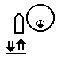and animated as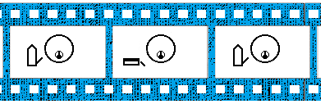

Kineme “rr” is written as 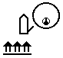 and animated as 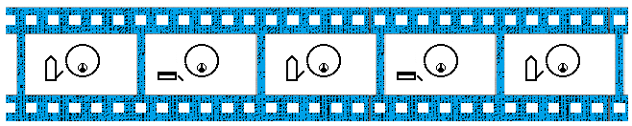

|  |  |  |  |
| --- | --- | --- | --- |
| Kinemes | | | |
| G | R | A | C |
|  |  |  |  |
| I | A | S |  |
|  |  |  |  |

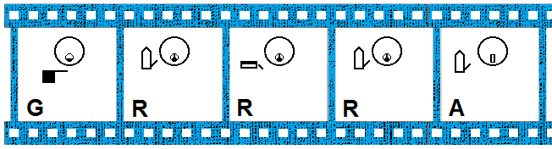

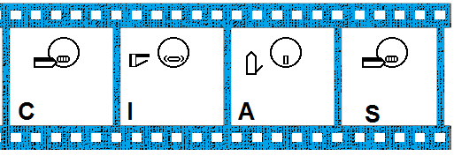

Gracias (Thanks in Spanish)

## Wöhrmann SpeechWriting System With Hand Codes

In the past, Wöhrmann SpeechWriting System also used hand shapes to express phonemes.

<http://www.gebaerdenschrift.de/read/Mundbilder/uebersicht_mundbilder.htm>

|  |  |  |
| --- | --- | --- |
| Graphemes | MouthWriting Symbol | German Words |
| C | http://www.gebaerdenschrift.de/images/SW%20symbols/dictionary/Artikulation/Mundbildschrift/k.gif | Cola |
| Ch | http://www.gebaerdenschrift.de/images/SW%20symbols/dictionary/Artikulation/Mundbildschrift/k.gif | Christus |
| D | http://www.gebaerdenschrift.de/images/SW%20symbols/dictionary/Artikulation/Mundbildschrift/d.gif | Dach |
| G | http://www.gebaerdenschrift.de/images/SW%20symbols/dictionary/Artikulation/Mundbildschrift/g.gif | Geld |
| K | http://www.gebaerdenschrift.de/images/SW%20symbols/dictionary/Artikulation/Mundbildschrift/k.gif | Kirche |
| N | http://www.gebaerdenschrift.de/images/SW%20symbols/dictionary/Artikulation/Mundbildschrift/n.gif | Name |
| Ng | http://www.gebaerdenschrift.de/images/SW%20symbols/dictionary/Artikulation/Mundbildschrift/ng_nk_lang_krank.gif | Wange |
| Qu | http://www.gebaerdenschrift.de/images/SW%20symbols/dictionary/Artikulation/Mundbildschrift/qu.gif | Quadrat |
| T | http://www.gebaerdenschrift.de/images/SW%20symbols/dictionary/Artikulation/Mundbildschrift/t.gif | Telefon |
| X | http://www.gebaerdenschrift.de/images/SW%20symbols/dictionary/Artikulation/Mundbildschrift/x_ks.gif | Xylophon |
| Y | http://www.gebaerdenschrift.de/images/SW%20symbols/dictionary/Artikulation/Mundbildschrift/ue_lang.gif | Dynamo |
| Ö | http://www.gebaerdenschrift.de/images/SW%20symbols/dictionary/Artikulation/Mundbildschrift/oe_lang.gif | Öl |
| ö | http://www.gebaerdenschrift.de/images/SW%20symbols/dictionary/Artikulation/Mundbildschrift/oe_kurz.gif | öffnen |
| Ü | http://www.gebaerdenschrift.de/images/SW%20symbols/dictionary/Artikulation/Mundbildschrift/ue_lang.gif | Übung |
| Ü | http://www.gebaerdenschrift.de/images/SW%20symbols/dictionary/Artikulation/Mundbildschrift/ue_kurz.gif | Mütze |
| st | http://www.gebaerdenschrift.de/images/SW%20symbols/dictionary/Artikulation/Mundbildschrift/sst_ast.gif | Ast |
| St | http://www.gebaerdenschrift.de/images/SW%20symbols/dictionary/Artikulation/Mundbildschrift/st_stunde.gif | Stern |

# Conclusion

We conclude that Wöhrmann SpeechWriting System can be used to express several spoken languages. As new MouthWriting symbols are created, new languages will be supported by the system.

The expansion of the LipWriting symbols will require much analysis as we did not find standardized viseme sets within or across languages. Several researchers develop different viseme sets for the same language. Visemes may be considered different within a language but undistinguisable in another language. Often, we found that viseme sets do not contain the complete phoneme set in several publications. One possible solution would be to develop the LipWriting symbols from the International Phonetic Alphabet categories.

We found that LipWriting and MouthWriting can be combined in animations with SignWriting, cued speech and even to a Peruvian gestural description of phonemes.

We believe that Wöhrmann SpeechWriting System can become a standardized way for scholars and students to teach, learn and analyse speech from a Deaf perspective.

# Annex A Multi-Lingual SpeechWriting

The following pages apply LipWriting, MouthWriting or Cued Speech to several languages. The sources used are not always complete or up to date. Some are not based on the International Phonetic Alphabet. The resulting conversion tables are often incomplete. Some conversion tables are not presented because of lack of available information. Before creating official conversion tables, an official list of phonemes must be chosen and a list of visemes may need to be eleaborated.

New symbols will be required as SpeechWriting will be applied to other languages. It is not the purpose of the current document to invent such symbols. The interest of this work is to illustrate that SpeechWriting can be adapted to each language and to identify some challenges that will need to be addressed.

Refer to the official web sites in the bibilography for cued speech charts.

|  |
| --- |
| LipWriting is Required to Animate Cued Speech |
| Cued speech hand configurations and position relatively to the face do not suffice to represent the phonemes. The viseme is required.  Wöhrmann’s LipWriting system (Mundbilder) expresses clearly the mouth configuration and SignWriting expresses clearly hand shapes and localisation. We combine both notations to animate cued speech. |

# Arabic

For the Algerian Arabic visemes equivalencies, we used:

Special Issue of International Journal of Computer Applications (0975 – 8887)

on Software Engineering, Databases and Expert Systems – SEDEXS, September 2012

Visual Speech Analysis,Application to Arabic Phonemes

Fatma Zohra Chelali*,* Khadidja Sadeddine, Amar Djeradi. Speech communication and signal processing laboratory. Electronics and computer Science Faculty. Houari Boumedienne University of sciences and Technologies, Algiers, Algeria

<http://research.ijcaonline.org/sedex/number2/sedex1015.pdf>

## LipWriting (Algerian Arabic)

|  |  |  |  |
| --- | --- | --- | --- |
| SignWriting Symbols | SignWriting Symbol Names | Algerian  Phonemes Equivalencies | Algerian Symbol Names |
|  | Mouth Open Oval Wrinkled | i | ممالة كسرة فم |
|  | Mouth Open Wrinkled | u | ممالة ظمه فم |
|  | Mouth Closed Neutral | m | م فم |
|  | Mouth Tense | b | ب فم |
|  | Teeth on Lips | f | ف فم |
|  | Tongue Tip Touches Inside Mouth | l | ل فم |
|  | Tongue Inside Mouth Relaxed (up) | d  n  t  added:  ť  ď | ت, ن, د, ط, ض فم |
|  | Mouth Open Forward | ʒ | فم ج |
|  | Teeth | z  s  added:  š | س , ص , ز فم |
|  | Mouth Wrinkles Single | j | ي فم |
|  | Tongue Inside Mouth Relaxed (down) | ?, ς, γ, ħ, h, k, q | {ه , ح , غ , ع , أ , ق , ك } فم |
| r | /r/ is a distinct viseme from /k,g/ in Algerian, this symbol cannot be used for /r/. |
|  | Mouth Wrinkles Double | x | خ فم |
|  | Teeth on Tongue | θ, δ, δ | ظ, ذ, ث فم |
| Exception |  |  |  |
|  | MouthWriting symbol used as LipWriting | r | ر فم |
|  | MouthWriting symbol used as LipWriting | w | و فم |

## MouthWriting

The table is not defined. Several phonemes in Arabic need the creation of new MouthWriting symbols:

* ť, ď , š , ς, γ, ħ, q, δ, w, u (u: exists).

## Cued Speech (Arabic)

The following cued speech keys can be combined with LipWriting. The head locations representing vowels are not available. The three vowels might be distinguished by lip reading.

|  |  |  |
| --- | --- | --- |
| Finger keys to code consonants  (Arabic Cued Speech) | SignWriting handshapes | Arabic consonants |
|  |  | **Voiced :**  **d – g – zh**  **Unvoiced:**  **s** |
|  |  | **Voiced :**  **tH –z -D**  **Unvoiced:**  **k** |
|  |  | **Voiced :**  **r**  **Unvoiced:**  **h - s** |
|  |  | **Voiced :**  **n - b**  **Unvoiced:**  **x** |
|  |  | **Voiced :**  **m**  **Unvoiced:**  **t - f** |
|  |  | **Voiced :**  **l - w**  **Unvoiced:**  **R – sh - s** |
|  |  | **Voiced :**  **j**  **Unvoiced:**  **T - tH** |
|  |  | **Voiced :**  **ng - y**  **Unvoiced:**  **H - z** |
|  |  | **Unvoiced:**  **q** |

# English

## MouthWriting

|  |  |  |
| --- | --- | --- |
| MouthWriting | Phonemes | English Word |
|  | [a:] | Arm |
|  | [ʌ] | Cup, Luck |
|  | [ɛ:] | Long as in “air” |
|  | [ɛ] | Cat, Black |
|  | [b] | Bed, Bad, Lab |
|  | [d] | Did, Lady |
|  | [dʒ] | Judge |
|  | [e:] | Similar to “a” in Northern English  Gate |
|  | [ə] | Away, Cinema |
|  | [f] | Find, If |
|  | [g] | Give, Go, Flag, Dog |
|  | [ʒ] | Like “sh” but voiced |
|  | [h] | House, He, Hat |
|  | [i:] | Long “ee” as in Bee or Teeth |
|  | [i] | Hit, Sitting |
|  | [j] | Yes, Yellow, You |
|  | [k] | Cat, Black, Skull |
|  | [l] | Leg, Little |
|  | [m] | Month, Him |
|  | [n] | No, Ten |
|  | [ŋ] | Sing, Finger |
|  | [o:] | Long “o” similar to Go but with the lips more rounded and more open |
|  | [ɔ] | Hot, Rock |
|  | [ø:] | Similar to “eu” in French Peu say a long “e” and purse your lips |
|  | [ø] | Short, cross between “i” in Dirt and "eu” in  French Peu |
|  | [ɔ:] | Call, Four, Saw |
|  | [p] | Pet, Map, Spear |
|  | [R] | “rrr” as if the speaker was gargling |
|  | [r] | Wrap, Red, Try |
|  | [z] | Zoo, Lazy |
|  | [s] | Sun, Miss |
|  | [ʃ] | She, Crash, Dish |
|  | [ð] | English “th“ voiced as in: This, Mother, They |
|  | [θ] | English “th“ voiceless as in: Think, Both |
|  | [t] | Tea, Pet, Getting |
|  | [u:] | Long “oo” as in Boot with the lips much more rounded |
|  | [ʊ] | Put, Could, Book |
|  | [y:] | Say a long German “ie“ sound and then purse your lips |
|  | [y] | Short, like “u“ in French Une or English Dune, but with lips pressed much closer together |
|  | [v] | Voice, Five, Have |

## LipWriting

|  |  |  |
| --- | --- | --- |
| Wöhrmann´s LipWriting Symbols  (Mundbilder) | SignWriting Symbol Names | Phoneme Equivalencies |
|  | Mouth Open Rectangle Yawn | ʌ  a: |
|  | Mouth Open Rectangle | ɛ  ɛ: |
|  | Mouth Open Oval | ə  e: |
|  | Mouth Open Oval Wrinkled | i  i: |
|  | Mouth Open Circle | ø  ø:  o: |
|  | Mouth Open Wrinkled | u:  ʊ  y  y: |
|  | Mouth Closed Neutral | m |
|  | Mouth Tense | b  p |
|  | Teeth on Lips | f  v |
|  | Tongue Tip Touches Inside Mouth | l |
|  | Tongue Inside Mouth Relaxed (up) | d  n  ŋ  t |
|  | Mouth Open Forward | ʒ  ʃ |
|  | Teeth | z  s  ks  ts |
|  | Mouth Wrinkles Single | j |
|  | Tongue Inside Mouth Relaxed (down) | k  r  ɡ |
|  | Mouth Wrinkles Double | X  ç |
|  | Teeth on Tongue | th ð θ |
|  | Mouth Open Oval Yawn | ɔ |

Wöhrmann, Stefan (2014) How I Teach Mundbildschrift.

## American English Cued Speech

|  |  |  |  |
| --- | --- | --- | --- |
| Hand positions to code vowels  American English Cued Speech | SignWriting Positions | Vowels | Position  Code |
|  |  |  | S  Side  Consonant alone |
|  | i, ɚ | M  Mouth |
|  | ɔ, u, ɛ | C  Chin |
|  | ʊ, ɪ, æ | T  Throat |

|  |  |  |  |
| --- | --- | --- | --- |
| SignAnimating Example  Receptive Perspective | SignWriting Positions | Vowels | Position Code |
|  |  | oʊ, ɑ | SF  Side Forward |
|  |  | ʌ, ə | SD  Side Down |
|  |  | ɔɪ, ɛɪ | C5T  Chin to 5 Throat |
|  |  | aɪ, aʊ | S5T  Side to 5 Throat |
| We can write the hand shapes horizontally for the mouth, this helps distinguishing from the chin when the symbols are small. Note that when using cued speech the hand remains almost vertical, aligned with the arm to avoid articulation injuries. | | | |

## British English

## British English Cued Speech

|  |  |  |  |
| --- | --- | --- | --- |
| Hand positions to code vowels  British English Cued Speech | SignWriting Positions | Vowels | Position |
|  |  | ur (fur)  ah (far)  uh (the) | Side |
|  | ee (eat)  aw (more)  u (up) | Mouth |
|  | e (egg)  ue (blue)  o (not) | Chin |
|  | i (it)  oo (book)  a (cap) | Throat |
| We can write the hand shapes horizontally for the mouth, this helps distinguishing from the chin when the symbols are small. Note that when using cued speech the hand remains almost vertical, aligned with the arm to avoid articulation injuries. | | | |

|  |  |  |  |
| --- | --- | --- | --- |
| Finger keys to code consonants  American and British English Cued Speech | SignWriting handshapes | Consonants | Hand Shape Code |
|  |  | p  d  zh (/ʒ/) | 1 |
|  |  | k  v  z  tH (/ð/) | 2 |
|  |  | h  r  s | 3 |
|  |  | b  n  American:  wh (/ʍ/) | 4 |
|  |  | m  t  f  and each vowel not preceded by a consonant | 5 |
|  |  | l  w  sh (/ʃ/) | 6 |
|  |  | g  j (/dʒ/)  th (/Ɵ/) | 7 |
|  |  | y (/j/)  ng (/ŋ/)  ch (/tʃ/) | 8 |

|  |  |  |  |  |
| --- | --- | --- | --- | --- |
| British Syllables | ur (fur)  ah (far)  uh (the) | ee (eat)  aw (more)  u (up) | e (egg)  ue (blue)  o (not) | i (it)  oo (book)  a (cap) |
| p  d  zh (/ʒ/) |  |  |  |  |
| k  v  z  tH (/ð/) |  |  |  |  |
| h  r  s |  |  |  |  |
| b  n |  |  |  |  |
| m  t  f |  |  |  |  |
| l  w  sh (/ʃ/) |  |  |  |  |
| g  j (/dʒ/)  th (/Ɵ/) |  |  |  |  |
| y (/j/)  ng (/ŋ/)  ch (/tʃ/) |  |  |  |  |

# Finnish

New MouthWriting symbols are required for Finnish.

|  |  |  |
| --- | --- | --- |
| Defined MouthWriting | Defined Phoneme | Needed Phoneme |
|  | [a:]  Not used in finish | [a]  Required in Finnish |
|  | [b] | - |
|  | [d] | - |
|  | [e:]  Not used in finish | [e]  Required in Finnish |
|  | [f] | - |
|  | [g] | - |
|  | [ʒ] | - |
|  | [h] | - |
|  | [i] | - |
|  | [j] | - |
|  | [k] | - |
|  | [l] | - |
|  | [m] | - |
|  | [n] | - |
|  | [ŋ] | - |
|  | [o:]  Not used in finish | [o]  Required in Finnish |
|  | [p] | - |
|  | [r] | - |
|  | [z] | - |
|  | [s] | - |
|  | [ʃ] | - |
|  | [t] | - |
|  | [tʃ] | - |
|  | [u:]  Not used in finish | [u]  Required in Finnish |
|  | [y] | - |
|  | [v] | - |
| - | - | [(o)]  Required in Finnish |
| - | - | [(å)]  Required in Finnish |
| - | - | [(u)]  Required in Finnish |
| - | - | [ä]  Required in Finnish |
| - | - | [ö]  Required in Finnish |

## Cued Speech

|  |  |  |  |
| --- | --- | --- | --- |
| Hand positions to code vowels  Finnish Cued Speech | SignWriting Positions | Vowels | Position |
|  |  | a  u  (o) | Side |
|  | ä  ö | Mouth |
|  | e  o  (å)  (u) | Chin |
|  | i  y | Throat |
| We can write the hand shapes horizontally for the mouth, this helps distinguishing from the chin when the symbols are small. Note that when using cued speech the hand remains almost vertical, aligned with the arm to avoid articulation injuries. | | | |

|  |  |  |
| --- | --- | --- |
| Finger keys to code consonants  Finnish Cued Speech | SignWriting handshapes | Consonants |
|  |  | p  d  (/ʒ/) |
|  |  | k  v  z |
|  |  | h  r  s |
|  |  | b  n |
|  |  | m  t  f |
|  |  | g  l  ʃ |
|  |  | j  ŋ  tʃ |

# French

## MouthWriting

|  |  |  |  |
| --- | --- | --- | --- |
| MouthWriting | Defined Phoneme | French Word | Needed Phoneme |
|  | [a:] |  | Needs a symbol for [a]  Papa |
|  | [ɛ:] | Mère | - |
|  | [ɛ] | Fête | - |
|  | [b] | Bateau | - |
|  | [d] | Ronde, Dalle | - |
|  | [dʒ] | Badge, jogging | - |
|  | [e:] |  | Needs a symbol for [e]  Bébé |
|  | [ə] | Le, Je | - |
|  | [f] | Fort, Physique, Fenêtre | - |
|  | [g] | Garder, Digue | - |
|  | [ʒ] | Je, Jouer | - |
|  | [i:] |  | Unused phoneme and symbol.  Needs a symbol for [I]  Bille, cirque, ville |
|  | [i] | Ami | - |
|  | [j] | Fille, Pied, Merveilleux, Yoga, Ail | - |
|  | [k] | Quatre, Qui, Coucou | - |
|  | [l] | Large | - |
|  | [m] | Maman | - |
|  | [n] | Nom, Numéro | - |
|  | [ŋ] |  | Unused phoneme and symbol.  Needs a symbol for [ɲ]  Campagne, gagner, agneau |
|  | [o:] |  | Unused phoneme and symbol.  Needs a symbol for [o]  Auto, bientôt, veau |
|  | [ɔ] | Mode, Poste | - |
|  | [ø] | Aveu, Jeu, Bleu, Feu, Joyeux | - |
|  | [p] | Pomme | - |
|  | [R] | Ronde | - |
|  | [r] | Terre | - |
|  | [z] | Zèbre, Chaise, Loisir | - |
|  | [s] | Assez, Sac | - |
|  | [ʃ] | Chat | - |
|  | [t] | Tourner | - |
|  | [tʃ] | Chips, Atchoum, Chum | - |
|  | [u:] |  | Unused phoneme and symbol.  Needs a symbol for [u]  Hibou, loup, vous |
|  | [y:] | Muse | - |
|  | [y] | Musique, Musée, Flûte, Du | - |
|  | [v] | Vase, Voir, Laver | - |
|  | [ks] | Xylophone | - |

The following phonemes need new symbols.

|  |  |  |  |
| --- | --- | --- | --- |
| Missing symbols for new French phonemes | | | |
| [ɑ] | Âme, Passe | [ã] | Ambulance, Dent |
| [ə] | Je, Le | [ɔ̃] | Nombre, Son |
| [e] | Bébé | [œ̃] | Un, Brun |
| [œ] | Beurre, Coeur, Seul | [ẽ] | Pain, Faim |
| [o] | Auto | [ʁ] | Ferme |
| [U] | Soupe | [w] | Oui, Toi |
| [Y] | Sur, Tuque | [ɥ] | Lui, Muet, Nuage |

## LipWriting

For the French visemes equivalencies, we used:

Freund, Noémie (2011) labiokids: développement d’un matériel d’entraînement à la lecture labiale pour enfants sourds âgés de huit à douze ans, Volume 1. Mémoire présenté dans le cadre de l’obtention du Certificat de Capacité d’Orthophoniste. Faculté de Médecine de Nancy Université Henri Poincaré – Nancy I, École d’orthophonie de Lorraine ©2011

<http://docnum.univ-lorraine.fr/public/SCDMED_MORT_2011_FREUND_NOEMIE.pdf>

« 4.3.2.1 Les visèmes consonnes

Il existe, dans la théorie, six visèmes consonnes qui représentent les dix-sept phonèmes consonantiques du français :

- Le visème des occlusives bilabiales [p, b, m] ;

- Le visème des fricatives labiodentales [f, v] ;

- Le visème des fricatives palatales protruses [ch, j] ;

- Le visème des occlusives dentales [t, d, n] ;

- Le visème des constrictives alvéolaires [s, z] ;

- Le visème de la liquide [l].

Les phonèmes [k, g, R], de par leur position très postérieure, ne sont pas visibles au niveau labial.

…

*4.3.2.2 Les visèmes voyelles*

Les seize phonèmes vocaliques sont en théorie représentés par sept visèmes voyelles :

- Le visème [a, ã] ;

- Le visème [o, õ, ø] ;

- Le visème [y, u] ;

- Le visème [ε, έ] ;

- Le visème [e] ;

- Le visème [i] ;

- Le visème [oe, ɔ] »

Note: Graphemes [ch, j] correspond to phonemes (ʃ, ʒ). Grapheme [y, lle] correspond to phonemes (j) like in Fille, Pied and Yoga which is not in the above list.

|  |  |  |  |  |  |
| --- | --- | --- | --- | --- | --- |
| Defined LipWriting Symbols | SignWriting Symbol Names | Defined Phoneme | Needed Phoneme | Notes | Suggested MouthWriting |
|  | Mouth Open Rectangle Yawn | ʌ  a: | Added :  a  ã |  |  |
|  | Mouth Open Rectangle | ɛ  ɛ: | ε  Added :  έ |  |  |
|  | Mouth Open Oval | ə  e: | Added :  e |  |  |
|  | Mouth Open Oval Wrinkled | i  i: | i |  |  |
|  | Mouth Open Oval Yawn | ɔ | ɔ  Added :  oe | oe, ɔ  should have a different viseme in French |  |
|  | Mouth Open Circle | ø  ø:  o: | Ø  Added :  o, õ | o, õ, ø  may keep the same symbol |  |
|  | Mouth Open Wrinkled | u:  ʊ  y  y: | y  Added :  u |  |  |
|  | Mouth Closed Neutral | m | m |  |  |
|  | Mouth Tense | b  p | p  b |  |  |
|  | Teeth on Lips | f  v | f  v |  |  |
|  | Tongue Tip Touches Inside Mouth | l | l |  |  |
|  | Tongue Inside Mouth Relaxed (up) | d  n  ŋ  t | t  d  n |  |  |
|  | Mouth Open Forward | ʒ  ʃ | ʒ  ʃ |  |  |
|  | Teeth | z  s  ks  ts | s  z |  |  |
|  | Tongue Inside Mouth Relaxed (down) | k  r  ɡ | k  g  Added :  R |  |  |

|  |  |  |  |
| --- | --- | --- | --- |
| Hand positions to code vowels  Language Parlé Complété LPC  (French Cued Speech) | SignWriting Positions | French Vowels | Cued Speech  Code |
|  |  | in - eu | p  pommette  (cheekbone) |
|  | [a] – [o] - e | c  côté  (side) |
|  | i – on - an | b  bouche  (mouth) |
|  | ou – è – [ɔ] | m  menton  (chin) |
|  | un – é – u - [ɑ] | g  gorge  (throat) |
| We can write the hand shapes horizontally for the mouth, this helps distinguishing between chin and cheekbone position when the symbols are small. Note that when using cued speech the hand remains almost vertical, aligned with the arm to avoid articulation injuries. | | | |

|  |  |  |  |
| --- | --- | --- | --- |
| Finger keys to code consonants  Language Parlé Complété LPC  (French Cued Speech) | SignWriting handshapes | French consonants | Cued Speech  Code |
|  |  | p – d – j (/ʒ/)  pied, **d**os, **j**oue, **g**enou | 1 |
|  |  | k – v –z  **c**ou, **v**entre, **z**èbre | 2 |
|  |  | s – r (and English r)  **s**ang, **r**ein, **r**eggae | 3 |
|  |  | b – n - / ɥ/  **b**ras, **n**ez, c**u**ir | 4 |
|  |  | m – t- f  and each vowel not preceded by a consonant  **m**ain, **t**ête, **f**ront | 5 |
|  |  | l - ch – gn – /w/  **l**obe, **ch**air, ga**gn**er, t**oi** | 6 |
|  |  | g – dj (/dʒ/)  **g**orge, **J**oe | 7 |
|  |  | y (/j/) – tch  oe**il**, **ch**ips | 8 |

# German

## MouthWriting (Mundbildschrift)

|  |  |  |
| --- | --- | --- |
| MouthWriting | Phonemes | German  Words |
|  | [a:] | Aal, Lahm |
|  | [ʌ] | Hat, Am, Ast |
|  | [ɛ:] | Käse, Spät,  Nähen,  Gähnen  Fähre, Mähne |
|  | [ɛ] | Hätte, Kette,  Es, Eltern, Bett, Ärger |
|  | [b] | Boot, Braun, Aber, Bei, Bis |
|  | [ç] | Ich, Teich,  Euch, Elch,  Männchen,  Echt,  Nächste,  Möchte,  Storch, Richtig |
|  | [x] | Acht,  Tochter,  Bauch,  Buch,  Tauchen, Krach |
|  | [d] | Dose, Das,  Dumm, Die, Du |
|  | [dʒ] | Dschungel |
|  | [e:] | Esel, Schnee, Mehl |
|  | [ə] | Eine, Katze |
|  | [f] | Fisch, Affe,  Fragen,Vater,  Voll, Frisch, Physik |
|  | [g] | Gut, Gras,  Gurke, Bagger, |
|  | [ʒ] | Garage,  Etage, Jalousie |
|  | [h] | Haus, Hund, Hallo, Heute |
|  | [i:] | Vieh, Igel,  Tier, Ihm, Die |
|  | [i] | In, Kind, Insel, Ist |
|  | [j] | Junge, Ja,  Jo – Jo, Yacht |
|  | [k] | Kind, Zucker, Mokka, Clown, Chaos, Flug, Krank, Dick, Trinken, |
|  | [l] | Lampe, Ball, Lesen, Leise, Alt |
|  | [m] | Mann, Mama, Im, Immer |
|  | [n] | Name, Nein, Hand,Tante,  Rennen, Kanne, Nun |
|  | [ŋ] | Ring, Zange, Junge, Bon,  Krank, Trinken |
|  | [o:] | Ofen, Oma, Kohle, Zoo |
|  | [ɔ] | Toll, Doch,  Offen, Tom, Komm |
|  | [ø:] | König, Löwe, Blöd, Öl, |
|  | [ø] | Öffnen,  Köstlich, Hölle |
|  | [p] | Papa, Opa, Laub, Raubt, |
|  | [pf] | Pflicht, Pferd |
|  | [R] | Rot, Raupe, Rudern, Rufen |
|  | [z] | So,Sie, Saft, Rasen, Riese, Rose, Leise |
|  | [s] | Glas, Klasse, Groß, City, Hast, Raspel, Muss,Wasser |
|  | [ʃ] | Schule, Stein, Hirsch  Spinne, Shampoo, Chance |
|  | [t] | Tasse, Ratte,  Theater, Stadt, Wand,  Hund, Turnen, Tot, Traurig, Rund |
|  | [tʃ] | Klatschen, Tschüs, Knutschen |
|  | [u:] | Du, Uhu, Buch, Tube, Huhn, Stuhl |
|  | [ʊ] | Mutter, Und, Hund, |
|  | [y:] | Güte,Gefühl, Kühl, Üben, Mühe, Mühle |
|  | [y] | Glück, Zurück, Küste, Dünn, Mücke |
|  | [v] | Wo, Wasser, Vase, Eventuell |
|  | [ks] | Taxi, Hexe, Keks |
|  | [ts] | Zahn, Katze, Pizza, Rätsel, Schiedsrichter, Zu |

## LipWriting (Mundbilder)

|  |  |  |
| --- | --- | --- |
| Wöhrmann´s LipWriting Symbols  (Mundbilder) | SignWriting Symbol Names | Phoneme Equivalencies |
|  | Mouth Open Rectangle Yawn | ʌ  a: |
|  | Mouth Open Rectangle | ɛ  ɛ: |
|  | Mouth Open Oval | ə  e: |
|  | Mouth Open Oval Wrinkled | i  i: |
|  | Mouth Open Circle | ø  ø:  o: |
|  | Mouth Open Wrinkled | u:  ʊ  y  y: |
|  | Mouth Closed Neutral | m |
|  | Mouth Tense | b  p |
|  | Teeth on Lips | f  v |
|  | Tongue Tip Touches Inside Mouth | l |
|  | Tongue Inside Mouth Relaxed (up) | d  n  ŋ  t |
|  | Mouth Open Forward | ʒ  ʃ |
|  | Teeth | z  s  ks  ts |
|  | Mouth Wrinkles Single | j |
|  | Tongue Inside Mouth Relaxed (down) | k  r  ɡ |
|  | Mouth Wrinkles Double | X  ç |
|  | Teeth on Tongue | th ð θ |
|  | Mouth Open Oval Yawn | ɔ |

# Italian

To develop the MouthWriting and LipWriting charts for Italian we used Wikipedia list of phonemes and examples.

<http://en.wikipedia.org/wiki/Help:IPA_for_Italian>

*“The charts below show how the International Phonetic Alphabet (IPA) represents Italian language pronunciations in Wikipedia articles.*

|  |  |  |  |  |  |  |  |  |  |  |  |  |  |  |  |  |  |  |  |  |  |  |  |  |  |  |  |  |  |  |  |  |  |  |  |  |  |  |  |  |  |  |  |  |  |  |  |  |  |  |  |  |  |  |  |  |  |  |  |  |  |  |  |  |  |  |  |  |  |  |  |  |  |  |  |  |  |  |  |  |  |  |  |  |  |  |  |
| --- | --- | --- | --- | --- | --- | --- | --- | --- | --- | --- | --- | --- | --- | --- | --- | --- | --- | --- | --- | --- | --- | --- | --- | --- | --- | --- | --- | --- | --- | --- | --- | --- | --- | --- | --- | --- | --- | --- | --- | --- | --- | --- | --- | --- | --- | --- | --- | --- | --- | --- | --- | --- | --- | --- | --- | --- | --- | --- | --- | --- | --- | --- | --- | --- | --- | --- | --- | --- | --- | --- | --- | --- | --- | --- | --- | --- | --- | --- | --- | --- | --- | --- | --- | --- | --- | --- | --- |
| |  |  | | --- | --- | |  | **Consonants** | | [**IPA**](http://en.wikipedia.org/wiki/Help:IPA) | **Examples** | | [b](http://en.wikipedia.org/wiki/Voiced_bilabial_stop) | **b**anca; ci**b**o | | [d](http://en.wikipedia.org/wiki/Voiced_dental_stop) | **d**ove; i**d**ra | | [dz](http://en.wikipedia.org/wiki/Voiced_dental_sibilant_affricate) | **z**aino; **z**elare; me**zz**o | | [dʒ](http://en.wikipedia.org/wiki/Voiced_palato-alveolar_affricate) | **gi**ungla; ma**g**ia; fin**g**ere; pa**g**ina | | [f](http://en.wikipedia.org/wiki/Voiceless_labiodental_fricative) | **f**atto; **f**os**f**oro | | [ɡ](http://en.wikipedia.org/wiki/Voiced_velar_stop) | **g**atto; a**g**ro; **g**lifo; **gh**etto | | [k](http://en.wikipedia.org/wiki/Voiceless_velar_stop) | **c**avolo; a**c**uto; an**ch**e; **q**uei; ***k****aiser* | | [l](http://en.wikipedia.org/wiki/Alveolar_lateral_approximant) | **l**ato; **l**ievemente; pa**l**a | | [ʎ](http://en.wikipedia.org/wiki/Palatal_lateral_approximant) | **gl**i; **gli**elo; ma**gli**a | | [m](http://en.wikipedia.org/wiki/Bilabial_nasal) | **m**ano; a**m**are; ca**m**po | | [n](http://en.wikipedia.org/wiki/Alveolar_nasal) | **n**a**n**o; pu**n**to; pe**n**sare; a**n**fibio | | [ŋ](http://en.wikipedia.org/wiki/Velar_nasal) | fa**n**go; u**n**ghia; pa**n**china; du**n**que | | [ɲ](http://en.wikipedia.org/wiki/Palatal_nasal) | **gn**occo; o**gn**i | | [p](http://en.wikipedia.org/wiki/Voiceless_bilabial_stop) | **p**rimo; am**p**io; co**p**ertura | | [r](http://en.wikipedia.org/wiki/Alveolar_trill) | **R**oma; quatt**r**o; mo**r**te | | [s](http://en.wikipedia.org/wiki/Voiceless_dental_sibilant) | **s**ano; **s**catola; pre**s**entire; pa**s**to | | [ʃ](http://en.wikipedia.org/wiki/Voiceless_palato-alveolar_sibilant) | **sc**ena; **sci**ame; pe**sc**i | | [t](http://en.wikipedia.org/wiki/Voiceless_dental_stop) | **t**ranne; mi**t**o; al**t**o | | [ts](http://en.wikipedia.org/wiki/Voiceless_dental_sibilant_affricate) | so**zz**o; can**z**one; mar**z**o | | [tʃ](http://en.wikipedia.org/wiki/Voiceless_palato-alveolar_affricate) | **C**ennini; **c**inque; **ci**ao; farma**c**ia | | [v](http://en.wikipedia.org/wiki/Voiced_labiodental_fricative) | **v**ado; po**v**ero; ***w****att* | | [z](http://en.wikipedia.org/wiki/Voiced_dental_sibilant) | **s**bavare; pre**s**entare; a**s**ma | | [**Semivowels**](http://en.wikipedia.org/wiki/Semivowel) | | | [j](http://en.wikipedia.org/wiki/Palatal_approximant) | **i**eri; sco**i**attolo; p**i**ù; **J**esi; ***y****acht* | | [w](http://en.wikipedia.org/wiki/Labio-velar_approximant) | **u**ovo; f**u**oco; q**u**i; ***w****eek-end* | | |  |  | | --- | --- | | **Vowels** | | | [**IPA**](http://en.wikipedia.org/wiki/Help:IPA) | **Examples** | | [a](http://en.wikipedia.org/wiki/Open_central_unrounded_vowel) | **a**lto; sar**à** | | [e](http://en.wikipedia.org/wiki/Close-mid_front_unrounded_vowel) | v**e**ro; perch**é** | | [ɛ](http://en.wikipedia.org/wiki/Open-mid_front_unrounded_vowel) | **e**lica; cio**è** | | [i](http://en.wikipedia.org/wiki/Close_front_unrounded_vowel) | **i**mposta; colibr**ì**; z**i**e | | [o](http://en.wikipedia.org/wiki/Close-mid_back_rounded_vowel) | **o**mbra; c**o**me | | [ɔ](http://en.wikipedia.org/wiki/Open-mid_back_rounded_vowel) | **o**tto; p**o**sso; sar**ò** | | [u](http://en.wikipedia.org/wiki/Close_back_rounded_vowel) | **u**ltimo; caucci**ù**; t**u**o | |  | | | [**Suprasegmentals**](http://en.wikipedia.org/wiki/IPA#Suprasegmentals) | | | [**IPA**](http://en.wikipedia.org/wiki/Help:IPA) | **Examples** | | [ˈ](http://en.wikipedia.org/wiki/Stress_(linguistics)) | Cen**ni**ni [tʃenˈniːni] | | [ˌ](http://en.wikipedia.org/wiki/Secondary_stress) | **lie**ve**men**te [ˌljɛveˈmente] | | . | t**uo** [ˈtu.o] | | [ː](http://en.wikipedia.org/wiki/Length_(phonetics)) | pr**i**mo [ˈpriːmo] | |

Another interesting source, not used here, is *Lyric Diction for Singers, Vol. I* by Bard Suverkrop – IPASource, LLC) © at: <http://www.ipasource.com/extras/diction/Italian%20Charts.pdf>

## MouthWriting

|  |  |  |
| --- | --- | --- |
| MouthWriting | Phonemes | Italian Words |
|  | [ɛ] | **E**lica; Cio**è** |
|  | [b] | **B**anca; Ci**b**o |
|  | [d] | **D**ove; I**d**ra |
|  | [dʒ] | **Gi**ungla; Ma**g**ia; Fin**g**ere; Pa**g**ina |
|  | [f] | **F**atto; **F**os**f**oro |
|  | [g] | **G**atto; A**g**ro; **G**lifo; **Gh**etto |
|  | [i] | **I**mposta; Colibr**ì**; Z**i**e |
|  | [j] | **I**eri; Sco**i**attolo; P**i**ù; **J**esi; ***Y****acht* |
|  | [k] | **C**avolo; A**c**uto; An**ch**e; **Q**uei; ***K****aiser* |
|  | [l] | **L**ato; **L**ievemente; Pa**l**a |
|  | [ʎ] | **Gl**i; **Gli**elo; Ma**gli**a |
|  | [m] | **M**ano; A**m**are; Ca**m**po |
|  | [n] | **N**a**n**o; Pu**n**to; Pe**n**sare; A**n**fibio |
|  | [ɲ] | **Gn**occo; O**gn**i |
|  | [ŋ] | Fa**n**go; U**n**ghia; Pa**n**china; Du**n**que |
|  | [ɔ] | **O**tto; P**o**sso; Sar**ò** |
|  | [p] | **P**rimo; Am**p**io; Co**p**ertura |
|  | [r] | **R**oma; Quatt**r**o; Mo**r**te |
|  | [z] | **S**bavare; Pre**s**entare; A**s**ma |
|  | [s] | **S**ano; **S**catola; Pre**s**entire; Pa**s**to |
|  | [ʃ] | **Sc**ena; **Sci**ame; Pe**sc**i |
|  | [t] | **T**ranne; Mi**t**o; Al**t**o |
|  | [tʃ] | **C**ennini; **C**inque; **Ci**ao; Farma**c**ia |
|  | [v] | **V**ado; Po**v**ero; ***W****att* |
|  | [ts] | So**zz**o; Can**z**one; Mar**z**o |

|  |  |  |  |
| --- | --- | --- | --- |
| New combination of existing symbols required for Italian | | | |
|  | [dz](http://en.wikipedia.org/wiki/Voiced_dental_sibilant_affricate) | **z**aino; **z**elare; me**zz**o |

**Italian requires new MouthWriting symbols for the following phonemes:**

|  |  |  |
| --- | --- | --- |
| Phonemes | Examples | English approximation |
| [a](http://en.wikipedia.org/wiki/Open_central_unrounded_vowel) | **a**lto; sar**à** | roughly like f**a**ther |
| [e](http://en.wikipedia.org/wiki/Close-mid_front_unrounded_vowel) | v**e**ro; perch**é** | roughly like p**a**y |
| [o](http://en.wikipedia.org/wiki/Close-mid_back_rounded_vowel) | **o**mbra; c**o**me | roughly like l**aw** (British English) |
| [u](http://en.wikipedia.org/wiki/Close_back_rounded_vowel) | **u**ltimo; caucci**ù**; t**u**o | T**oo** |
| [dz](http://en.wikipedia.org/wiki/Voiced_dental_sibilant_affricate) | **z**aino; **z**elare; me**zz**o | Da**ds** |
| [w](http://en.wikipedia.org/wiki/Labio-velar_approximant) | **u**ovo; f**u**oco; q**u**i; ***w****eek-end* | **w**ine |

|  |  |  |  |
| --- | --- | --- | --- |
| MouthWriting | Defined Phoneme | Needed phoneme | Italain Word |
|  | [a:] | [[a](http://en.wikipedia.org/wiki/Open_central_unrounded_vowel)] | **a**lto; sar**à** |
|  | [e:] | [[e](http://en.wikipedia.org/wiki/Close-mid_front_unrounded_vowel)] | v**e**ro; perch**é** |
|  | [o:] | [[o](http://en.wikipedia.org/wiki/Close-mid_back_rounded_vowel)] | **o**mbra; c**o**me |
|  | [u:] | [[u](http://en.wikipedia.org/wiki/Close_back_rounded_vowel)] | **u**ltimo; caucci**ù**; t**u**o |

The suprasegmental phonetic notations are not considered. Only the long vowels ( **:**  ) are part of Wöhrmann’s MouthWriting.

|  |  |  |
| --- | --- | --- |
| Phonemes | Examples | English approximation |
| [ˈ](http://en.wikipedia.org/wiki/Stress_(linguistics)) | Cen**ni**ni [tʃenˈniːni] | **bo**ttle |
| [ˌ](http://en.wikipedia.org/wiki/Secondary_stress) | **lie**ve**men**te [ˌljɛveˈmente] | **in**to**na**tion |
| . | t**uo** [ˈtu.o] | m**oai** |

## LipWriting

We use a preliminary visemes list developed in:

*E.Magno Caldognetto, C. Zmarich, P. Cosi and F. Ferrero.* Italian consonantal visemes: relationships between spatial/ temporal articulatory characteristics and coproduced acoustic signal. Centro di Studio per le Ricerche di Fonetica –C.N.R. Consiglio Nazionale delle Ricerche. Via G. Anghinoni, 10 – 35121 Padova (Italy).

It can be downloaded at:

<http://www2.pd.istc.cnr.it/Papers/EmanuelaMagno/em-AVSP98.pdf>

or at <http://www.google.ca/url?sa=t&rct=j&q=&esrc=s&source=web&cd=1&cad=rja&uact=8&ved=0CBwQFjAA&url=http%3A%2F%2Fwww.researchgate.net%2Fpublication%2F2312222_Italian_Consonantal_Visemes_Relationships_Between_SpatialTemporal_Articulatory_Characteristics_And_Coproduced_Acoustic_Signal%2Ffile%2F60b7d518a074879f9b.pdf&ei=c0HqU8bwMsme8gHfoYG4DA&usg=AFQjCNGYuhlwt7BtiUVtdOsU0gL9ypg7Gw&bvm=bv.72676100,d.b2U>

*“In fact, 5 classes were identified:*

a) /p, b, m/: LH < 0mm;

b) /f, v/: 0mm < LH <3mm;

c) /t, d, s, z, ts, dz/: 6mm < LH < 8mm;

d) /N, L, S, tS, dZ/: 9mm < LH < 12mm;

e) /k, g, n, r, l/: 12mm < LH < 17mm.

*These 5 groups of consonants should probably correspond to the 5 visemes of Italian, but a more robust statistical analysis will be executed in the future in order to justify this conclusion.”*

One or several LipWriting symbols are required for the Italian viseme /N, L, S, tS, dZ/.

Because this research does not include the vowels, we refer to Wikipedia list of phonemes and simply reuse existing LipWriting sets. Similarly, the research does not mention the following consonants from the Wikipedia list: j, ʒ, ʃ , [ŋ](http://en.wikipedia.org/wiki/Velar_nasal) . We add them. The LipWrirting symbols for the following phonemes are undefined:

|  |  |  |
| --- | --- | --- |
| Phoneme | Examples | English approximation |
| [dʒ](http://en.wikipedia.org/wiki/Voiced_palato-alveolar_affricate) | **gi**ungla; ma**g**ia; fin**g**ere; pa**g**ina | **j**ab |
| [ɲ](http://en.wikipedia.org/wiki/Palatal_nasal) | **gn**occo; o**gn**i | roughly like *ca****ny****on* |
| [tʃ](http://en.wikipedia.org/wiki/Voiceless_palato-alveolar_affricate) | **C**ennini; **c**inque; **ci**ao; farma**c**ia | **Ch**ip |
| [w](http://en.wikipedia.org/wiki/Labio-velar_approximant) | **u**ovo; f**u**oco; q**u**i; ***w****eek-end* | **w**ine |
| [ʎ](http://en.wikipedia.org/wiki/Palatal_lateral_approximant) | **gl**i; **gli**elo; ma**gli**a | roughly like *mi****lli****on* |

The viseme for /n/ presents a difficulty. It already has a LipWriting symbol but the research associates it with an opposite symbol.

|  |  |  |  |
| --- | --- | --- | --- |
| SignWriting Symbol | SignWriting Symbol Name | LipWriting Phoneme Set | Research Phoneme Set |
|  | Tongue Inside Mouth Relaxed (**up**) | d  **n**  ŋ  t | d  t |
|  | Tongue Inside Mouth Relaxed (**down**) | k  r  ɡ | k  r  g  **n** |

|  |  |  |  |
| --- | --- | --- | --- |
| Wöhrmann´s LipWriting Symbols  (Mundbilder) | SignWriting Symbol Names | Phoneme Equivalencies | Italian Phoneme Equivalencies |
|  | Mouth Open Rectangle Yawn | ʌ  a: | a |
|  | Mouth Open Rectangle | ɛ  ɛ: | ɛ |
|  | Mouth Open Oval | ə  e: | e |
|  | Mouth Open Oval Wrinkled | i  i: | i |
|  | Mouth Open Oval Yawn | ɔ | ɔ |
|  | Mouth Open Circle | ø  ø:  o: | O |
|  | Mouth Open Wrinkled | u:  ʊ  y  y: | u |
|  | Mouth Closed Neutral | m | m |
|  | Mouth Tense | b  p | b  p |
|  | Teeth on Lips | f  v | f  v |
|  | Tongue Tip Touches Inside Mouth | l | l |
|  | Tongue Inside Mouth Relaxed (up) | d  n  ŋ  t | d  t  ŋ |
|  | Mouth Open Forward | ʒ  ʃ | ʒ  ʃ |
|  | Teeth | z  s  ks  ts | z  s  ts  Added:  dz |
|  | Mouth Wrinkles Single | j | j |
|  | Tongue Inside Mouth Relaxed (down) | k  r  ɡ | k  r  g |

## Norwegian

In the following example, we have a preliminary list based on work by Ingvild Roald. The first column distinguish the desired viseme categoriesbased on *Kristoffersen, Kristian Emil; Simonsen, Hanne Gram & Sveen, Andreas (red):* **Språk, En grunnbok**. The second column provides examples of graphemes. The third column contains the phonemes.

The fourth and fifth column contains the symbols from Wöhrmann´s LipWriting and MouthWriting strictly applied.

We observe that several Norwegian phonemes do not have a LipWriting symbol. They need to be created. We also observe that in Norwegian, the visemes are grouped differently than in German. A reviewed table and new symbols will be required.

One obvious difference is that [ ŋ ] is associated either:

* with  or
* its “opposite” .

The letter Å can be represented:

* with  or
* with .

Choice of spoken variant: Eastern Norwegian (western Oslo and related areas)

|  |  |  |  |  |
| --- | --- | --- | --- | --- |
| Ingvild Roald Suggested LipWriting Categories | Letter(s)  Eastern Norwegian (western Oslo areas) | Eastern  Phonemes Symbol Norwegian (western Oslo areas) | Wöhrmann´s LipWriting Symbols | Wöhrmann´s MouthWriting Symbols |
|  | A | a: |  |  |
| a | - | - |
|  | E | e: |  |  |
| ɛ |  |  |
|  | E, light  (schwa) | ə |  |  |
|  | I | i: |  |  |
| ɪ | - | - |
|  | O  Ø | u: |  |  |
| ʊ |  |  |
| ø: |  |  |
| oe | - | - |
|  | Y | y: |  |  |
| ʏ | - | - |
|  | U, Skj, Sj,  Sl, sk | ʉ: | - | - |
| ʉ | - | - |
| ʃ |  |  |
|  | Æ | æ: | - | - |
| æ | - | - |
|  | Å | o: |  |  |
| ɔ |  |  |
|  | B, P | b |  |  |
| p |  |  |
|  | F, V | f |  |  |
| v |  |  |
| ʋ | - | - |
|  | D, N, T, RN | d |  |  |
| n |  |  |
| t |  |  |
| ɳ | - | - |
|  | G, K, NG, R-throath | ɡ |  |  |
| k |  |  |
| ŋ |  |  |
|  | J | j |  |  |
|  | Kj, Tj | ç |  |  |
|  | L, R- tongue tip,  --rt, -rd-, -rl | l |  |  |
| ɭ | - | - |
| ʈ |  |  |
| ɖ | - | - |
| ɾ | - | - |
| r |  |  |
| ɽ | - | - |
|  | M | m |  |  |
|  | S | s |  |  |

Preliminary list based on work by Ingvild Roald, dr. philos, by Stephan Wöhrmann (his MundbildShrift as of 2012) and on the book

*Kristoffersen, Kristian Emil; Simonsen, Hanne Gram & Sveen, Andreas (red):*

**Språk, En grunnbok,** Oslo 2005 (Universitetsforlaget), ISBN 82-15-00760-0

# Portuguese

## MouthWriting

**Consonants**

|  |  |  |
| --- | --- | --- |
| MouthWriting | Phonemes | Portuguese Words |
|  | [b] | Belo, Cabo, Buzina |
|  | [x] | Rato, Carta, Arroz (more gutural than velar) |
|  | [d] | Dar, Dedo, Dia, Dois, Dom, Duna |
|  | [dʒ] | Dia, Dica, Vadia, Digrafo |
|  | [f] | Faca, Fé, Figo, Foto |
|  | [g] | Gato, Gota, Gurì |
|  | [ʒ] | Gelo, Giz, Jato, Jogo, Juiz |
|  | [h] | Hamster, Carro, Rato, Carta, Mar |
|  | [j]  [ʎ] | Milha, Olho, Velha |
|  | [k] | Casa, Quero, Kart, Kochia |
|  | [l] | Lar, Ler, Livro, Lua |
|  | [m] | Mar, Meu, Mia, Moer, Mugir |
|  | [n] | Nau, Neve, Noz, Nunca |
|  | [ɲ] | Amanhã, Sonho, Banho, Punhado |
|  | [p] | Pá, Polvo, Capa, Perola |
|  | R produced with the trembling tongue | Fernando |
|  | [r] | Para, Prova, Mar |
|  | [z] | Azedo, Zunir, Casa, José |
|  | [s] | Sol, Assar, Cedo, Nasce, Aço, Cresço, Exceto, Paz |
|  | [ʃ] | Chá, Achado, Xadrez, Xicara |
|  | [t] | Tatu, Terra, Tudo |
|  | [tʃ] | Tia |
|  | [v] | Vaga, Viga, Voto |

Portuguese examples are from Capovilla, Fernando Cesar (2011) Transtornos de aprendizagem 2, Editor: Memnon, pages 276-283. Chart was reviewed with Stefan Wöhrmann in 2014, some symbols need to be created in the future.

**Vowels**

We use the list of vowels from Wikipedia to complete the list of phonemes. Several vowels do not have a symbol in MouthWriting. Portuguese also has five nasal vowels and several diphtongues; they are not defined in MouthWriting (example: in “maç**ã**", "s**em**pre", "cap**im**", "b**on**dade", and "f**un**do").

<http://pt.wikipedia.org/wiki/Fonema>

|  |  |  |
| --- | --- | --- |
| MouthWriting | Phonemes | Portuguese Grapheme |
|  | [a:] | á |
|  | [ɛ] | é |
|  | [i] | í |
|  | [ɔ] | ó |

|  |  |  |  |
| --- | --- | --- | --- |
| MouthWriting | Existing Phonemes | New Phoneme required | Portuguese Grapheme |
|  | [u:] | [u] | u |
|  | [ɜ:] | [ɜ̝]  Similar to  [ɐ] | â |
|  | [e:] | [e] | ê |
|  | [o:] | [o] | ô |
|  |  | [ɯ̟]  Similar to  [ɨ] | i |

# Spanish

We use the list of phonemes from Wikipedia: <http://es.wikipedia.org/wiki/Fonema>

We did not use a viseme list, only a one to one correspondence with German phonemes. This conversion tables needs further analysis and a few new symbols or association to existing symbols.

|  |  |  |  |
| --- | --- | --- | --- |
| Wöhrmann´s LipWriting Symbols  (Mundbilder) | SignWriting Symbol Names | German  Phonemes Equivalencies | Spanish Phonemes Equivalencies |
|  | Mouth Open Rectangle Yawn | ʌ  a: | a  ɑ |
|  | Mouth Open Rectangle | ɛ  ɛ: |  |
|  | Mouth Open Oval | ə  e: | e , ɛ |
|  | Mouth Open Oval Wrinkled | i  i: | i |
|  | Mouth Open Oval Yawn | ɔ | ɔ |
|  | Mouth Open Circle | ø  ø:  o: | o |
|  | Mouth Open Wrinkled | u:  ʊ  y  y: | u , y |
|  | Mouth Closed Neutral | m | m , ɱ |
|  | Mouth Tense | b  p | B , b , β , p |
|  | Teeth on Lips | f  v | f , ɸ |
|  | Tongue Tip Touches Inside Mouth | l | l |
|  | Tongue Inside Mouth Relaxed (up) | d  n  ŋ  t | D , d , δ , t , n, ŋ, ɴ |
|  | Mouth Open Forward | ʒ  ʃ | č , ʒ , ʃ |
|  | Teeth | z  s  ks  ts | s |
|  | Mouth Wrinkles Single | j | j |
|  | Tongue Inside Mouth Relaxed (down) | k  r  ɡ | k , G , g , γ , r , rr |
|  | Mouth Wrinkles Double | X  ç | x |
|  | Teeth on Tongue | th ð θ | θ |

|  |
| --- |
| Needed Symbols |
| h , ɟ , ʎ , ɲ , ɾ |

## Cued Speech

|  |  |  |  |
| --- | --- | --- | --- |
| Hand positions to code vowels  (Spanish Cued Speech) | SignWriting Positions | Spanish Vowels | Cued Speech  Code |
|  |  | a  paso | l  lado  (side) |
|  | e – o  peso, poso | b  barbilla  (chin) |
|  | i – u  piso, pujo | g  garganta  (throat) |

|  |  |  |  |
| --- | --- | --- | --- |
| Finger keys to code consonants  (Spanish Cued Speech) | SignWriting handshapes | Spanish consonants | Cued Speech  Code |
|  |  | **d - p**  dopa | 1 |
|  |  | **k – ñ – d**  cañada | 2 |
|  |  | **x - s – ŕ**  jersey | 3 |
|  |  | **n - b**  nube | 4 |
|  |  | **m - f - t**  and each vowel not preceded by a consonant  mofeta | 5 |
|  |  | **w - l**  huelo | 6 |
|  |  | **q - g – r - l**  cigarillo | 7 |
|  |  | **c- j – n guttural**  chio | 8 |

|  |  |  |  |
| --- | --- | --- | --- |
|  | [a] | [e –o] | [i, u] |
|  | l | b | g |
| d - p    1 | 1c | 1m | 1g |
| k – ñ – d    2 | 2c | 2m | 2g |
| x - s – ŕ    3 | 3c | 3m | 3g |
| b – n    4 | 4c | 4m | 4g |
| m - f – t    5 | 5c | 5m | 5g |
| l - w    6 | 6c | 6m | 6g |
| q - g – r - l    7 | 7c | 7m | 7g |
| c- j – n    8 | 8c | 8m | 8g |

# Annex B Mundbildschrift Examples

## Mundbildschrift Bulgarian Example

Prepared by Stefan Wöhrmann.

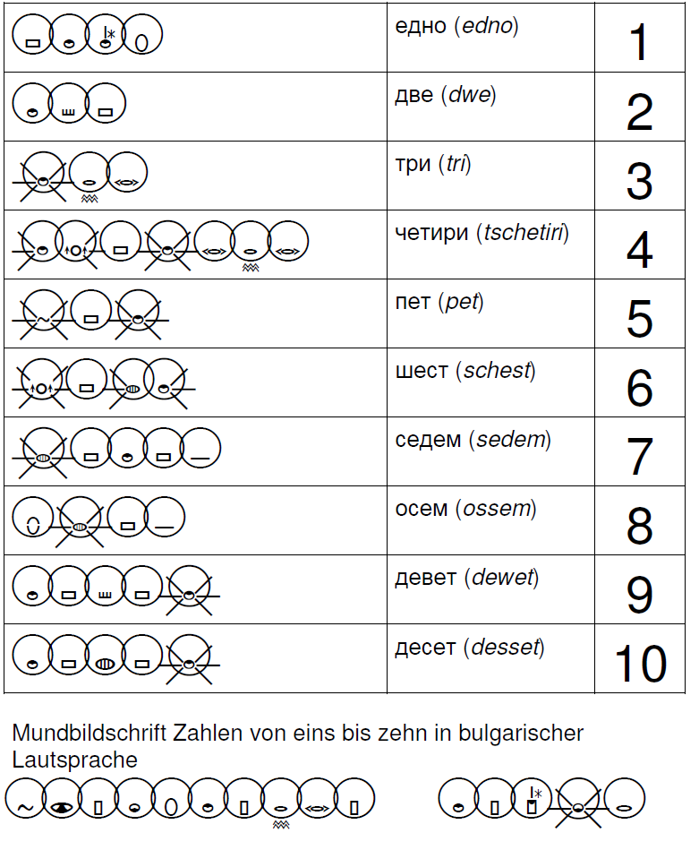

## Mundbildschrift Polish Example

Prepared by Stefan Wöhrmann.

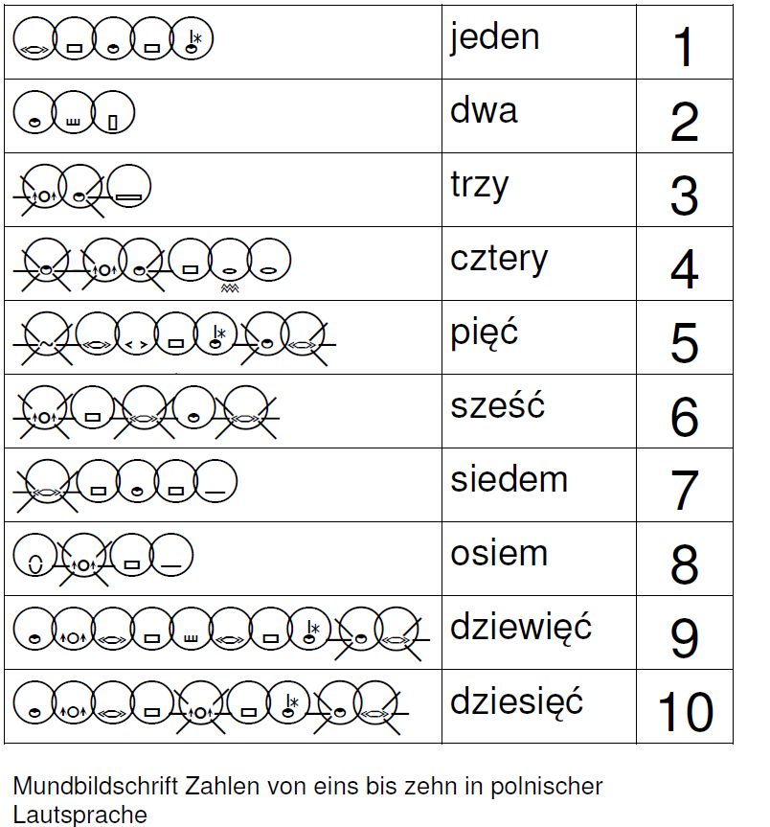

## Mundbildschrift Russian Example

Prepared by Stefan Wöhrmann.

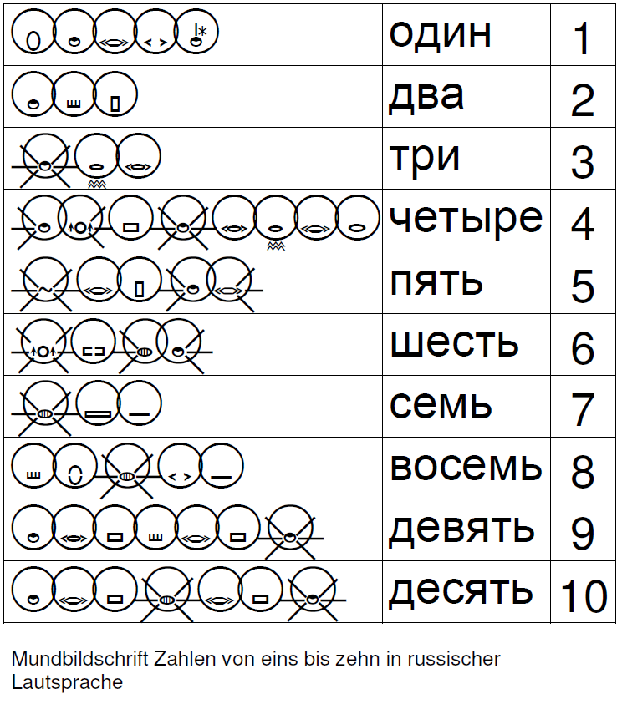

# Annex C Deleg SignWriting Software

**Video Presentation**

Wöhrmann, Stefan (2014) DELEGS-Editor: A Software Tool For Teaching Deaf Students Spoken Language.

<http://www.signwriting.org/symposium/presentation0012.html>

Deleg free SignWriting software. <http://www.delegs.com/DelegsPage/>

***List of features***

* Real-time translation of typed words into SignWriting
* Easy selection of alternate sign translations of typed words
* Storing and loading of SignWriting documents in a shared public area
* Collaboration support by a sophisticated yet simple room concept
* PDF export and printing of SignWriting documents
* Creating and modifying signs on-the-fly within the editor
* Support of English, German, Spanish, Portuguese
* Support of ASL, DGS, LIBRAS, LSE, LSF, LSFB, LSM, LSQ, SZJ.

The team is located in northern Germany (Hamburg and Osnabrück) and consists of members of IT company [Workplace Solutions GmbH](http://www.workplace-solutions.de/) and [University of Hamburg](http://www.uni-hamburg.de/).

Click on the “Delegs international” button and on the icon in the pop-up.

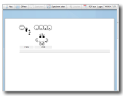

German at <http://www.delegs.com/delegseditor/>

American Sign Language (ASL) at <http://www.delegs.com/delegseditor/?locale=en&signlocale=asl>



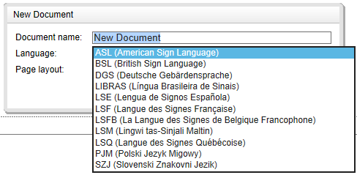

# Bibliography

*References for specific languages phonemes and visemes are not repeated here. They are detailed in the document when used.*

**SpeechWriting**

* Wöhrmann, Stefan. (2002) Ein Plädoyer für den Einsatz der GebärdenSchrift im Unterricht bei hörgeschädigten Kindern. (Teil 1). Hörgeschädigte Kindern 1/2002 (29-39). gGmbH, Hamburg: Verlag hörgeschädigte Kindern. (ISSN 0018-3121).
* Wöhrmann, Stefan. (2002) Ein Plädoyer für den Einsatz der GebärdenSchrift im Unterricht bei hörgeschädigten Kindern. (Teil 2). Hörgeschädigte Kindern 2/2002 (71-82). gGmbH, Hamburg: Verlag hörgeschädigte Kindern. (ISSN 0018-3121).
* Wöhrmann, Stefan. (2003) “ Übersicht - GebärdenSchrift - Mundbilder (Sprechbewegungen Deutsch)“ in B. Jacobsen: Das Gebärdenbuch 1. Das kleine lxl der Gebärdensprache (pp. 172-176). Verlag Birgit Jacobsen, Hamburg. (ISBN 3- 9809004-0-1).
* Wöhrmann, Stefan. (2005) Handbuch zur GebärdenSchrift. Lehrbuch; Verlag Birgit Jacobsen, Hamburg, Hardcover, 230 pages. (ISBN 3-9809004-2-8)
* Wöhrmann, Stefan. (2006) “Mouth-picture-writing”. In B. Jacobsen (Ed.), The gesture book: The small lxl of the gesture-language (pp.178-183). Hamburg, Germany. Verlag (ISBN 3-9809004-1-X) (Die MundbildSchrift in B. Jacobsen (Ed.) Das Gebärdenbuch. Das kleine lxl der Gebärdensprache)

A conversion table toward phonetic was published:

* Stefan Wöhrmann (2007) “Die Mundbilder in der GebärdenSchrift” and “Die Mundbildschrift” in Jacobsen, Birgit. Das Gebärdenbuch Band 2. Pages 181-192. Hamburg. Germany.
* **Wöhrmann, Stefan (2014) Wöhrmann´s SpeechWriting, in SignWriting Documents, Teaches Deaf Students Spoken Language.**

**Additional readings about SpeechWriting:**

Even for a non-German reader, the information is clear and the phonetic notation may be used in other languages.

Stefan Wöhrmann web site at <http://www.gebaerdenschrift.de/> and “Übersicht über die in der Mundschrift verwendeten Symbole (Stand Februar 2002)” at <http://www.gebaerdenschrift.de/read/Mundbilder/uebersicht_mundbilder.htm>.

Stefan Wöhrmann SpeechWriting symbol set is presented for German in:

“Übersicht der Mundbild-Symbole in der GebärdenSchrift (Stand Juni 2012)”

* Wöhrmann, Stefan (2014) **Wöhrmann´s SpeechWriting, in SignWriting Documents, Teaches Deaf Students Spoken Language.**

<http://www.signwriting.org/symposium/presentation0002.html>

* Wöhrmann, Stefan (2014) How I Teach Mundbildschrift. 3 pages.

<http://www.signwriting.org/symposium/archive/sws0002_01_How_I_teach_Mundbildschrift.pdf>

* Wöhrmann, Stefan (2014) Mundbilder in SignWriting and Spelling rules. 5 pages.

<http://www.signwriting.org/symposium/archive/sws0002_02_Mundbilder_in_SignWriting_and_Spelling_rules.pdf>

* Wöhrmann, Stefan (2014) ABC (the Alphabet) in Mundbildschrift For English. 1 page.

<http://www.signwriting.org/symposium/archive/sws0002_03_ABC_in_Mundbildschrift_For_English.pdf>

* Wöhrmann, Stefan (2014) ABC Tabelle Neu SignWriting Deutsch. 10 pages.

<http://www.signwriting.org/symposium/archive/sws0002_04_ABC_Tabelle_neu_SW_Deutsch.pdf>

* Wöhrmann, Stefan (2014) An Overview of Symbols in Mundbildschrift. 8 pages.

<http://www.signwriting.org/symposium/archive/sws0002_05_Overview_of_Symbols_in_Mundbildschrift_Juli_2014.pdf>

**Mundbildschrift animations:**

<http://www.signwriting.org/symposium/presentation0002.html>

We suggest visiting the animation web page: <http://movementwriting.org/animation/sgn-DE/> . It displays a welcome message in German Sign Language.

*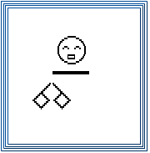“A wonderful animation is on the opening page of the German SignWriting web site, designed and animated by Stefan* Wöhrmann*, a teacher of Deaf children in Osnabruck:*

[*http://www.gebaerdenschrift.de*](http://www.gebaerdenschrift.de)

*Historically, this is the first animation of a full SignWriting sentence. For those who know how to sign, it looks as if someone is standing in front of you, signing! You can follow along and sign with the animation. Spoken languages cannot be animated in the same way that SignWriting can. Animated sentences hold the potential of teaching deaf children to read full sentences sooner, and with better understanding.”*

Several other animations are available at: <http://www.movementwriting.org/animation/>

**SignWriting**

Documents on SignWriting can be downloaded for free at:

* <http://www.signwriting.org/archive/docs2/sw0116-Lessons-SignWriting.pdf>
* <http://www.signwriting.org/lessons/books/>
* <http://www.signwriting.org/lessons/web/>
* <http://www.signwriting.org/lessons/elessons/>
* <http://www.signwriting.org/archive/docs5/sw0493-SWLessonsBook-Parkhurst-EngLSE.pdf>
* <http://www.signwriting.org/lessons/iswa/>
* <http://std.dkuug.dk/jtc1/sc2/wg2/docs/n4090.pdf>

**About SignWriting**

* Sutton, Valerie (2014) Lessons in SignWriting. Text book. Center for Sutton Movement Writing, Inc. La Jolla, California. USA. Available for free online. Several illustrations of this document are an adaptation of the textbook.
* Sutton, Valerie and Frost, Adam (2010) SignWriting Reference Manual 2. SignWriting Hand Symbols, ISWA 2010 by Valerie Sutton. Available for free online.
* Parkhurst, Dianne and Parkhurst, Stephen (2010) A Cross-Linguistic Guide to SignWriting®. A phonetic approach.
* Frost, Adam (2010) ISWA 2010 Symbol. Lessons Online Web lessons show moving hand shapes with symbols.

**Leçons en français pour apprendre à écrire les signes:**

**Sutton, Valerie (2002) Leçons en SignWriting...lire et écrire les mouvements des langues des signes. Les langues des signes sont des langues écrites.** Center for Sutton Movement Writing, Inc. La Jolla, California. USA. Disponible en téléchargement gratuit:

* <http://www.signwriting.org/archive/docs3/sw0221-Lecons-SW-Francais-1.pdf>
* <http://www.signwriting.org/archive/docs3/sw0222-Lecons-SW-Francais-2.pdf>
* <http://www.signwriting.org/archive/docs3/sw0223-Lecons-SW-Francais-3.pdf>
* <http://www.signwriting.org/archive/docs3/sw0224-Lecons-SW-Francais-4.pdf>

**Visemes**

* DUMONT, A. (2008). Orthophonie et surdité. Communiquer, comprendre, parler. Issy-les-Moulineaux, Elsevier Masson. Degré de visibilité des mouvements des organes phonateurs. Page 195.

**Arabic Visemes and Phonemes**

* Special Issue of International Journal of Computer Applications (0975 – 8887) on Software Engineering, Databases and Expert Systems – SEDEXS, September 2012

Fatma Zohra Chelali*,* Khadidja Sadeddine, Amar Djeradi. Visual Speech Analysis,Application to Arabic Phonemes. Speech communication and signal processing laboratory. Electronics and computer Science Faculty Houari Boumedienne University of sciences and Technologies. Algiers, Algeria.

<http://research.ijcaonline.org/sedex/number2/sedex1015.pdf>

**French Visemes and Phonemes**

* (1997) Programme d'entraînement à la lecture labiale. DVD 1 Leçon 1. (c) Institut Raymond-Dewar. Centre de réadaptation spécialisé en surdité et en communication. La Fondation Surdité et Communication. Montreal, Canada.
* Freund, Noémie (2011) labiokids: développement d’un matériel d’entraînement à la lecture labiale pour enfants sourds âgés de huit à douze ans, Volume 1. Mémoire présenté dans le cadre de l’obtention du Certificat de Capacité d’Orthophoniste. Faculté de Médecine de Nancy Université Henri Poincaré – Nancy I, École d’orthophonie de Lorraine ©2011

<http://docnum.univ-lorraine.fr/public/SCDMED_MORT_2011_FREUND_NOEMIE.pdf>

**Portuguese SpeechWriting**

* Capovilla, Fernando Cesar (2011) Transtornos de aprendizagem 2, Editor: Memnon, pages 276-283 on SpeechWriting in collaboration with Wöhrmann, Stefan, ISBN 9788579540158

**Phonetic symbols for Brazilian Portuguese:**

* Barbosa, Plinio A. and Albano, Eleonora C. (2004) Brazilian Portuguese. ILLUSTRATIONS OF THE IPA. Phonetics and Psycholinguistics Laboratory & Department of Linguistics. Instituto de Estudos da Linguagem, State University of Campinas. Journal of the International Phonetic Association 34/2 C, International Phonetic Association. Printed in the United Kingdom DOI:10.1017/S0025100304001756

<http://www.unicamp.br/iel/site/docentes/plinio/BarbosaAlbano.pdf>

**Phonetic symbols for Portuguese:**

* Ian Maddieson Applied Phonetics: Portuguese Text-to-Speech. Arlo Faria. University of California, Berkeley. Linguistics 110

<http://www1.icsi.berkeley.edu/~arlo/publications/faria_ling110_proj.pdf>

**Cued Speech**

About cued speech or French Langage Parlé Complété (LPC) consult:

* <http://cure-lequin.ecoles.csmv.qc.ca/ecole-st-jude/lpc/>
* <http://cure-lequin.ecoles.csmv.qc.ca/files/2011/09/Dictionnaire-LPC_v8.pdf>
* <http://sourdsressources.wordpress.com/2012/02/09/bref-petit-cours-dlpc/>
* <http://www.alpc.asso.fr/category/accueil/>
* Bull, Kathleen; Gauthier, Mélanie and St-Jacques, Sophie (2012) Le langage parlé complété. Cahier de formation de base. École St-Jude, Commission scolaire Marie-Victorin, Région de la montérégie, 5e édition, Montréal, Canada. 87 pages.

Official web sites:

* <http://www.cuedspeech.org/>
* <http://www.cuedspeech.com/index.asp>

Charts for several languages:

* <http://www.cuedspeech.org/cued-speech/international-cue-charts.php>

International links (several languages):

* <http://www.cuedspeech.org/resources/cued-speech-international.php>
* <http://www.cuedspeech.com/links.asp>

**Peruvian Alternative to Cued Speech with Kinemes**

Oscar Huamaní C. Psychologist, specialized in speech therapy web site:

* <http://logopediaperu.blogspot.ca/2009/11/visemas-y-kinemas.html>
* <http://logopediaperu.blogspot.ca/search/label/material%20de%20apoyo>
* Santos Borregón Sanz (2010) Los trastornos de la articulación. Volume 26 de Colección Lenguaje y Comunicación. Volume 26 de Lenguaje y comunicación. Ciencias de la Educación Preescolar y Especial. ISBN: 8478697616, 9788478697618. 96 pages.