**SignAnimating**

**2-Design**

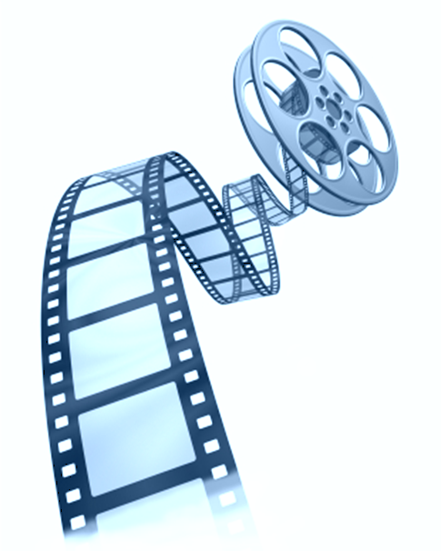

By André Lemyre

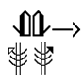

SignAnimating. 2-Design

By André Lemyre

[andre-andre@hotmail.ca](mailto:andre-andre@hotmail.ca)

Montreal, Quebec, Canada

First Edition

©2014-07-15

This book was prepared with SignWriter Studio™ version 1.2.2 © 2009 created by Jonathan Duncan. It can be downloaded at <http://signwriterstudio.com/>

This manual is posted on the web:

<http://www.signwriting.org/symposium/presentation0020.html>

This publication and the SignWriting Script are free

to use under the Creative Commons Attribution 3.0 License

<http://creativecommons.org/licenses/by/3.0/>

Contents

Introduction 5

Deciding the Style of Animation 7

Identification of Characters 9

SignAnimating Several Characters 11

Introducing a new character 11

Story Telling Mode with More Than One Character 12

View Points 16

Receptive Viewpoint 16

Viewpoint Changes 18

Mixing Receptive and Expressive View Points 20

Frame Size and Speed 21

Creation of base frames 22

Frame size 22

Symbols Size 23

Frame rate 24

Symbols and Subtitling 25

SignWriting not positioned relatively to the head 26

Symbols not required in animations 26

Symbols that cannot be animated 27

Location symbols 28

Subtitling 28

Creative SignAnimating 29

White on Black 30

Handwritten Animation 31

Alternate SignWriting Symbols 31

Gallaudet or HandSign Font Animation 32

SignWriting in 3 Dimensions 32

Deciding the Layout of the Animation 33

Animated Gif Constraint 34

Animated Gif Advantages 34

Videos Constraints 35

Videos Advantages 35

Short Message SignWriting Mode 36

Short Message SignAnimating Mode 36

Web Icon Mode 37

Signature Mode (E-mail, Web Page and PowerPoint) 38

Congratulation, Holiday, Event Card Mode 38

Teaching Modes 41

Dictionary Mode 43

Anki Electronic Flashcards Mode 44

Overview of SignAnimating and SpeechAnimating Modes 46

SpeechWriting - Mundbilder in GebärdenSchrift 46

SignWriting Mode 48

SignAnimating Mode 49

SpeechWriting - Mundbilder in GebärdenSchrift Mode 50

SpeechAnimating Mode 51

Mundbildschrift Word Mode 52

Mundbildschrift Phoneme Mode 54

Mundbildschrift with SignAnimating Mode 55

SpeechWriting - Mundbilder with SignWriting Mode 56

SpeechAnimating with SignAnimating Mode 57

Cued Speech with SpeechAnimating Mode 57

SignAnimating Subtitle Modes 61

SignWriting Subtitling With One Sign Mode 61

SignAnimating Subtitling With One Sign Mode 62

One Signwriting Column Simultaneous With Illustrations Mode 63

Several Scrolling SignWriting Columns with Illustrations Mode 65

Electronic Book Behaviour Modes 66

Presentation with Illustrations Mode 66

Several Signwriting Columns Simultaneous With Illustrations Mode 67

Conclusion 69

Bibliography 70

# Introduction

This document suggests several alternative designs on how best to represent signs with SignWriting animation. It discusses the advantages and limitations of animations over static SignWriting. No suggestion is definitive until SignWriters reflect on it, improve it and agree on its official usage.

SignWriting is abstract and concise; it uses Movement symbols and leave out unnecessary details. In SignAnimating only a fraction of the SignWriting text is displayed at a given moment with a smaller surface. The animation tends to contain facial expressions and shoulder line that are not required in SignWriting.

We believe that a good animation should be complete enough to allow reverting to SignWriting without ambiguity. We view SignAnimating like a form of subtitling; unlike an avatar which represents the human body, it remains based on SignWriting conventions.

A movement may be expressed by 2 or more frames. An animation is more continuous when more frames a displayed in rapid succession. In this document, we will use a few frames to present the general idea and let the SignWriters add more frames in their animations if needed.

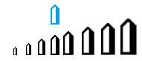Most movement and speed symbols are replaced by displacement of symbols during the animation. SignAnimating follows all SignWriting rules except for one: symbols change of size depending of their proximity to the body.

Animated gif images may be used on web pages, pop-up windows, buttons, e-mails, PowerPoint documents… Signwriting videos can be used for long texts. SignAnimating focuses on hand shapes and facial expressions.

Refer to SignAnimating 1-Techniques for a step-by-step instructions on how to produce SignAnimating video or GIF files.

Refer to SignAnimating 3-Symbols for suggested conventions on how SignWriting symbols may be converted to SignAnimating symbol sequences.

Refer to SignAnimating 4-SpeechAnimating for a reflection on how to animate SpeechWriting.

André Lemyre



# Deciding the Style of Animation

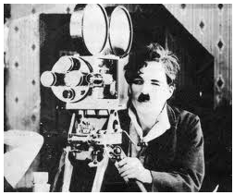

Charlie Chaplin

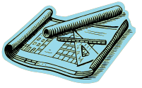The animation may be colored and contain illustrations or may be black on a transparent background. It may be a slide show of SignWriting. It may display dynamic facial expressions and hand configurations without movement symbols. The amount of available time for the project will determine how smooth the animations will be, from 2 frames per seconds up to 10 frames per second, or even more.

The basic frames that will be used throughout the animation may be any combination of the following symbols:

* Head,
* Eyes,
* Mouth,
* Hair,
* Neck,
* Shoulder (possibly only for alignment and that will be erased),
* Hips (possibly only for alignment and that will be erased),
* Arms,
* Contact symbols,
* Movement symbols (that can be grayed out if displayed).

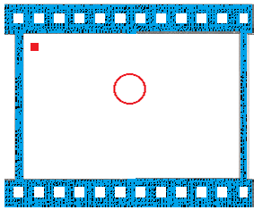

Example: In this base frame, a square indicates where contact symbols should be placed. This square is always erased.

The more symbols the basic frame contains, the less compatible it will be with other sentences. A simple face with opened eyes suffices. This ensures that the eyes are not misaligned. Other symbols may be added afterward. Several basic frames may be created with different mouth shapes.

## Identification of Characters

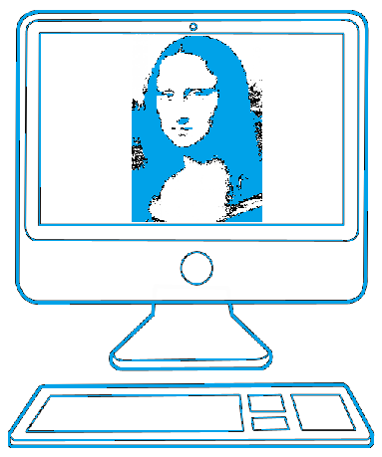

C:\Users\alemyre\AppData\Local\Microsoft\Windows\Temporary Internet Files\Content.IE5\UINPU9Q9\MC900240341[1].wmf

If reusability is not an important consideration or if animations already exist and can be altered; then characters may be represented differently. Hair, eyes color, eyelashes, and lipstick color may be used. Shoulder orientation may be used to indicate who is signing to whom. The facial expression may limit the reusability of a sign. For instance, a CAR may be expressed with a sad face for an accident or a happy face when winning it at a lottery.

Several symbols may be personalized by a choice of color. Faces and/or hands may be colored to identify the skin color, the gender, nationality (flag colors) or the age (grey would represent the hair color). Unlike in SignWriting were hand shapes are harder to read when overlapped with the face, the usage of color may allow overlapping hand shapes with the face. Shoulders may be colored differently to identify a character by its “clothing”. Pale colors are to avoid as they fade in the background. Green and red are perceived as grey by color blind people. They should not be used when the information they carry is not present otherwise.

|  |  |  |  |
| --- | --- | --- | --- |
| Valerie Sutton colors | Character which has an earring | Old lady with young African boy |  |

 Chaplin Marilyn Monroe

## SignAnimating Several Characters

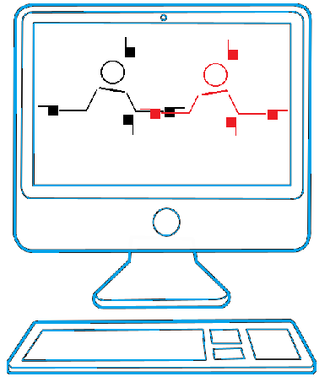

### Introducing a new character

We may present a character coming from far ahead or entering the field of vision from the side.

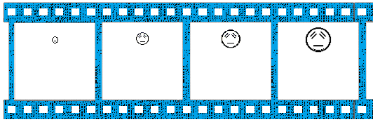

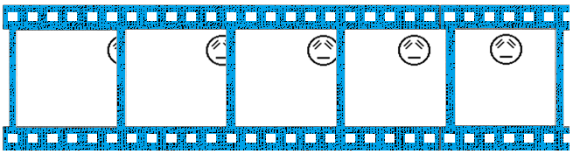

### Story Telling Mode with More Than One Character

Animations allow reproducing the physical environment in which a conversation is held. People closer will be larger than distant people. Children may be represented by a head that is lower than an adult’s. A narrator may be present. When the amount of simultaneous characters is defined, a basic frame with several heads is designed. Tilting of shoulder may be used to indicate who is communicating with whom.

**Three Lanes for Role Shifting and Storytelling**

*C:\Users\alemyre\AppData\Local\Microsoft\Windows\Temporary Internet Files\Content.IE5\UINPU9Q9\MC900439913[1].wmf“Playing different roles - one person is over on one side and the other person is over on the other side, and they are having a conversation. … that is why my Deaf co-workers, the DAC members Lucinda O’Grady, Meriam Ina Schroeder and others in the 1980s, asked to write vertically in three lanes - Vertical writing really helps writing the grammar of such conversations properly in sign languages, because when a signer is telling a story, there are little weight shifts - we don’t even realize this, but automatically the narrator (storyteller) places one person on the right side of his body, and another person on the left side of his body, and the narrator of the story is in the center.*

*When the person on the right in the story says something, then the storyteller shifts his weight just a tiny bit over to the right side, and might possibly turn his shoulder a little to look at the left side as if looking at the other person on the left - that sign or signs are placed in the Right Lane because the weight and the signs shifted over to the Right Side of the Body.*

*Then the narrator comes back to the Center Lane, and if the person on the left responds, then the narrator shifts his body a little to the left and places the sign over to the left side in the Left Lane - so the 3 Lanes are needed to write storytelling…*

*So how do you place signs in the 3 Lanes? In SignText, there are two different ways to place signs in three Lanes…”*

Valerie Sutton, SignWriting List, March 8, 2014.

SignPuddle 3 Lanes buttons:

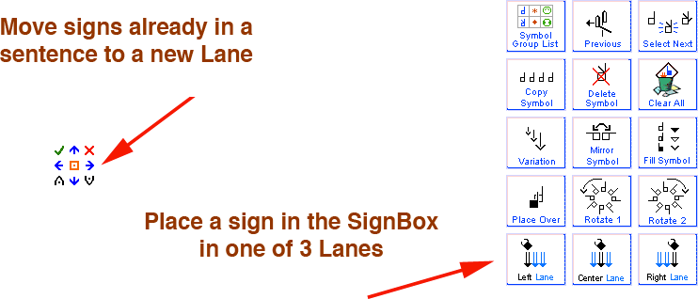

A larger frame size is required for two animated characters. Overlap of their signing spaces is acceptable. It is expected that one character is signing while the other watches.

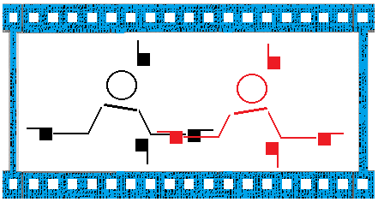

SignWriting or SignAnimating dialogs may be displayed with or without illustration. One or several characters may sign within the same frame. After an instant, new text is displayed. This obliges the reader to focus on the text or to pause the animation to not lose information. The punctuation structures the message.

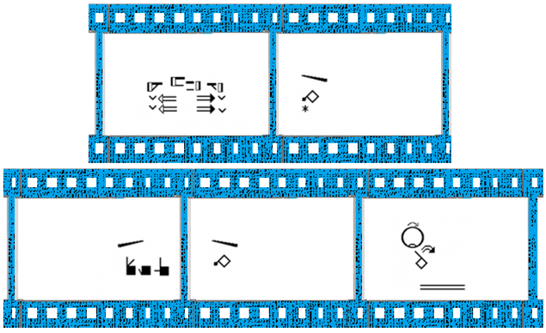

Example (extract) by Charles Butler SignWriting List, March 8, 2014.

A larger enough frame size could display 2 animated characters in expressive view point and 2 animated characters in receptive view point. Overlap of their signing spaces is acceptable. It is expected that one character is signing while the others watch.

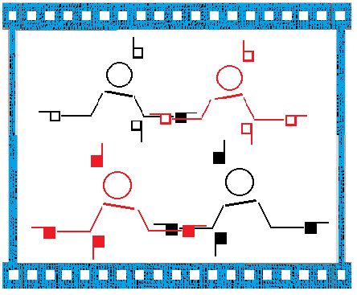

SignWriting or SignAnimating dialogs may be displayed beside a video or an image. After an instant, new images and text are displayed. This allows the reader to focus on the video and read or have time to pause the video.

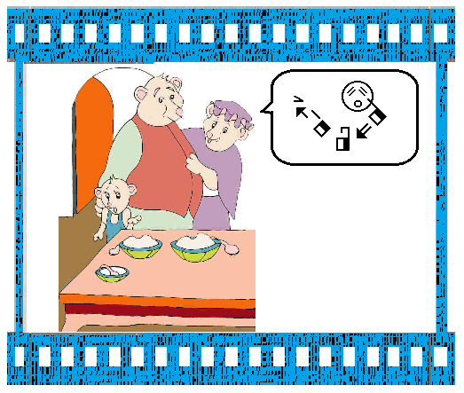

## View Points

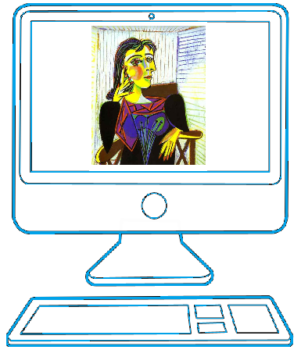

Pablo Picasso, portrait of Dora Maar (1937)

### Receptive Viewpoint

Standard SignWriting is written from the expressive viewpoint. SignWriting can also be written from the receptive view point.

|  |  |
| --- | --- |
| Receptive View Point | Expressive View Point |
|  |  |
| The same hand shape has 2 different representations. | |

Opacity could be applied to the interior of the hand shapes such that they would hide parts of the face, limbs or the other hand shape.

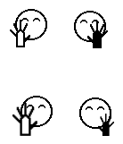

When animating from the receptive viewpoint, the left and right sides are inversed. Also the zoom effect is inversed. As the hand goes further from the signer, it becomes closer to the viewer. Instead of animating a zoomed out hand shape on the right side, it becomes a zoomed in hand shape on the left side.

In the Expressive view point, a dialog between 2 characters can easily be represented by the shoulder line angle. The same is true in the receptive view point.

|  |
| --- |
| Dialog with shoulder lines from the expressive view point. |
| Illustrations from Parkhurst, Dianne and Parkhurst, Stephen (2010) A Cross-Linguistic Guide to SignWriting®. A phonetic approach. |

### Viewpoint Changes

**The animation may pass from the expressive perspective to a lateral perspective.**

1. We stop displaying the hand shapes. We stop animating the mouth.
2. We display the head rotation symbol (thicker line on one side) and we move the head toward the side of the frame.
3. We display the side of the head and we move the head toward the edge of the frame.
4. The frame dimensions should allow displaying movements in both perspectives for such animation.
5. The hand shapes are zoomed in when the hand moves laterally toward the viewer. The hand shapes moving forward do not change of zoom. The hand shapes moving upward do not change of zoom.

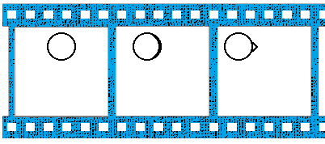

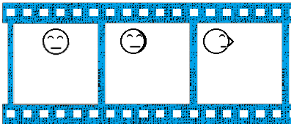

**The animation may pass from the expressive perspective to a top perspective.**

1. We stop displaying the hand shapes. We stop animating the mouth.
2. We display the shoulder line.
3. We lower the head. We display the shoulder line closer to the head.
4. We lower the head. We display the shoulder line touching the head.
5. We lower the head toward the edge of the frame. We display the shoulder line under the middle of the head.
6. Progressively the eyes move up until they are hidden, the mouth is also hidden.
7. The frame dimensions should allow displaying movements in both perspectives for such animation.
8. The hand shapes are zoomed in when the hand moves upward for the viewer. The hand shapes moving forward do not change of zoom. The hand shapes moving sideways do not change of zoom.

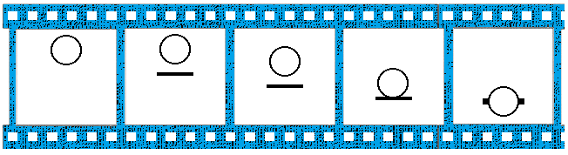

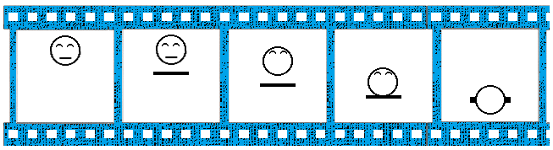

The animation may pass from the top perspective to a lateral perspective by transiting through the expressive perspective.

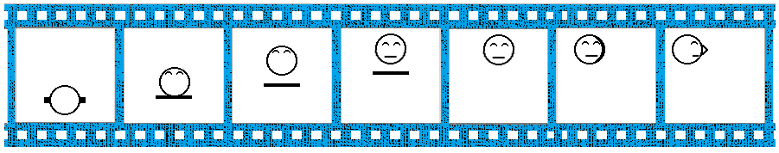

### Mixing Receptive and Expressive View Points

A difficulty arises if an animation mixes expressive and receptive view point to represent a dialog. We do not suggest this approach. The expressive view point could be identified by different eye shapes. This is no longer SignWriting. The hand shape color is reversed as we see the opposite side of the hand. The zoom is also inversed. A hand getting further from the receptive perspective gets bigger from the expressive perspective. The whole character in receptive perspective could be zoomed out.

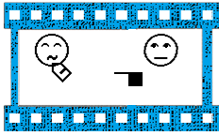 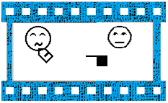

# Frame Size and Speed

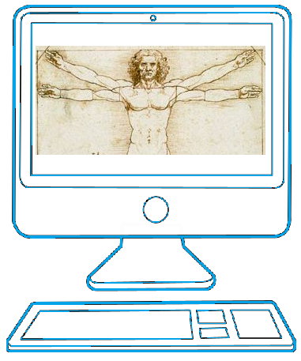

Vitruvian Man by Leonardo da Vinci

## Creation of base frames

C:\Users\alemyre\AppData\Local\Microsoft\Windows\Temporary Internet Files\Content.IE5\UINPU9Q9\MC900291940[1].wmfThe head will be static during the animation (unless a head movement is required). Identify the tallest and widest signs. Evaluate how much room will be required above, below, left and right of the head. A forward arrow does not increase a sign height because it represents a horizontal movement.

## Frame size

The frame size needs to be sufficient to contain all used signs in the message and possibly other signs when reused.

In the example below, the signer indicate up, down, left and right, to do so, space is needed above, below and both sides of the character. This seems to be the standard frame minimal size if animations need to be reusable. If the chosen frame size is smaller, the addition of a single larger sign may require resizing and re-centering each frame of each sign previously animated.

|  |  |
| --- | --- |
|  |  |
|  | A frame may require 6.5 head sizes horizontally and 4.5 head sizes vertically to fit an almost complete range of motion. |

## Symbols Size

Animated gif files may be resized in a web page, an e-mail, a web page or a Powerpoint presentation. Ensure that the symbols and subtitles will remain clear and readable when shrunk. The resolution of details may not suffice.

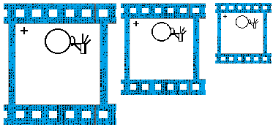

## Frame rate

C:\Users\alemyre\AppData\Local\Microsoft\Windows\Temporary Internet Files\Content.IE5\JXQ3VG0N\MC900297971[1].wmfThe frame rate is the amount of different images displayed during 1 second. A simple sign involving a movement may last 1 second. A sign with 2 movements may last 2 seconds. We may assume that a fast sign may last ¾ of second. Some signs with emphasis start with a static tensed position followed by a fast movement. This may be represented by a static sign during 1 second or more followed by a frame of the final hand shape position.

The frame rate per second limits the reusability of animation. It may be noticeable when the number of frames per second increases and decreases during the animation. The animation should be viewed as it is developed to ensure frame rate uniformity. The frame rate needs to be adapted with the reading speed of the intended audience; it may differ from signing speed.

The simplest animations are as follow:

* Very slow static frame rate: Several static signs are displayed simultaneously during several seconds.
* Slow static frame rate: 1 frame of 1 second for 1 sign: Display the complete static SignWriting word with hand shapes, contact and displacement symbols.
* Slow dynamic frame rate: 2 frames of 1 second for 1 sign: Display the start hand shapes in the signer space. Display the end hand shapes in the signer space. Displacement symbols are omitted, except for fingers and wrists.

# Symbols and Subtitling

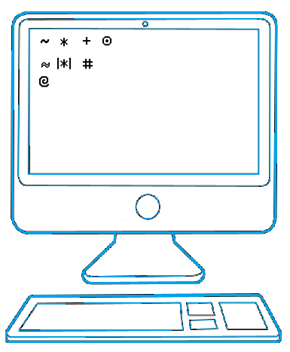

## SignWriting not positioned relatively to the head

Most of signs are not represented with a head, they are easy to represent between the level of the shoulder and the hip during an animation. Signs without head cans be used for short messages like within a web page button or in teaching material.

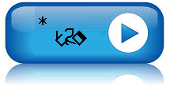

Purchase (LSQ last frame)

## Symbols not required in animations

Movement symbol are expressed by moving left and right, up and down. Movements forward and backward are represented by decreasing or increasing the symbol size. The default symbol size represent the natural signing area. A greater size represent a hand being close or touching the body and a small hand implies an extended arm. Even the head may be tilted back by increasing its diameter or moved forward with a smaller diameter.

The region of contact on the head rims need not be defined. The hand shape may directly overlap it in one frame if another frame allows reading the hand shape clearly.

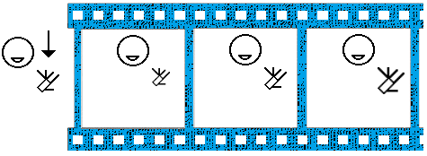

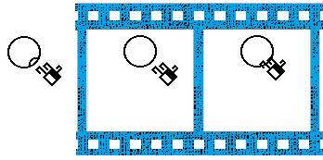

Punctuation may be represented with SignWriting symbols. It may be inclined to reiterate who is pausing. A comma may also be represented by a blank or neutral face during half a second and a period may be represented by an empty frame during 1 second. The empty frame is suitable to imply a change of signer. Emphasis on a sign may be expressed by a still frame with the face and the hand shape.

## Symbols that cannot be animated

If animations are developed for less experienced sign readers, it may be assumed that they need explicit sign contacts. It is suggested to always keep them in at least one frame when the contact occurs.

Contact symbols may be represented literally in an animation when they occur. This ensures that the animation could be understood and written without loss of information. They may be implicit and obvious for a Deaf or an experienced sign reader, but may be insufficient for less experienced viewers. Contact symbol may have the same color as the character or different color. Keeping the same color eases reuse of the animation in other contexts over the years. For instance, with animations in black and white with grey contact symbol or movement symbols would not compatible with pure black and white animation or with other shades of grey.

Contact symbols may be confined always the top left corner of the animation. This would ease automation and provide uniformity through the animation.

Animation allows the viewer to see the hand configurations before they overlap. Two overlapped hand shapes in contact may not be readable in a frame. The purpose of such frame would be to indicate when and where the contact occurs with known hand configurations.

## Location symbols

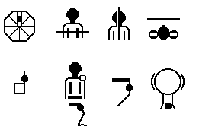

Location symbols are rarely used in SignWriting. They can be of assistance for proper positioning of hand shapes in the signer space.

Location symbols rarely need to be displayed in animations. They may be used for specific animations teaching where a hand or a movement should be relatively to the signer.

## Subtitling

Subtitling can be expressed in gloss or in written language. If it is embedded in the animation, it reduces the reusability. It is affected by the frame rate that may change. The same text must be copied exactly at the same location in several frames. It must be added after the face, before the hands. If different face frames are used for a word, same text must be copied exactly at the same location. The addition of a written word may require to re-edit all subsequent frames if the signed and the written words are not in the same order.

If the subtitle is displayed under the animation, but not within it, it is easier to update. The animation and the subtitle may not be synchronized.

A simple font like Arial may be a better choice than a fancy font. The font size must allow the longest word of the language to fit within the frame and remain readable. There may be 2 lines of subtitles.

Subtitles may be preferred to FingerSpelling to fill in when a word has no equivalent in the SignWriting dictionary. It may be under a face, or simply a display of text. The signer may point to the subtitle.

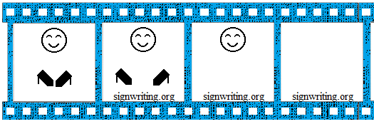

# Creative SignAnimating

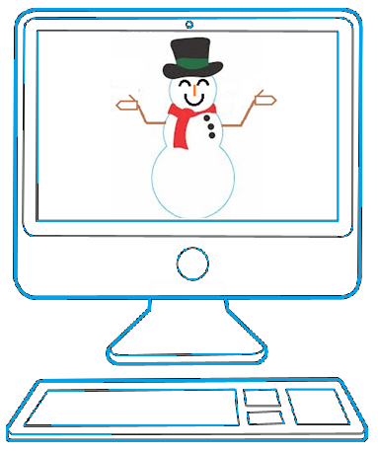

Creativity can make an animation interesting. Children and teenagers learning SignWriting will appreciate a touch of imagination. We believe that a good animation should be complete enough to allow reverting to SignWriting without ambiguity (if only a few frames represent movements like a curved and an angled zig-zag, it may not be possible to guess the initial Signwriting from the SignAnimating.). We view SignAnimating like a form of subtitling; unlike an avatar which represents the human body, it remains based on SignWriting conventions.

## White on Black

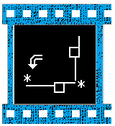

On a cell phone, it may be interesting to allow inversing the colors to a night mode that may be more visible under some lighting conditions. In Microsoft Paint software, select the area, right click and in the pop-up menu chose the Inverse Colors option.

The effect is interesting on black and white images but arbitrary colors cannot be inversed nicely.



## Handwritten Animation

A personalized animation may be built on an electronic copy of handwritten signs.

## Alternate SignWriting Symbols

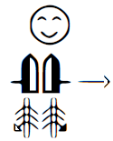

A nice alternate SignWriting symbol set can be found at:

<http://std.dkuug.dk/jtc1/sc2/wg2/docs/n4090.pdf>

Everson, Michael; Slevinski, Stephen; Sutton, Valerie (2011-08-05) Revised proposal for encoding the SignWriting script in the SMP of the UCS Universal Multiple-Octet Coded Character Set. International Organization for Standardization. JTC1/SC2/WG2 N4090R. L2/11-217R

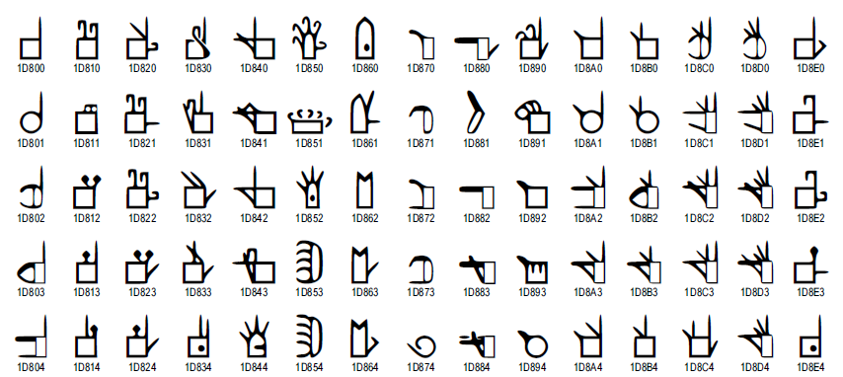

(extracts)

## Gallaudet or HandSign Font Animation

Hand drawings look nice but they have too many details. Many hand shapes are unclear in a drawing form. They cannot display all required orientation. Few hand configurations are available. Overlap of hand shapes may be hard to understand.

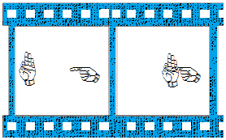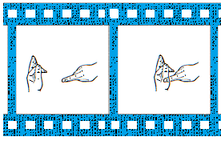

## SignWriting in 3 Dimensions

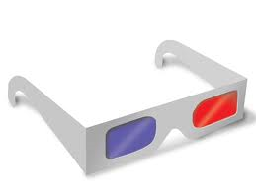A future avenue for SignAnimating could be with 3D animations. A blue and a red image are overlapped and the reader wears 3D glasses. One filter blocks the blue image for the right eye and one filter blocks the red image for the left eye. Depth perception is created with the offset between the blue and the red images. Both the right eye and the left eye will see the objects from a different angle. This will lead to a shift in the position of the objects in relation to each other. More separation between the 2 images equates to closer to the viewer. This offset would need some computation and may not be clearly noticeable. A zoom-in and a zoom-out of symbols may still be required to represent depth.

Some computer monitors may use different colors not compatible with the 3D glasses. If we do not get the color perfectly right, we will see ghost shadows which may eventually even ruin the stereoscopic effect if too strong.

3D animations cannot be performed with Paint because it overlaps colors instead of mixing them.

Printed 3D SignWriting on paper could be amusing for children. Again, ghost shadows may eventually ruin the stereoscopic effect.

# Deciding the Layout of the Animation

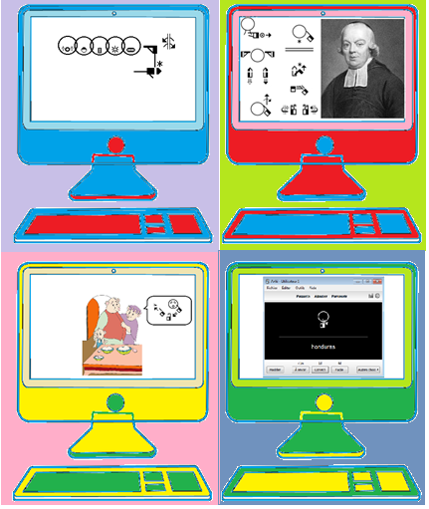

Several layouts of animation are possible. They may focus on either:

* 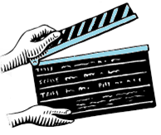SignWriting,
* SignWriting narration or conversation,
* SpeechWriting,
* SignAnimating,
* SpeechAnimating,
* Cued speech animating,
* Images,
* Video…

The display of the head, the eyes and the mouth may be optional depending on the chosen design and the desired reusability of the animations in other contexts.

They may contain written subtitles for earing people or for educational purposes.

SignWriting symbols or SignAnimating symbols subset may be displayed in an animated gif image or in a video.

## Animated Gif Constraint

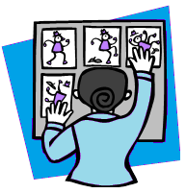Animated gif does not allow the reader to watch the message at her/his own pace without missing a part of the message. The animated gif loop is acceptable only for short messages. Because the animated image loops, the reader must wait for the next iteration to read missed symbols. There must be a frame separating the end of the animation from the next iteration.

## Animated Gif Advantages

It is sufficient for short messages. It is portable on all computers. The files are small. The files can be inserted in e-mails, PowerPoint presentations, web pages… The animation background may be transparent; they can be displayed in front of any background or illustration.

## Videos Constraints

The files are bigger and may not be readable on computers which do not have the corresponding video viewer. To be shared, they must be accessed through internet with you tube or equivalent social media.

## Videos Advantages

In a video, the reader can rewind the message, but it restarts at an arbitrary location and several symbols must be read before the missed sign is displayed.

## Short Message SignWriting Mode

SignWriting symbols may be displayed in an animated gif image.

|  |  |  |  |  |
| --- | --- | --- | --- | --- |
| Short Message SignWriting Mode (gif) | | | | |
| Unit size | Context | Frame speed | Reader’s attention | Search |
| Sign in SignWriting. | Message of less than 10 consecutive signs. | Fast. | Constant. | Cannot search.  Wait next loop. |
| The message structure is obvious for short messages. | | | | |

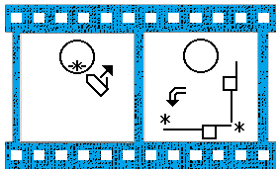

Bonne Journée (Good day in LSQ)

## Short Message SignAnimating Mode

SignAnimating symbols may be displayed in an animated gif image.

|  |  |  |  |  |
| --- | --- | --- | --- | --- |
| Short Message SignAnimating Mode (gif) | | | | |
| Unit size | Context | Frame speed | Reader’s attention | Search |
| SignAnimating sequence of symbols. | Message of less than 10 consecutive signs. | Very fast. | Constant. | Cannot search.  Wait next loop. |
| The message structure is obvious for short messages. | | | | |

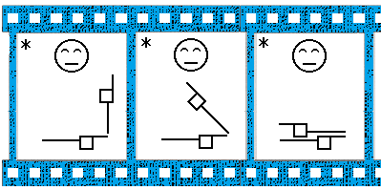

Journée (Day in LSQ)

## Web Icon Mode

For web pages, SignWriting symbols or SignAnimating subset may be displayed in an animated gif image like in a button identifier or a section header. The face may be omitted if not required to fit the button size.

|  |  |  |  |  |
| --- | --- | --- | --- | --- |
| Web Icon Mode (gif) | | | | |
| Unit size | Context | Frame speed | Reader’s attention | Search |
| Sign in SignWriting.  SignAnimating sequence of symbols. | Message of less than 10 consecutive signs. | Very fast. | When needed. | Cannot search.  Wait next loop. |
| The message structure is obvious for short messages. | | | | |



Purchase (LSQ last frame)

## Signature Mode (E-mail, Web Page and PowerPoint)

An animated gif may be used as a signature for an electronic dynamic document. The name sign of the person or the institution is animated. Some creativity may be present in the lay-out: colors, symbols shape, illustrations, logo… The background must be transparent unless the background is always perfectly white.

|  |  |  |  |  |
| --- | --- | --- | --- | --- |
| Signature Mode (gif) | | | | |
| Unit size | Context | Frame speed | Reader’s attention | Search |
| Sign in SignWriting.  SignAnimating sequence of symbols. | Message of less than 10 consecutive signs. | Very fast. | When needed. | Cannot search.  Wait next loop. |
| The message structure is obvious for short messages. | | | | |

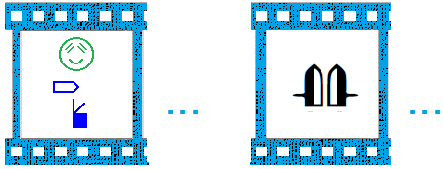

## Congratulation, Holiday, Event Card Mode

C:\Users\alemyre\AppData\Local\Microsoft\Windows\Temporary Internet Files\Content.IE5\LGEC3ZJ2\MC900326844[1].wmfAn animated gif with a picture or an animated drawing may be used as an event card. It may contain the animated name sign of the author. Much creativity is expected in the lay-out: colors, symbols shape, illustrations, sparkles, transparent or colored background… This animation would be sent by e-mail. Online Image Editor © OIE Internet Concepts free software has several animation effects for animated gif files. It supports at most 15 frames per animation. It can be used online at <http://www.online-image-editor.com/gifmaker/>

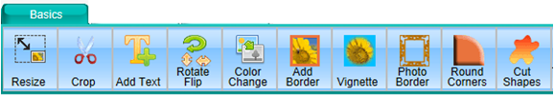

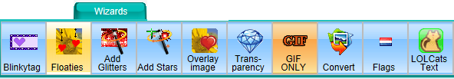

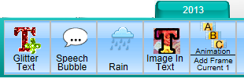

|  |  |  |  |  |
| --- | --- | --- | --- | --- |
| Event Card Mode (gif) | | | | |
| Unit size | Context | Frame speed | Reader’s attention | Search |
| Sign in SignWriting.  SignAnimating sequence of symbols. | Message of less than 15 frames. | Very fast. | When needed. | Cannot search.  Wait next loop. |
| The message structure is obvious for short messages.  The card illustration provide and obvious context.  Need a gif editor that supports many frames.  Gif format supports only 256 colors per frame. The rendering of high quality pictures is not guaranteed.  Online Image Editor supports at most 15 frames per animation. | | | | |

|  |  |  |
| --- | --- | --- |
| Valentine’s day | Bienvenue  (Welcome LSQ first frame) | Merci  (Thanks LSQ first frame) |

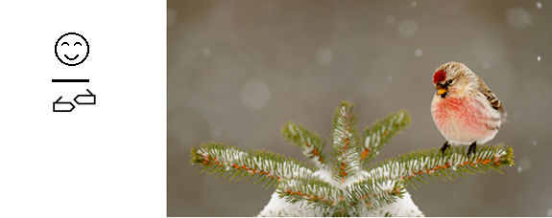

Bonne année

(Happy new year LSQ first frame)

## Teaching Modes

C:\Users\alemyre\AppData\Local\Microsoft\Windows\Temporary Internet Files\Content.IE5\LGEC3ZJ2\MC900334096[1].wmf

In teaching mode, SignWriting symbols are added progressively to teach new concepts. They are displayed in grey. Movement and directional verbs may be represented. Hands pictures may accompany hand shapes.

These animations may relate to existing teaching material. Animations linked to SignWriting text book could be shared for several sign languages. Good candidates are for instance:

* Sutton, Valerie (2014) Lessons in SignWriting. Text book. Center for Sutton Movement Writing, Inc. La Jolla, California. USA. Available for free online.
* Parkhurst, Dianne and Parkhurst, Stephen (2010) A Cross-Linguistic Guide to SignWriting®. A phonetic approach.

|  |  |  |  |  |
| --- | --- | --- | --- | --- |
| Teaching Mode (gif) | | | | |
| Unit size | Context | Frame speed | Reader’s attention | Search |
| Sign in SignWriting.  SignAnimating sequence of symbols.  Several signs. | Message of less than 10 consecutive signs. | Very fast. | When needed. | Cannot search.  Wait next loop. |
| The message structure is obvious for teaching material.  Animations are embedded in a PowerPoint presentation or an html page on an intranet, on internet and even on a CD-ROM. | | | | |

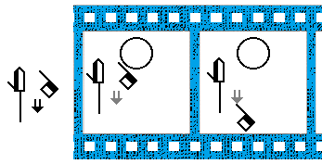

Xiex (What in Maltese Sign Language)

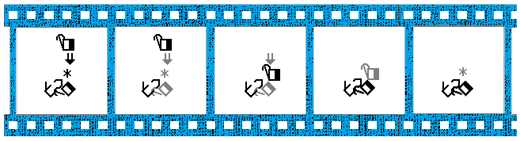

Acheter (Purchase in LSQ)

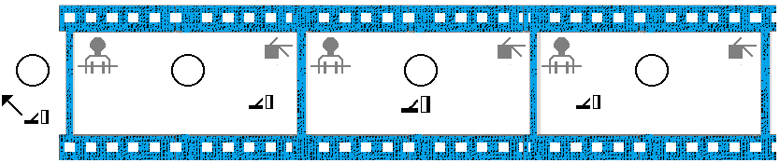

To give a car to the right to someone to the left (LSQ)

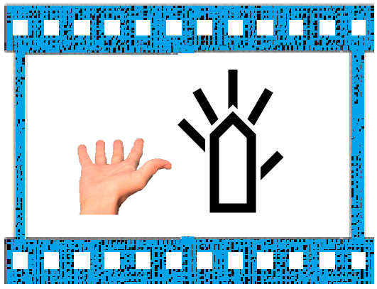

Frost, Adam (2010) ISWA 2010 Symbol. Lessons Online Web lessons show all hand shapes moving with symbols. <http://www.signwriting.org/lessons/iswa/>

### Dictionary Mode

A SignWriting dictionary with animations may be easier to read for less experiences sign writers. It can be a simple alternative to existing dictionaries using videos.

|  |  |  |  |  |
| --- | --- | --- | --- | --- |
| Dictionary Mode (gif) | | | | |
| Unit size | Context | Frame speed | Reader’s attention | Search |
| Sign in SignWriting.  SignAnimating sequence of symbols. | Image.  Individual signs | Very fast. | When needed. | Cannot search.  Wait next loop. |
| The message structure is obvious for teaching material.  Animations are embedded in a PowerPoint presentation or an html page on an intranet, on internet and even on a CD-ROM. | | | | |

|  |  |  |
| --- | --- | --- |
| **Strauß** http://www.oiseaux.net/photos/loic.epelboin/images/autruche.d.afrique.loep.6g.jpg |  |  |

Ostrich (German prononciation, DGS SignWriting with SpeechWriting and SignAnimating first frames)

|  |  |  |
| --- | --- | --- |
| **Éléphant** |  |  |
| **Funambule**  http://www2.csdm.qc.ca/Gadbois/Eleves/cirque/contenu/images/funambule.jpg | http://www.signbank.org/signpuddle2.0/glyphogram.php?size=0.7&ksw=M31x34S1001an30x19S11504n9xn14S26506n15xn33S225109x6 |  |
| **Jongler** | http://www.signbank.org/signpuddle2.0/glyphogram.php?size=0.7&ksw=M42x52S1503016xn41S15038n42xn52S15636n4x18S1563en38x13S2e600n11xn20S2e618n30xn21S2fd04n21x46 |  |

Elephant, tightrope walker and juggle (LSQ SignWriting and SignAnimating first frames)

### Anki Electronic Flashcards Mode

In the example, we see a free SignWriting flashcard application developed with SignWriter StudioTM and Anki. With SignWriter StudioTM dictionary, everybody can export easily a selected subset of any SignWriting dictionary. Anki and Ankidroid display the words on a frequency based on the errors of the user. Anki and Ankidroid can display text and small MP4 videos. Anki can be used online, offline and even on Android cell phones. Anki interface is multi-lingual and it is often used to learn languages (for example Chinese).

<http://signwriterstudio.com/>

<http://ankisrs.net/>

<https://ankiweb.net/>

<https://play.google.com/store/apps/details?id=com.ichi2.anki&hl=fr>

|  |  |  |  |  |
| --- | --- | --- | --- | --- |
| Flashcards Mode (gif) | | | | |
| Unit size | Context | Frame speed | Reader’s attention | Search |
| Sign in SignWriting.  SignAnimating sequence of symbols. | Individual signs | Static.  Very fast. | When needed. | Cannot search.  Wait next loop. |
| The message structure is obvious for teaching material.  Anki can be used online, offline and even on Android cell phones. | | | | |

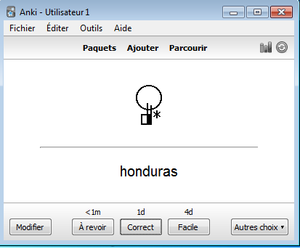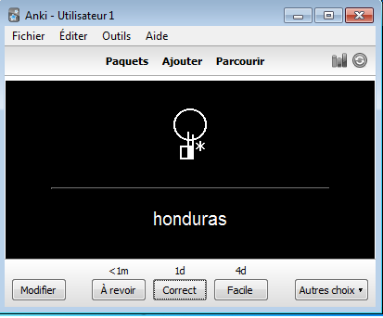

## Overview of SignAnimating and SpeechAnimating Modes

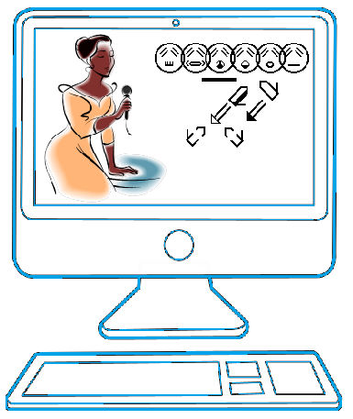

Willkommen (Welcome in DGS)

### SpeechWriting - Mundbilder in GebärdenSchrift

The SpeechWriting system was invented by Stefan Wöhrmann (refer to the partial bibliography of his work and to volume 4 of this series). He integrated it in animations.

SpeechWriting may be used in animation. Several base frames are required for mouth configuration. A frame with a neutral mouth is required. The amount of visible syllables combined with the amount of hand configuration or displacement determines the minimal number of frames required. We assume that 4 syllables are pronounced per second and that some may not be readable on lips.

Articulation is superposed with SignWriting. Care must be taken to not overlap articulation with a neutral mouth, the eyes or the nose. Hand shapes close to the head should remain clearly displayed, if not in all frames, at least in some frame to be read.

For static SignWriting with articulation, the size of the frames will contain the largest amount of faces with mouth to carry the intended message.

**Mundbilder in GebärdenSchrift**

**(articulatory movement writing)**

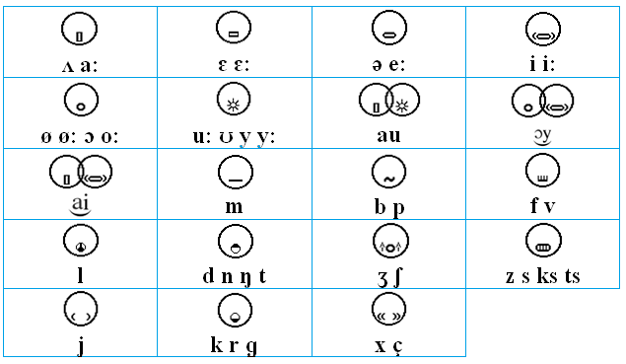

We will use the German word and sign for Strauß (Ostrich in German) to compare the SpeechAnimating modes.

Officially, the sign is written as follow in Jacobsen, Birgit (2007) Das Gebardenbuch Das kleine 1x1 der Gebardensprache. Band 2. Hamburg, Geermany. The SignWriting uses Stefan Wöhrmann’s SpeechWriting system representing the visemes (Mundbild) that can be read on lips.

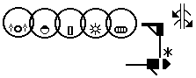

The SignWriting is completed with a sequence of phoneme symbols (Mundbildschrift) matching a phonetic character.

|  |  |  |  |  |  |
| --- | --- | --- | --- | --- | --- |
|  | | | | | |
| ʃ | t | r | a | ʊ | s |

Depending on the purpose of the animation, several sub-sets of those symbols may be animated.

### SignWriting Mode

SignWriting Mode represents the sign in one frame. Several signs may be displayed one after the other, each in a single frame.

|  |  |  |  |  |  |
| --- | --- | --- | --- | --- | --- |
| SignWriting Mode (gif or video) | | | | | |
| Unit size | | Context | Frame speed | Reader’s attention | Search |
| Sign. | Sign.  Sentence. | | Fast. | Constant.  Can pause a video.  Cannot read forward and backward. | Wait next loop.  Hard to find beginning of a sign within a sentence. |
| Allows displaying a long text within a small surface. | | | | | |

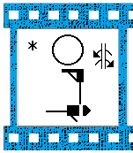

### SignAnimating Mode

SignAnimating Mode represents the sign in several frames. Several signs may be displayed one after the other, each in several frames.

|  |  |  |  |  |
| --- | --- | --- | --- | --- |
| SignAnimating Mode (gif or video) | | | | |
| Unit size | Context | Frame speed | Reader’s attention | Search |
| Symbols. | Sign. | Fast. | Constant.  Can pause. | Wait next loop.  Hard to find beginning of a sign within intermediary symbols |
| Can convey a message accurately with many details. Needs more frames than SignWriting. Need to create intermediary frames for animation purpose. Can be displayed with high frame rate depending on the reader’s expected speed; but with more frames. Takes longer to edit intermediary positions and hand shapes. Need to follow some SignAnimating standards for reusability and to accelerate the editing. SignWriting standards do not suffice. | | | | |

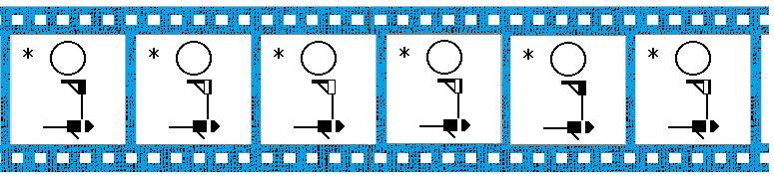

### SpeechWriting - Mundbilder in GebärdenSchrift Mode

SpeechWriting symbols - Mundbilder in GebärdenSchrift (articulatory movement writing) may be displayed in an animated gif image. The SpeechWriting is either horizontal or vertical. The faces are not centered. Horizontally; the reader’s eyes focus on the left edge of the animation and go toward the left for longer words. Vertically; the reader’s eyes focus on the top of the animation and go downward for longer words.

|  |  |  |  |  |
| --- | --- | --- | --- | --- |
| SpeechWriting - Mundbilder in GebärdenSchrift Mode (gif and video) | | | | |
| Unit size | Context | Frame speed | Reader’s attention | Search |
| Word. | Sentence. | Slow. | Constant.  Can pause. | Wait next loop for Gif.  Slow frames easy to browse but slow to view for videos. |
| The symbols are in a sentence context.  The message structure is not obvious for a Deaf reader unless the SpeechWriting is combined with SignWriting. It is a representation of lip reading and the associated difficulties to distinguish phonemes that share the same visemes. Some phonemes are not lip readable, they are not represented in SpeechWriting unless by longer previous phonemes. | | | | |

|  |  |
| --- | --- |
| Vertical SpeechWriting | Horizontal  SpeechWriting |
|  |  |
| Bonne journée (Good day in French) | |

### SpeechAnimating Mode

SpeechAnimating symbols may be displayed in an animated gif image. It may be used for short messages. The message structure is not obvious for a Deaf reader unless the SpeechAnimating is combined with SignAnimating. It is a representation of lip reading and the associated difficulties to distinguish phonemes that share the same visemes. Some phonemes are not lip readable, they are not represented in SpeechWriting - Mundbilder in GebärdenSchrift - unless by longer previous phonemes.

|  |  |  |  |  |
| --- | --- | --- | --- | --- |
| SpeechAnimating Mode (gif and video) | | | | |
| Unit size | Context | Frame speed | Reader’s attention | Search |
| Viseme. | Sentence. | Slow. | Constant.  Can pause. | Wait next loop for Gif.  Slow frames easy to browse but slow to view for videos. |
| The symbols are in a sentence context. | | | | |

In the example, to provide some structure, we introduced an Eyes Blink symbol with a Neutral Mouth symbol to represent the end of a word and a period to indicate an end of sentence.

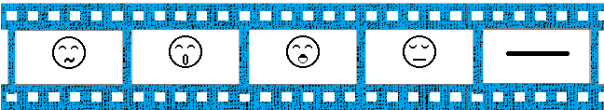

Bonne (Good in French)

### Mundbildschrift Word Mode

The pronunciation of a word is displayed graphically. The written word can be displayed in subtitled to associate it to the pronunciation. The symbols may be displayed horizontally or vertically.

|  |  |  |  |  |
| --- | --- | --- | --- | --- |
| Mundbildschrift Word Mode (gif or video) | | | | |
| Unit size | Context | Frame speed | Reader’s attention | Search |
| Word | Sentence. | Slow. | Constant.  Can pause a video.  Cannot read forward and backward. | Wait next loop. |
| Allows displaying several words within a small surface. The reader could pronounce the sounds while they are displayed. | | | | |

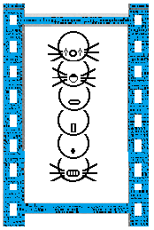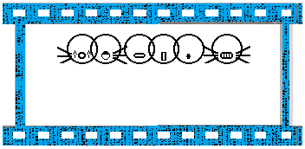

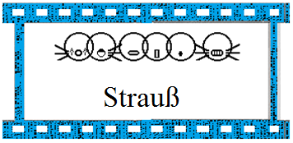

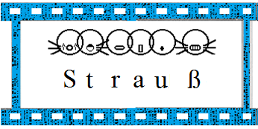

### Mundbildschrift Phoneme Mode

Mundbildschrift Phoneme Mode represents phonemes in several frames. It can be used to teach speech. It may contain text or phonetic subtitles.

|  |  |  |  |  |
| --- | --- | --- | --- | --- |
| Mundbildschrift Phoneme Mode (gif or video) | | | | |
| Unit size | Context | Frame speed | Reader’s attention | Search |
| Phoneme | Word. | Fast. | Constant.  Can pause a video.  Cannot read forward and backward. | Wait next loop.  Hard to find beginning of a word within phonemes symbols. |
| Allows displaying several words within a small surface. The reader could pronounce the sounds while they are displayed. | | | | |

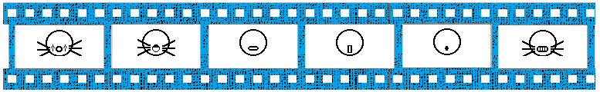

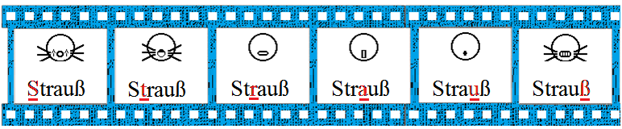

### Mundbildschrift with SignAnimating Mode

Mundbildschrift with SignAnimating Mode represents each phoneme in several frames with the sign. The reader could pronounce the sounds while they are displayed. It is the most complete way to express a sign with articulation through an animation.

|  |  |  |  |  |
| --- | --- | --- | --- | --- |
| Mundbildschrift with SignAnimating Mode (gif or video) | | | | |
| Unit size | Context | Frame speed | Reader’s attention | Search |
| Phoneme | Word.  Sign. | Fast. | Constant.  Can pause a video.  Cannot read forward and backward. | Wait next loop.  Hard to find beginning of a word within phonemes symbols and intermediary movements of the sign. |
| Allows displaying several words within a small surface. | | | | |

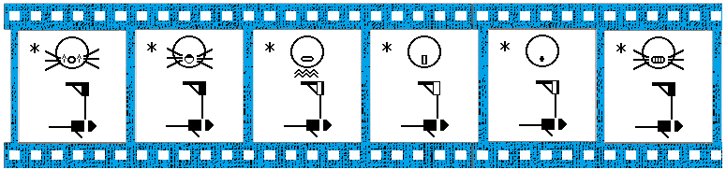

### SpeechWriting - Mundbilder with SignWriting Mode

SpeechWriting - Mundbilder and SignWriting is a concise combination of the visemes with the signs. It resumes in a single image all what the Deaf person sees during the communication of a sign with articulation.

|  |  |  |  |  |
| --- | --- | --- | --- | --- |
| SpeechWriting with SignWriting Mode (gif or video) | | | | |
| Unit size | Context | Frame speed | Reader’s attention | Search |
| Word.  Sign. | Sentence | Slow. | Constant.  Can pause a video.  Cannot read forward and backward. | Wait next loop.  Can search a sign within a sentence |
| Allows displaying several words within a small surface. | | | | |

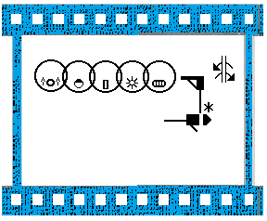

### SpeechAnimating with SignAnimating Mode

SpeechAnimating and SignAnimating is a combination of the visemes with the signs. It represents dynamically and precisely what the Deaf person sees during the communication of a sign.

|  |  |  |  |  |
| --- | --- | --- | --- | --- |
| SpeechAnimating with SignAnimating Mode (gif or video) | | | | |
| Unit size | Context | Frame speed | Reader’s attention | Search |
| Phoneme.  SignWriting symbols. | Word.  Sign. | Fast. | Constant.  Can pause a video.  Cannot read forward and backward. | Wait next loop.  Hard to find beginning of a word within visemes symbols and intermediary movements of the sign. |
| Allows displaying several words within a small surface. | | | | |

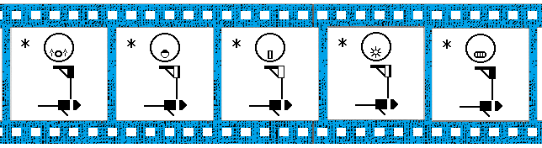

### Cued Speech with SpeechAnimating Mode

Cued speech is used to teach written languages and also lip reading. It is a visual representation of a spoken language. Cued speech was invented by the Dr. Orin Cornett in the United States in 1966. Speech has many phonemes that look the same by lip reading. Several phonemes are not visible by lip reading. Cued speech combines the visemes information with hand configurations and positions. This allows distinguishing each phoneme.

It is a syllabic system where in French:

* Oral syllables are displayed by the movement of the lips and the tongue,
* The oral consonants and half-consonants are distinguished by 8 hand configurations,
* The oral vowels are distinguished by 5 hand positions relatively to the face.

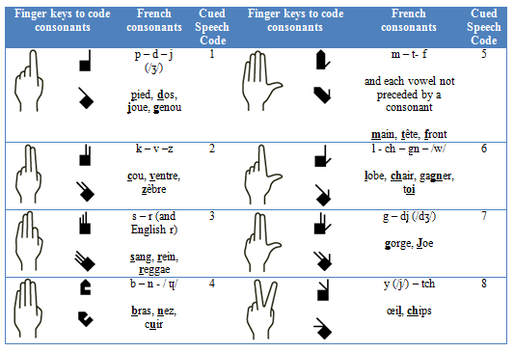

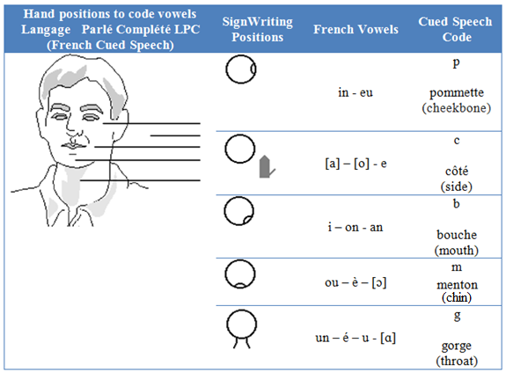

Cued speech differs from sign language. It is not a language. It is a system of codes used to teach speech and written language. The teacher speaks to students while placing a hand shape on a location on the face.

To write cued speech we use the word in text and add a number and a letter representing the hand shape and its position on the face. There is no written version for the mouth configuration.

|  |  |  |
| --- | --- | --- |
| Viens voir | V/iens/ v/oi/r | 2c 8p 2c 6g 3c |
| (Come see in French and Langage Parlé Complété LPC) | | |

The written version of cued speech is text based. Wöhrmann’s SpeechWriting system (Mundbilder) expresses clearly the mouth configuration and SignWriting expresses clearly hand shapes and localisation. We combine both notations to animate cued speech. Refer to to volume 4 of this series for details.

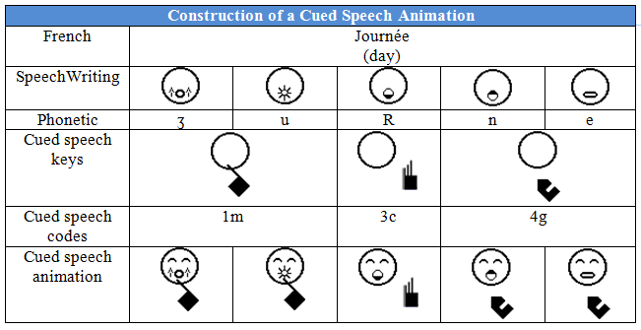

|  |  |  |  |  |
| --- | --- | --- | --- | --- |
| Cued Speech with SpeechAnimating (gif or video) | | | | |
| Unit size | Context | Frame speed | Reader’s attention | Search |
| Phoneme. | Syllable. | Very fast | Constant | Wait next loop.  Hard to find beginning of a word within intermediary syllables. |
| Cued speech completes lip reading to distinguish phonemes. | | | | |

In the example, to provide some structure, we introduced an Eyes Blink symbol with a Neutral Mouth symbol to represent the end of a word and a period to indicate an end of sentence.

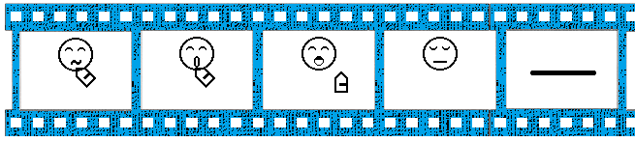

Bonne (Good with LPC cued speech in French)

## SignAnimating Subtitle Modes

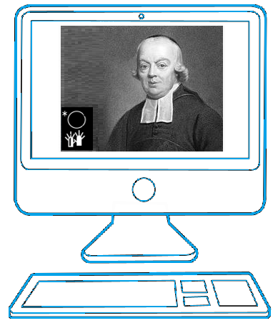

Text and illustration copied from ASL Wikipedia article on Charles-Michel de l’Épée: <http://www.signwriting.org/encyclopedia>

### SignWriting Subtitling With One Sign Mode

Signs are displayed one after the other in pure SignWriting. Movement and contact symbols are displayed close to the hand shapes, not in a corner. There is no zoom applied when the hand shape is closer to the body. The SignWriting may contain simultaneously two locations for the hands (before and after a movement).

|  |  |  |  |  |
| --- | --- | --- | --- | --- |
| SignWriting Subtitling With One Sign at a Time Mode (gif or video) | | | | |
| Unit size | Context | Frame speed | Reader’s attention | Search |
| Sign. | Image.  Sign. | Fast. | Constant.  Can pause. | Wait next loop.  Hard to find beginning of a sentence. |
| Can convey a message accurately and concisely. Needs fewer frames than SignAnimating; no need to create intermediary frames for animation purpose. Can be displayed faster depending on the reader’s expected speed. Can be edited rapidly. No need to follow SignAnimating standards, SignWriting standards suffice. | | | | |

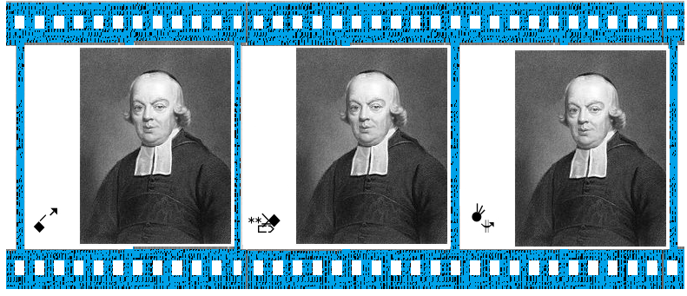

### SignAnimating Subtitling With One Sign Mode

Hand shapes, facial expressions, shoulders symbols are displayed. Contact symbols are not displayed close to the hand shapes; they are always in the top left corner. The hand shapes are zoomed in or zoomed out when they are closer or further the body. There is at most two hand shapes in one position.

|  |  |  |  |  |
| --- | --- | --- | --- | --- |
| SignAnimating Subtitling With One Sign at a Time Mode (gif or video) | | | | |
| Unit size | Context | Frame speed | Reader’s attention | Search |
| Symbols. | Image.  Sign. | Fast. | Constant.  Can pause. | Wait next loop.  Hard to find beginning of a sign within intermediary symbols |
| Can convey a message accurately with many details. Needs more frames than SignWriting. Need to create intermediary frames for animation purpose. Can be displayed with high frame rate depending on the reader’s expected speed; but with more frames. Takes longer to edit intermediary positions and hand shapes. Need to follow some SignAnimating standards for reusability and to accelerate the editing. SignWriting standards do not suffice. | | | | |

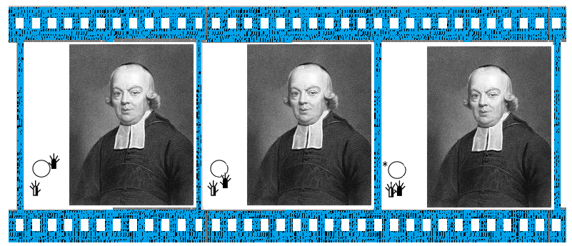

### One Signwriting Column Simultaneous With Illustrations Mode

A column of SignWriting may be displayed beside the video. After an instant, a new column replaces the previous. There is no overlap between the frames text. This allows the reader to focus on the video, read ahead or have time to pause the video. The punctuation structures the message. Illustrations or videos are displayed simultaneously with sentences. The reader focus is split between the text and the embedded video or illustrations.

|  |  |  |  |  |
| --- | --- | --- | --- | --- |
| One SignWriting Column Simultaneous With Illustrations Mode (video) | | | | |
| Unit size | Context | Frame speed | Reader’s attention | Search |
| Partial or complete sentence. | Image.  Sentence. | Very slow. | Can pause.  Automatic pauses.  Can read forward and backward  Text competing with images. | Slow frames.  Easy to browse but slow to view.  Easy to find beginning of a sentence. |
| The animation is slow enough to give time to the viewer to read and to watch embedded videos or illustrations. The viewer may lack of time or feel the pace is too slow. | | | | |

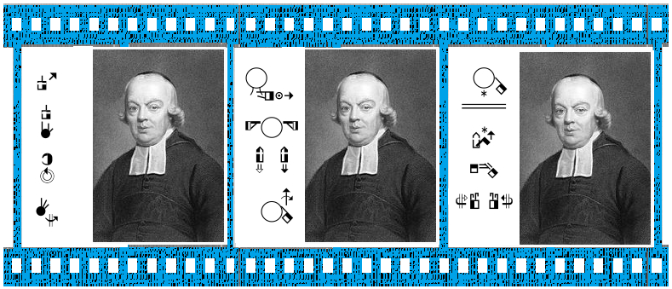

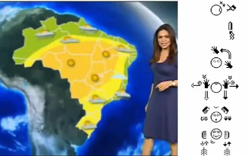See the following video from Brazil on You Tube, about captioning video in SignWriting using a software developed in Brazil: Previsão do tempo com SW by Ronnie Fagundes de Brito.

<https://www.youtube.com/watch?v=gvtdzaOVj-I>

### Several Scrolling SignWriting Columns with Illustrations Mode

SignWriting symbols may scroll up at each frame: removing the top sign and inserting a new sign at the bottom. This allows the reader to focus on the video, read ahead or have time to pause the video. This requires attention from the reader to keep an eye on the text to read before unread symbols are lost. The punctuation structures the message. In a video, the reader can rewind the message to the missed sign. Several frames contain the missed symbol, it is easier to find.

|  |  |  |  |  |
| --- | --- | --- | --- | --- |
| Several Scrolling SignWriting Columns With Illustrations Mode (video) | | | | |
| Unit size | Context | Frame speed | Reader’s attention | Search |
| Partial or complete sentence. | Image.  Sentence. | Very slow. | Can pause.  Automatic pauses.  Can read forward and backward.  Text competing with images. | Slow frames.  Easy to browse but slow to view.  Easy to find beginning of a sentence. |
| The animation is slow enough to give time to the viewer to read and to watch embedded videos or images. The viewer may lack of time or feel the pace is too slow. | | | | |

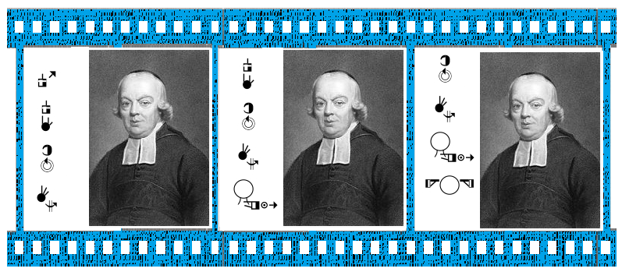

## Electronic Book Behaviour Modes

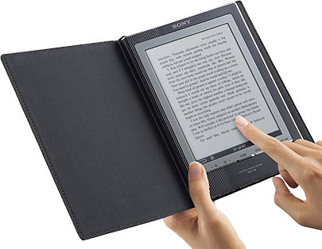Several columns of SignWriting may be displayed with a video. After an instant, new columns replace the previous. This allows the reader to focus on the video, read or have time to pause the video. The punctuation structures the message. In a video, the reader can rewind the message to the missed sign. The animation behaves like an electronic book. It is possibly the most efficient and concise way to carry information within a video. Only a Pdf with pure SignWriting and illustrations can be closer from an electronic book and more convivial.

### Presentation with Illustrations Mode

Sequences of SignWriting follow one another. There is no overlap between the sequences. Illustrations or videos are inserted between sentences. The reader focus passes form the text to the embedded video or illustration smoothly.

|  |  |  |  |  |
| --- | --- | --- | --- | --- |
| Presentation With Illustrations Mode (video) | | | | |
| Unit size | Context | Frame speed | Reader’s attention | Search |
| Partial or complete sentence. | Image.  Sentence. | Very slow | Can pause.  Automatic pauses.  Can read forward and backward  Text alternating with images. | Slow frames.  Easy to browse but slow to view.  Easy to find beginning of a sentence. |
| The animation gives time to the viewer to read and to watch embedded videos or images. | | | | |

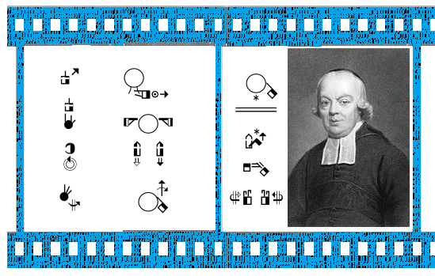

### Several Signwriting Columns Simultaneous With Illustrations Mode

Several columns of SignWriting may be displayed beside the video. After an instant, new columns replace the previous. This allows the reader to focus on the video, read ahead or have time to pause the video. The signs are within a sentence context. The punctuation structures the message. In a video, the reader can rewind the message to the missed sign. Frames are slower because much text is displayed, so more time is lost while waiting for the desired frame.

|  |  |  |  |  |
| --- | --- | --- | --- | --- |
| Several SignWriting Columns Simultaneous With Illustrations Mode (video) | | | | |
| Unit size | Context | Frame speed | Reader’s attention | Search |
| Partial or complete sentence. | Image.  Sentence. | Very slow. | Can pause.  Automatic pauses.  Can read forward and backward.  Text competing with images. | Slow frames.  Easy to browse but slow to view.  Easy to find beginning of a sentence. |
| The animation is slow enough to give time to the viewer to read and to watch embedded videos or images. The viewer may lack of time or feel the pace is too slow. | | | | |

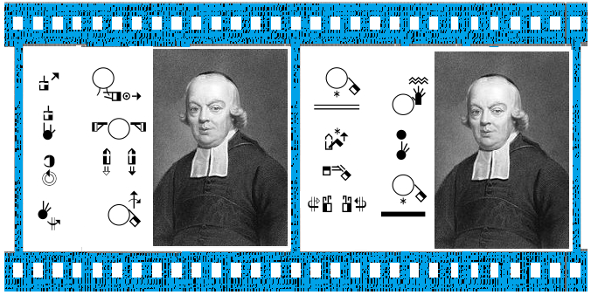

# Conclusion

With this series of four SignAnimating documents, we demonstrated that SignWriting symbol set is complete and sufficient. It can be used for accurate animations of sign languages and spoken visemes when combined with SpeechWriting.

Just like radio, television, books and handwriting are different forms of communication; SignWriting, SignAnimating, subtitles, avatars and videos are different ways to communicate with Deaf people. Each of these media has its benefit and cannot be fully replaced by the others. As sign languages will become more recognized as official languages, the need to write them down will grow. SignWriting will be the natural choice because of its clarity, its expressiveness, its rigor and its wide spread usage.

# Bibliography

Documents can be downloaded for free at:

* <http://www.signwriting.org/archive/docs2/sw0116-Lessons-SignWriting.pdf>
* <http://www.signwriting.org/lessons/books/>
* <http://www.signwriting.org/lessons/web/>
* <http://www.signwriting.org/lessons/elessons/>
* <http://www.signwriting.org/archive/docs5/sw0493-SWLessonsBook-Parkhurst-EngLSE.pdf>
* <http://www.signwriting.org/lessons/iswa/>
* <http://std.dkuug.dk/jtc1/sc2/wg2/docs/n4090.pdf>

About SignWriting, refer to:

* Sutton, Valerie (2014) Lessons in SignWriting. Text book. Center for Sutton Movement Writing, Inc. La Jolla, California. USA. Available for free online. Several illustrations of this document are an adaptation of the textbook.
* Sutton, Valerie and Frost, Adam (2010) SignWriting Reference Manual 2. SignWriting Hand Symbols, ISWA 2010 by Valerie Sutton. Available for free online.
* Parkhurst, Dianne and Parkhurst, Stephen (2010) A Cross-Linguistic Guide to SignWriting®. A phonetic approach.
* Frost, Adam (2010) ISWA 2010 Symbol. Lessons Online Web lessons show moving hand shapes with symbols.
* Everson, Michael; Slevinski, Stephen; Sutton, Valerie (2011-08-05) Revised proposal for encoding the SignWriting script in the SMP of the UCS Universal Multiple-Octet Coded Character Set. International Organization for Standardization. JTC1/SC2/WG2 N4090R. L2/11-217R

**Leçons en français pour apprendre à écrire les signes:**

**Sutton, Valerie (2002) Leçons en SignWriting...lire et écrire les mouvements des langues des signes. Les langues des signes sont des langues écrites.** Center for Sutton Movement Writing, Inc. La Jolla, California. USA. Disponible en téléchargement gratuit:

* <http://www.signwriting.org/archive/docs3/sw0221-Lecons-SW-Francais-1.pdf>
* <http://www.signwriting.org/archive/docs3/sw0222-Lecons-SW-Francais-2.pdf>
* <http://www.signwriting.org/archive/docs3/sw0223-Lecons-SW-Francais-3.pdf>
* <http://www.signwriting.org/archive/docs3/sw0224-Lecons-SW-Francais-4.pdf>

About SpeechWriting:

Documents can be downloaded for free at:

* <http://www.signwriting.org/symposium/presentation0002.html>
* <http://www.gebaerdenschrift.de/>
* <http://www.gebaerdenschrift.de/read/Mundbilder/uebersicht_mundbilder.htm>.

**Wöhrmann, Stefan (2014) Wöhrmann´s SpeechWriting, in SignWriting Documents, Teaches Deaf Students Spoken Language.**

Additional readings about SpeechWriting:

Even for a non-German reader, the information is clear and the phonetic notation may be used in other languages.

Refer to the work of Stefan Wöhrmann, at <http://www.gebaerdenschrift.de/> and “Übersicht über die in der Mundschrift verwendeten Symbole (Stand Februar 2002)” at <http://www.gebaerdenschrift.de/read/Mundbilder/uebersicht_mundbilder.htm>.

Stefan Wöhrmann SpeechWriting symbol set is presented for German in:

“Übersicht der Mundbild-Symbole in der GebärdenSchrift (Stand Juni 2012)”

Also, a conversion table toward phonetic was published:

Stefan Wöhrmann (2007) “Die Mundbilder in der GebärdenSchrift” and “Die Mundbildschrift” in Jacobsen, Birgit. Das Gebärdenbuch Band 2. Pages 181-192. Hamburg. Germany.

Download sign fonts for Microsoft word here:

* <http://www.searchfreefonts.com/free/gallaudet.htm>
* <http://www.searchfreefonts.com/free/handsign.htm>

About cued speech or French Langage Parlé Complété (LPC) consult:

* <http://www.cuedspeech.org/>
* <http://www.cuedspeech.org/cued-speech/international-cue-charts.php>
* <http://cure-lequin.ecoles.csmv.qc.ca/ecole-st-jude/lpc/>
* <http://cure-lequin.ecoles.csmv.qc.ca/files/2011/09/Dictionnaire-LPC_v8.pdf>
* <http://sourdsressources.wordpress.com/2012/02/09/bref-petit-cours-dlpc/>
* <http://www.alpc.asso.fr/category/accueil/>

Animations:

We suggest visiting the animation web page: <http://movementwriting.org/animation/sgn-DE/> . It displays a welcome message in German Sign Language.

*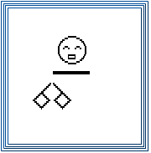“A wonderful animation is on the opening page of the German SignWriting web site, designed and animated by Stefan* Wöhrmann*, a teacher of Deaf children in Osnabruck:*

[*http://www.gebaerdenschrift.de*](http://www.gebaerdenschrift.de)

*Historically, this is the first animation of a full SignWriting sentence. For those who know how to sign, it looks as if someone is standing in front of you, signing! You can follow along and sign with the animation. Spoken languages cannot be animated in the same way that SignWriting can. Animated sentences hold the potential of teaching deaf children to read full sentences sooner, and with better understanding.”*

Several other animations are available at: <http://www.movementwriting.org/animation/>