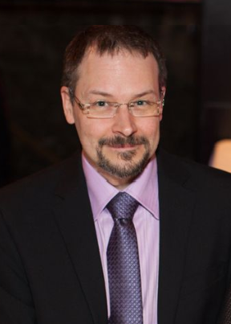
André Lemyre is a Bachelor of Social work and in Computer Sciences.
He has worked as a counselor helping new immigrants adjust to living in Canada, and now works as a software tester in the medical field.
He has a long standing interest for written and spoken languages covering, French, English, Spanish, Creole, classical Arabic, Interlingua, Braille, Morse code, simplified Chinese writing system, Quebec Sign Language (LSQ), tactile Quebec sign language (LSQT), Cued Speech (Langage parlé complété québécois LPC) and SignWriting.
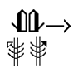
He developed an activity guide to teach SignWriting to children and several documents on SignAnimating.

His objective is to support the development of sign language by the diffusion of teaching material for Deaf children, Deaf and hearing adults. Currently, he is involved in:
- Supporting the development of free dictionaries in video, printed version with pictures or in SignWriting.
- Translating SignWriting material in French and develop new material.
- Assisting in the testing of SignWriting software.

I am a Bachelor of Social work and in Computer Sciences.
I worked as a counselor helping new immigrants adjust to living in Canada, and now I work as a software tester in the medical field.
I have a long standing interest for written and spoken languages covering, French, English, Spanish, Creole, classical Arabic, Interlingua, Braille, Morse code, simplified Chinese writing system, Quebec Sign Language (LSQ), tactile Quebec sign language (LSQT), Cued Speech (Langage parlé complété québécois LPC) and SignWriting.
I developed an activity guide to teach SignWriting to children and several documents on SignAnimating.
My objective is to support the development of sign language by the diffusion of teaching material for Deaf children, Deaf and hearing adults. Currently, I am involved in:
- Supporting the development of free dictionaries in video, printed version with pictures or in SignWriting.
- Translating SignWriting material in French and develop new material.
- Assisting in the testing of SignWriting software.

André Lemyre

