ABSTRACT
Presentation 12
SignWriting Symposium 2014

DELEGS-Editor: A Software Tool For
Teaching Deaf Students Spoken Language

Stefan Wöhrmann

Teacher of Deaf Children
Osnabrück School for the Deaf (LZBH)
Landesbildungszentrum fur Hoergeschaedigte
August-Hoelscher-Straße 89,
49080 Osnabrück, Germany
stefanwoehrmann@gebaerdenschrift.de

For many years, I have been concerned with the question of how I can support my deaf students to develop better oral language skills (better speech).

First, starting in 1999, I worked for many years with the SignWriter DOS computer program, programmed by Richard Gleaves. I created an extensive German Sign Language dictionary, but this finally reached its limits, because it could not accommodate the large number of new signs I wished to write. The SignWriter DOS computer program's dictionary feature could only include up to 10,000 sign entries, and I had many more signs than that!

After switching to Windows XP, I was able to continue to use the SignWriter DOS program in conjunction with another program called DOS-BOX, which makes it possible to use SignWriter DOS on a variety of operating systems to this day. However, I still needed a bigger dictionary feature, which SignWriter DOS could not provide.

In 2004, thanks to the tireless work of software developer Stephen E. Slevinski Jr., a new software program was created - called "SignPuddle". SignPuddle gave me new opportunities to create SignWriting documents and dictionaries, and I could add unlimited amount of signs to the German Sign Language Dictionary in SignPuddle, so that problem was solved! Our current dicionary holds 22,805 signs!

For the practical work at my school here (the Osnabrück School for the Deaf in Germany), however, we needed some specific features for my students, that the SignPuddle software did not provide us. This has been overcome by the development of new software called the DELEGS Editor, developed here in Germany, at the University of Hamburg, with close cooperation between computer scientists on the one hand, and deaf and hearing educators on the other hand. This led to the DELEGS Editor, a software tool that directly takes into account the practical wishes and bilingual needs of teachers and students in everyday school life.

Educators are now optimally supported in the preparation of bilingual teaching and learning materials. The development is not yet complete. Further efforts to enhance the capabilities of this software are being made in the current development project. This Delegs Editor, is a freely available Web application. No need to install any software!

One types directly – as in a Microsoft Word document on a standard A4 sheet of paper, the individual spoken-language words from left to right. If the equivalent words, terms and written signs are in the SignPuddle Dictionary, then this sign will now appear directly in the line above the word you just typed. We refer to this line as a sign signature line.

You can also choose other alternative choices of signs from the SignPuddle Dictionary, if they exist in the dictionary. The choices of signs can be quickly checked and selected.

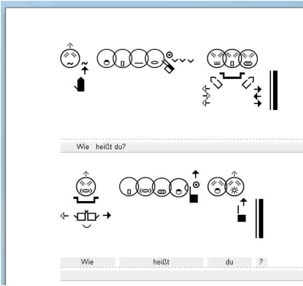

Example of a document written with the
Delegs Editor using the DGS-SignPuddle
as a background dictionary.
https://www.delegs.com/delegseditor/
In my presentation, I will give a brief introduction showing how the procedure in my classroom works, when students use the Delegs Editor. I will also explain how I create documents using the Delegs software.

I do not want to give a precise description of the technical foundations of this web application. On one hand I am not an expert in this field, on the other hand I want to focus on questions of practical application. Interested software developers may find suitable information by contacting our Delegs team.

It is my pleasure to present live at the SignWriting Symposium via the internet. I wish to practically demonstrate how easy it is now to design and create bilingual documents between written spoken and sign languages using the Delegs Editor.

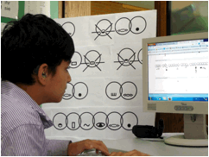

One of my students working on his own
with the Delegs Editor program

In my presentation I will show how a new document is created and how this document can be eventually saved or printed on your own computer as a PDF. Participants on site then have an opportunity to directly create their first document with this fantastic software.

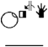Stefan

