HOW TO PRINT TO PDF
> Example from the Swiss French SIGNPUDDLE

- http://www.signbank.org/signpuddle
- Select the Swiss French flag
- Open the Swiss French dictionary SignPuddle
- Example to print the list of all animals of the FARM

- Select search by word button 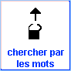
- In this example Write « liste: ANIMAUX DE LA FERME » (sorry it’s in French it means FARM ANIMALS )
- Click on search button 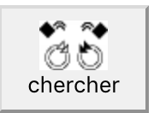

2 options to PRINT:

OPTION 1
If you click on the result you’ll see all the words in the list in the FARM ANIMALS list (theme). You can print the list going at the bottom of the page and clicking on the PRINT TO PDF

OPTION 2
Directly click on the PRINT TO PDF button

You see all the vocabulary items (words/signwriting) of this list
You can keep all the word of the list or take away some of them which you don’t want to print (by clicking on them)

You can put them in order A B C D…. or leave them mixed

You have to set up your printing settings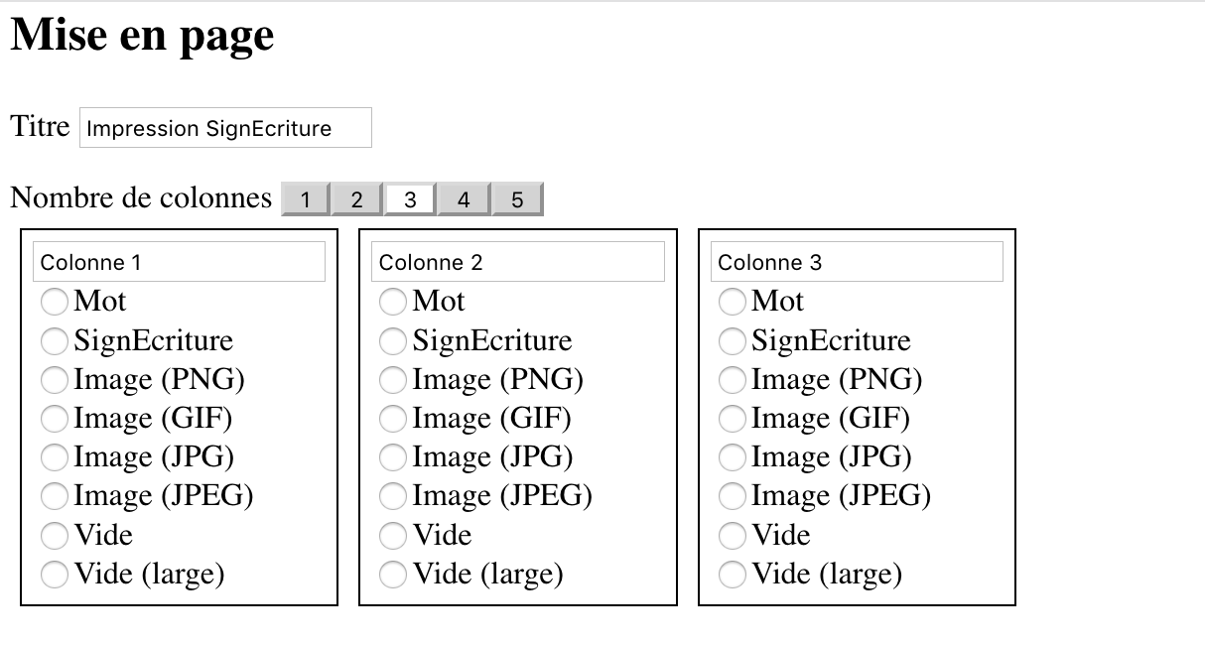
- How many columns do you want?
  - You can pick 1 to 5 columns (You can set your columns the way you want, the order)
    - Word
    - Signwriting (signecriture)
    - PNG = illustrations or picture of LSF
    - JPG = images
    - Empty= empty column to let children write the word a sentence (choose a large empty column) or draw ….
  - Size of you paper USLetter / A4
  - You have to choose the layout of your page PORTRAIT/LANDSCAPE(better to choose landscape if you have 5 columns…)
- Once all your settings are done > you can click to PRINT TO PDF or HTML (and your computer will get it ready for you)
- Open you downloaded document to check if everything is OK….
- You can print it…

