A home and education for deaf children
by Kristina Tworek
SignWriting Symposium 2016, Presentation 53

In Peru there are lots of deaf children, especially in the south. Some time ago there was a home for deaf children here in Sicuani, however now the situation changed. Right now only disabled children, for example with down syndrom are staying there. That is why we want to open a new place for all the deaf children in the South of Peru. In the house they are supposed to get food, because good and healthy nutrition is so important for their physical development and for their health in general.
Moreover we want to create a place, where they get a bed and a significant other they can come to, because unfortunately most of the indigent and disabled children are left out of society. We want to give these children a home, where they feel comfortable and happy. That is why we want a primary school for all the deaf children in the south of Peru. The education of this children is so important for their future. In primary school they will learn the basics, how to communicate and express themselves. There they will have the opportunity to learn:
1) signing
2) speaking
3) lipreading
If they don’t have the opportunity to learn these three basics, they don’t have the same rights for their future as other children have. They have the right for equal opportunities. We want to try to make it possible at any cost. For the necessary educaction there is a big possibility: “SignWriting”. It is a system of writing to demonstrate movements and hand, arm and the used face gestures in the language of sings. This system that we will use in primary school, will make it easier to learn the signs and will improve the comprehension of Spanish, its grammatic and the language in general.
In the following attachment you will find an example for our idea how to learn by just playing a game.
Deaf children have to learn two languages, their mother tongue and the signs of the country they are living in. It is so necessary, that we help them with those things. If the deaf kids learn and practice the basics they will be able to go to any high school in the city. In the afternoon we can accompany the children, when they have to do their homework.
Of course the children still need support with their homework and to manage some things. But with the knowledge they will already be able to ask us for help and how to look for a solution on their own.
That’s a big and an important point in the primary school to learn how to help themselves whith a problem. They have to think and find a resolution and we will just be there to support them. In the afternoon the kids can sit together in groups and talk about whatever they want.
The house should be able to offer the opportunity to communicate. They can talk about school stuff, but also about stuff, that doesn’t belong to the school. There will be space for feelings, emotions and life concerned matters. It should be a place where they dont feel alone. This is really neccessary for their personal develpoment. At this age they make so many experiences. They have to be able to develop normally and age-appropriate.
We will need many people and help, but it’s not a problem because here, we have great possibilities. In Sicuani and around there are lots of deaf adults. They can also help and learn in the house and primary school. They will have an exemplary function.
We are team of two people (a teacher for sign language from Peru and a german student) with a lot of help from the people in Sicuani and Peruvian people in general.
The project belongs to “Young Talents”, which is a german trademark. They help young people with their projects. Our project here in Sicuani, Peru is the education of indigent deaf children from the south of Peru.
The game – without words

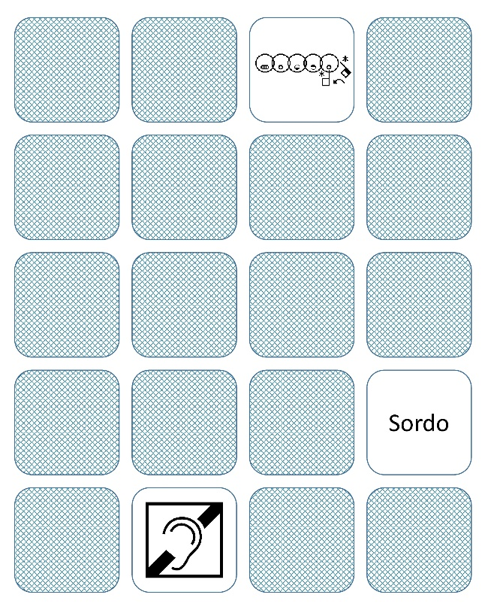 | For each word there are three cards, which belong together.  That’s how everyone can understand sign language.
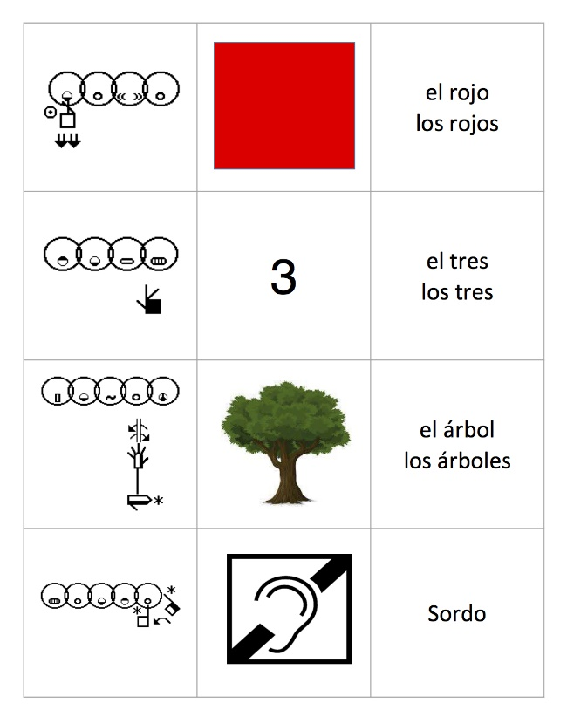 | One group of three cards includes:  The SignWriting  +  The picture  +  The word in spanish

