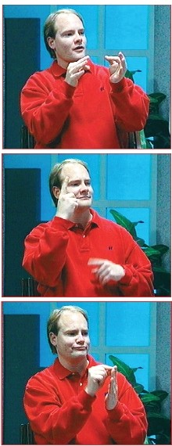

**SignWriting**

*Sign Languages Are Written Languages!*

Manual1:

**SignWriting Basics**

by

Valerie Sutton

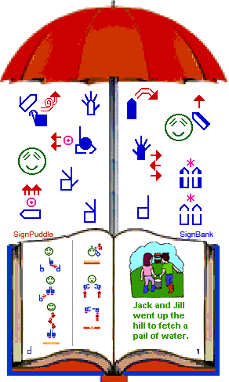

SignWriting

*Sign Languages Are Written Languages!*

**Manual 1: SignWriting Basics by**

**Valerie Sutton**

**ISBN: 978-0-914336-49-5**

**First Edition**

Copyright © 2009

Center for Sutton Movement Writing, Inc.

All Rights Reserved

**The SignWriting System was first**

**invented by Valerie Sutton in 1974.**

**This book is based on the Lessons in SignWriting® Textbook by Valerie Sutton**

Cartoons by Frank Allen Paul

Illustrations by

Ida Candelaria & Jayne Gunderson

Photos of Kevin Clark & Lucinda O’Grady Batch

are captured from the

Lessons In SignWriting Video Series DVD

This book was prepared with SignPuddle Online.

SignPuddle Software by Stephen E. Slevinski, Jr

This manual is posted on the web:

SignWriting Lessons Online

<http://www.SignWriting.org/lessons>

This publication and the SignWriting System are free

to use under the Creative Commons Attribution 3.0 License

<http://creativecommons.org/licenses/by/3.0/>

Published by

**The SignWriting Press**

<http://www.SignWriting.org/shop>

**The SignWriting Literature Project**

<http://www.SignWriting.org/literature>

**Deaf Action Committee for SignWriting**

<http://www.SignWriting.org/deaf>

**Center for Sutton Movement Writing, Inc.**

an educational 501c3 non-profit organization

P.O. Box 517 •La Jolla • CA • 92038-0517 • USA

SignWriting.org • SignBank.org • SignPuddle.org

Email: [sutton@signwriting.org](mailto:sutton@signwriting.org) • Tel 858-456-0098

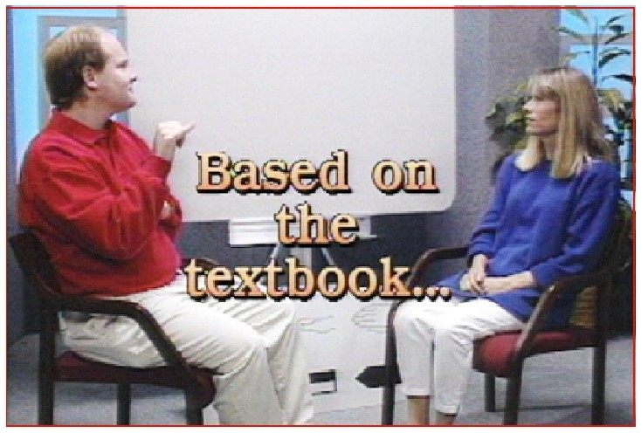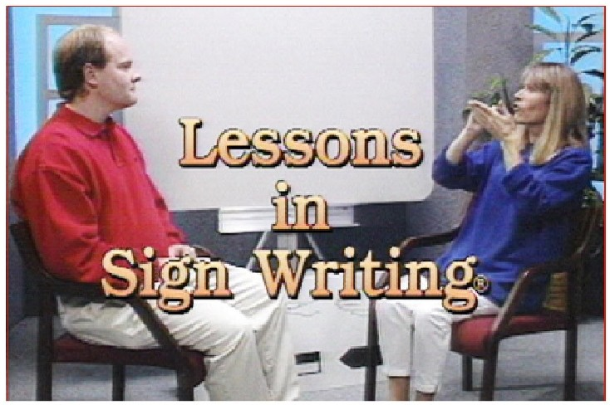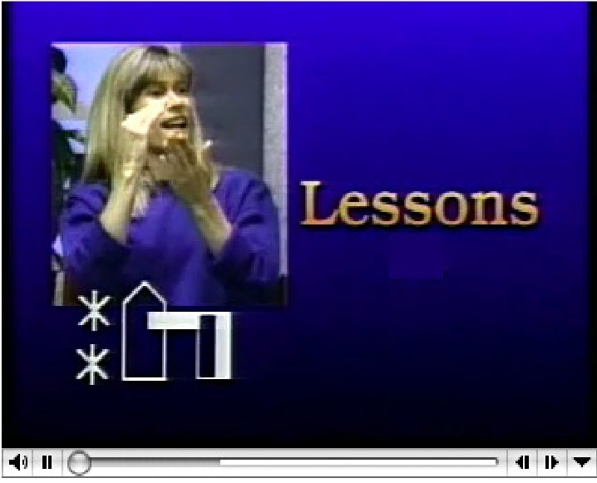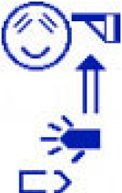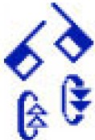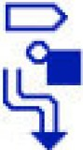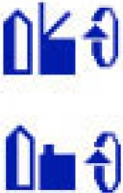

**Learn SignWriting on the web!**

Download books & view videos: [www.SignWriting.org/lessons](http://www.SignWriting.org/lessons)

Ca

by

Fr

All

Pa

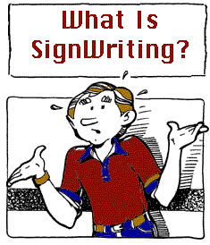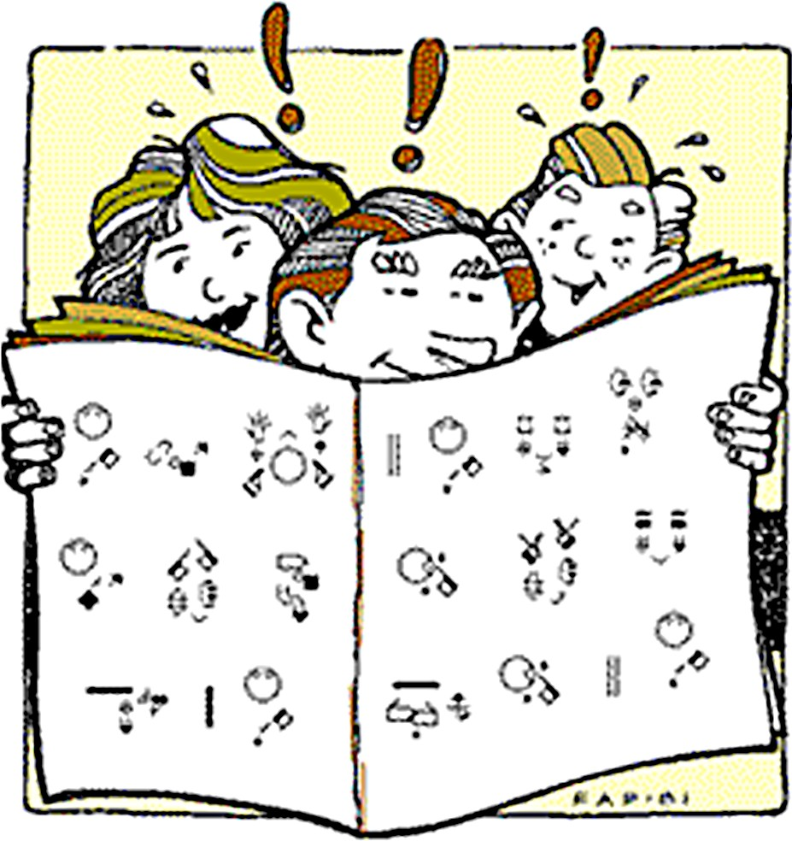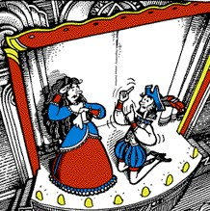

READ

Sign

Language

With SignWriting,

you can....

PRESERVE

Sign Poetry and Theater

WRITE

Sign

Language

Write SignWriting

on the web!

Write signs and Sign Language documents: [www.SignPuddle.org](http://www.SignPuddle.org/)

rtoons

ank en ul

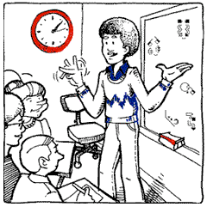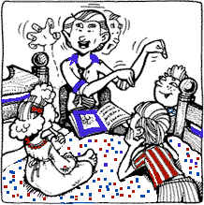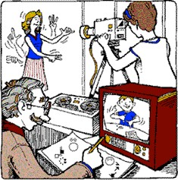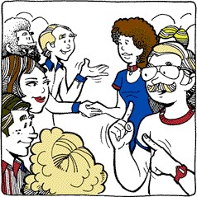

LEARN

Sign

Language

TRANSCRIBE

Sign

Language

SHARE

Sign

Language

MEET Signers

Who Write

Sign Language Too!

Join the SignWriting

Email List!

Go to this web page to join: [www.SignWriting.org/forums/swlist](http://www.SignWriting.org/forums/swlist)

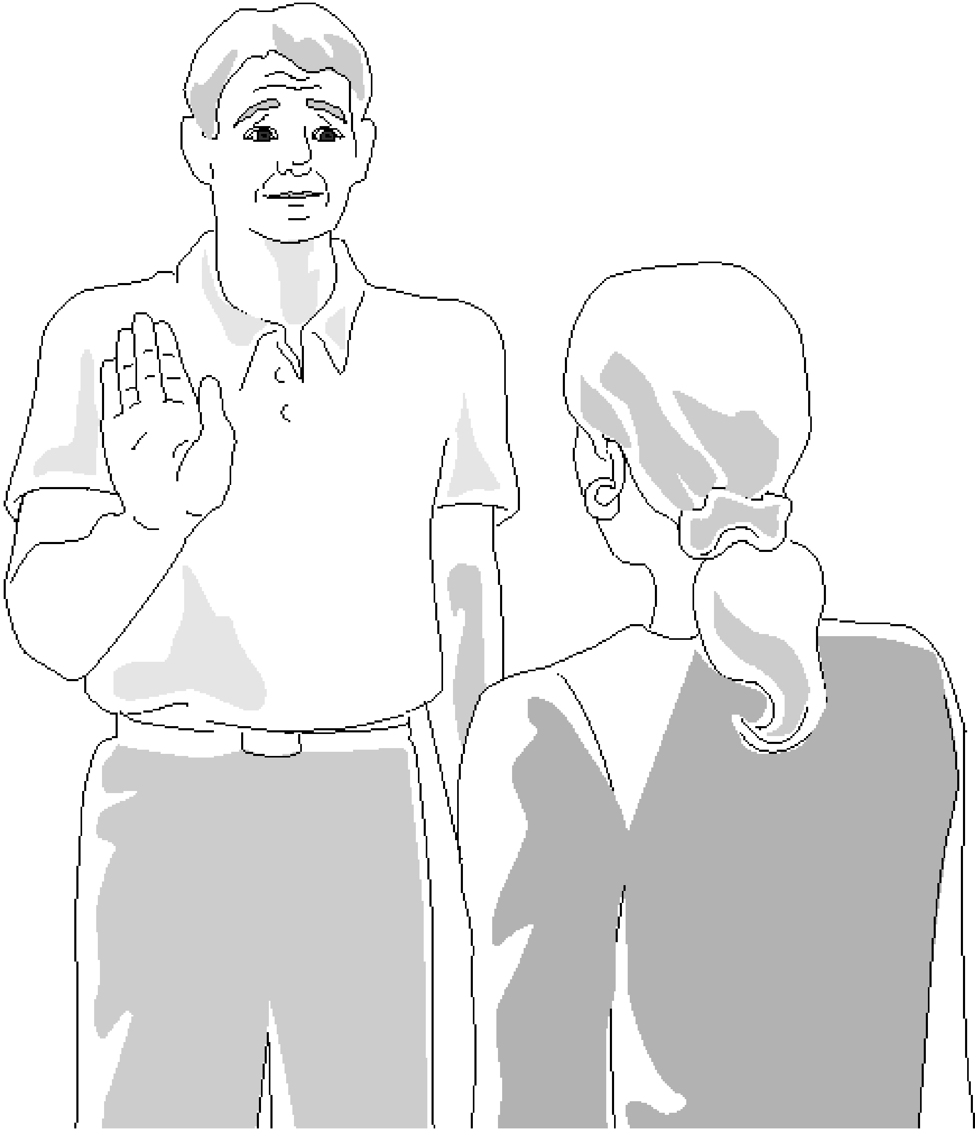

Receptive Viewpoint

When someone is facing you, signing to you, you view the signs as an observer. The signer's right side is your left side. This is called the Receptive Viewpoint.

1

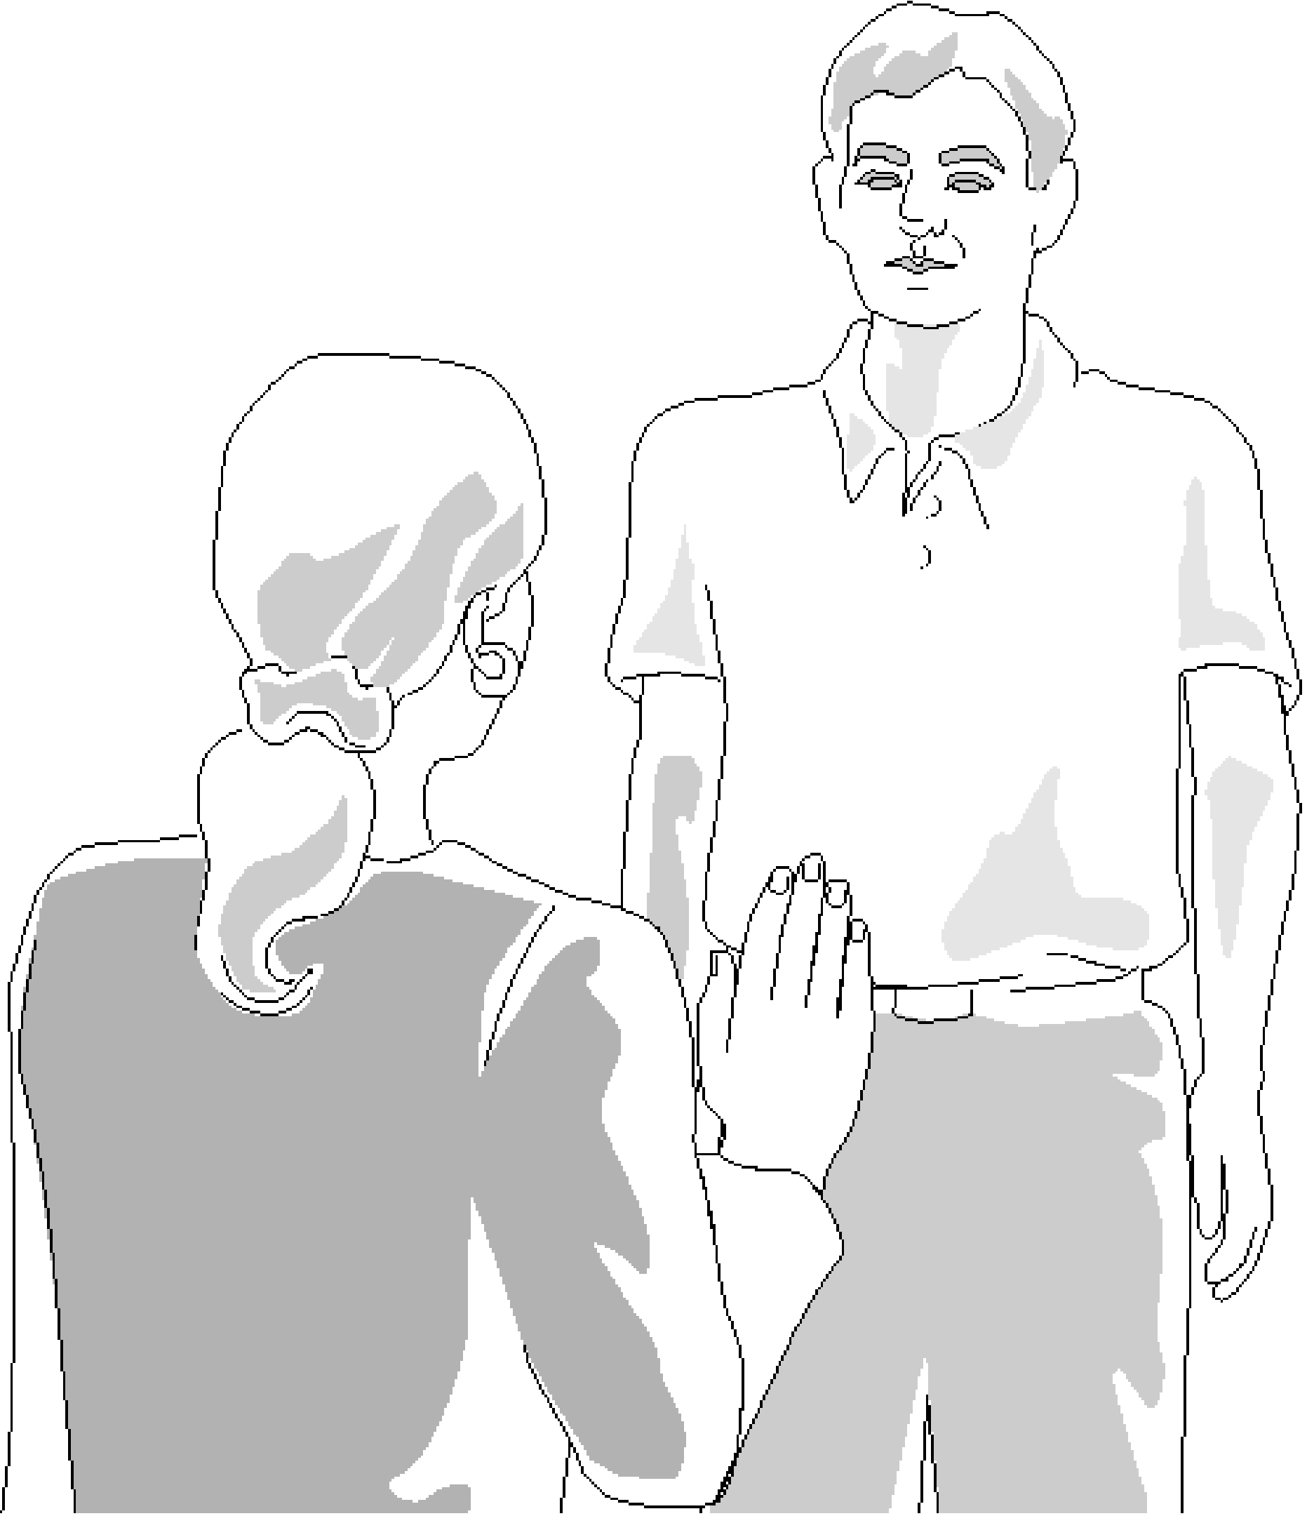

Expressive Viewpoint

When you are signing to someone else, you see signs from your own point of view.

This is called the Expressive Viewpoint.

2

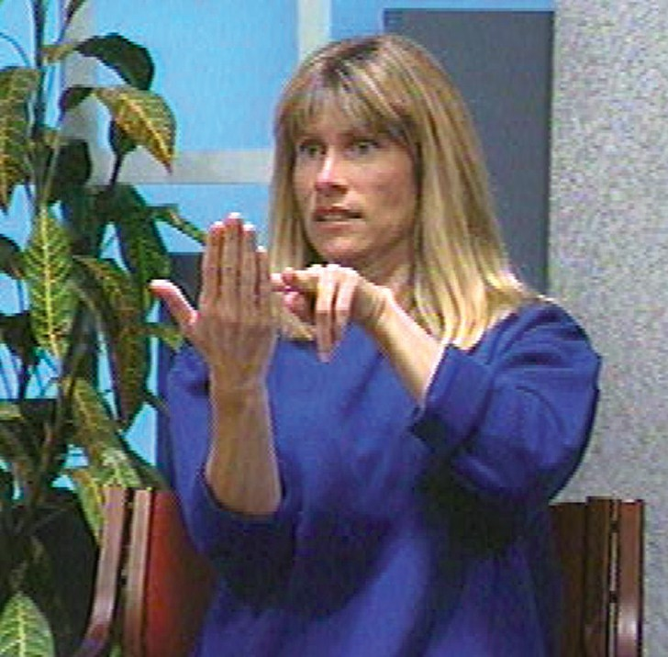

The

Expressive

Viewpoint

Read and write signs as if you are looking at your own hands, from your own perspective.

Palm of

Hand

When you see the palm of your hand, while you are signing, the symbol for the hand will be white, or hollow.

The palm of the hand is

always written with a white, hollow symbol.

3



Side of

Hand

When you see the side of your hand while you are signing, the symbol for the hand will be half black and half white.

The white part of the sym-

bol shows where the palm of the hand faces. The dark part represents the back of the hand.

Back of

Hand

When you see the back of

your hand while you are signing, the symbol will be black, or filled-in.

The back of the hand

is always written with a black, filled-in symbol.

4

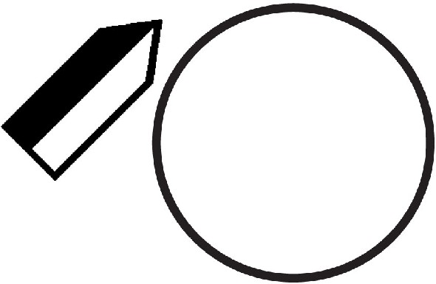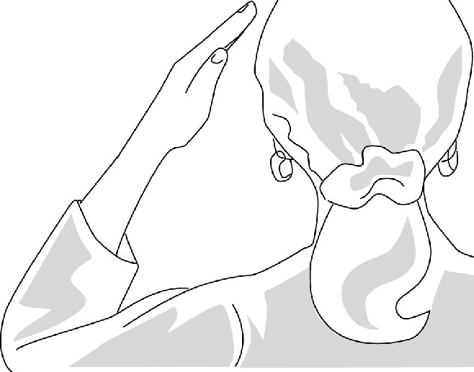

**Left Side of Head**

The head is written with a circle, viewed from the back. When the left hand is near the left side of the head, the symbol for the hand is placed to the left:

**

*I*

**know**

(hand on the left side)

Note: An asterisk means touch.

Two asterisks mean touching two times.

5

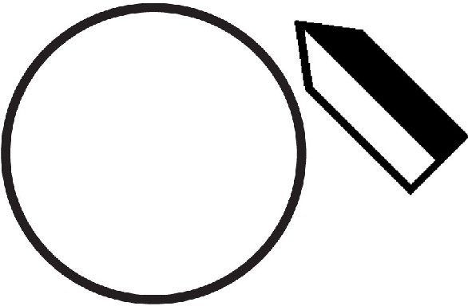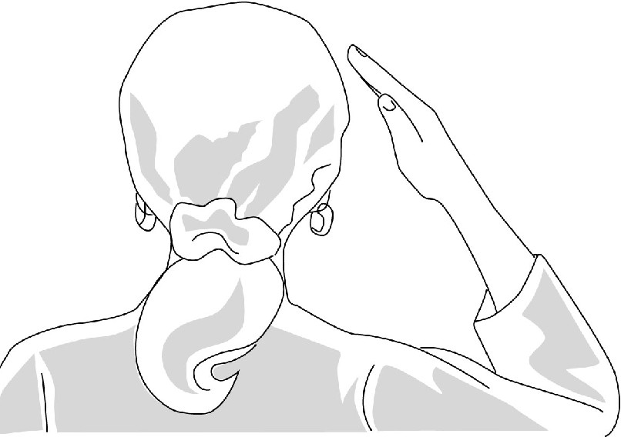

**Right Side of Head**

The head is written with a circle, viewed from the back. When the right hand is near the right side of the head, the symbol for the hand is placed to the right:

**

**know**

(hand on the right side)

Note: An asterisk means touch.

Two asterisks mean touching two times.

6

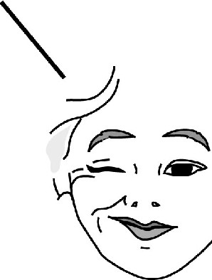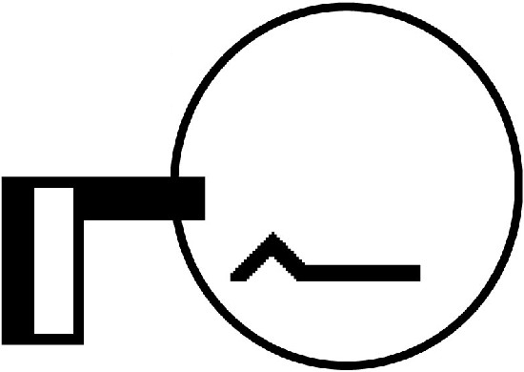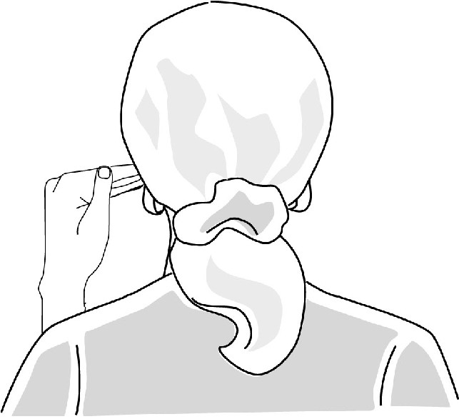

**Left Side of Face**

Pretend you can see through the back of the head.

You are reading and writing how your face **"feels"** when you sign:

**

Your face

feels

like this:

**know**

**(mouth pushed up on left side)**

7

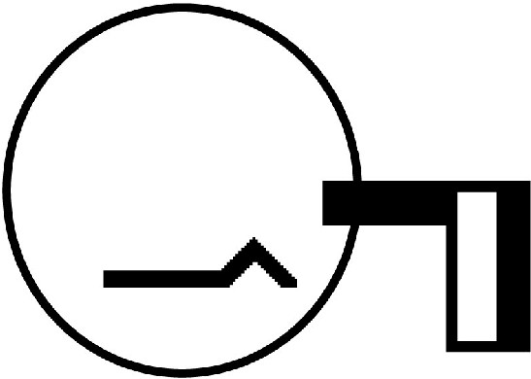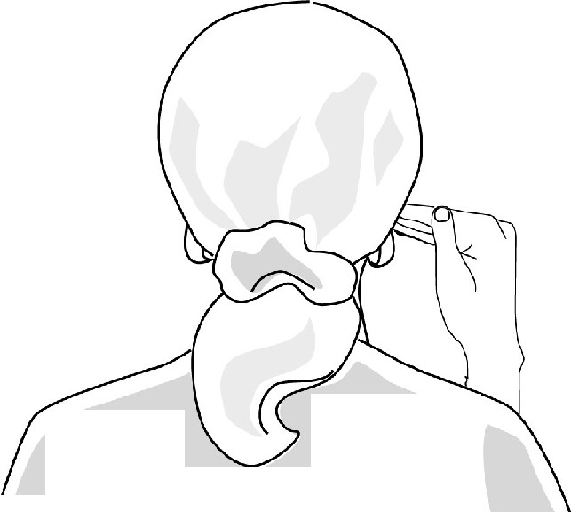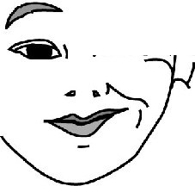

**Right Side of Face**

Pretend you can see through the back of the head.

You are reading and writing how your face **"feels"** when you sign:

**

Your f ace

feels like this:

I...,;;;;;_

\

(

-----

-

**know**

**(mouth pushed up on right side)**

8

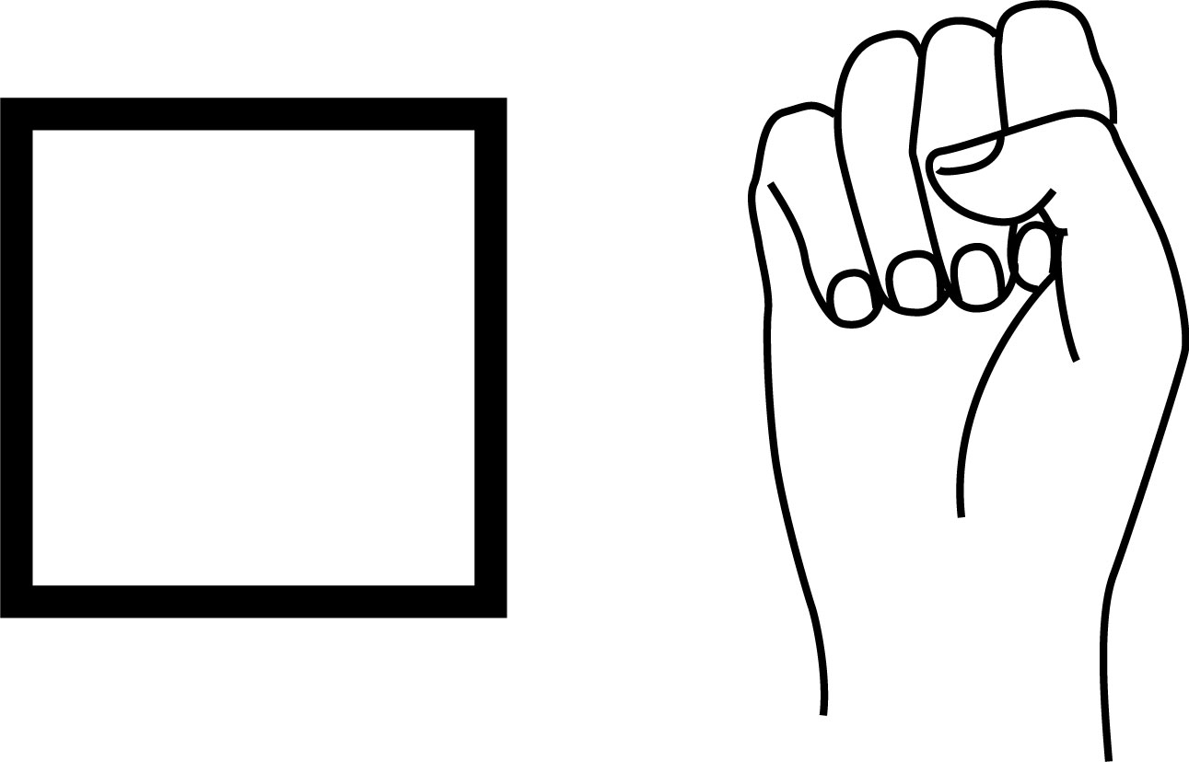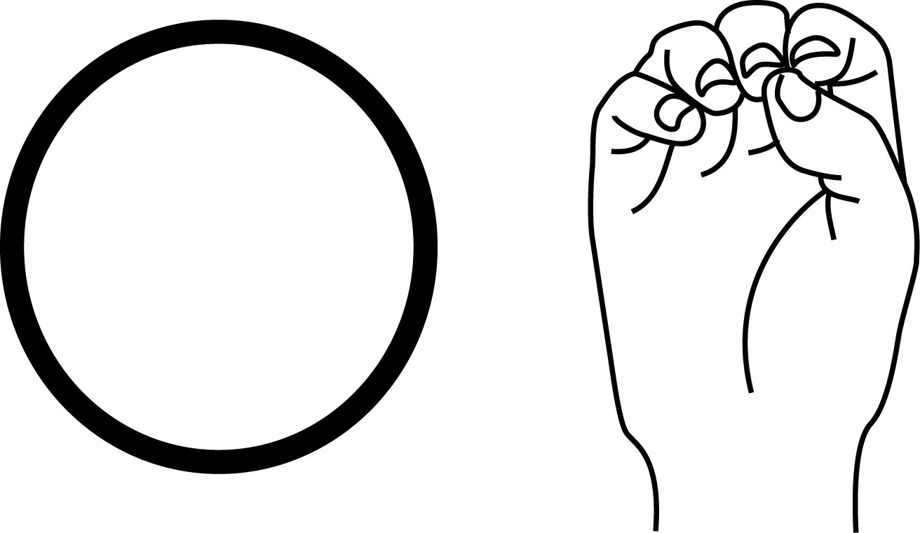

3

Basic

Handshapes

Closed

Fist

When the fingertips touch the palm of the hand, it is called a Closed Fist.

A Closed Fist is

with a square.

written

Open

Fist

When the fingertips touch each other, it is called an Open Fist.

An Open Fist is written

with a circle.

9

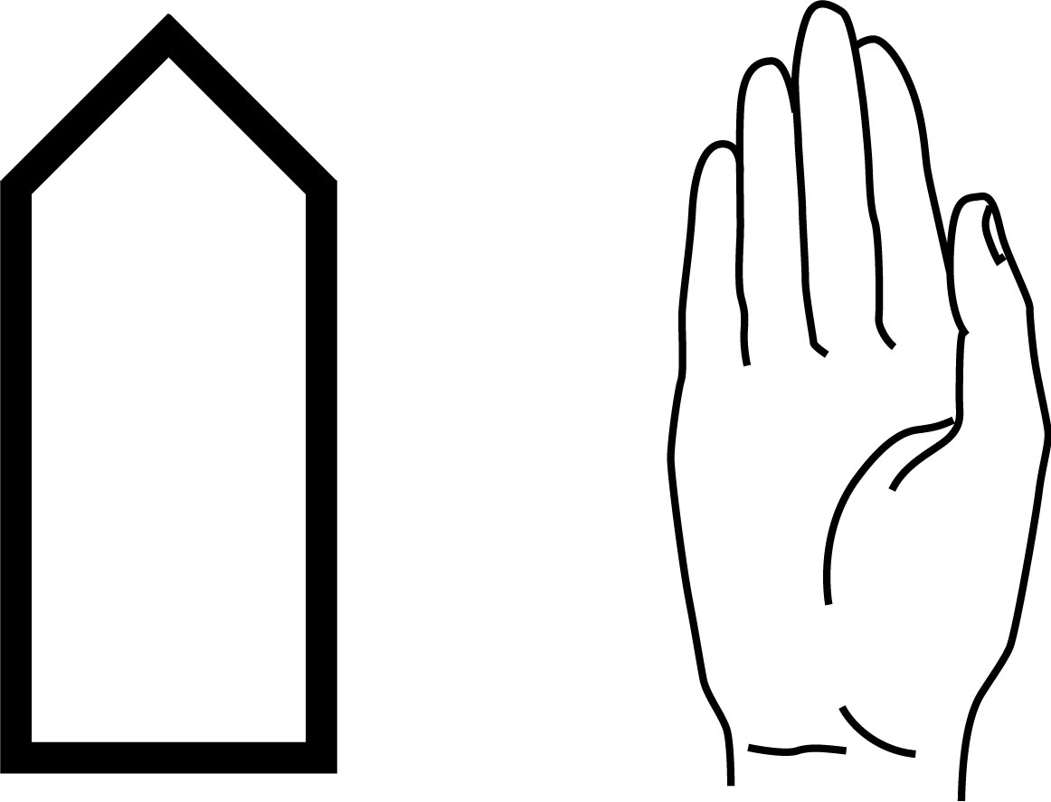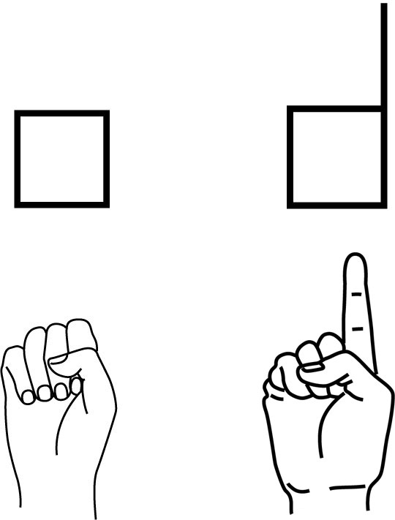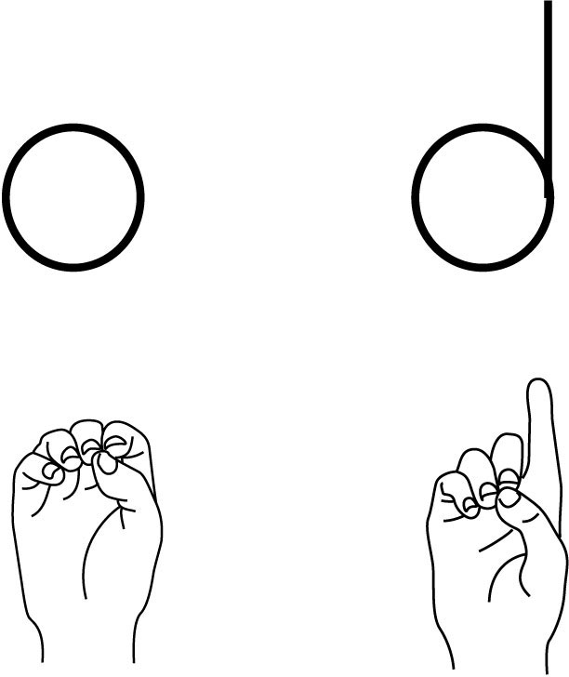

3

Basic

Handshapes

Flat

Hand

When the fingers stretch straight up, and touch each other, it is called a Flat Hand.

A Flat Hand is written with

a rectangle, with a tip for

the fingertips.

Closed Fist

Open Fist

Both the letter S and the num-

ber 1 in ASL are written with a square for the Closed Fist, since the fingertips touch the palm:

Both the letter O and the let-

ter D in ASL are written with a circle for the Open Fist, since the fingertips touch each other:

10

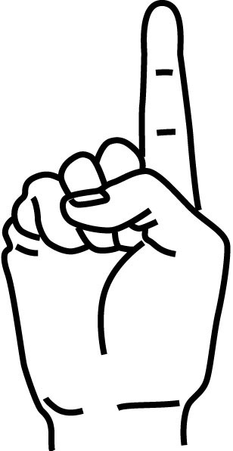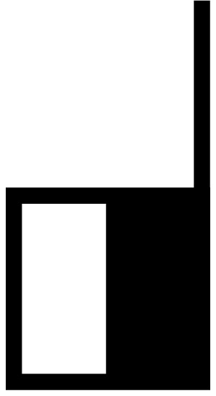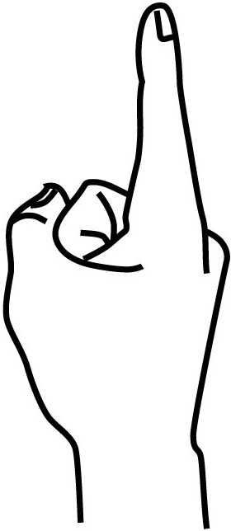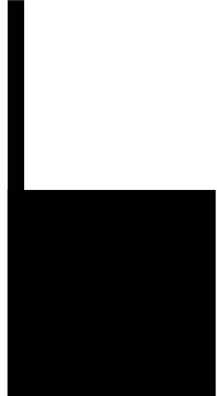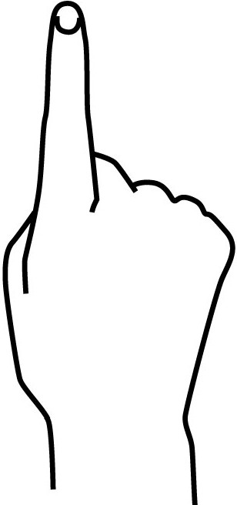

**Palm Facing**

Front View

The hand is parallel with the front wall.

11

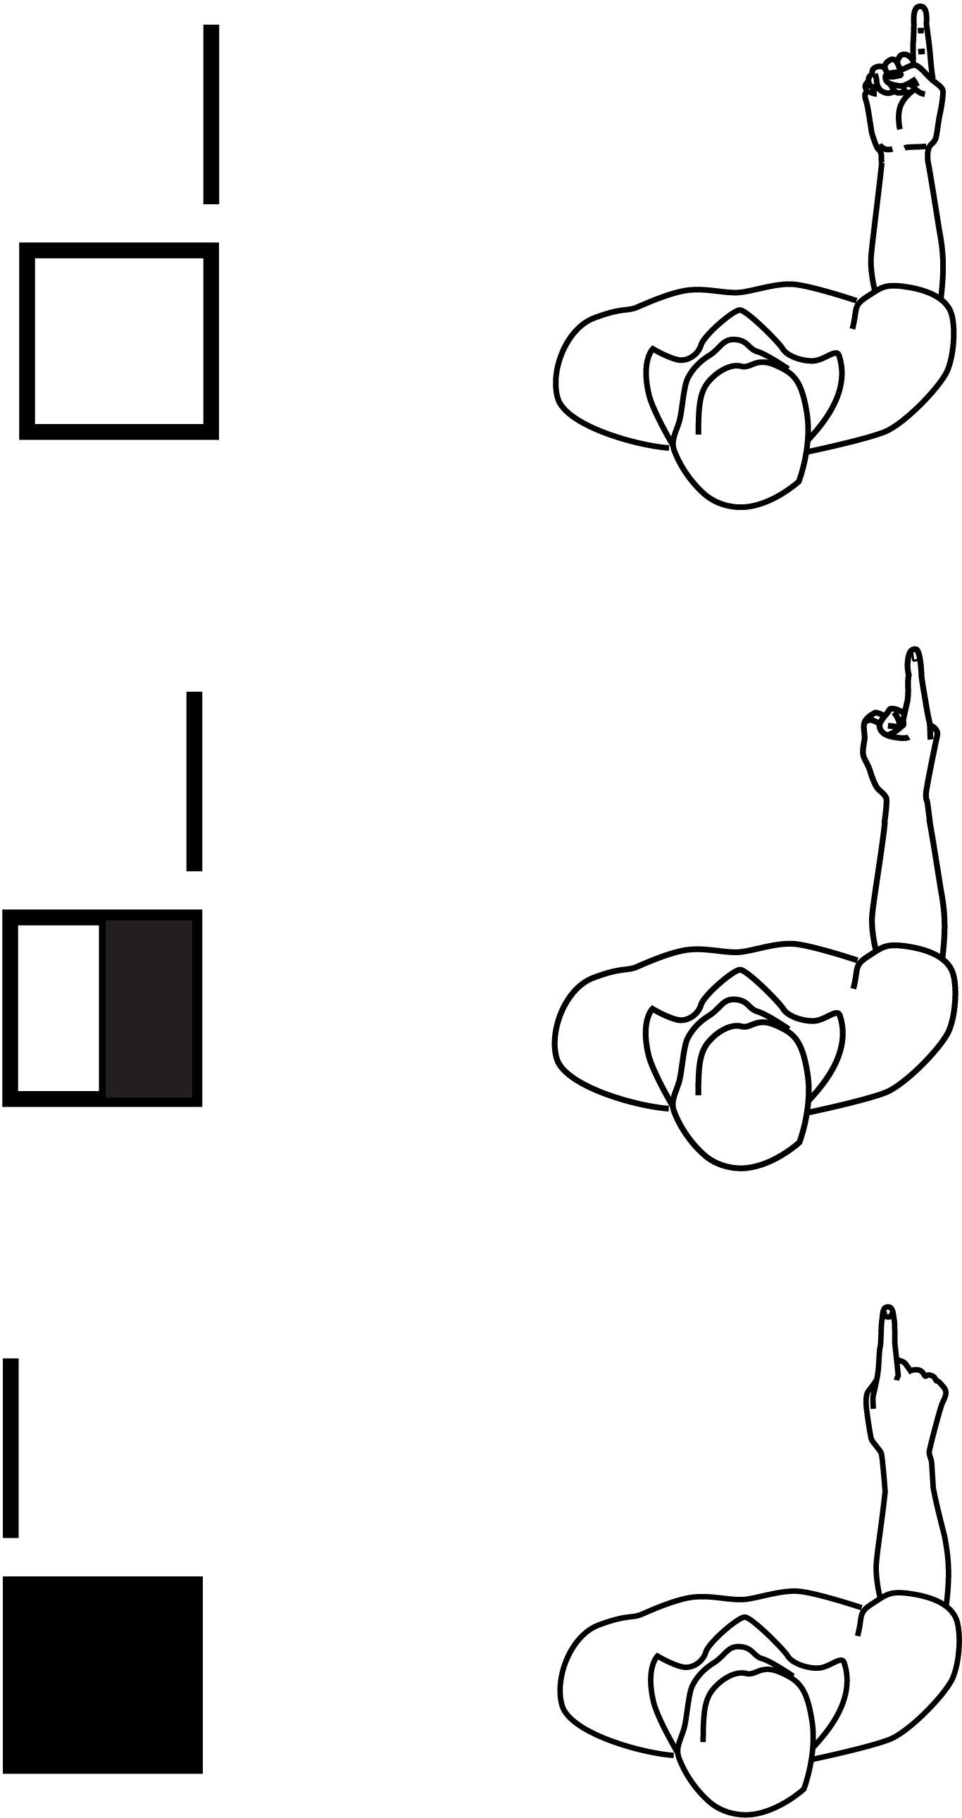

Palm Facing

Top View

The hand is parallel with the floor.

space at

knuckle joint means hand is parallel

to the floor

12

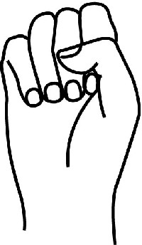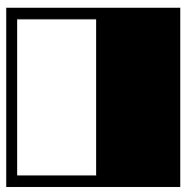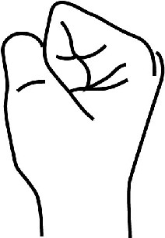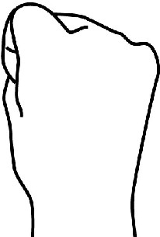

**Palm Facing**

Front View

The hand is parallel with the front wall.

vv

*[Y*

13

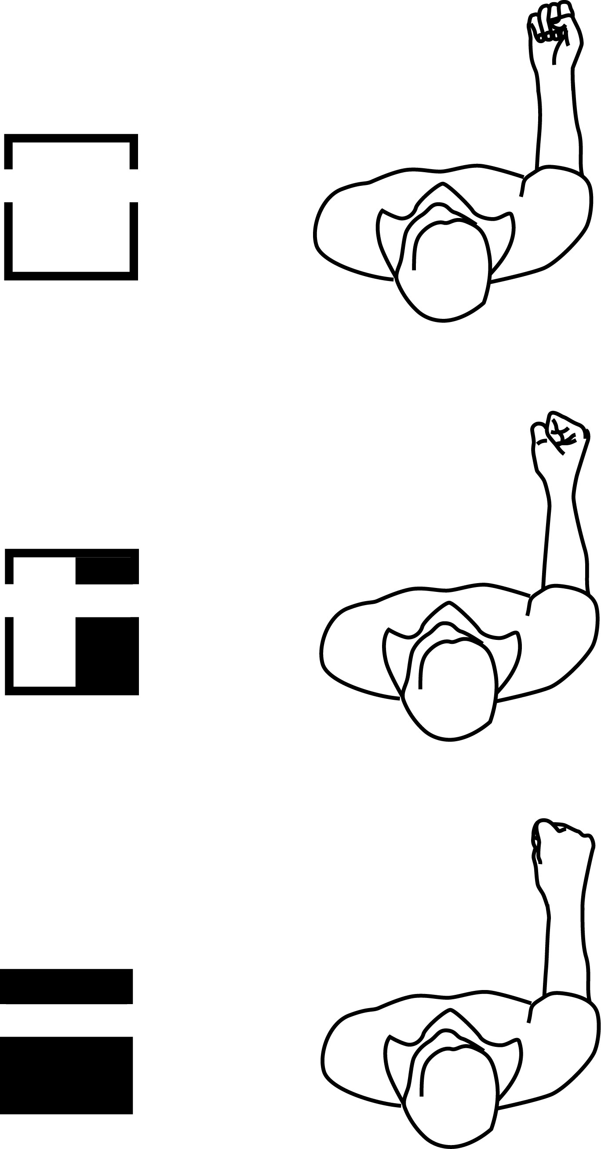

Palm Facing

Top View

The hand is parallel with the floor.

space at

knuckle joint means hand is parallel

to the floor

14

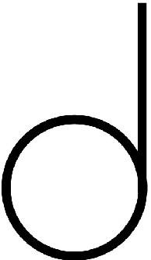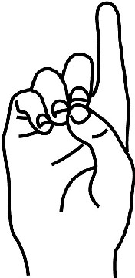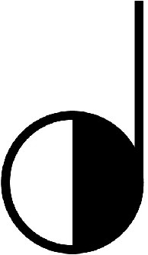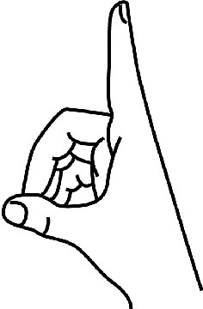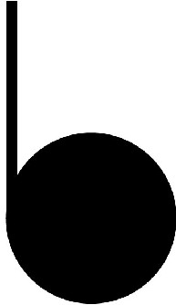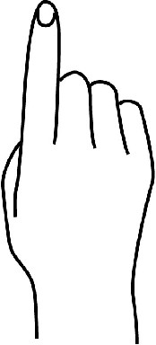

**Palm Facing**

Front View

The hand is parallel with the front wall.

15

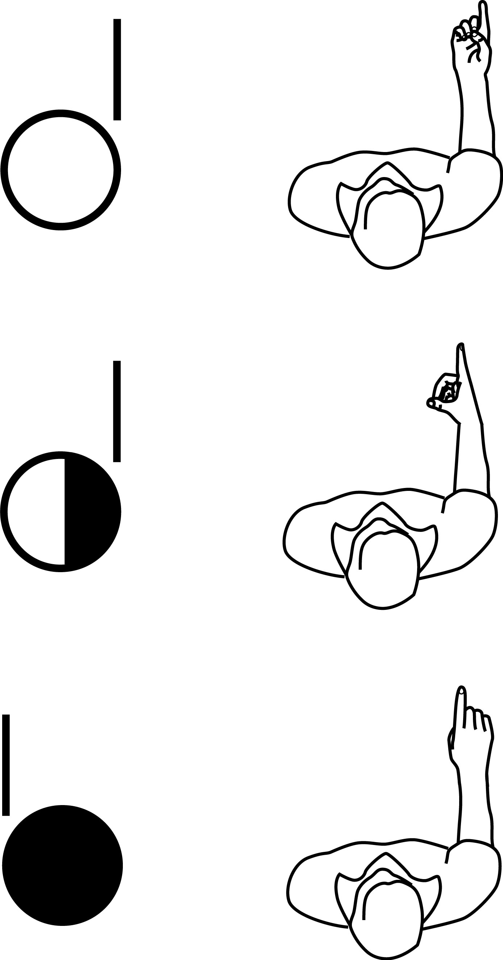

Palm Facing

Top View

The hand is parallel with the floor.

space at

knuckle joint means hand is parallel

to the floor

16

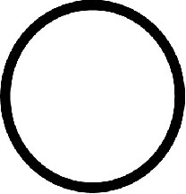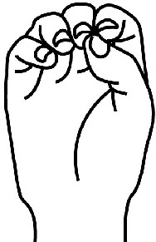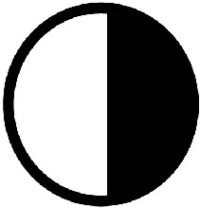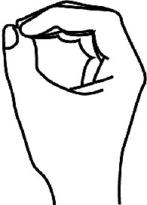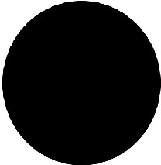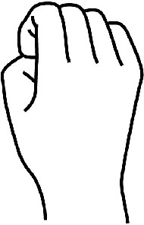

**Palm Facing**

Front View

The hand is parallel with the front wall.

17

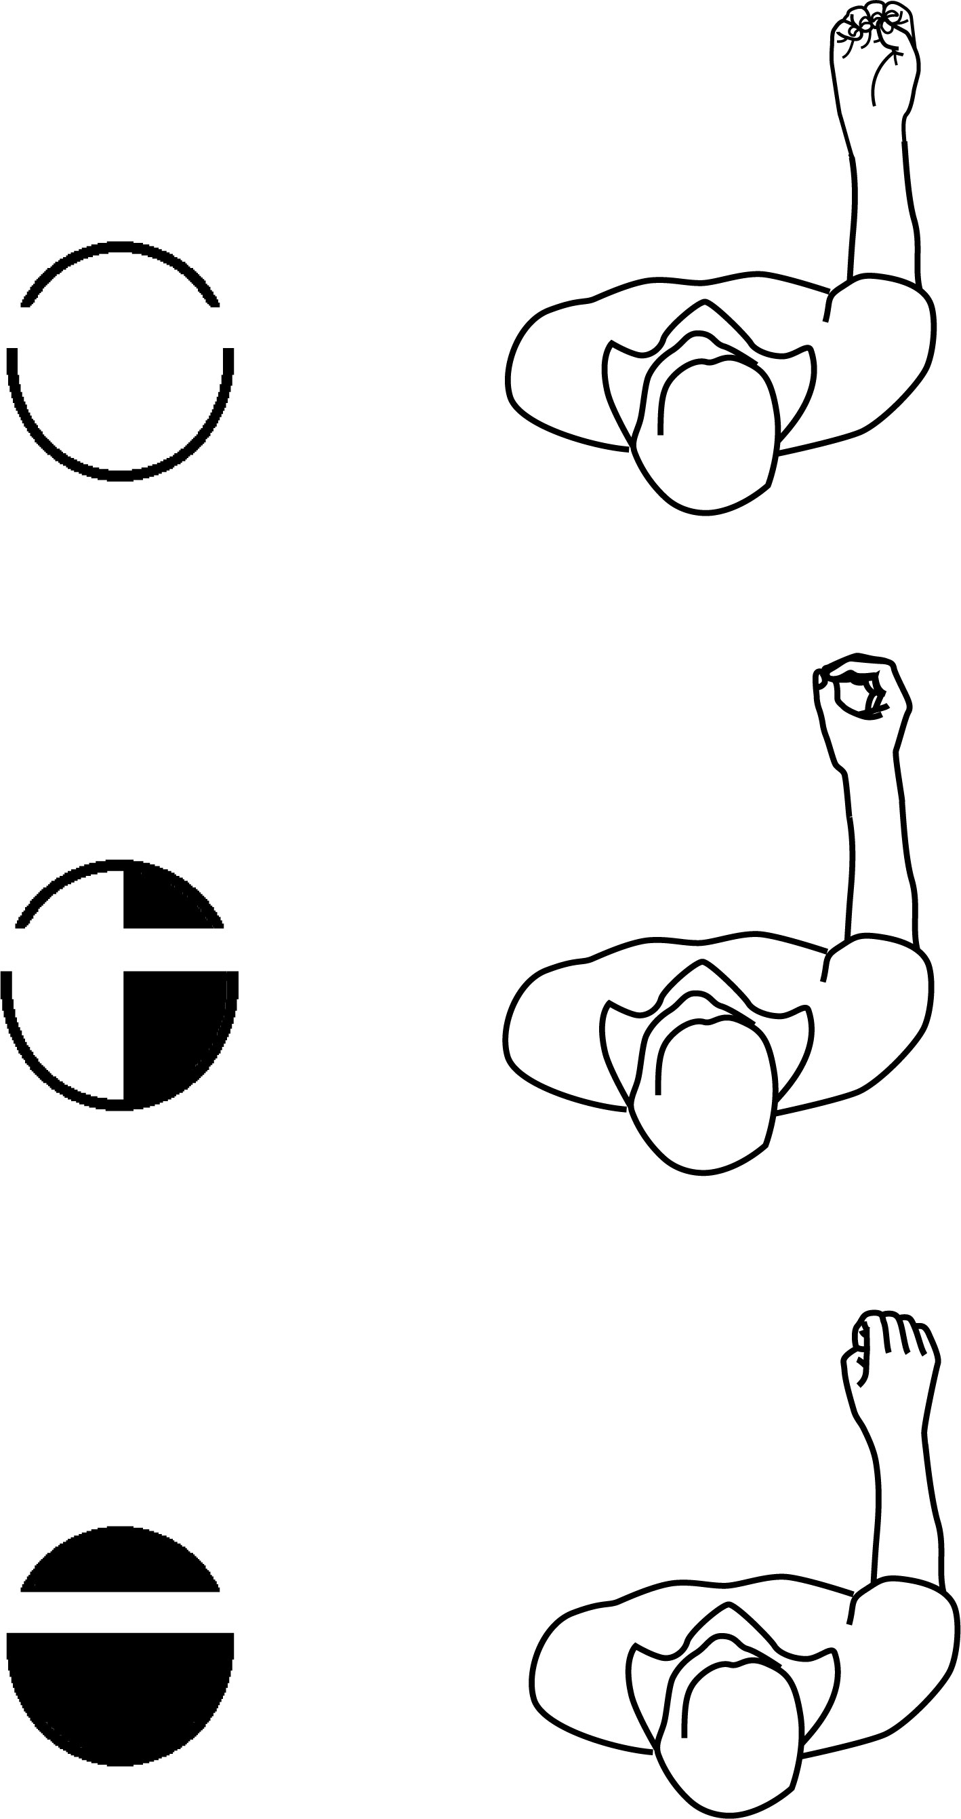

Palm Facing

Top View

The hand is parallel with the floor.

space at

knuckle joint means hand is parallel

to the floor

18

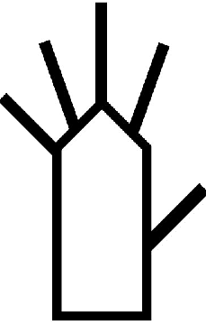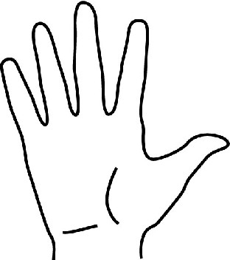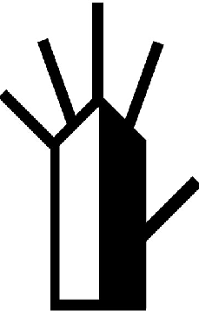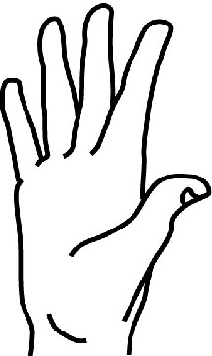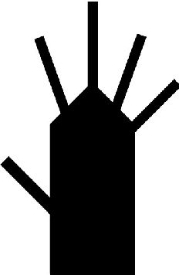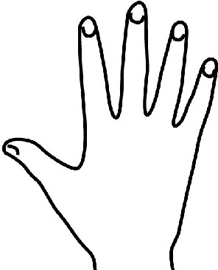

**Palm Facing**

Front View

The hand is parallel with the front wall.

19

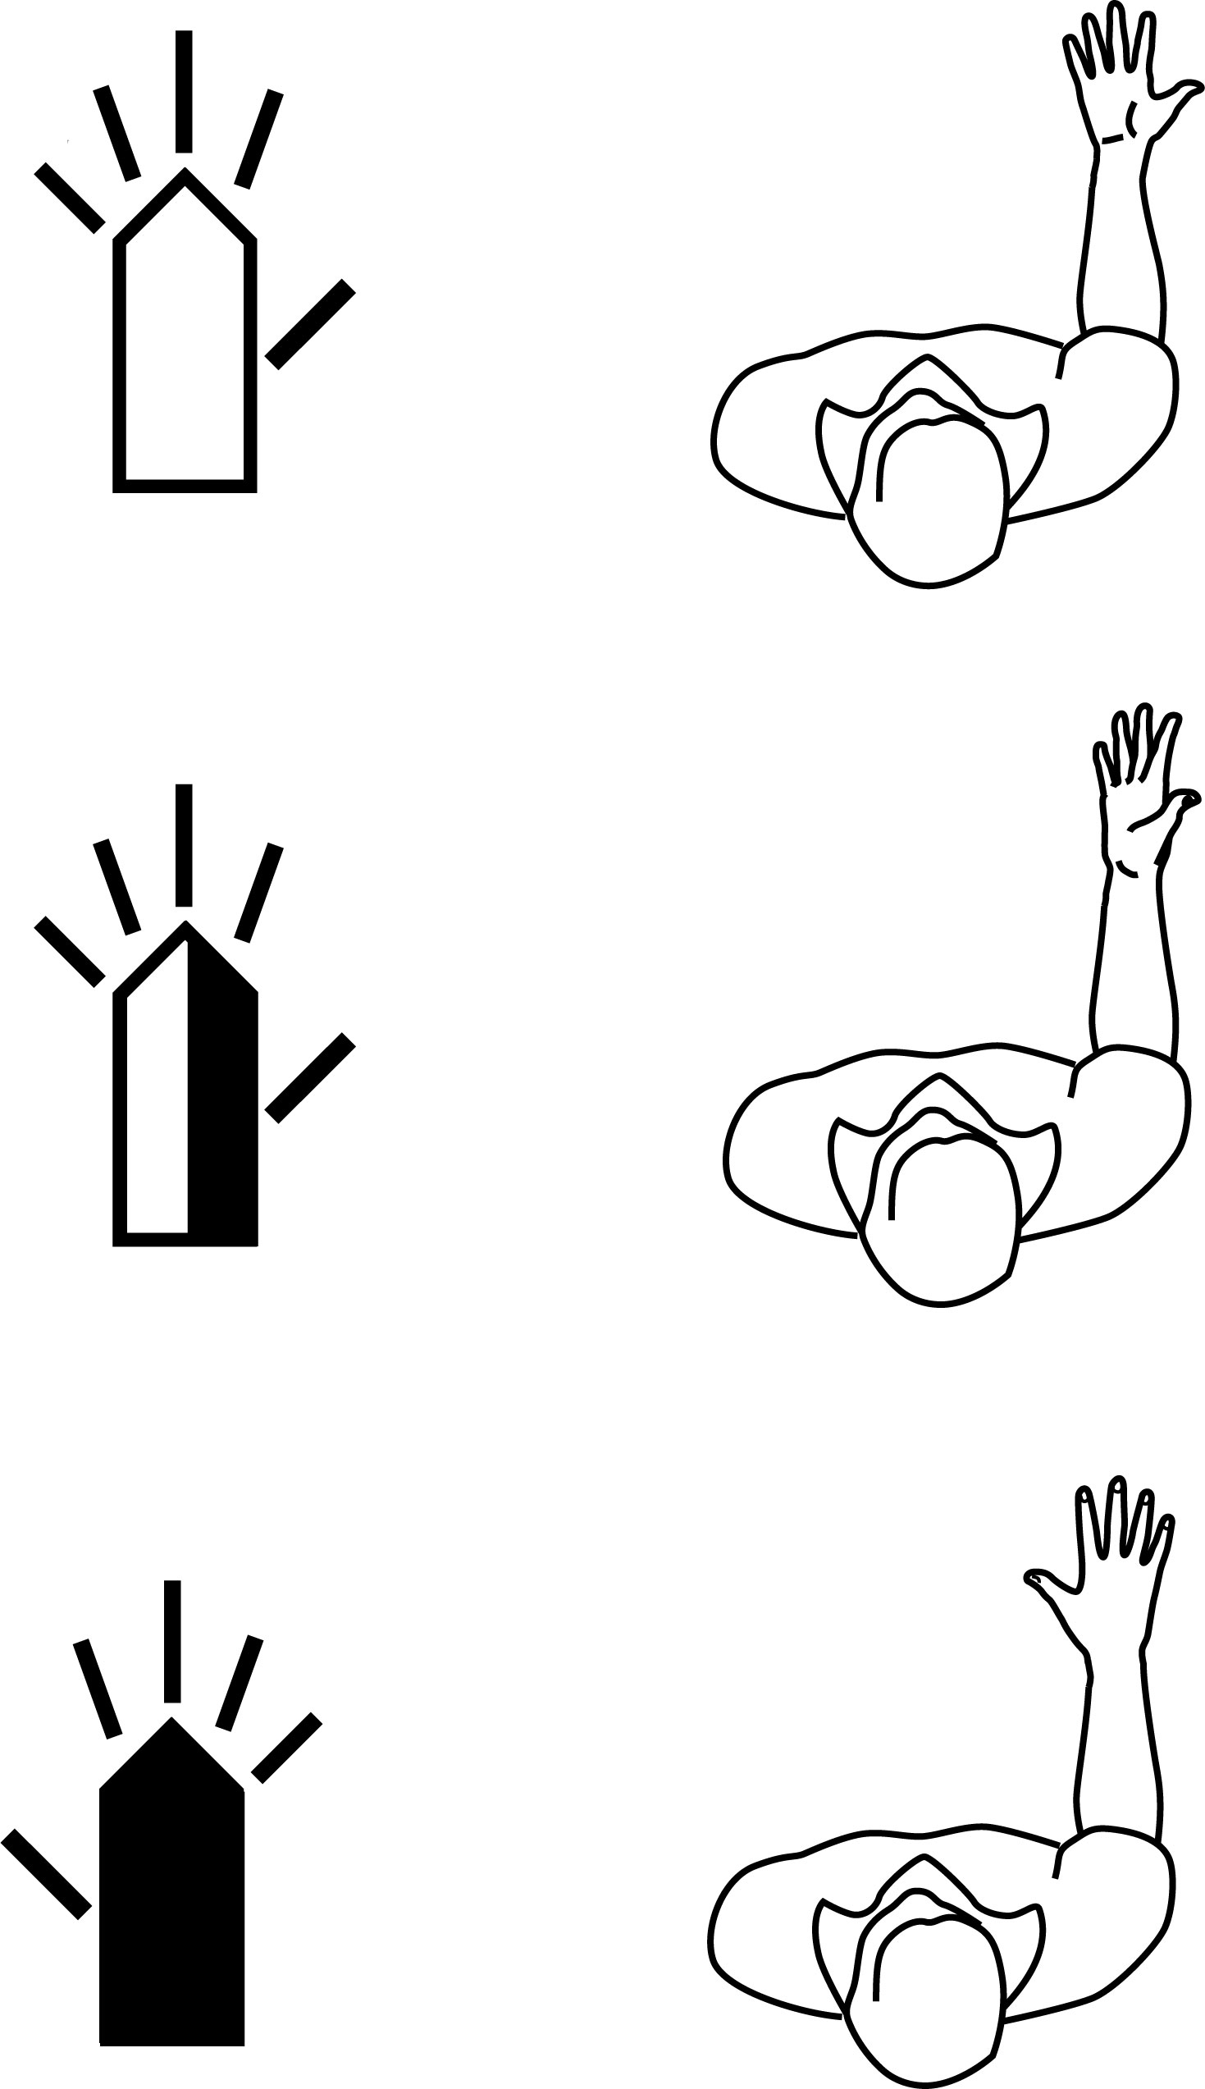

Palm Facing

Top View

The hand is parallel with the floor.

space at

knuckle joint means hand is parallel

to the floor

20

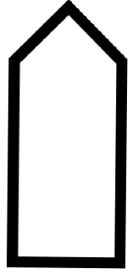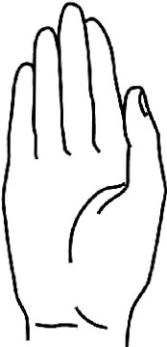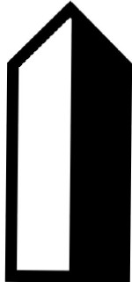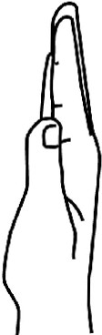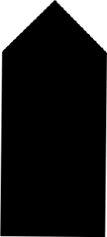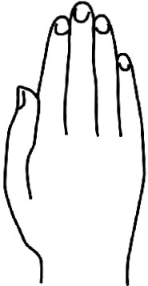

**Palm Facing**

Front View

The hand is parallel with the front wall.

21

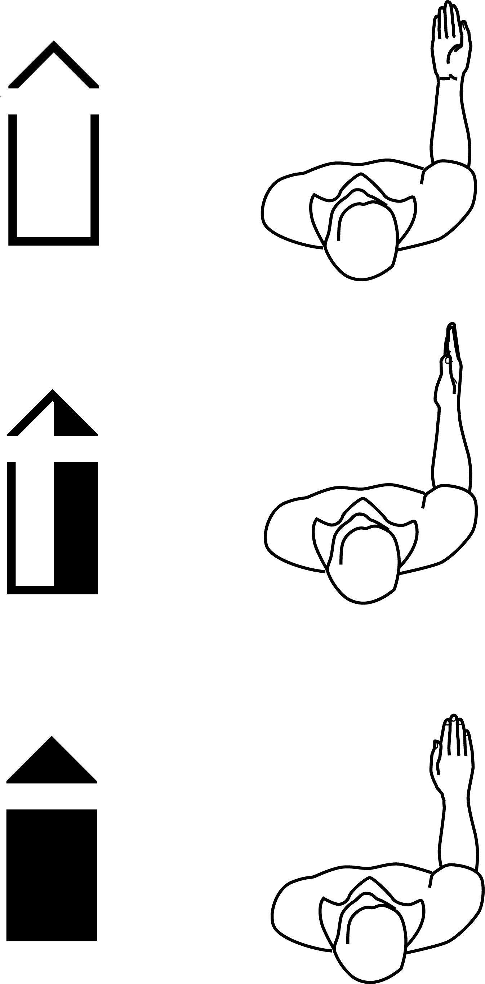

Palm Facing

Top View

The hand is parallel with the floor.

space at

knuckle joint means hand is parallel

to the floor

22

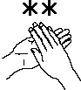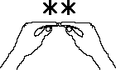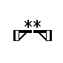

6

Contact Symbols

1. Touch

2. Grasp

3. Between

4. Strike

5. Brush

6. Rub

Touch

Touch Contact is written

with an asterisk.

Touch is defined as the

hand gently contacting another part of the body.

more

school

23

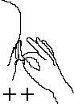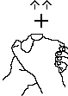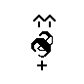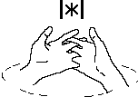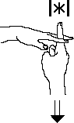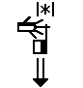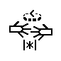

Grasp

Grasp Contact is written with two crossed lines.

Grasp is defined as the hand

grasping or pinching a part of the body or a prop, such as clothing.

earring

congratulations

Between

Between Contact is writ- ten with a Contact Symbol between two lines.

Between is defined as con-

tacting between two fingers

or other parts of the body.

disappear

America

24

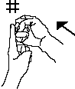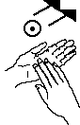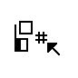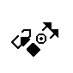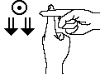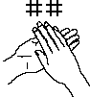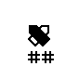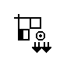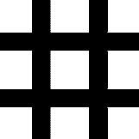

Strike

Strike Contact is written with two lines crossing two lines.

Strike is defined as the

hand contacting a surface

with force.

hit

clap

Brush

Brush Contact is

writ-

ten with a circle with a

dark dot in the center.

Bru sh i s d e fi n e d a s

movement that first

con ta cts an d

then

monthly

moves off the surface.

excuse me

25

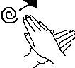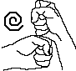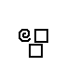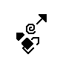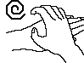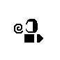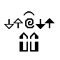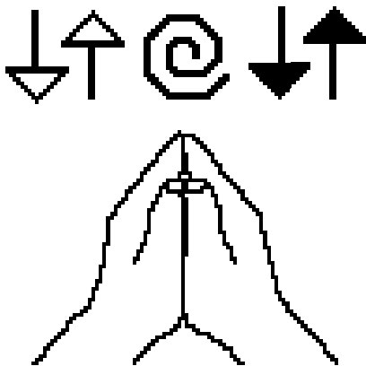

Circular

Rub

Circular Rub Contact is written with a spiral.

Rub is defined as contact

that moves, but stays on the surface.

coffee

chocolate

Straight

Rub

Straight Rub Contact is written with the same spi- ral symbol, but the spiral symbol is connected with a straight arrow.

When the Rub Contact

symbol is connected with an arrow, it rubs in a straight line (not in a circle). It stays on the surface but moves in the direction of the arrow.

neat

eager

26



6

Finger Symbols

1. Squeeze, Middle Joint Closes

2. Flick, Middle Joint Opens

3. Hinge, Knuckle Joint Closes

4. Hinge, Knuckle Joint Opens

5. Hinge, Knuckles Open & Close Together

6. Trill, Knuckles Open-Close Alternating

Knuckle Joint

Hinge & Trill

Middle Joint

Squeeze & Flick

Middle Joint Finger Move-

ments, also called Squeeze

Knuckle Joint Finger Move-

me nt, a l so ca ll e d H in ge and Trill Movements, are written with small arrows.

and Flick Movements,

are

writ t en wit h small dot s .

27

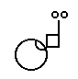

Middle Joint

Closes

When the middle joint of the finger squeezes tight (bends down or in), this closing finger movement is written with a dark dot.

The dot is placed near the

finger joint that does the squeezing. Two dots repre- sent two squeezes..

huh?

milk

Middle Joint

Opens

When the middle joint of the finger flicks open (goes from bent to straight), this open- ing flicking movement is written with a hollow dot.

The dot is placed near the

finger that flicks. Two dots represent two flicks.

eleven

understand

28

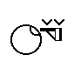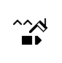

Knuckle Joint

Closes

The middle joint of the finger locks, while the knuckle joint bends down, like the Hinge on a door.

Thi s c losing k nuck le movement is written with a small arrow that points down. The arrow pushes the fingers down. Two

arrows mean 2 hinges.

twenty

boy

Knuckle Joint

Opens

The middle joint of finger locks, while knuckle joint bends

the

the up,

like the Hinge on a door.

T his o p en i n g knu ck - le movement is written with a small arrow that points up. The arrow pulls the fingers up. Two ar- rows mean 2 hinges up.

send

send-send

29



Knuckle Joints

Open-Close

The fingers move together

in the same direction, as a unit. The knuckle-joints of the fingers open and close (bend up and down) together. This open-close knuckle movement i s written with one row of small connected arrows pointing up and down.

goodbye

why

Knuckle Joints

Alternate

The fingers do not move together in a unit. Instead they hinge in opposite di- rections. One moves up, as the other moves down. This Alternating Finger Movement, also called Finger Trills, is written with two rows of small ar- rows pointing up and down.

typing

fingerspell

30

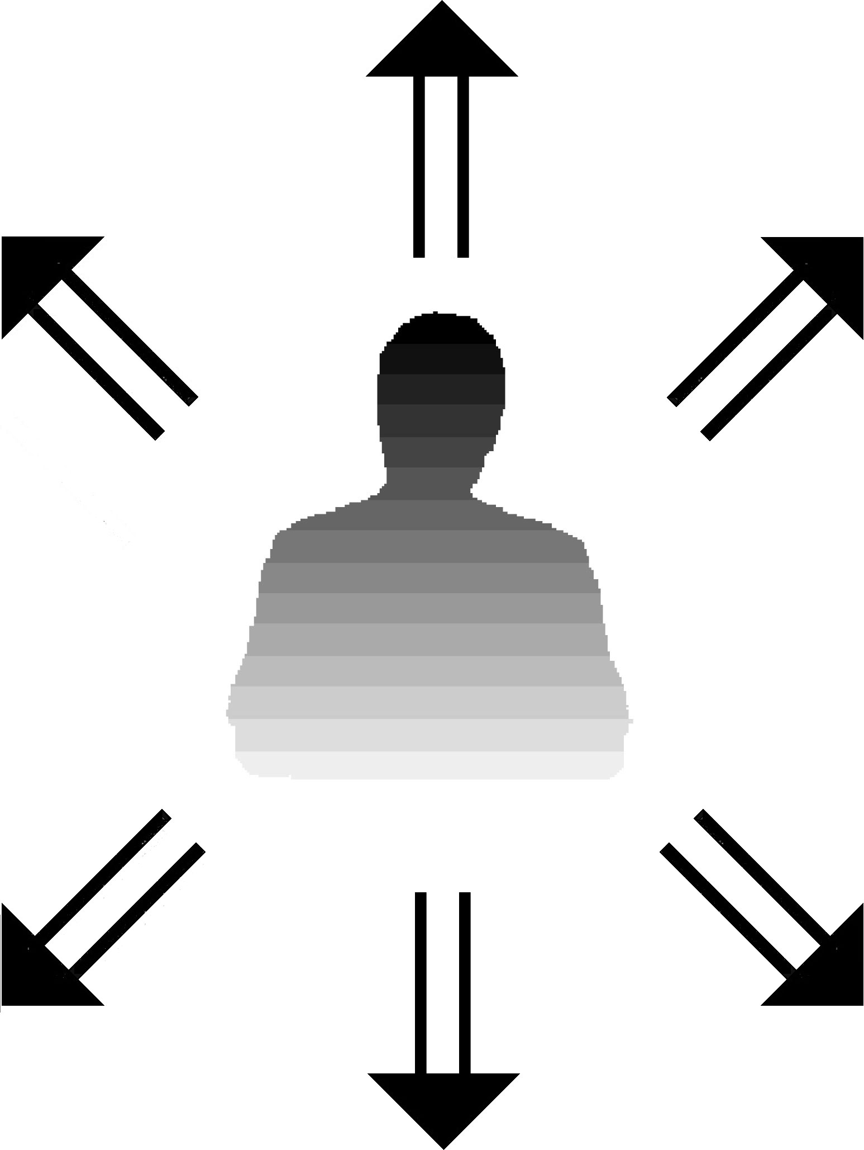

Up-Down Movement

Up-Down Movement is parallel with the Front Wall or your chest.

It is written with double-stemmed arrows:

Up

Up

Diagonal

Up

Diagonal

Down

Diagonal

Down

Diagonal

Down

31

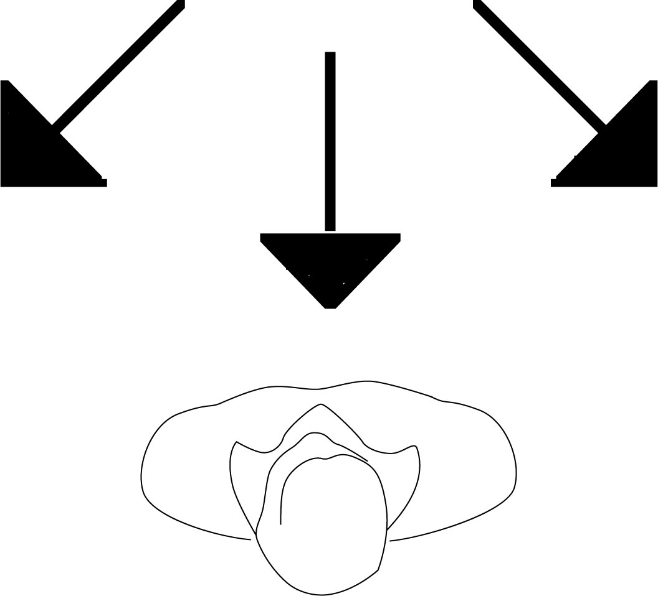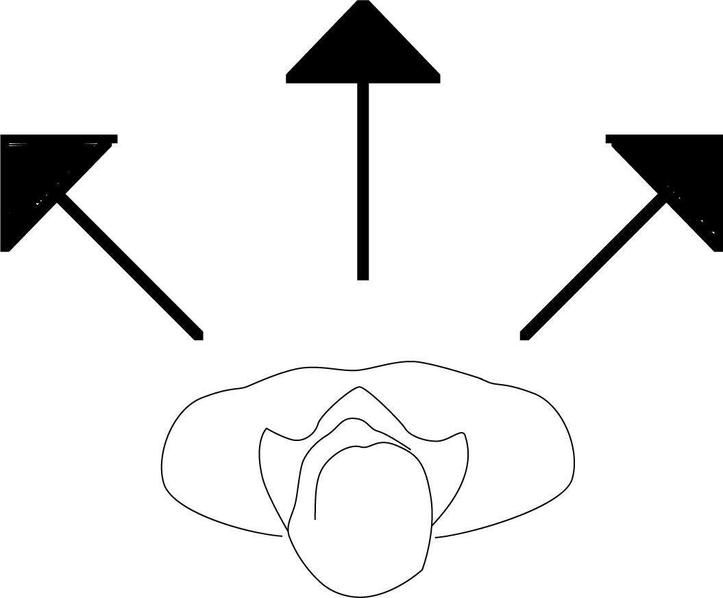

Forward-Back Movement

Forward-Back Movement is parallel with the Floor or a table top.

It is written with single-stemmed arrows:

Forward

Forward

Diagonal

Forward

Diagonal

Back

Back

Diagonal

Back

Diagonal

32

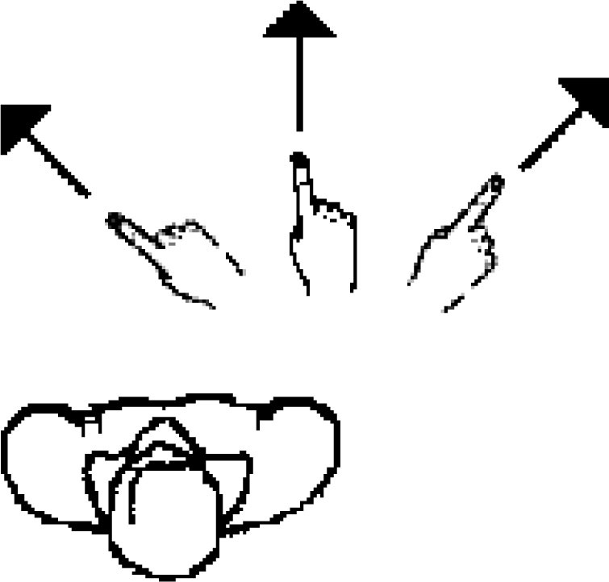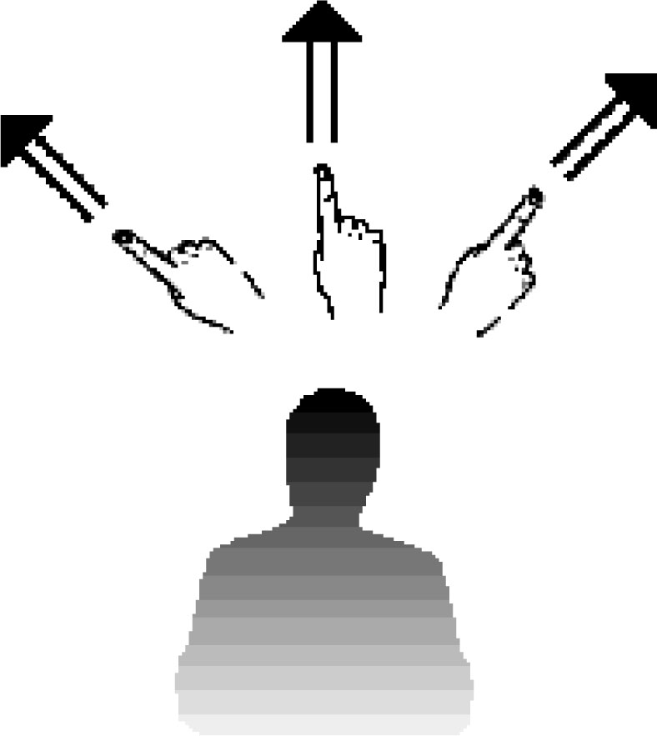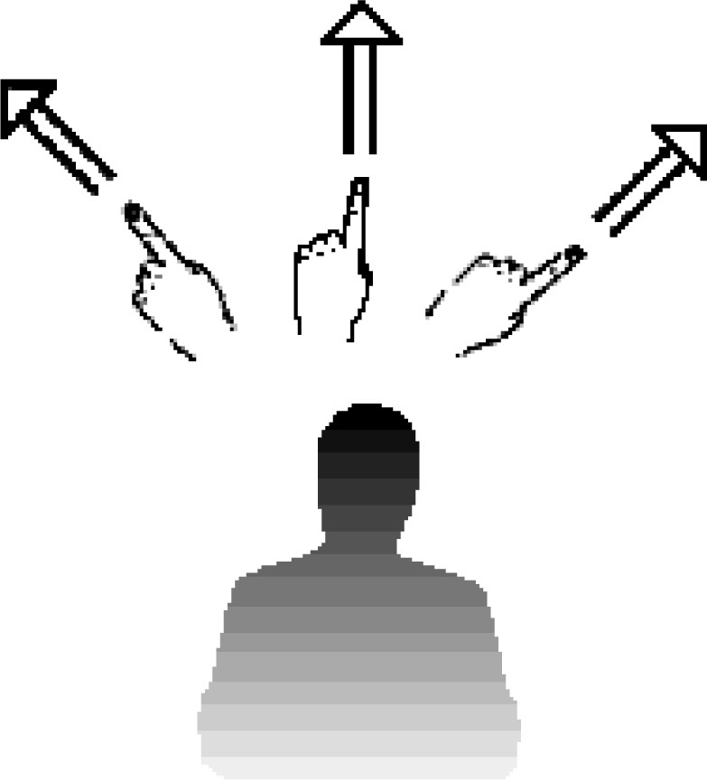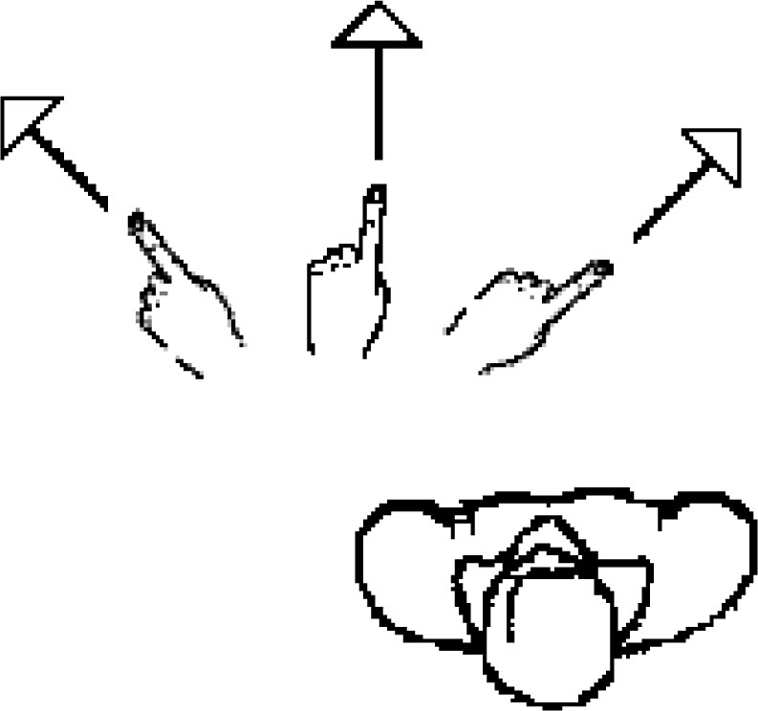

Movement With The Right Hand

A dark arrowhead.

Front View

Top View

Movement With The Left Hand

A light arrowhead.

Front View

Top View

33

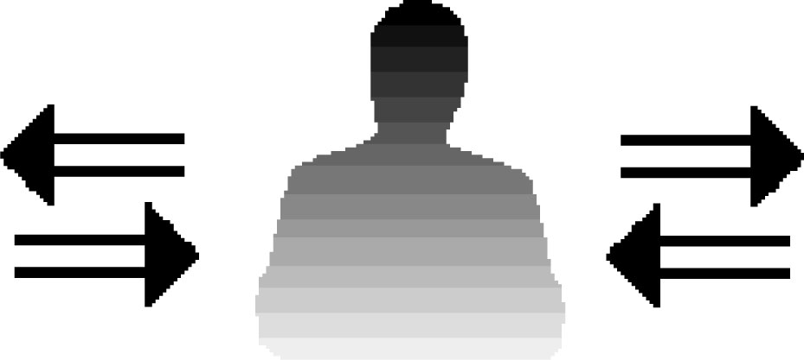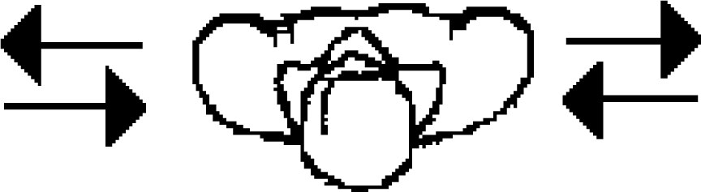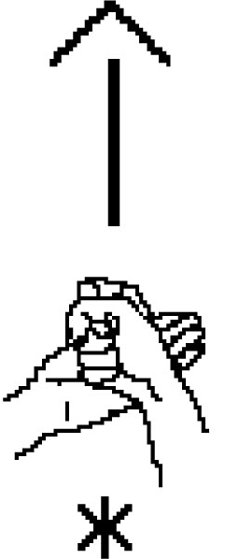

Movement To The Side

Movement to the side can be viewed from either the Front View or the Top

View.

It

can

be

written

with

either

double-stemmed or single-stemmed arrows.

General Arrowhead

Writes Overlapping Paths

When a right movement arrow

writes ON TOP OF a left move- ment arrow, the two movement paths overlap each other. The two arrows blend together. The dark arrowhead and the light ar- rowhead become one arrowhead, called the General Arrowhead.

Often the hands are contacting

when moving in overlapping paths, but it is NOT ONLY for contacting hands. For example, two hands can be parallel, side by side, without contact, and then both move to the same side, so that the right arrow writes on top of the left arrow. This creates a General Arrowhead.

I help you.

34



follow



plan



Front View



Top View

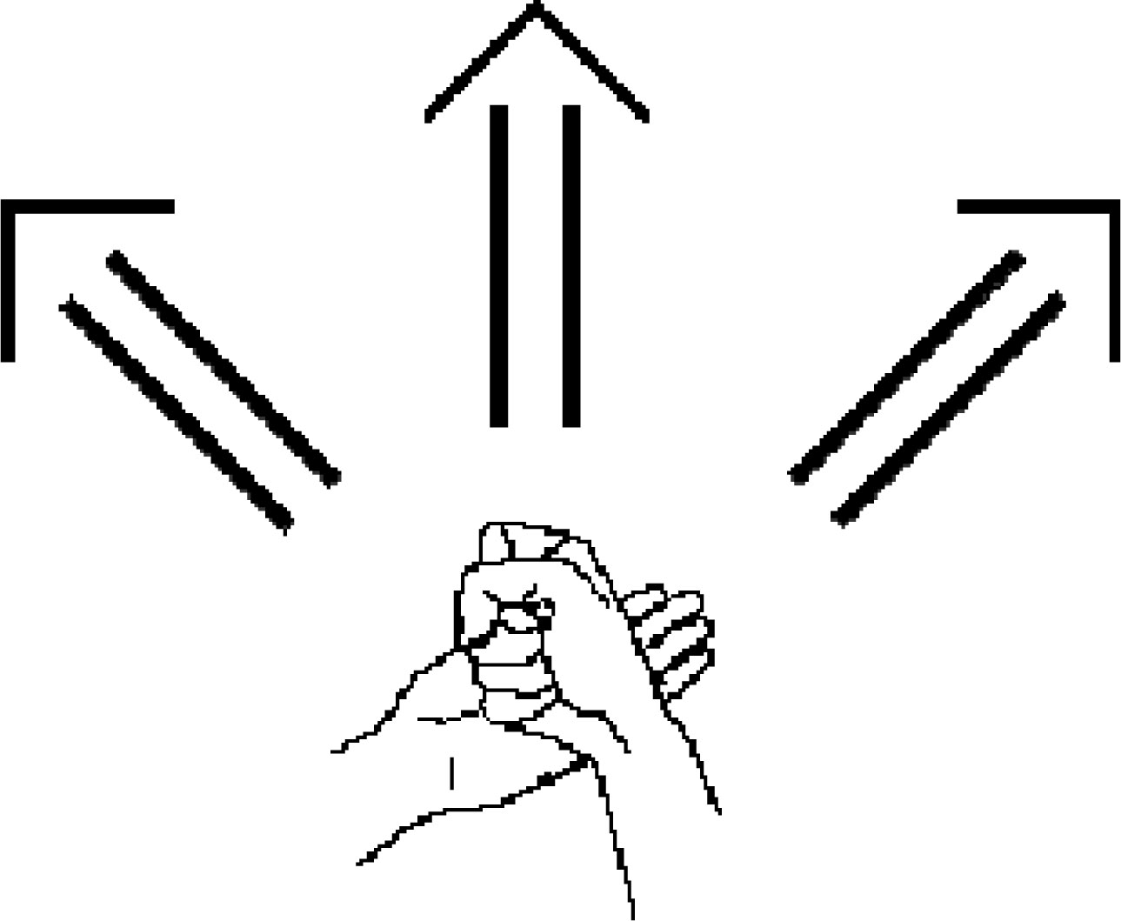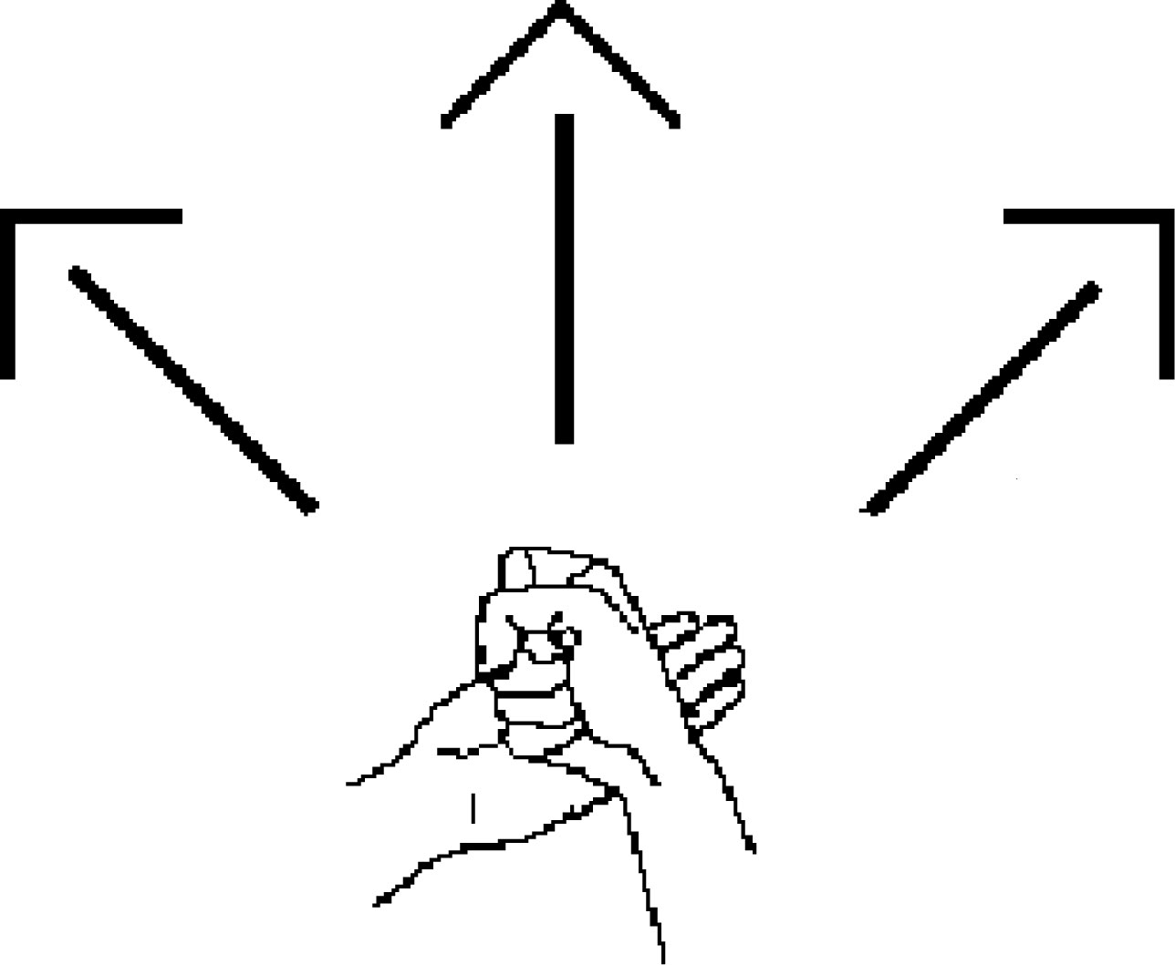

Do

not

confuse

these

arrows:

double

stemmed arrows mean movement is UP

single

stemmed arrows mean

movement

is FORWARD

35

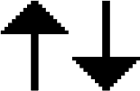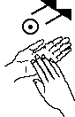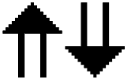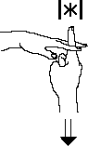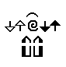

Straight Movement

Up or Down

A double-stemmed arrow

means that the movement is straight up or down, parallel with the front wall. The movement is flat with the front of your body.

monthly

disappear

Straight Movement

Forward

or Back

A single-stemmed arrow

means t hat t he move - ment is forward or back, parallel with the floor. You are looking down, on top of the movement.

eager

excuse me

36

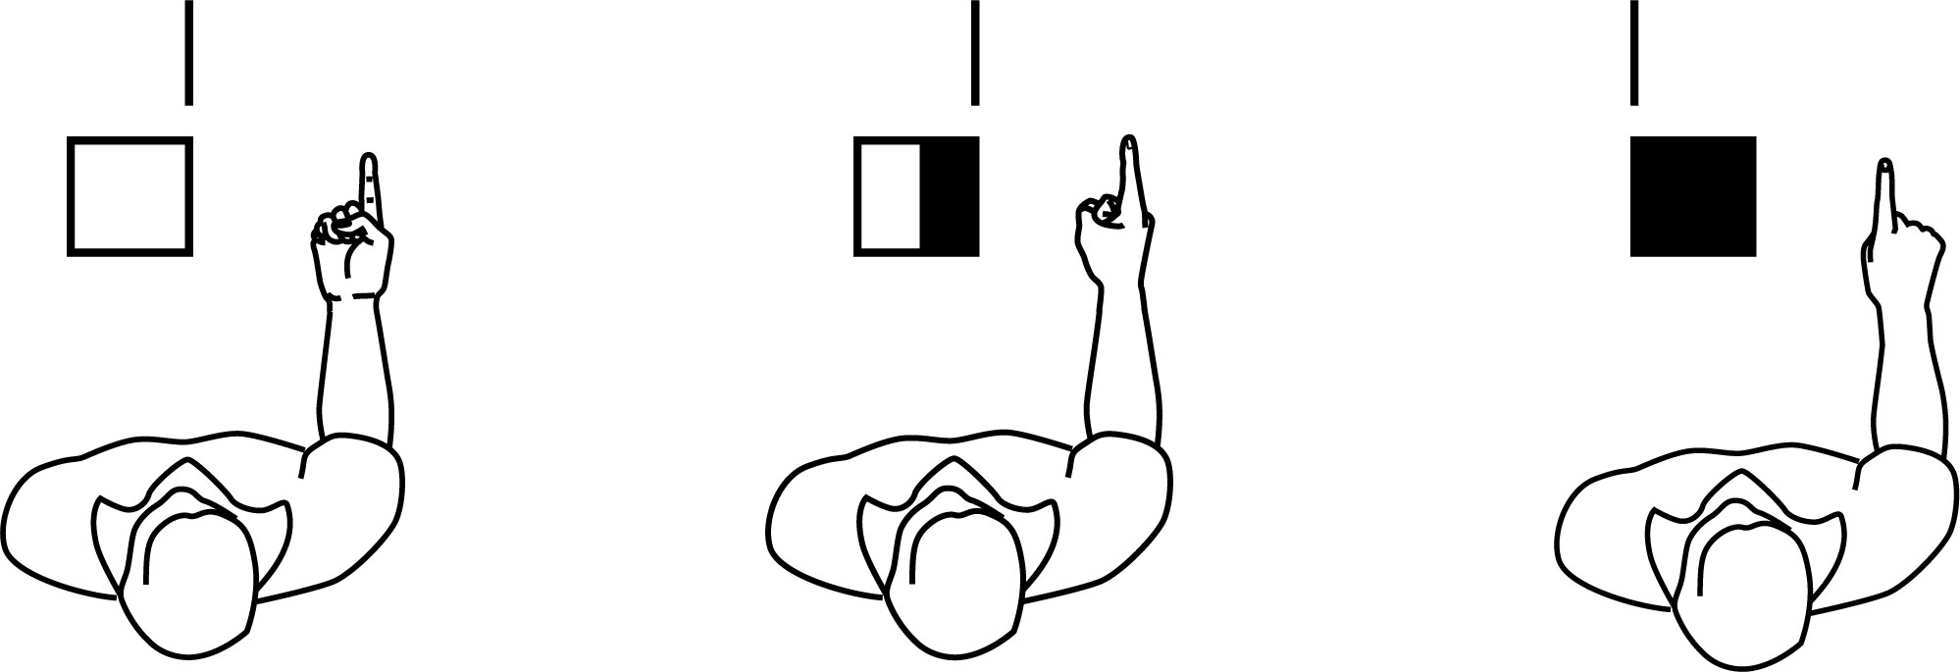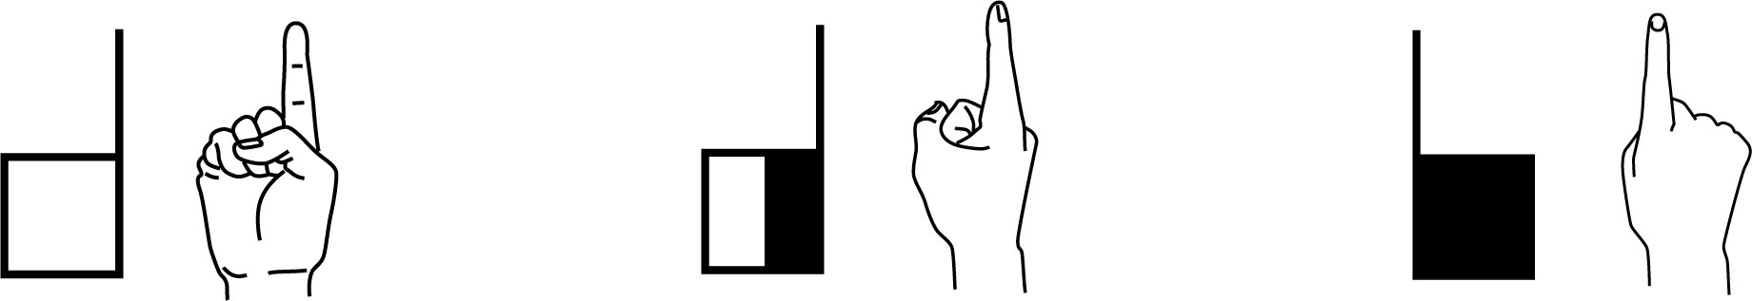

Front View

Hands parallel with the Front Wall.

one half

Deaf

where

Top View

Hands parallel with the Floor.

happen

you

also

37

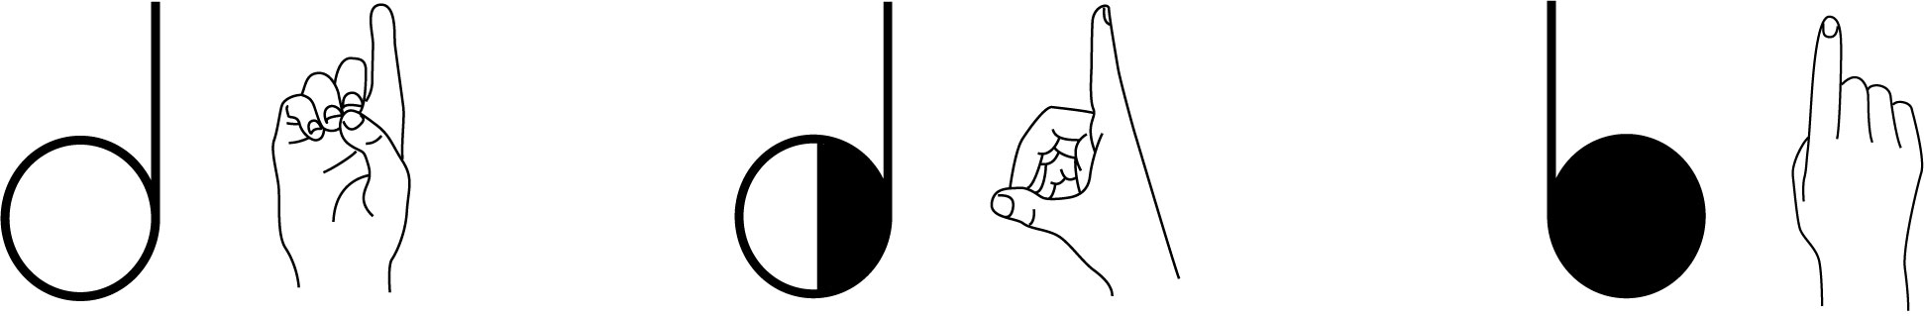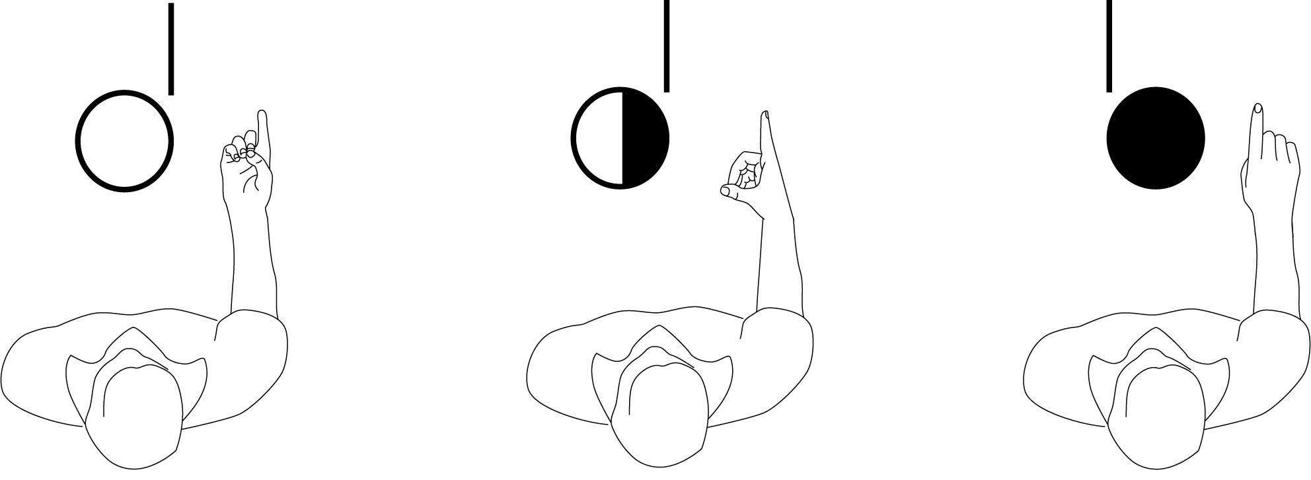

Front View

Hands parallel with the Front Wall.

dinner

democracy

dating

Top View

Hands parallel with the Floor.

do-do?

dessert

doctor

38

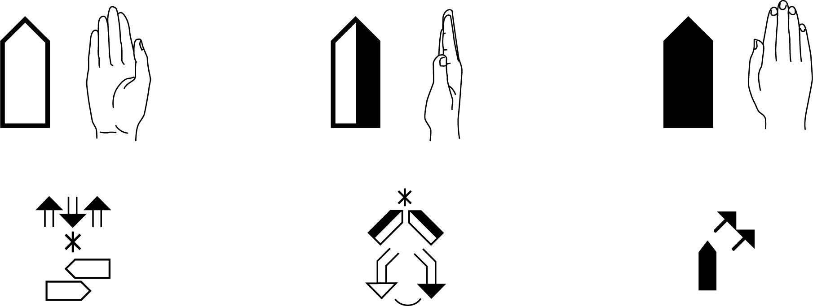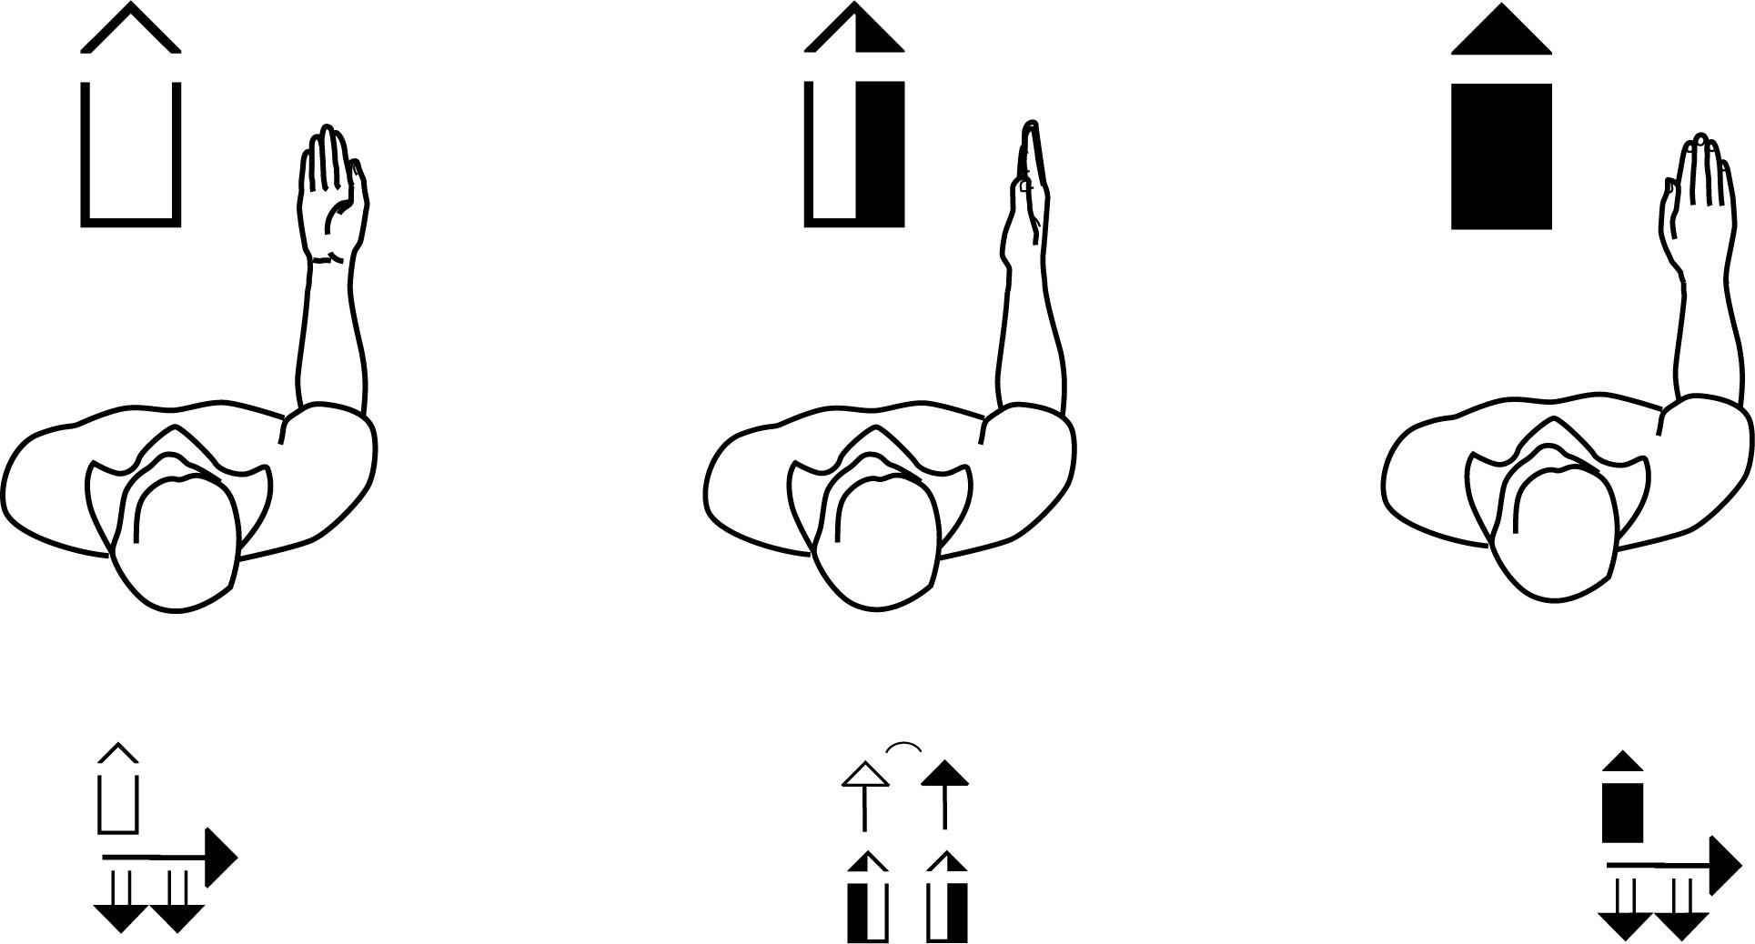

Front View

Hands parallel with the Front Wall.

window

house

his, hers

Top View

Hands parallel with the Floor.

things

way, street

children

39

written

horizontally

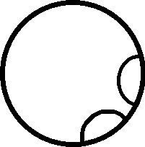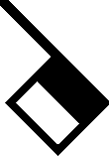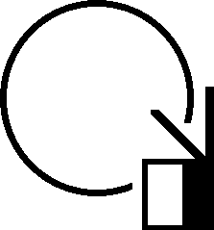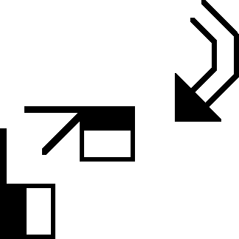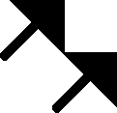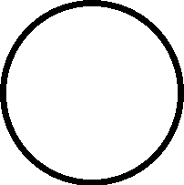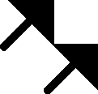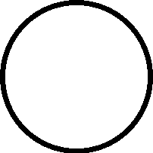

Period,

Pause,

Comma

End of

Sentence

English Translation: Writing ASL from the Deaf perspective.

40



Eyebrows

Down

**Where**

**house**

Head

Forward

**where**

Question

Mark,

Slight Pause at End of Sentence

**?**

English Translation: Where is the house?

41

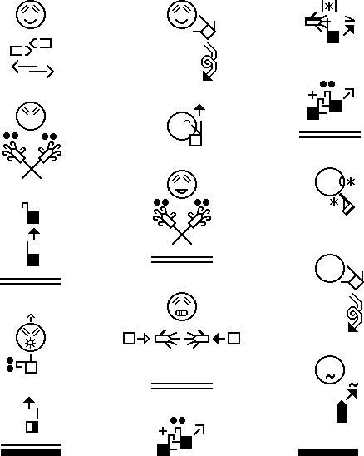

Fast

Movement

Tension

Symbol

English Translation: Baby Bear asks “Who are you?”

Goldilocks saw the bears, became frightened,

shot out of the house, and ran all the way home.

42

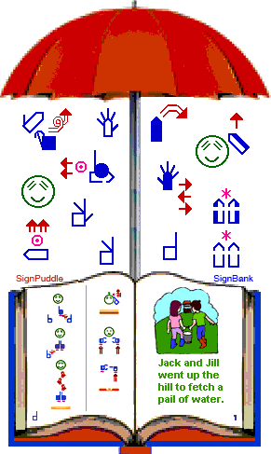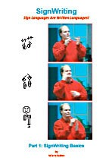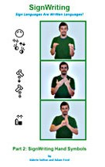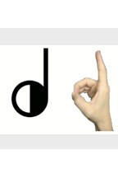

SignWriting Instruction

SignWriting.org/lessons • SignWriting.org/shop

1

SignWriting Reference Manual

Manual 1: SignWriting Basics

Learn the basics of SignWriting with this slender, 42 page, spiral-bound manual. An introduction to reading and writing any sign language, it gives a summary of hand symbols, con- tact symbols, finger movements, arm movements, facial ex- pressions, and reading of sign language literature. All exam- ples are in American Sign Language (ASL). Free for down- load on the web, and only $10.00 in the SignWriting Shop. ISBN: 978-0-914336-49-5

2

SignWriting Reference Manual

Manual 2: SignWriting Hand Symbols

This 300-page sprial-bound reference manual devotes a full page to each of the 261 hand symbols of the Interna- tional SignWriting Alphabet (ISWA 2010), used to write over 40 sign languages on the web in SignPuddle Online. Each page shows one handshape with 6 photos showing

6 different palm facings. The corresponding SignWriting symbol is placed next to each photo. Additional SignWriting instruction is included in the front and the back of the book.

ISBN: 978-0-914336-86-0

SignWriting Lessons on the Web

Web lessons show moving handshapes with symbols Adam Frost’s photos of his own hands move from one palm facing to another, on 261 web pages, each devoted to one of the 261 hand symbols of the ISWA 2010. This popular site is located in SignWriting Lessons Online. Take a visit:

3

ISWA 2010 Symbol Lessons Online

Animated GIFs by Adam Frost<http://www.signwriting.org/lessons/iswa/>

The SignWriting Press

Deaf Action Committee For SignWriting (the DAC) Center for Sutton Movement Writing, Inc. (CSMW), a 501c3 non-profit educational organization • [dac@signwriting.org](mailto:dac@signwriting.org) Box 517 • La Jolla • CA • 92038-0517 • USA • tel 858-456-0098

S ignW r it ing S hop O nline: [www. s ignwr it ing. or g/ s hop](http://www.signwriting.org/shop)

SignWriting on CafePress: [www.cafepress.com/signwriting](http://www.cafepress.com/signwriting)

SignPuddle Online: [www.signbank.org/signpuddle](http://www.signbank.org/signpuddle)

ISBN 978-0-914336-49-5

90000

9 780914 336495

SIGNWRITING BASICS